Chapter 1. Introduction to PyTorch

When it comes to creating artificial intelligence (AI), machine learning (ML) and deep learning are great places to begin. When you’re getting started, however, it’s easy to get overwhelmed by the options and all the new terminology. This book aims to demystify things for you as a programmer. It takes you through writing code to implement concepts of ML and deep learning, and it also takes you through building models that behave more as a human does, with scenarios like computer vision, natural language processing (NLP), and more. Thus, these models become a form of synthesized, or artificial, intelligence.

But when we refer to *machine learning*, what exactly is it? Let’s take a quick look at that and consider it from a programmer’s perspective before we go any further. After that, in the rest of this chapter, we’ll show you how to install the tools of the trade, from PyTorch itself to environments where you can code and debug your PyTorch-based models.

What Is Machine Learning?

Before we get into the ins and outs of ML, let’s consider how it evolved from traditional programming. We’ll start by examining what traditional programming is, and then we’ll consider cases where it’s limited. After that, we’ll see how ML evolved to handle those cases and thus opened up new opportunities to implement new scenarios, thereby unlocking many of the concepts of AI.

Traditional programming involves writing rules that are expressed in a programming language and that act on data and give us answers. This applies just about everywhere we can program something with code.

For example, consider a game like the popular Breakout. Code determines the movement of the ball, the score, and the various conditions for winning or losing the game. Think about the scenario where the ball bounces off a brick, like in [Figure 1-1](https://learning.oreilly.com/library/view/ai-and-ml/9781098199166/ch01.html#ch01_figure_1_1748548870009162).

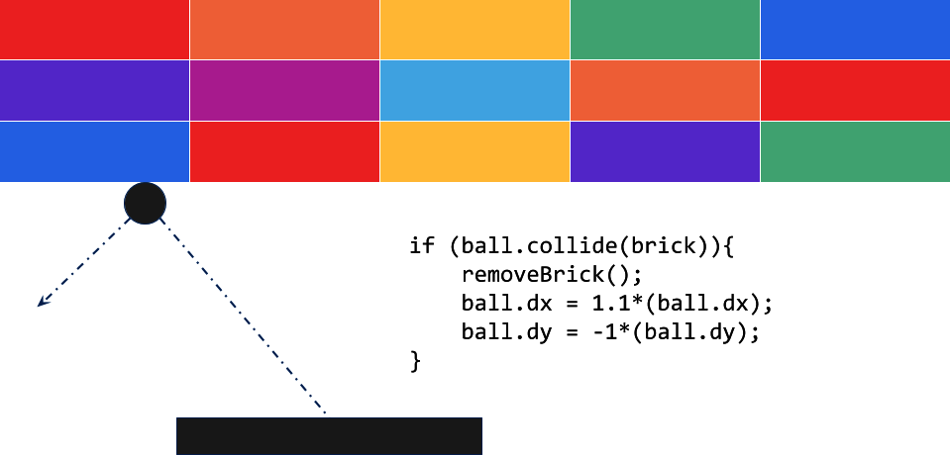

Figure 1-1. Code in a Breakout game

Here, the motion of the ball can be determined by its dx and dy properties. When the ball hits a brick, the brick is removed, the velocity of the ball increases, and the direction of the ball’s movement changes. The code acts on data about the game situation.

Alternatively, consider a financial services scenario. Say you have data about the company, such as its current stock price and earnings. By using code like that in [Figure 1-2](https://learning.oreilly.com/library/view/ai-and-ml/9781098199166/ch01.html#ch01_figure_2_1748548870009198), you can calculate a valuable ratio called the *price-to-earnings ratio* (or P/E, which stands for price divided by earnings).

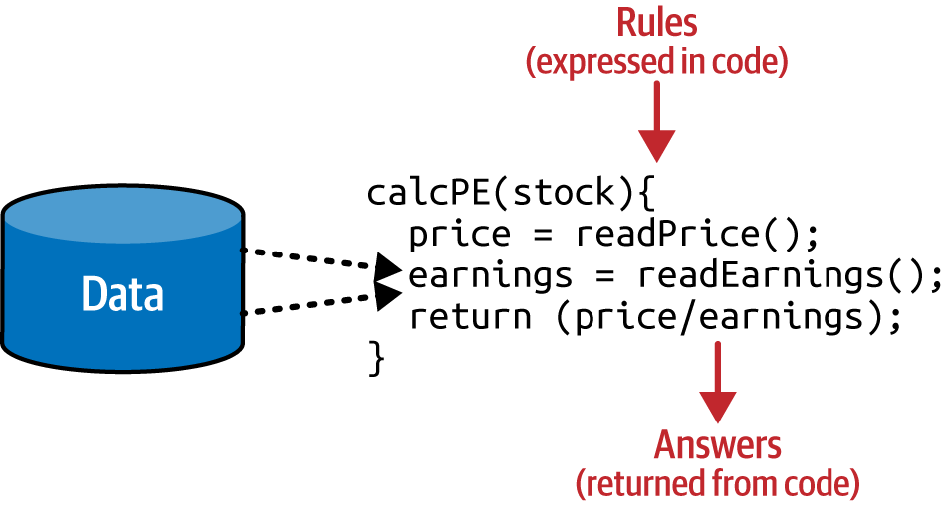

Figure 1-2. Code in a financial services scenario

Your code reads the price, reads the earnings, and returns a value that is the former divided by the latter.

If I were to try to sum up traditional programming like this in a single diagram, it might look like [Figure 1-3](https://learning.oreilly.com/library/view/ai-and-ml/9781098199166/ch01.html#ch01_figure_3_1748548870009219).



Figure 1-3. High-level view of traditional programming

As you can see, you have rules expressed in a programming language. These rules act on data, and the result is answers.

Limitations of Traditional Programming

The model from [Figure 1-3](https://learning.oreilly.com/library/view/ai-and-ml/9781098199166/ch01.html#ch01_figure_3_1748548870009219) has been the backbone of development since its inception. But it has an inherent limitation: namely, the only scenarios that you can implement are ones for which you can derive rules. But what about other scenarios? Usually, it’s unfeasible to develop them because the code is too complex. It’s just not possible to write code to handle them.

Consider, for example, activity detection. Fitness monitors that can detect our activity are a recent innovation, not just because of the availability of cheap and small hardware but also because the algorithms to handle detection weren’t previously feasible. Let’s explore why.

[Figure 1-4](https://learning.oreilly.com/library/view/ai-and-ml/9781098199166/ch01.html#ch01_figure_4_1748548870009237) shows a naive activity detection algorithm for walking. It can consider the person’s speed and if that speed is less than a particular value, we can determine that they are probably walking.

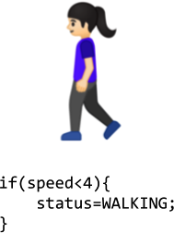

Figure 1-4. Algorithm for activity detection

Given that our data is speed, we could also extend this to detect whether they are running, as in [Figure 1-5](https://learning.oreilly.com/library/view/ai-and-ml/9781098199166/ch01.html#ch01_figure_5_1748548870009255).

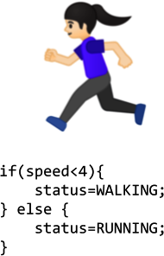

Figure 1-5. Extending the algorithm for running

As you can see, going by the speed, we might say that if it is less than a particular value (say, 4 mph) the person is walking, and otherwise, they are running. It still sort of works.

Now, suppose we want to extend this to another popular fitness activity, biking. The algorithm could look like the one in [Figure 1-6](https://learning.oreilly.com/library/view/ai-and-ml/9781098199166/ch01.html#ch01_figure_6_1748548870009270).

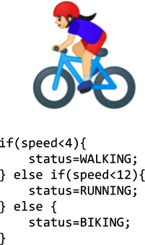

Figure 1-6. Extending the algorithm for biking

I know this algorithm is naive in that it just detects speed—some people run faster than others, and you might run downhill faster than you can cycle uphill—but on the whole, it still works. However, what happens if we want to implement another scenario, such as golfing (see [Figure 1-7](https://learning.oreilly.com/library/view/ai-and-ml/9781098199166/ch01.html#ch01_figure_7_1748548870009286))?



Figure 1-7. How do we write a golfing algorithm?

Now, we’re stuck. Whether a person is golfing or not, they might walk for a bit, stop, do some activity, walk for a bit more, stop, etc. So how can we use this methodology to tell whether they’re playing golf?

Our ability to detect this activity using traditional rules has hit a wall. But maybe there’s a better way.

Enter ML.

From Programming to Learning

Let’s look back at the diagram that we used to demonstrate what traditional programming is (see [Figure 1-8](https://learning.oreilly.com/library/view/ai-and-ml/9781098199166/ch01.html#ch01_figure_8_1748548870009301)). Here, we have rules that act on data and give us answers. In our activity detection scenario, the data was the speed at which the person was moving—and from that, we could write rules to detect their activity, be it walking, biking, or running. However, we hit a wall when it came to golfing because we couldn’t come up with rules to determine what that activity looks like.



Figure 1-8. The traditional programming flow

But what would happen if we were to flip the axes around on this diagram? Instead of us coming up with the *rules*, what if we were to come up with the *answers* and, along with the data, have a way of figuring out what the rules might be?

[Figure 1-9](https://learning.oreilly.com/library/view/ai-and-ml/9781098199166/ch01.html#ch01_figure_9_1748548870009316) shows what this would look like, and we can say that this high-level diagram defines *machine learning*.

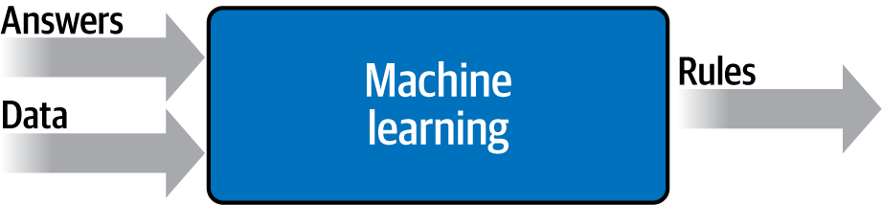

Figure 1-9. Changing the axes to get ML

So, what are the implications of this? Well, now, instead of *us* trying to figure out what the rules are, we can get lots of data about our scenario and label that data, and then the computer can figure out what the rules are that make one piece of data match a particular label and another piece of data match a different label.

How would this work for our activity detection scenario? Well, we can look at all the sensors that give us data about this person. If the person has a wearable device that detects information such as heart rate, location, and speed—and if we collect a lot of instances of this data while they’re doing different activities—then we end up with a scenario of having data that says, “This is what walking looks like,” “This is what running looks like,” and so on (see [Figure 1-10](https://learning.oreilly.com/library/view/ai-and-ml/9781098199166/ch01.html#ch01_figure_10_1748548870009331)).

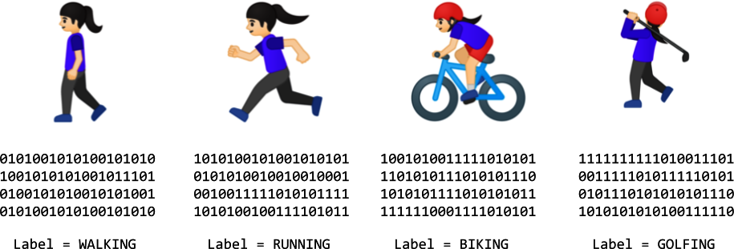

Figure 1-10. From coding to ML: gathering and labeling data

Now, our job as programmers changes from figuring out the rules, to determining the activities, to writing the code that matches the data to the labels. If we can do this, then we can expand the scenarios that we can implement with code.

ML is a technique that enables us to do this, but to get started, we’ll need a framework—that’s where TensorFlow enters the picture. In the next section, we’ll take a look at what TensorFlow is and how to install it. Then, later in this chapter, you’ll write your first code that learns the pattern between two values, like in the preceding scenario. It’s a simple “Hello World” scenario, but it has the same foundational code pattern that’s used in extremely complex ones.

The field of AI is large and abstract, encompassing everything that has to do with making computers think and act the way human beings do. One of the ways a human takes on new behaviors is through learning by example, and the discipline of ML can thus be thought of as an on-ramp to the development of AI. By way of an ML field called *computer vision*, a machine can learn to see like a human, and by way of another ML field called *natural language processing*, it can learn to read text like a human. Many more such applications of ML are possible, and we’ll be covering the basics of ML in this book by using the TensorFlow framework.

What Is PyTorch?

PyTorch is an ML library that is based on a previous library called *Torch*, which is an open source ML framework and scripting language that is itself based on a programming language called Lua. In 2017, development of Torch moved to PyTorch, which is a port of the framework in Python.

So, when installing PyTorch, you’ll often see it referred to as “torch.”

PyTorch was originally developed by Meta AI, but it was moved out to the Linux Foundation as a way of building developer confidence that it wasn’t made by and for a big tech company. It’s one of the two most popular ML libraries, alongside the TensorFlow/Keras ecosystem.

With the emergence of generative AI, and in particular the “open sourcing” of generative text and image models, PyTorch has exploded in popularity. It’s often used for training models (which we cover in Part I of this book) as well as for inference of models (which we cover in Part II of this book).

PyTorch could also be seen as an ecosystem of libraries, each of which is tailored to specific scenarios. The important libraries and scenarios to consider are as follows:

*TorchServe*

This is an easy-to-use tool that lets you deploy PyTorch models at scale. It’s designed to run in multiple environments, and it’s generally technology agnostic. It supports features such as multimodel serving, logging, metrics, and the easy creation of RESTful endpoints that let you do inference on models from a variety of clients.

*Distributed training*

When larger models don’t fit onto a single chip or machine, there are technologies and techniques that allow you to share them across multiple devices. The torch.distributed libraries allow you easy and native support of asynchronous execution across multiple devices.

*Mobile*

An important surface for inference is, of course, mobile. It’s important for you to be able to deploy your AI work to Android and iOS devices, and PyTorch supports this through PyTorch Mobile.

*Pretrained models*

An active community of researchers and developers have created a rich ecosystem of models that you can simply use with one line of code, wrapped in the torchvision.models library.

[Figure 1-11](https://learning.oreilly.com/library/view/ai-and-ml/9781098199166/ch01.html#fig-1-11) provides a high-level representation of this.

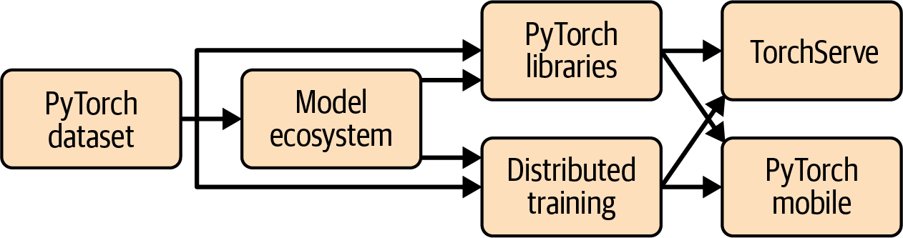

Figure 1-11. PyTorch ecosystem

The process of creating ML models is called *training*, and it’s where a computer uses a set of algorithms to learn about inputs and what distinguishes them from one another. So, for example, if you want a computer to recognize cats and dogs, you can use lots of pictures of both to create a model, and the computer will use that model to try to figure out what makes a cat a cat and what makes a dog a dog. Once the model is trained, the process of having it recognize or categorize future inputs is called *inference*.

So, for training models, there are several things that you need to consider, and we will cover them in this book. Primarily, your choice will boil down to one of three things:

* Creating the model entirely from scratch yourself
* Using someone else’s model because it’s enough for your task
* Using parts of another person’s model that have already been trained and building on top of them

The last option on the list is called *transfer learning*, and we’ll cover it later in the book.

There are many ways to train a model. For the most part, you’ll probably just use a single chip, whether it’s a central processing unit (CPU), a graphics processing unit (GPU), or something new called a tensor processing unit (TPU). In more advanced working and research environments, you can use parallel training across multiple chips, employing a distributed training where training is intelligently spanned across multiple chips. PyTorch supports this, too, through “distributed training” libraries, as shown in [Figure 1-11](https://learning.oreilly.com/library/view/ai-and-ml/9781098199166/ch01.html#fig-1-11).

The lifeblood of any model is its data. As we discussed earlier, if you want to create a model that can recognize cats and dogs, you need to train it with lots of examples of cats and dogs. But how can you manage these examples? Over time, you’ll see that this can often involve a lot more coding than the creation of the models themselves.

But luckily, the PyTorch ecosystem includes a number of built-in datasets that make this easy for you. We will also explore these throughout this book.

Beyond creating models, you’ll need to be able to get them into people’s hands so they can use them. To this end, PyTorch includes libraries for serving, where you can provide model inference over an HTTP connection for cloud or web users. For models to run on mobile or embedded systems, there’s PyTorch Mobile, which provides tools for model inference on Android and iOS.

Next, I’ll show you how to install PyTorch so that you can get started creating and using ML models with it!

Using PyTorch

In this section, we’ll look at the three main ways you can install and use PyTorch. We’ll start with how to install it on your developer box using the command line. Then, we’ll explore using the popular PyCharm IDE to install and use PyTorch. Finally, we’ll look at Google Colab and how you can use it to access your PyTorch code with a cloud-based backend in your browser.

**Installing Porch in Python**

The *Py* in PyTorch stands for Python, so it’s important to have a Python environment already set up. If you don’t have Python already, I strongly recommend you visit [the Python website](https://python.org/) to get up and running with it and [the Learn Python website](https://learnpython.org/) to learn the Python language syntax.

With Python, there are many ways to install frameworks, but the default one supported by the TensorFlow team is pip.

So, in your Python environment, installing PyTorch is as easy as using this:

> pip install torch

Once you’re up and running, you can test your PyTorch version with the following code:

import torch

print(torch.__version__)

You should then see output like that in [Figure 1-12](https://learning.oreilly.com/library/view/ai-and-ml/9781098199166/ch01.html#ch01_figure_12_1748548870009360). It will print the currently running version of PyTorch—here, you can see that version 2.4.1 is installed.

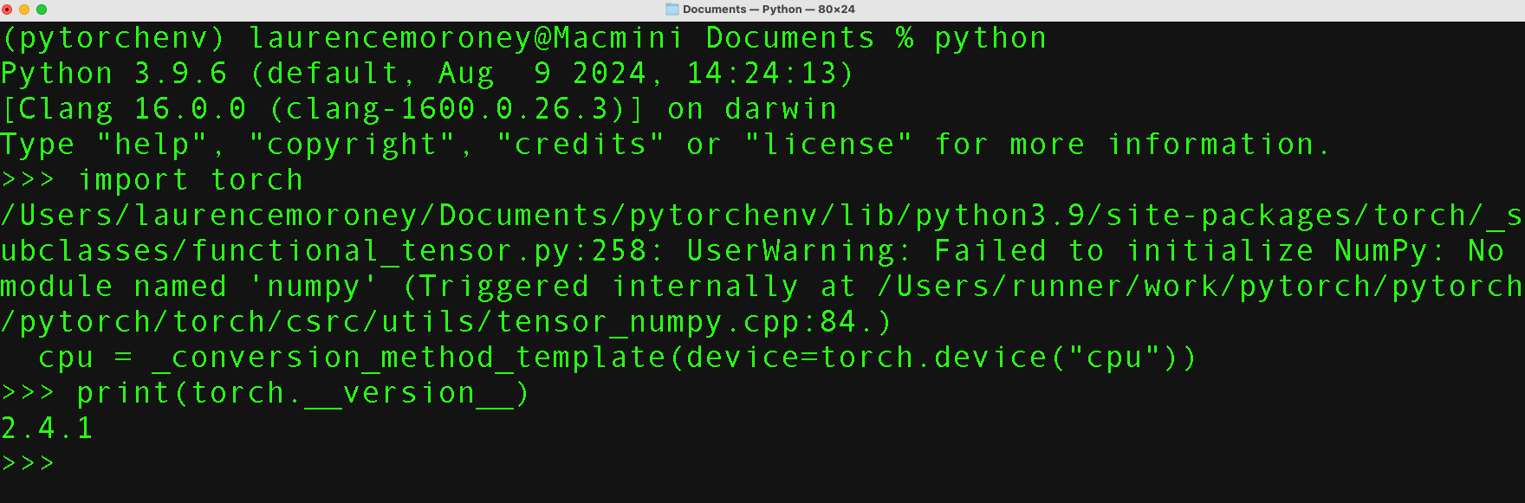

Figure 1-12. Running PyTorch in Python

**Note**

If you look closely at [Figure 1-12](https://learning.oreilly.com/library/view/ai-and-ml/9781098199166/ch01.html#ch01_figure_12_1748548870009360), you’ll see a note that shows that the torch device is “cpu.” In this case, I natively installed it on my Mac, and it is configured to use the CPU. However, this is not optimal for complex models, where an accelerator like a GPU or Metal may be necessary. We will cover installation of PyTorch for accelerators later in this book.

**Using PyTorch in PyCharm**

I’m particularly fond of using the [free community version of PyCharm](https://oreil.ly/I2mP2)for building models using PyTorch. PyCharm is useful for many reasons, but one of my favorites is that it makes the management of virtual environments easy. This means you can have Python environments with versions of tools such as PyTorch that are specific to your particular project. So, for example, if you want to use PyTorch 1.x in one project and PyTorch 2.x in another, you can separate them with virtual environments and not have to deal with installing/uninstalling dependencies when you switch between them. Additionally, with PyCharm, you can do step-by-step debugging of your Python code—which is a must, especially if you’re just getting started!

For example, in [Figure 1-13](https://learning.oreilly.com/library/view/ai-and-ml/9781098199166/ch01.html#ch01_figure_13_1748548870009375), I have a new project that’s called *example1*, and I’m specifying that I’m going to create a new environment using Conda. When I create the project, I’ll have a clean, new, virtual Python environment into which I can install any version of PyTorch I want.

Once you’ve created a project, you can open the File → Settings dialog and choose the entry for “Project: *<your project name>*” from the menu on the left. In the menu on the left, you’ll see choices to change the settings for the Python Interpreter and the Project Structure. If you choose the Python Interpreter link, you’ll see the interpreter that you’re using, as well as a list of packages that are installed in this virtual environment (see [Figure 1-14](https://learning.oreilly.com/library/view/ai-and-ml/9781098199166/ch01.html#ch01_figure_14_1748548870009389)).

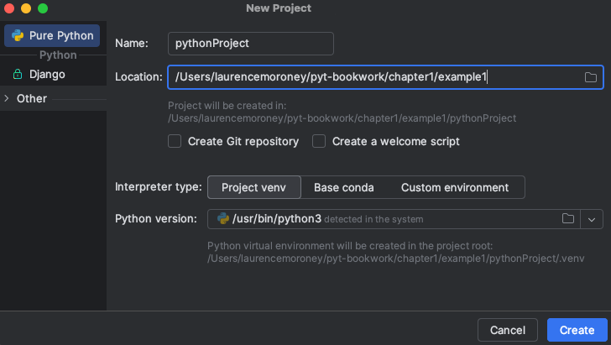

Figure 1-13. Creating a new virtual environment using PyCharm

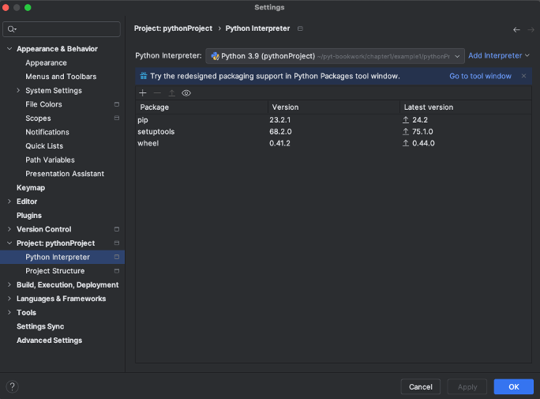

Figure 1-14. Adding packages to a virtual environment

You can then click the + button at the upper left, and a dialog will open showing the packages that are currently available. Type **torch** into the search box and you’ll see all available packages with *torch* in the name (see [Figure 1-15](https://learning.oreilly.com/library/view/ai-and-ml/9781098199166/ch01.html#ch01_figure_15_1748548870009404)). Remember that the name of the package is *torch*, even if the technology is PyTorch.

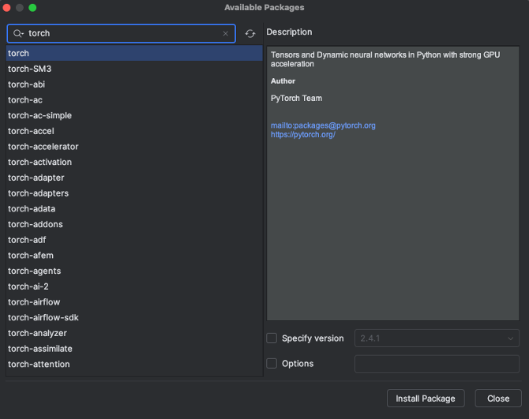

Figure 1-15. Installing torch with PyCharm

Once you’ve selected torch or any other package you want to install, you can click the Install Package button and PyCharm will do the rest. Then, once torch is installed, you can write and debug your PyTorch code in Python.

**Using PyTorch in Google Colab**

Another option, perhaps the easiest one for getting started, is to use [*Google Colab*](https://oreil.ly/c0lab), which is a hosted Python environment that you can access via a browser. What’s really neat about Colab is that it provides GPU and TPU backends so you can train models using state-of-the-art hardware at no cost.

When you visit the Colab website, you’ll be given the option to open previous Colabs or start a new notebook (see [Figure 1-16](https://learning.oreilly.com/library/view/ai-and-ml/9781098199166/ch01.html#ch01_figure_16_1748548870009418)). If you click the + New notebook button, it will open the editor, where you can add panes of code or text (see [Figure 1-17](https://learning.oreilly.com/library/view/ai-and-ml/9781098199166/ch01.html#ch01_figure_17_1748548870009451)). You ⁠ can then execute the code by clicking the Play button (the arrow) to the left of the pane.

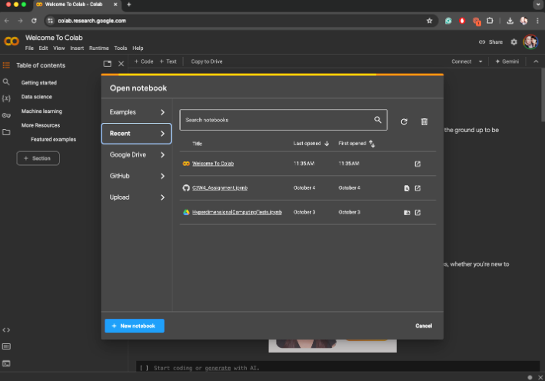

Figure 1-16. Getting started with Google Colab

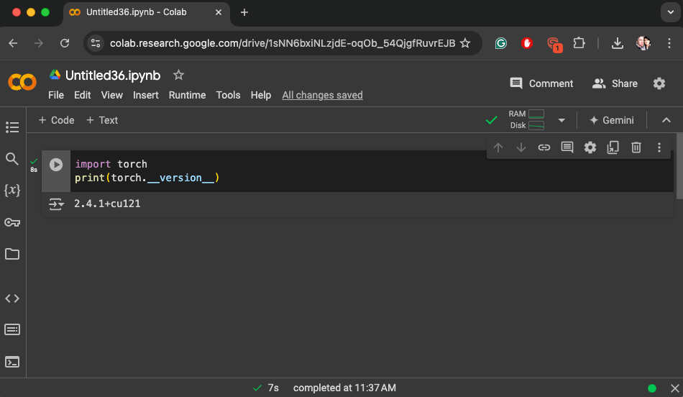

Figure 1-17. Running PyTorch code in Colab

It’s always a good idea to check the PyTorch version, as shown here, to be sure you’re running the correct version for the task at hand.

You can also see that in [Figure 1-17](https://learning.oreilly.com/library/view/ai-and-ml/9781098199166/ch01.html#ch01_figure_17_1748548870009451) the version shown is 2.4.1+cu121, and you might want to know what the *cu121* part is! The *cu* stands for *Cuda*, which is Nvidia’s library for accelerated ML on GPUs. So, the preceding message demonstrates that PyTorch 2.4.1 is installed, along with accelerators for Cuda version 12.1.

Often, Colab’s built-in versions of various libraries, including PyTorch, will be a version or two behind the latest release. If that’s the case, you can update it with pip install as shown earlier, by simply using a block of code like this, where you specify the desired version:

!pip install torch==<different version number>

Once you run this command, your current environment within Colab will use the desired version of PyTorch. However, you should be careful when doing this in Colab because the version of PyTorch you change to may not have Cuda drivers installed, meaning you could downgrade to using the CPU.

Getting Started with Machine Learning

As we saw earlier in the chapter, the ML paradigm is one in which you have data, that data is labeled, and you want to figure out the rules that match the data to the labels. The simplest possible scenario to show this in code is as follows.

Consider these two sets of numbers:

*x* = –1, 0, 1, 2, 3, 4

*y* = –3, –1, 1, 3, 5, 7

There’s a relationship between the *x* and *y* values (for example, if *x* is –1, then *y* is –3; if *x* is 3, then *y*is 5; and so on). Can you see it?

After a few seconds, you probably saw that the pattern here is *y* = 2*x* – 1. How did you get that? Different people work it out in different ways, but I typically hear the observation that *x* increases by 1 in its sequence and *y* increases by 2; thus, *y* = 2*x* +/– something. Then, they look at when *x* = 0 and see that *y* = –1, so they figure that the answer could be *y*= 2*x* – 1. Next, they look at the other values and see that this hypothesis “fits,” and the answer is *y* = 2*x* – 1.

That’s very similar to the ML process. Let’s take a look at some code that you could write to have a neural network figure this out for you.

Here’s the full code, using PyTorch. Don’t worry if it doesn’t make sense yet; we’ll go through it line by line:

import torch

import torch.nn as nn

import torch.optim as optim

import numpy as np

# Model

model = nn.Sequential(nn.Linear(1, 1))

# Loss and optimizer

criterion = nn.MSELoss()

optimizer = optim.SGD(model.parameters(), lr=0.01)

# Data

xs = torch.tensor([[–1.0], [0.0], [1.0], [2.0], [3.0], [4.0]],

dtype=torch.float32)

ys = torch.tensor([[–3.0], [–1.0], [1.0], [3.0], [5.0], [7.0]],

dtype=torch.float32)

# Train

for _ in range(500):

optimizer.zero_grad()

outputs = model(xs)

loss = criterion(outputs, ys)

loss.backward()

optimizer.step()

# Predict

with torch.no_grad():

print(model(torch.tensor([[10.0]], dtype=torch.float32)))

The first few lines are the importers that ensure the correct libraries are available, so let’s jump to this line:

model = nn.Sequential(nn.Linear(1, 1))

You’ve probably heard of neural networks, and you’ve probably seen diagrams that explain them by using layers of interconnected neurons, a little like in [Figure 1-18](https://learning.oreilly.com/library/view/ai-and-ml/9781098199166/ch01.html#ch01_figure_18_1748548870009467).

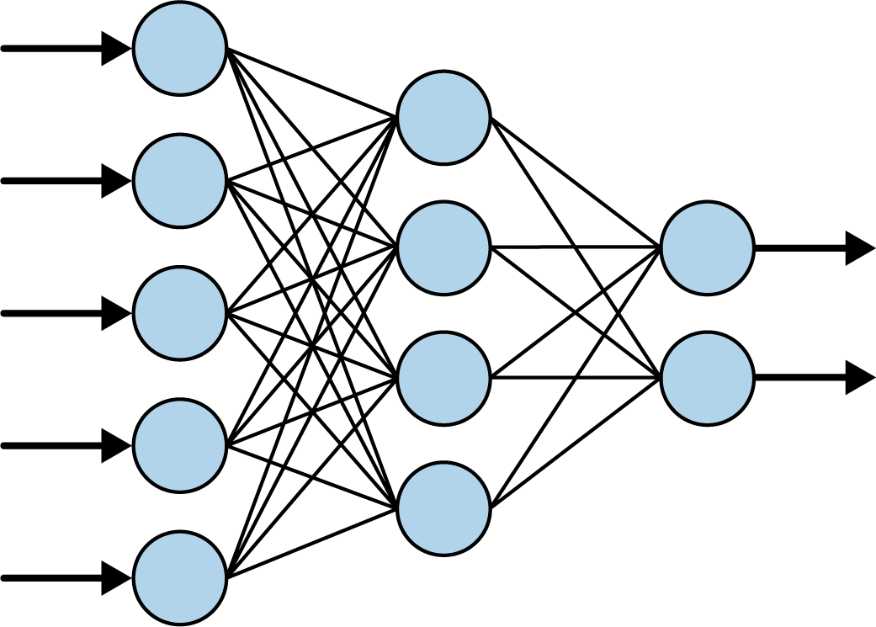

Figure 1-18. A typical neural network

When you see a neural network like this, you should consider each of the circles to be a *neuron* and each of the columns of circles to be a *layer*. So, in [Figure 1-18](https://learning.oreilly.com/library/view/ai-and-ml/9781098199166/ch01.html#ch01_figure_18_1748548870009467), there are three layers: the first has five neurons, the second has four, and the third has two.

These layers are organized in a sequence through which the data flows from left to right.

Now, if we look back at our code, you’ll see that we’re defining a sequence of something, with what’s contained in the brackets being the definition of the sequence:

model = nn.Sequential(nn.Linear(1, 1))

When using PyTorch, you define your layers by using a Sequential, and inside the Sequential, you then specify what each layer looks like. We have only one line inside our Sequential, so the neural network this code defines will have only one layer.

Then, you define what the layer looks like by using the torch.nn libraries. There are lots of different layer types, but here, we’re using a Linear layer, in which a linear relationship (where the definition of a line is *y* = *wx* + *b*) can be defined or learned.

Our Linear layer has the (1,1) parameters specified, which indicates one feature “in” and one feature “out.” So ultimately, we have just one layer with one neuron in our entire neural network.

In other words, the Sequential containing a Linear with the parameters (1,1) ultimately looks like [Figure 1-19](https://learning.oreilly.com/library/view/ai-and-ml/9781098199166/ch01.html#ch01_figure_19_1748548870009483).

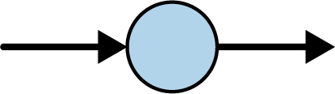

Figure 1-19. A neural network with one layer, containing one neuron

The next lines are where the fun really begins. Let’s look at them again:

# Loss and optimizer

criterion = nn.MSELoss()

optimizer = optim.SGD(model.parameters(), lr=0.01)

If you’ve done anything with ML before, you’ve probably seen that it involves a lot of mathematics—and if you haven’t done calculus in years, it might have seemed like a barrier to entry. Here’s the part where the math comes in—it’s the core of ML.

In a scenario such as this one, the computer has *no idea* what the relationship between *x* and *y* is. So, it will make a guess. Say, for example, it guesses that *y* = 10*x* + 10. Then, it needs to measure how good or how bad that guess is—and that’s the job of the *loss function*.

The computer already knows the answers when *x* is –1, 0, 1, 2, 3, and 4, so the loss function can compare these to the answers for the guessed relationship. If it guessed *y* = 10*x* + 10, then when *x* is –1, *y* will be 0. However, the correct answer there was –3, so it’s a bit off. But when *x* is 4, the guessed answer is 50, whereas the correct one is 7. That’s really far off.

Armed with this knowledge, the computer can then make another guess. That’s the job of the *optimizer*. This is where the heavy calculus is used, but with PyTorch, that can be hidden from you. You just pick the appropriate optimizer to use for different scenarios. In this case, we picked one called sgd, which stands for *stochastic gradient descent*—a complex mathematical function that, when given the values, the previous guess, and the results of calculating the errors (or loss) on that guess, can then generate another guess. Over time, its job is to minimize the loss, and by doing so bring the guessed formula closer and closer to the correct answer.

Next, we simply format our numbers into the data format that the layers expect:

# Data

xs = torch.tensor([[–1.0], [0.0], [1.0], [2.0], [3.0], [4.0]],

dtype=torch.float32)

ys = torch.tensor([[–3.0], [–1.0], [1.0], [3.0], [5.0], [7.0]],

dtype=torch.float32)

You’ll see the word *tensor* a lot in ML; it gives the TensorFlow framework its name. Think of a tensor as a way of storing data that’s like an array that is optimized for flexibility in array size. To have PyTorch understand our data, we will load the values into tensors representing the *x* and *y* values.

The *learning* process will then begin with the training loop like this:

# Train

for _ in range(500):

optimizer.zero_grad()

outputs = model(xs)

loss = criterion(outputs, ys)

loss.backward()

optimizer.step()

If you’re new to ML, this is probably the most difficult part to understand, so let’s go through it line by line.

Remember that the ML process looks like [Figure 1-20](https://learning.oreilly.com/library/view/ai-and-ml/9781098199166/ch01.html#ch01_figure_20_1748548870009497).

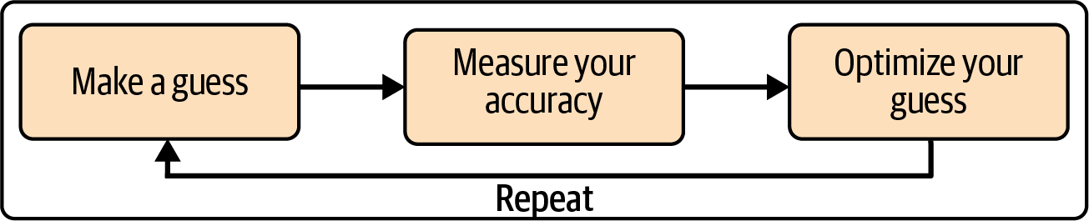

Figure 1-20. The ML process

So, the preceding code implements this as follows:

optimizer.zero_grad()

This line reads as “zero the gradients” of the optimizer. The calculus of learning involves navigating down a curve to find its minimum, and to do that, we need the gradient of the curve. The curve is calculated when we measure our accuracy, so we need to reset it at the beginning of each loop:

outputs = model(xs)

This line creates an array of the outputs that we calculate for the input *x* values. Even though we have given the computer the *correct* answers in our *Y* array, we want to measure the accuracy of the guess that the computer has made for the parameters defining this line. The first time through the loop, the *w* and *b* parameters within the neuron will be randomly initialized, so our guess might be *Y* = 10*x* + 10, for example:

loss = criterion(outputs, ys)

This line then compares the outputs (aka our guesses) with the correct answers to calculate the *loss*—which is effectively a value that tells us how good or bad the guess is:

loss.backward()

This line is the essential part of the learning process where a process called *backpropagation* happens. It’s where the math from the optimizer and the loss function combine to figure out the gradients for the new set of parameters. In our case, the error from *Y* = 10*x* + 10 is really high and not even close to our desired values, so the calculations done in figuring out the loss will give us a *direction* or gradient in which we should go to get closer to our desired results:

optimizer.step()

This line of code finishes the job by updating the model parameters to the values based on the gradients calculated in the preceding backpropagation step.

We then repeat this process five hundred times, with the goal of finding a set of parameters for our single neuron that will give us *y* values that are close to our desired *y* values. If the set of parameters does so, it can then infer the *y* value for *x* values that the computer has never previously seen. Thus, it will have learned the relationship between the *x* and *y* values we provided.

[Figure 1-21](https://learning.oreilly.com/library/view/ai-and-ml/9781098199166/ch01.html#ch01_figure_21_1748548870009510) shows a screenshot of this running in a Colab notebook. Take a look at the loss values over time.

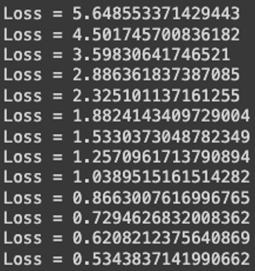

Figure 1-21. Training the neural network

We can see that over the first 10 epochs, the loss went from 5.64 to 0.86. That is, after only 10 tries, the network was performing about six times better than with its initial guess.

Then take a look at what happens by the 500th epoch (see [Figure 1-22](https://learning.oreilly.com/library/view/ai-and-ml/9781098199166/ch01.html#ch01_figure_22_1748548870009531)).

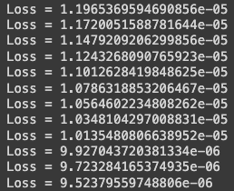

Figure 1-22. Training the neural network—the last few epochs

We can now see that the loss is 9.52 × 10**-6**. The loss has gotten so small that the model has pretty much figured out that the relationship between the numbers is *y* = 2*x* – 1. This means that the *machine* has *learned* the pattern between them.

If we want our neural network to try to predict a new value, we can use code like this:

# Predict

with torch.no_grad():

prediction = model(torch.tensor([[10.0]], dtype=torch.float32))

print(prediction)

**Note**

The term *prediction* is typically used when dealing with ML models—but don’t think of it as looking into the future! We use this term because we’re dealing with a certain amount of uncertainty. Think back to the activity detection scenario we spoke about earlier. When the person was moving at a certain speed, she was *probably* walking. Similarly, when a model learns about the patterns that exist between two things, it will tell us what the answer *probably* is. In other words, it is *predicting* the answer. (Later, you’ll also learn about *inference*, in which the model picks one answer among many and *infers* that it has picked the correct one.)

What do you think the answer will be when we ask the model to predict *y* when *x* is 10? You might instantly think 19, but that’s not correct. The model will pick a value *very close* to 19, and there are several reasons for this. First of all, our loss wasn’t 0. It was a very small amount, so we should expect any predicted answer to be off by a very small amount. Second, the neural network is trained on only a small amount of data—and in this case, it’s only six pairs of (*x*, *y*) values.

The model only has a single neuron in it, and that neuron learns a *weight* and a *bias* so that *y* = *wx* + *b*. This looks exactly like the desired *y* = 2*x* – 1 relationship, in which we want the model to learn that *w* = 2 and *b* = –1. Given that the model was trained on only six items of data, we’d never expect the answer to be exactly these values; instead, we’d expect it to be something very close to them.

Now, run the code for yourself to see what you get. I got 18.991 when I ran it, but your answer may differ slightly because when the neural network is first initialized, there’s a random element: your initial guess will be slightly different from mine and from a third person’s.

**Seeing What the Network Learned**

This is obviously a very simple scenario in which we are matching *x’*s to *y’*s in a linear relationship. As mentioned in the previous section, neurons have weight and bias parameters. That makes a single neuron fine for learning a relationship like this; namely, when *y* = 2*x* – 1, the weight is 2 and the bias is –1.

With PyTorch, we can actually take a look at the weights and biases that are learned, with code like this:

# Access the first (and only) layer in the sequential model

layer = model[0]

# Get weights and bias

weights = layer.weight.data.numpy()

bias = layer.bias.data.numpy()

print("Weights:", weights)

print("Bias:", bias)

Once the network finishes learning, you can print out the values (or weights) that the layer learned. In my case, the output was as follows:

Weights: [[1.998695]]

Bias: [–0.9959542]

Thus, the learned relationship between *x* and *y* was *y* = 1.998695 *x* – 0.9959542.

This is pretty close to what we’d expect (*y* = 2*x* – 1), and we could argue that it’s even closer to reality because we’re *assuming* that the relationship will hold for other values!

Summary

That’s it for your first “Hello World” of ML. You might be thinking that this seems like massive overkill for something as simple as determining a linear relationship between two values—and you’d be right. But the cool thing about this is that the pattern of code we’ve created here is the same pattern that’s used for far more complex scenarios. You’ll see those scenarios starting in [Chapter 2](https://learning.oreilly.com/library/view/ai-and-ml/9781098199166/ch02.html#ch02_introduction_to_computer_vision_1748548889076080), where we’ll explore some basic computer vision techniques—in which the machine will learn to “see” patterns in pictures and identify what’s in them!

Chapter 2. Introduction to Computer Vision

[Chapter 1](https://learning.oreilly.com/library/view/ai-and-ml/9781098199166/ch01.html#ch01_introduction_to_pytorch_1748548870019566) introduced the basics of how machine learning works. You saw how to get started with programming using neural networks to match data to labels, and from there, you saw how to infer the rules that can be used to distinguish items.

In this chapter, we’ll consider the next logical step, which is to apply these concepts to computer vision. In this process, a model learns how to recognize content in pictures so it can “see” what’s in them. You’ll work with a popular dataset of clothing items and build a model that can differentiate between them and thus “see” the difference between different types of clothing.

How Computer Vision Works

*Computer vision* is the ability of a computer to recognize items beyond just storing their pixels. For example, consider items of clothing that might look like those in [Figure 2-1](https://learning.oreilly.com/library/view/ai-and-ml/9781098199166/ch02.html#ch02_figure_1_1748548889066336). They’re very complex, with lots of different varieties of the same item. Take a look at the two shoes—they’re very different, but they’re still shoes!



Figure 2-1. Clothing examples

There are a number of different recognizable clothing items here. You understand the difference between a shirt, a coat, and a dress, and you fundamentally know what each of these items are—but how would you explain all that to somebody who has never seen clothing? How about a shoe? There are two shoes in this image, but given the major differences between them, how would you explain to someone what makes them both shoes? This is another area where the rules-based programming we spoke about in [Chapter 1](https://learning.oreilly.com/library/view/ai-and-ml/9781098199166/ch01.html#ch01_introduction_to_pytorch_1748548870019566) can fall apart. Sometimes, it’s just unfeasible to describe something with rules.

Of course, computer vision is no exception to this issue. But consider how you learned to recognize all these items—by seeing lots of different examples and gaining experience with how they’re used. Can a computer learn the same way? The answer is yes, but with limitations. Throughout the rest of this chapter, we’ll take a look at an example of how to teach a computer to recognize items of clothing using a well-known dataset called Fashion MNIST.

The Fashion MNIST Database

One of the foundational datasets for learning and benchmarking algorithms is the Modified National Institute of Standards and Technology (MNIST) database, which was created by Yann LeCun, Corinna Cortes, and Christopher Burges. This dataset consists of images of 70,000 handwritten digits from 0 to 9, and the images are 28 × 28 grayscale.

[Fashion MNIST](https://oreil.ly/f-mnist) is designed to be a drop-in replacement for MNIST that has the same number of records, the same image dimensions, and the same number of classes. Rather than images of the digits 0 through 9, Fashion MNIST contains images of 10 different types of clothing.

You can see an example of the dataset contents in [Figure 2-2](https://learning.oreilly.com/library/view/ai-and-ml/9781098199166/ch02.html#ch02_figure_2_1748548889066375), in which three lines are dedicated to each clothing item type.

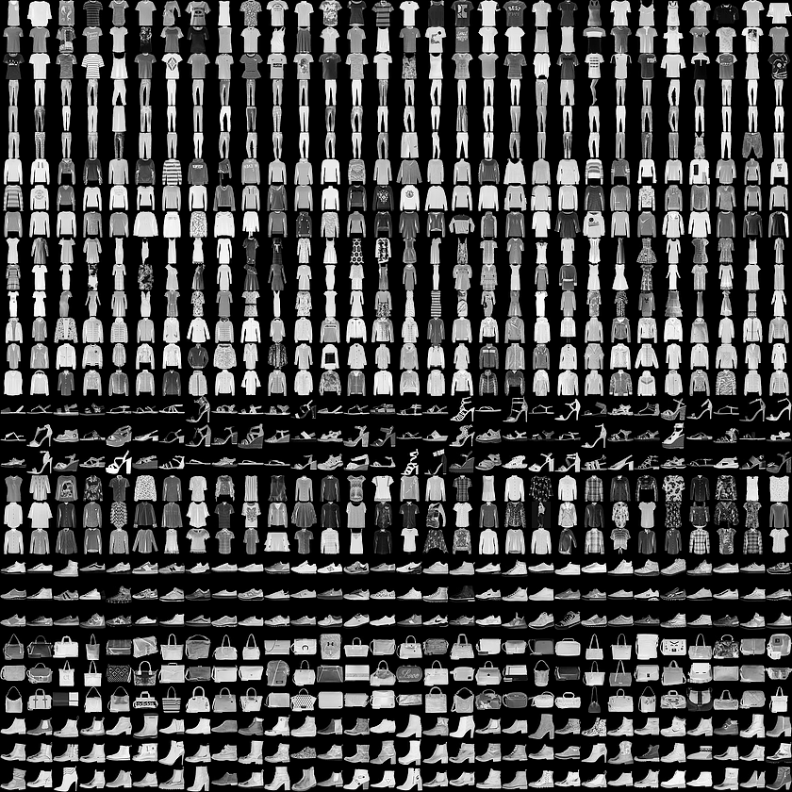

Figure 2-2. Exploring the Fashion MNIST dataset

Fashion MNIST has a nice variety of clothing, including shirts, trousers, dresses, and lots of types of shoes! Also, as you may notice, it’s monochrome, so each picture consists of a certain number of pixels with values between 0 and 255. This makes the dataset simpler to manage.

You can see a close-up of a particular image from the dataset in [Figure 2-3](https://learning.oreilly.com/library/view/ai-and-ml/9781098199166/ch02.html#ch02_figure_3_1748548889066397).

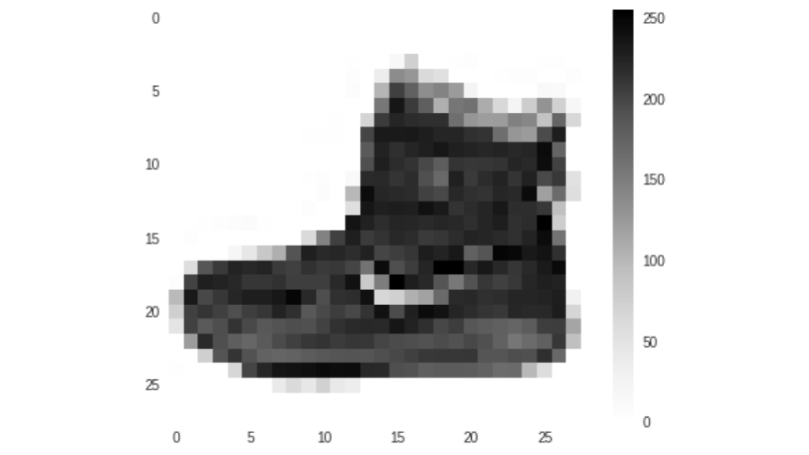

Figure 2-3. Close-up of an image in the Fashion MNIST dataset

Like any image, this one is a rectangular grid of pixels. In this case, the grid size is 28 × 28, and each pixel is a value between 0 and 255, so it is represented by a square in grayscale. To make it easier to see, I have expanded it so that it looks pixelated.

Let’s now take a look at how you can use these pixel values with the functions we saw previously.

Neurons for Vision

In [Chapter 1](https://learning.oreilly.com/library/view/ai-and-ml/9781098199166/ch01.html#ch01_introduction_to_pytorch_1748548870019566), you saw a very simple scenario in which a machine was given a set of *x* and *y* values and it learned that the relationship between them was *y* = 2*x* – 1. This was done using a very simple neural network with one layer and one neuron. If you were to draw that visually, it might look like [Figure 2-4](https://learning.oreilly.com/library/view/ai-and-ml/9781098199166/ch02.html#ch02_figure_4_1748548889066415).

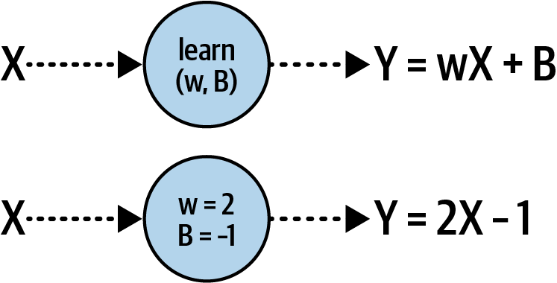

Figure 2-4. A single neuron learning a linear relationship

Each of our images is a set of 784 values (28 × 28) between 0 and 255. They can be our *x*. We also know that we have 10 different types of images in our dataset, so let’s consider them to be our *y*. Now, we want to learn what the function looks like in which *y* is a function of *x*.

Given that we have 784 *x* values per image and our *y* is going to be between 0 and 9, a simple equation like *y* = *mx* + *c* isn’t going to be enough to solve the problem. That’s because there’s a large variety of possible values and the equation can only plot values on a line.

But what we *can* do is have several neurons working together. Each neuron will learn *parameters*, and when we have a combined function of all of these parameters working together, we can see whether we can match that pattern to our desired answer (see [Figure 2-5](https://learning.oreilly.com/library/view/ai-and-ml/9781098199166/ch02.html#ch02_figure_5_1748548889066432)).

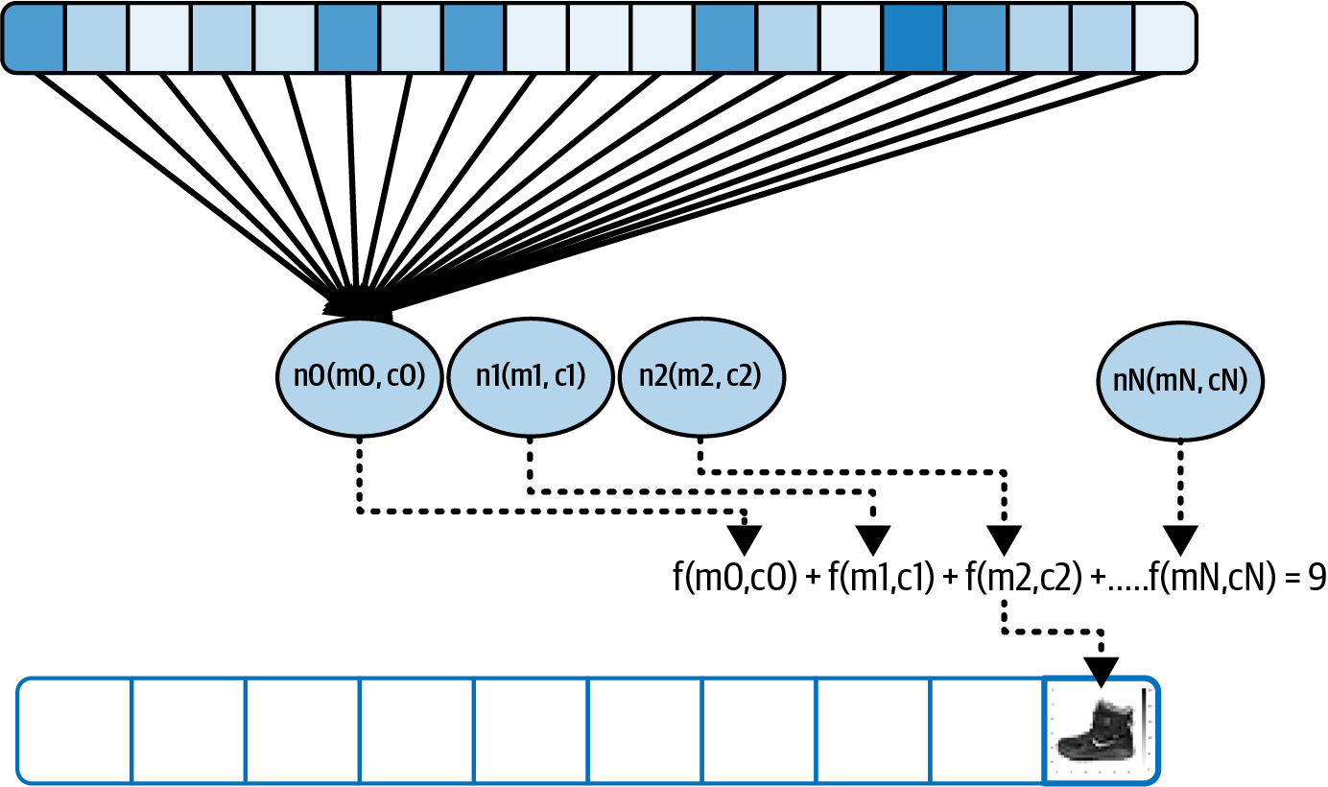

Figure 2-5. Extending our pattern for a more complex example

The gray boxes at the top of this diagram can be considered the pixels in the image, which are our *X* values. When we train the neural network, we load the pixels into a layer of neurons—[Figure 2-5](https://learning.oreilly.com/library/view/ai-and-ml/9781098199166/ch02.html#ch02_figure_5_1748548889066432) shows them being loaded into the first neuron, but the values are loaded into just each of them. Also, consider each neuron’s weight and bias (*w* and *b*) to be randomly initialized. Then, when we sum up the values of the output of each neuron, we’re going to get a value. We’ll do this for *every* neuron in the output layer, so neuron 0 will contain the value of the probability that the pixels will add up to label 0, neuron 1 will contain the value of the probability that the pixels will add up to label 1, etc.

Over time, we want to match that value to the desired output―which, for this image, is the number 9, which is also the label for the ankle boot that was shown in [Figure 2-3](https://learning.oreilly.com/library/view/ai-and-ml/9781098199166/ch02.html#ch02_figure_3_1748548889066397). So, in other words, this neuron should have the largest value of all of the output neurons.

Given that there are 10 labels, a random initialization should get the right answer about 10% of the time. From that, the loss function and optimizer can do their job epoch by epoch to tweak the internal parameters of each neuron to improve on that 10%. And thus, over time, the computer will learn to “see” what makes a shoe a shoe or a dress a dress. You’ll see this process of improvement when you run the code and your neural network effectively learns to distinguish the different items.

Designing the Neural Network

Let’s take the example we just walked through and explore what it looks like in code. First, we’ll look at the design of the neural network that was shown in [Figure 2-5](https://learning.oreilly.com/library/view/ai-and-ml/9781098199166/ch02.html#ch02_figure_5_1748548889066432):

self.linear_relu_stack = nn.Sequential(

nn.Linear(28*28, 128),

nn.ReLU(),

nn.Linear(128, 10),

nn.LogSoftmax(dim=1)

)

If you remember, in [Chapter 1](https://learning.oreilly.com/library/view/ai-and-ml/9781098199166/ch01.html#ch01_introduction_to_pytorch_1748548870019566) we had a Sequential model to specify that we had many layers. In that case, we had only one layer, but now we’re using it to define multiple layers.

The first layer, a Linear, is a layer of neurons that learn a linear relationship between their inputs and their outputs. As before, when using a Linear, you give two parameters: the input shape and the output shape. Conveniently, the output shape is effectively the number of neurons you want in this layer, and we’re specifying that we want 128 of them. The *input* shape is defined as (28 × 28), which is the size of the data coming into the network, and as you saw earlier, this is the dimension of a Fashion MNIST image.

The input is shown as the middle layer in [Figure 2-5](https://learning.oreilly.com/library/view/ai-and-ml/9781098199166/ch02.html#ch02_figure_5_1748548889066432), and you’ll often hear such layers described as *hidden layers*. The term *hidden* just means that there’s no direct interface to that layer. This takes a little bit of getting used to—the middle layer is the first layer that you *define*, and in a diagram like [Figure 2-5](https://learning.oreilly.com/library/view/ai-and-ml/9781098199166/ch02.html#ch02_figure_5_1748548889066432), you can see that it’s in the middle of the diagram. This is because we also drew the data “coming in” to this layer. One other thing to note is that image data from datasets like Fashion MNIST is usually rectangular in shape, but a layer doesn’t recognize that, so it will need to be “flattened” into a 1-D array, as shown across the top of [Figure 2-5](https://learning.oreilly.com/library/view/ai-and-ml/9781098199166/ch02.html#ch02_figure_5_1748548889066432). You’ll see the code for that in a moment.

With this first Linear, we’re asking for 128 neurons to have their internal parameters randomly initialized. Often, the question I’ll get asked at this point is “Why 128?” This is entirely arbitrary—there’s no fixed rule for the number of neurons to use. As you design the layers, you want to pick the appropriate number of values to enable your model to actually learn. More neurons means it will run more slowly, as it has to learn more parameters. More neurons could also lead to a network that is great at recognizing the training data but not so good at recognizing data that it hasn’t previously seen. (This is known as *overfitting*, and we’ll discuss it later in this chapter). On the other hand, fewer neurons means that the model might not have sufficient parameters to learn.

You will need to explore this trade-off between speed of learning and accuracy of learning and do some experimentation over time to pick the right values. This process is typically called *hyperparameter tuning*. In ML, a *hyperparameter* is a value that is used to control the training, as opposed to the internal values of the neurons that get trained/learned, which are referred to as *parameters*.

When you’re defining a neural network with PyTorch and using the Sequential, you don’t just define the layers of the network and what types of neurons they may use. You can also define functions that execute on the data while it flows between the neural network layers. These are typically called *activation functions*, and an activation function is the next thing you see specified in the code as nn.ReLU(). An activation function is code that will execute on each neuron in the layer. PyTorch supports a number of activation functions out of the box, and a very common one in middle layers is ReLU, which stands for *rectified linear unit*. It’s a simple function that returns a value only if it’s greater than 0. In this case, we don’t want negative values being passed to the next layer to potentially impact the summing function, so instead of writing a lot of if-then code, we can simply activate the layer with ReLU.

Finally, there’s another Linear layer, which will be the *output layer*. If you look at the defined shape of (128, 10) and think of it through that “input size, output size” framework, you’ll see that it has 128 “inputs” (i.e., the number of neurons in the layer above) and 10 “outputs.” What are these 10? Recall that Fashion MNIST has 10 classes of clothing. Each of these neurons is effectively assigned one class, and it will end up with a probability that the input pixels match that class, so our job is to determine which one has the highest value. You might wonder how these assignments happen: where is the code that says one neuron is for a shoe and another is for a shirt? To answer that question, recall the *y* = 2*x* ‒ 1 example in [Chapter 1](https://learning.oreilly.com/library/view/ai-and-ml/9781098199166/ch01.html#ch01_introduction_to_pytorch_1748548870019566), where we had a set of input data and a set of known, correct answers that is sometimes called the *ground truth*. Fashion MNIST will work in the same way. When training the network, we provide the input images *and* their known answers as a set of what we want the output neurons to look like. Thus, the network will “learn” that when it sees a shoe, the output neurons that don’t represent that shoe should have a zero value and the ones that do should have a “1” value.

We *could* also loop through the output neurons to find the highest value, but the LogSoftmax activation function does that for us.

So now, when we train our neural network, we have two goals. We want to be able to feed in a 28 × 28–pixel array, and we want the neurons in the middle layer to have weights and biases (*w* and *B* values) that, when combined, will match those pixels to one of the 10 output values.

The Complete Code

Now that we’ve explored the architecture of the neural network, let’s look at the complete code for training a model with the Fashion MNIST data.

Here’s the complete code:

import torch

import torch.nn as nn

import torch.optim as optim

from torchvision import datasets, transforms

from torch.utils.data import DataLoader

# Load the dataset

transform = transforms.Compose([transforms.ToTensor()])

train_dataset = datasets.FashionMNIST(root='./data', train=True,

download=True, transform=transform)

test_dataset = datasets.FashionMNIST(root='./data', train=False,

download=True, transform=transform)

train_loader = DataLoader(train_dataset, batch_size=64,

shuffle=True)

test_loader = DataLoader(test_dataset, batch_size=64,

shuffle=False)

# Define the model

class FashionMNISTModel(nn.Module):

def __init__(self):

super(FashionMNISTModel, self).__init__()

self.flatten = nn.Flatten()

self.linear_relu_stack = nn.Sequential(

nn.Linear(28*28, 128),

nn.ReLU(),

nn.Linear(128, 10),

nn.LogSoftmax(dim=1)

)

def forward(self, x):

x = self.flatten(x)

logits = self.linear_relu_stack(x)

return logits

model = FashionMNISTModel()

# Define the loss function and optimizer

loss_function = nn.NLLLoss()

optimizer = optim.Adam(model.parameters())

# Train the model

def train(dataloader, model, loss_fn, optimizer):

size = len(dataloader.dataset)

model.train()

for batch, (X, y) in enumerate(dataloader):

# Compute prediction and loss

pred = model(X)

loss = loss_fn(pred, y)

# Backpropagation

optimizer.zero_grad()

loss.backward()

optimizer.step()

if batch % 100 == 0:

loss, current = loss.item(), batch * len(X)

print(f"loss: {loss:>7f}

[{current:>5d}/{size:>5d}]")

# Training process

epochs = 5

for t in range(epochs):

print(f"Epoch {t+1}\n-------------------------------")

train(train_loader, model, loss_function, optimizer)

print("Done!")

Let’s walk through this piece by piece. First, let’s consider where the data comes from. In the torchvision library, there’s a datasets collection, and we can load Fashion MNIST from that, addressed as follows:

datasets.FashionMNIST

So, in our first block of code, you’ll see these:

train_dataset = datasets.FashionMNIST(root='./data', train=True,

download=True, transform=transform)

test_dataset = datasets.FashionMNIST(root='./data', train=False,

download=True, transform=transform)

Now, you might wonder why we’re using *two* datasets. It’s simple: one is for training, and one is for testing. The idea here is also simple: if you train a neural network on a set of data, it can become an expert on *that* set of data, but it may not be effective at understanding or classifying *other* data that it previously has not seen. In the case of Fashion MNIST, it might become excellent at understanding the difference between a subset of shoes and shirts, but it will do poorly when new data is presented to it. So, it’s good practice to always hold back a little of your data and *not* train the neural network with it. In this case, Fashion MNIST has 70,000 items of data, but only 60,000 of them are used to train the network and the other 10,000 are used to test it. If you look at the preceding code carefully, you’ll see that the difference between the two lines is the train= parameter. For the first one, the training set the parameter is set to True. For the other, it’s set to False.

You’ll also see the transform parameter in the datasets. It specifies a transformation to apply to the data, which was defined like this:

transform = transforms.Compose([transforms.ToTensor()])

Neural networks typically work with *normalized* values (i.e., those between 0 and 1). However, the pixels in our image are in the range of 0–255, and the values indicate their color depth, with 0 being black, 255 being white, and everything in between being shades of gray. To prepare the data for the neural network, we should map these shades to values between 0 and 1. The preceding code will automatically do that for you in PyTorch, so applying this transform parameter as you’re loading the code will then map the pixel values from the [0, 255] integer range to a [0, 1] floating-point range and load them into an array that’s suitable for the neural network (aka a Tensor).

Our job will be to fit the training images to the training labels in a manner that’s similar to how we fit *y* to *x*in [Chapter 1](https://learning.oreilly.com/library/view/ai-and-ml/9781098199166/ch01.html#ch01_introduction_to_pytorch_1748548870019566).

The math for [why normalized data is better for training neural networks](https://oreil.ly/6d_Po) is beyond the scope of this book, but bear in mind that when you’re training a neural network in PyTorch, normalization will improve performance. Often, your network will not learn and will have massive errors when dealing with nonnormalized data. You’ll recall that the *y* = 2*x* – 1 example from [Chapter 1](https://learning.oreilly.com/library/view/ai-and-ml/9781098199166/ch01.html#ch01_introduction_to_pytorch_1748548870019566) didn’t require the data to be normalized because it was very simple, but for fun, try training it with different values of *x* and *y* where *x* is much larger—and you’ll see it quickly fail!

Next, we define the neural network that makes up our model, as discussed earlier, but we’ll flesh it out with a bit more detail—including the flattening layers and how we want the “forward” pass to work in the model.

Here’s the code:

# Define the model

class FashionMNISTModel(nn.Module):

def __init__(self):

super(FashionMNISTModel, self).__init__()

self.flatten = nn.Flatten()

self.linear_relu_stack = nn.Sequential(

nn.Linear(28*28, 128),

nn.ReLU(),

nn.Linear(128, 10),

nn.LogSoftmax(dim=1)

)

def forward(self, x):

x = self.flatten(x)

logits = self.linear_relu_stack(x)

return logits

model = FashionMNISTModel()

Some key things to note here are that the FashionMNISTModel class subclasses nn.Module, which gives you the ability to override its forward method. We use this method when data is passing forward through the network. Remember back in [Chapter 1](https://learning.oreilly.com/library/view/ai-and-ml/9781098199166/ch01.html#ch01_introduction_to_pytorch_1748548870019566) when we saw the loss.backward() call that did backpropagation and changed the parameters of the network? You’ll frequently encounter that same pattern when training models with PyTorch. You’ll define functions to execute as the data moves *forward* through the network, and then you’ll define others to execute as the gradients that we calculate from the loss move *backward* through the network.

So, if we look at the init for the class, we define two methods: flatten, which is set to nn.FLatten() (a built-in function to flatten the 2D image to 1D), and lin⁠ear​_relu_stack, which is set to the sequence of layers and operations (often abbreviated to *ops*) that define the behavior of the network.

In forward, we then simply define how these work. First, we flatten our data, x, by calling self.flatten, and then the results will be passed into linear_relu_stack to get the results. The results are called *logits*, which are log probabilities (as defined by LogSoftmax) that indicate the confidence the model has that each class is the correct classification.

To learn from our data, we need a loss function to calculate how good or bad our current “guess” is, and we also need an optimizer to figure out the next set of parameters for an improved guess.

Here’s an example of how to define both:

# Define the loss function and optimizer

loss_function = nn.NLLLoss()

optimizer = optim.Adam(model.parameters())

First, let’s look at the loss function. It’s defined as nn.NLLLoss(), which stands for “Negative Log Likelihood Loss.” Don’t worry—nobody expects you to understand what that means at this point! Ultimately, as you work through learning how to do ML, you’ll learn about different loss functions, and you’ll experiment with which ones work well in particular scenarios. In this case, given that the output logits are log probabilities, I chose this loss function because it works particularly well for this scenario. As mentioned, over time, you’ll learn a lot more about the library of loss functions, and you can choose the best ones for your scenario. But for now, just go with the flow and use this one!

For the optimizer, I’ve opted to use the Adam optimization algorithm. It’s similar to the stochastic gradient descent that we used for the *y* = 2*x* – 1 model in [Chapter 1](https://learning.oreilly.com/library/view/ai-and-ml/9781098199166/ch01.html#ch01_introduction_to_pytorch_1748548870019566), but it’s generally faster and more accurate. As with the loss function, you’ll learn more about optimization algorithms over time, and you’ll be able to choose from the menu of optimizers that fit your scenario best. One important thing here is to note that I’ve passed in model.parameters() as a parameter to this. This parameter passes all the trainable parameters in the model to the optimizer so that it can adjust them to help minimize the loss calculated by the loss function.

Now, let’s get down to the specifics and explore what the code we use for training the network looks like:

# Train the model

def train(dataloader, model, loss_fn, optimizer):

size = len(dataloader.dataset)

model.train()

for batch, (X, y) in enumerate(dataloader):

# Compute prediction and loss

pred = model(X)

loss = loss_fn(pred, y)

# Backpropagation

optimizer.zero_grad()

loss.backward()

optimizer.step()

if batch % 100 == 0:

loss, current = loss.item(), batch * len(X)

print(f"loss: {loss:>7f} [{current:>5d}/{size:>5d}]")

While some of this will look familiar because it builds on the simple neural network from [Chapter 1](https://learning.oreilly.com/library/view/ai-and-ml/9781098199166/ch01.html#ch01_introduction_to_pytorch_1748548870019566), there are a few new concepts here, given that we’re using much more data. First, you’ll see that we get the size of the dataset. We simply use this to report on progress, as shown in the very last line.

Then, we call model.train to explicitly set the model into training mode. PyTorch has optimizations that occur during training that are beyond the scope of this chapter. (To take advantage of them, you’ll switch the model between training and inference modes.) Note that this is more a property of the model than a method, but the method syntax is there. Sorry if it’s a little confusing!

Next up is this interesting line:

for batch, (X, y) in enumerate(dataloader):

Let’s explore this in a little more detail. We made the Fashion MNIST dataset available to our code by using a data loader. There are 60,000 records available for training, each of which is 784 pixels. That’s a lot of data, and you don’t necessarily need all of it in memory at once. The idea of a batch is to take a chunk of that data—which, by default, is 64 items—and work with it. Enumerating the data loader gives us that, so we’ll train with 938 batches, 937 of 64, and the last one of 32 because you can’t evenly divide 60,000 by 64!

Now, for each batch, we’ll go through the same loop that we saw for the previous example. We’ll get the predictions from the model, calculate the loss, backpropagate the gradients from the loss function, and optimize with new parameters.

We’ll also use the term *epoch* for a training cycle with *all* of the data (i.e., every batch). We can then output the status of the training every one hundred batches so as not to overload the output console!

So, to train the network for five epochs, we can use code like this:

# Training process

epochs = 5

for t in range(epochs):

print(f"Epoch {t+1}\n-------------------------------")

train(train_loader, model, loss_function, optimizer)

print("Done!")

This will simply call the train function we specified five times—putting the network through the training loop by calculating the predictions, figuring out the loss, optimizing the parameters, and repeating five times.

Training the Neural Network

Once you’ve executed the code, you’ll see the network train epoch by epoch. Then, after running the training, you’ll see something at the end that looks like this:

Epoch 5

-------------------------------

loss: 0.429329 [ 0/60000]

loss: 0.348756 [ 6400/60000]

loss: 0.237481 [12800/60000]

loss: 0.336960 [19200/60000]

loss: 0.435592 [25600/60000]

loss: 0.272769 [32000/60000]

loss: 0.362881 [38400/60000]

loss: 0.202799 [44800/60000]

loss: 0.354268 [51200/60000]

loss: 0.205381 [57600/60000]

Done!

You can see here that over time, the loss has gone down. For example, in my case, the loss value at the end of the first epoch was .345, and by the end of the fifth epoch, it was .205. This data shows us that the network is learning.

But how can we tell how *accurately* it’s learning? Note that loss and accuracy, while related, don’t have a direct linear relationship—for example, we can’t say that if loss is 20%, then accuracy is 80%. So, we need to go a little deeper.

Recall that when we were getting the data, we got *two* datasets: one for training and one for testing. Here’s a great place where we can write code to pass the test data through our network and evaluate how accurate the network is at predicting answers. We already know the correct answers, so we could do inference on all 10,000 test records, get the answers that the model predicts, and then check them against the ground truth for accuracy.

Here’s the code:

# Function to test the model

def test(dataloader, model):

size = len(dataloader.dataset)

num_batches = len(dataloader)

model.eval() # Set the model to evaluation mode

test_loss, correct = 0, 0

with torch.no_grad():

for X, y in dataloader:

pred = model(X)

test_loss += loss_function(pred, y).item()

correct += (pred.argmax(1) ==

y).type(torch.float).sum().item()

test_loss /= num_batches

correct /= size

print(f"Test Error: \n Accuracy: {(100*correct):>0.1f}%,

Avg loss: {test_loss:>8f} \n")

# Evaluate the model

test(test_loader, model)

There are a few things to note in this code. First is the model.eval() line, which indicates that we are switching the model from training mode to inference mode. Similarly, torch.no_grad()will turn off gradient calculation in PyTorch to speed up inference. We’re no longer *training* the model, so we don’t need to do all the loss function backpropagation and optimization. We can just turn that off.

Then, as it does during training, the network just goes through every item in the data loader, gets the prediction for that item, and checks its correctness with this line:

correct += (pred.argmax(1) == y).type(torch.float).sum().item()

That’s a bit of a mouthful, so let’s break it down.

First, the pred value will give us the prediction from the network. The network outputs 10 values, each of which includes the probability of the class it represents being the correct one. Calling argmax on this will give us which one had the biggest value (i.e., the one with the probability closest to 1). The *y* value is the correct answer. For example, if we get a prediction, the neuron with the highest value is the sixth one, and *y* = 6, so we know we have a correct answer. Also, because we’re dealing in batches, we want to count each time pred.argmax(1) == y for this batch, hence, the sum().

Therefore, our accuracy value will be the sum of correct items divided by the total number of items. So, when you run this code after training the model, you should see output like this:

Test Error:

Accuracy: 86.9%, Avg loss: 0.366243

Remarkably, after running the neural network for only five epochs, we can see that it is 86.9% accurate on data it hadn’t previously seen!

At this point, you may be thinking that it’s really nice to see the accuracy of the model on the test set, but you may also be asking why we’ve only reported loss on the training—why not also report accuracy there? It seems silly to finish training the model by only looking at minimizing loss and *then* to figure out the accuracy. And you’d be right!

Fortunately, updating the model training code to *also* report on accuracy is pretty easy to do. Here’s a function called get_accuracy() that you can use during training:

# Function to calculate accuracy

def get_accuracy(pred, labels):

_, predictions = torch.max(pred, 1)

correct = (predictions == labels).float().sum()

accuracy = correct / labels.shape[0]

return accuracy

Then, in your training loop, you can simply call this function after the loss function call like this:

for batch, (X, y) in enumerate(dataloader):

# Compute prediction and loss

pred = model(X)

loss = loss_fn(pred, y)

accuracy = get_accuracy(pred, y)

# Backpropagation

And when you’re reporting on the output of the training, you can use the accuracy metric like this:

if batch % 100 == 0:

current = batch * len(X)

avg_loss = total_loss / (batch + 1)

avg_accuracy = total_accuracy / (batch + 1) * 100

print(f"Batch {batch}, Loss: {avg_loss:>7f},

Accuracy: {avg_accuracy:>0.2f}%

[{current:>5d}/{size:>5d}]")

Running this will give you output a bit like this:

Epoch 5

-------------------------------

Batch 0, Loss: 0.177518, Accuracy: 95.31% [ 0/60000]

Batch 100, Loss: 0.304973, Accuracy: 88.89% [ 6400/60000]

Batch 200, Loss: 0.311628, Accuracy: 88.51% [12800/60000]

Batch 300, Loss: 0.307373, Accuracy: 88.63% [19200/60000]

Batch 400, Loss: 0.309722, Accuracy: 88.67% [25600/60000]

Batch 500, Loss: 0.310240, Accuracy: 88.60% [32000/60000]

Batch 600, Loss: 0.306988, Accuracy: 88.70% [38400/60000]

Batch 700, Loss: 0.308556, Accuracy: 88.64% [44800/60000]

Batch 800, Loss: 0.309518, Accuracy: 88.67% [51200/60000]

Batch 900, Loss: 0.311487, Accuracy: 88.59% [57600/60000]

Done!

Now, you’re probably wondering why the accuracy for the test data (86.9%) is *lower* than the accuracy for the training data (88.59%). This is very common, and when you think about it, it makes sense: the neural network only really knows how to match the inputs it has been trained on with the outputs for those values. Our hope is that given enough data, the network will be able to generalize from the examples it has seen and thus “learn” what a shoe or a dress looks like. But there will always be examples of items that it hasn’t seen that are also different enough from what it has seen to confuse it.

For example, if you grew up only ever seeing sneakers, then that’s what a shoe looks like to you. So, when you first see a high-heeled shoe, you might be a little confused. From your experience, it’s probably a shoe, but you don’t know for sure. That’s exactly what a neural network “thinks” when it “sees” inputs that are different enough from what it’s been trained on.

Exploring the Model Output

Now that we’ve trained the model and gotten a good gauge of its accuracy by using the test set, let’s explore it a little. Here’s a function we can use to predict a single image:

import matplotlib.pyplot as plt

def predict_single_image(image, label, model):

# Set the model to evaluation mode

model.eval()

# Unsqueeze image as the model expects a batch dimension

image = image.unsqueeze(0)

with torch.no_grad():

prediction = model(image)

print(prediction)

predicted_label = prediction.argmax(1).item()

# Display the image and predictions

plt.imshow(image.squeeze(), cmap='gray')

plt.title(f'Predicted: {predicted_label}, Actual: {label}')

plt.show()

return predicted_label

# Choose an image from the test set

image, label = test_dataset[0] # Change index to test different images

# Predict the class for the chosen image

predicted_label = predict_single_image(image, label, model)

print(f"The model predicted {predicted_label}, and the actual label is {label}.")

Let’s start with this code, which should look familiar to you now that you’ve seen the previous accuracy calculation code:

with torch.no_grad():

prediction = model(image)

print(prediction)

predicted_label = prediction.argmax(1).item()

Here, we get the image, send it to the model, get back a prediction, and print it out. Then, we get the argmax of that to show the label. Here’s an example output of the prediction:

tensor([[–12.4290, –16.0639, –14.3148, –16.2861, –13.1672, –4.5377, –13.6284,

–1.3124, –8.9946, –0.3285]])

These numbers may seem vague, but ultimately, our goal is simply to look for the biggest one! The Softmax function gets the log() of the value, where log(1) is zero and the log of any value less than one is a negative value. As you look through the list, you’ll notice that the value closest to 0 (–0.3285) is the very last one. This indicates that the function believes the class for this image should be class number 9. (There are 10 classes in Fashion MNIST, which are numbered 0 through 9.)

Fashion MNIST’s class number 9 is “Ankle Boot,” so I’ve also included the code to render the image in [Figure 2-6](https://learning.oreilly.com/library/view/ai-and-ml/9781098199166/ch02.html#ch02_figure_6_1748548889066448).

Also, as we can see, this is an example of where the model got the prediction right. The ground truth was that it’s label 9, and the prediction was for number 9. Drawing the image so that we mere humans can compare the two also gives us an ankle boot!

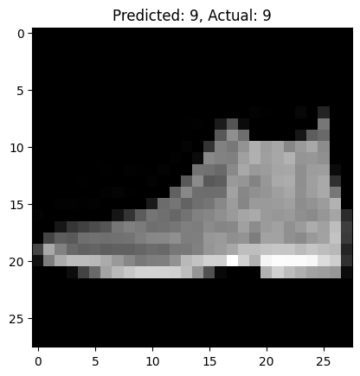

Figure 2-6. Exploring the output of the predictive model

Now, try a few different values for yourself and see if you can find anywhere the model gets it wrong.

Overfitting

In the last example, we trained for only five epochs. That is, we went through the entire training loop of having the neurons randomly initialized and checked against their labels, then that performance was measured by the loss function and updated by the optimizer five times. And the results we got were pretty good: 88.59% accuracy on the training set and 86.5% on the test set. So what happens if we train for longer?

Next, try updating it to train for 50 epochs instead of 5. In my case, I got the following accuracy figures on the training set:

Epoch 50

-------------------------------

Batch 0, Loss: 0.077159, Accuracy: 96.88% [ 0/60000]

Batch 100, Loss: 0.094825, Accuracy: 96.57% [ 6400/60000]

Batch 200, Loss: 0.093598, Accuracy: 96.67% [12800/60000]

Batch 300, Loss: 0.095906, Accuracy: 96.54% [19200/60000]

Batch 400, Loss: 0.096683, Accuracy: 96.48% [25600/60000]

Batch 500, Loss: 0.101872, Accuracy: 96.31% [32000/60000]

Batch 600, Loss: 0.103130, Accuracy: 96.22% [38400/60000]

Batch 700, Loss: 0.103901, Accuracy: 96.17% [44800/60000]

Batch 800, Loss: 0.104216, Accuracy: 96.15% [51200/60000]

Batch 900, Loss: 0.104010, Accuracy: 96.15% [57600/60000]

Done!

This is particularly exciting because we’re doing much better: we’re getting 96.15% accuracy!

However, for the test set, accuracy reached 89.2%:

Test Error:

Accuracy: 89.2%, Avg loss: 0.433885

So, we got a big improvement over the training set and a smaller one over the test set. This might suggest that training our network for much longer would lead to much better results—but that’s not always the case. The network is doing much better with the training data, but the model is not necessarily a better model. In fact, the divergence in the accuracy numbers shows that the model might have become overspecialized to the training data, in a process that’s often called *overfitting*. As you build more neural networks, this problem is something to watch out for—and as you go through this book, you’ll learn a number of techniques to avoid it!

Early Stopping

In each of the cases so far, we’ve hardcoded the number of epochs we’re training for. While that works, we might want to train until we reach the desired accuracy instead of constantly trying different numbers of epochs and training and retraining until we get to our desired value. So, for example, if we want to train until the model is at 95% accuracy on the training set, and if we want to do it without knowing in advance how many epochs it will take. . .how can we do it?

Given that we’ve updated our code to check the accuracy as the model trained and to print it out, now, all we have to do is check that accuracy and end the training if it’s above a certain amount—such as 95% (or 0.95 when normalized). For example, we can do this:

if batch % 100 == 0:

current = batch * len(X)

avg_loss = total_loss / (batch + 1)

avg_accuracy = total_accuracy / (batch + 1) * 100

print(f"Batch {batch}, Loss: {avg_loss:>7f},

Accuracy: {avg_accuracy:>0.2f}% [{current:>5d}/{size:>5d}]")

# Early stopping condition

if avg_accuracy >= 95:

print("Reached 95% accuracy, stopping training.")

return True # Stop training

Note that if we use this code inside the if batch % 100 == 0 block, we can break the training loop before all batches in a particular epoch have been processed. It’s better to do this check at the end of the epoch, so we need to be sure to place the if avg_accuracy >= 95 in the right place!

Now, when we’re training, at the end of every epoch, the average accuracy for the epoch will be calculated—and if it hits 95%, the training will stop. Previously, I had trained the model for 50 epochs to get 96.15% accuracy, but with this early stopping, where I’ve defined 95% as “good enough,” you can see that the model stopped training after only 37 epochs. Interestingly, accuracy was 94.99% for a couple of epochs before that, so I might have been able to stop even earlier!

This process of *early stopping* is very powerful in helping you save time as you evaluate different model architectures for solving specific problems. It helps you train your model until it’s “good enough,” instead of having a fixed training loop. For example, the process can look like this:

Epoch 36

-------------------------------

Batch 0, Loss: 0.098307, Accuracy: 96.88% [ 0/60000]

Batch 100, Loss: 0.119195, Accuracy: 95.45% [ 6400/60000]

Batch 200, Loss: 0.127049, Accuracy: 95.20% [12800/60000]

Batch 300, Loss: 0.126001, Accuracy: 95.34% [19200/60000]

Batch 400, Loss: 0.127823, Accuracy: 95.25% [25600/60000]

Batch 500, Loss: 0.131262, Accuracy: 95.11% [32000/60000]

Batch 600, Loss: 0.135573, Accuracy: 94.95% [38400/60000]

Batch 700, Loss: 0.135920, Accuracy: 94.95% [44800/60000]

Batch 800, Loss: 0.135125, Accuracy: 94.99% [51200/60000]

Batch 900, Loss: 0.134854, Accuracy: 94.99% [57600/60000]

Epoch 37

-------------------------------

Batch 0, Loss: 0.104421, Accuracy: 96.88% [ 0/60000]

Batch 100, Loss: 0.122693, Accuracy: 95.34% [ 6400/60000]

Batch 200, Loss: 0.124787, Accuracy: 95.26% [12800/60000]

Batch 300, Loss: 0.127841, Accuracy: 95.16% [19200/60000]

Batch 400, Loss: 0.130558, Accuracy: 95.05% [25600/60000]

Batch 500, Loss: 0.131684, Accuracy: 95.00% [32000/60000]

Batch 600, Loss: 0.132620, Accuracy: 94.95% [38400/60000]

Batch 700, Loss: 0.132498, Accuracy: 95.01% [44800/60000]

Batch 800, Loss: 0.132462, Accuracy: 95.05% [51200/60000]

Batch 900, Loss: 0.133915, Accuracy: 95.03% [57600/60000]

Reached 95% accuracy, stopping training.

This process can save you a lot of time you would otherwise spend manually checking on the network to see if it’s learning appropriately.

Summary

In [Chapter 1](https://learning.oreilly.com/library/view/ai-and-ml/9781098199166/ch01.html#ch01_introduction_to_pytorch_1748548870019566), you learned about how ML is based on fitting features to labels through sophisticated pattern matching with a neural network. In this chapter, you took that to the next level by going beyond a single neuron and learning how to create your first (very basic) computer vision neural network. The network was somewhat limited because of the data: all the images were 28 × 28 grayscale, with the item of clothing centered in the frame. This is a good start, but it’s a very controlled scenario.

To do better at vision, you may need the computer to learn features of an image instead of learning merely the raw pixels. You can do that with a process called *convolutions*, and in the next chapter, you’ll learn how to define convolutional neural networks to understand the contents of images.

Chapter 3. Going Beyond the Basics: Detecting Features in Images

In [Chapter 2](https://learning.oreilly.com/library/view/ai-and-ml/9781098199166/ch02.html#ch02_introduction_to_computer_vision_1748548889076080), you learned how to get started with computer vision by creating a simple neural network that matched the input pixels of the Fashion MNIST dataset to 10 labels, each of which represented a type (or class) of clothing. And while you created a network that was pretty good at detecting clothing types, there was a clear drawback. Your neural network was trained on small monochrome images, each of which contained only a single item of clothing, and each item was centered within the image.

To take the model to the next level, you need it to be able to detect *features* in images. So, for example, instead of looking merely at the raw pixels in the image, what if we could filter the images down to constituent elements? Matching those elements, instead of raw pixels, would help the model detect the contents of images more effectively. For example, consider the Fashion MNIST dataset that we used in the last chapter. When detecting a shoe, the neural network may have been activated by lots of dark pixels clustered at the bottom of the image, which it would see as the sole of the shoe. But if the shoe were not centered and filling the frame, this logic wouldn’t hold.

One method of detecting features comes from photography and image processing methodologies that you may already be familiar with. If you’ve ever used a tool like Photoshop or GIMP to sharpen an image, you’ve used a mathematical filter that works on the pixels of the image. Another word for what these filters do is *convolution*, and by using such filters in a neural network, you’ll create a *convolutional neural network* (CNN).

In this chapter, you’ll start by learning about how to use convolutions to detect features in an image. Then, you’ll dig deeper into classifying images based on the features within. We’ll also explore augmentation of images to get more features and transfer learning to take preexisting features that were learned by others, and then we’ll look briefly into optimizing your models by using dropouts.

Convolutions

A *convolution* is simply a filter of weights that are used to multiply a pixel by its neighbors to get a new value for the pixel. For example, consider the ankle boot image from Fashion MNIST and the pixel values for it (see [Figure 3-1](https://learning.oreilly.com/library/view/ai-and-ml/9781098199166/ch03.html#ch03_figure_1_1748570891059985)).

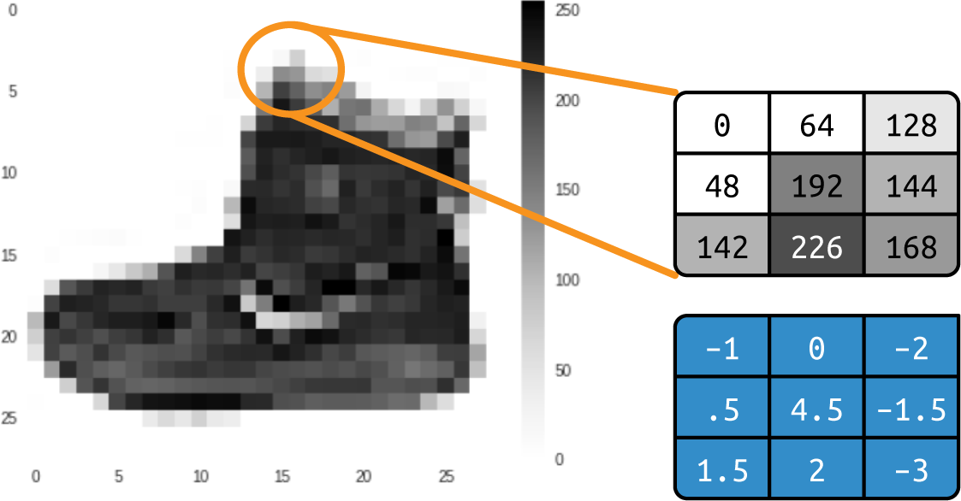

Figure 3-1. Ankle boot with convolution

If we look at the pixel in the middle of the selection, we can see that it has the value 192. (Recall that Fashion MNIST uses monochrome images with pixel values from 0 to 255.) The pixel above and to the left has the value 0, the one immediately above has the value 64, etc.

If we then define a filter in the same 3 × 3 grid, as shown below the original values, we can transform that pixel by calculating a new value for it. We do this by multiplying the current value of each pixel in the grid by the value in the same position in the filter grid and then summing up the total amount. This total will be the new value for the current pixel, and we then repeat this calculation for all pixels in the image.

So, in this case, while the current value of the pixel in the center of the selection is 192, we calculate the new value after applying the filter as follows:

new_val = (–1 * 0) + (0 * 64) + (–2 * 128) +

(.5 * 48) + (4.5 * 192) + (–1.5 * 144) +

(1.5 * 142) + (2 * 226) + (–3 * 168)

The result equals 577, which will be the new value for the pixel. Repeating this process for every pixel in the image will give us a filtered image.

Now, let’s consider the impact of applying a filter on a more complicated image: specifically, the [ascent image](https://oreil.ly/wP8TE) that’s built into SciPy for easy testing. This is a 512 × 512 grayscale image that shows two people climbing a staircase.

Using a filter with negative values on the left, positive values on the right, and zeros in the middle will end up removing most of the information from the image except for vertical lines (see [Figure 3-2](https://learning.oreilly.com/library/view/ai-and-ml/9781098199166/ch03.html#ch03_figure_2_1748570891060023)).



Figure 3-2. Using a filter to derive vertical lines

Similarly, a small change to the filter can emphasize the horizontal lines (see [Figure 3-3](https://learning.oreilly.com/library/view/ai-and-ml/9781098199166/ch03.html#ch03_figure_3_1748570891060045)).

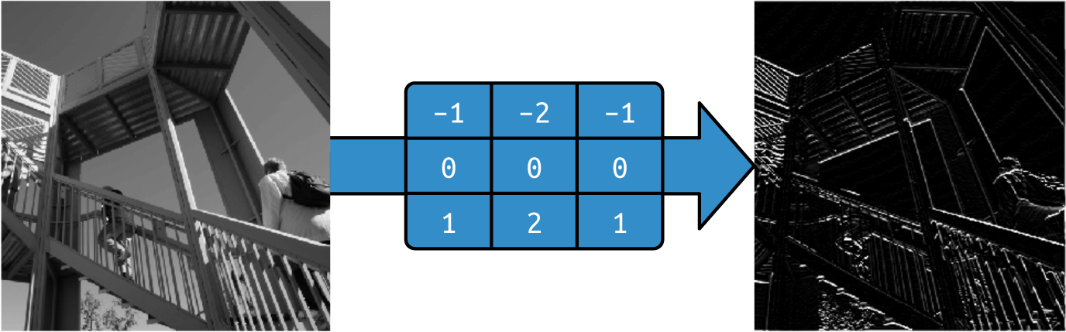

Figure 3-3. Using a filter to derive horizontal lines

These examples also show that the amount of information in the image is reduced. Therefore, we can potentially *learn* a set of filters that reduce the image to features, and those features can be matched to labels as before. Previously, we learned parameters that were used in neurons to match inputs to outputs, and similarly, we can learn the best filters to match inputs to outputs over time.

When we combine convolution with pooling, we can reduce the amount of information in the image while maintaining the features. We’ll explore that next.

Pooling

*Pooling* is the process of eliminating pixels in your image while maintaining the semantics of the content within the image. It’s best explained visually. [Figure 3-4](https://learning.oreilly.com/library/view/ai-and-ml/9781098199166/ch03.html#ch03_figure_4_1748570891060063) depicts the concept of *max pooling*.

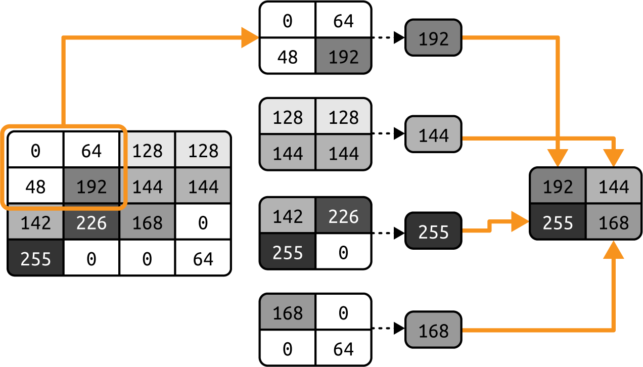

Figure 3-4. An example of max pooling

In this case, consider the box on the left to be the pixels in a monochrome image. We group them into 2 × 2 arrays, so in this case, the 16 pixels are grouped into four 2 × 2 arrays. These arrays are called *pools*.

Then, we select the *maximum* value in each of the groups and reassemble them into a new image. Thus, the pixels on the left are reduced by 75% (from 16 to 4), with the maximum value from each pool making up the new image. [Figure 3-5](https://learning.oreilly.com/library/view/ai-and-ml/9781098199166/ch03.html#ch03_figure_5_1748570891060080) shows the version of ascent from [Figure 3-2](https://learning.oreilly.com/library/view/ai-and-ml/9781098199166/ch03.html#ch03_figure_2_1748570891060023), with the vertical lines enhanced, after max pooling has been applied.

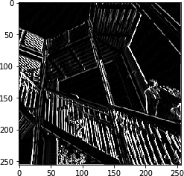

Figure 3-5. Ascent after applying vertical filter and max pooling

Note how the filtered features have not just been maintained but have been further enhanced. Also, the image size has changed from 512 × 512 to 256 × 256—making it a quarter of the original size.

**Note**

There are other approaches to pooling. These include *min pooling*, which takes the smallest pixel value from the pool, and *average pooling*, which takes the overall average value from the pool.

Implementing Convolutional Neural Networks

In [Chapter 2](https://learning.oreilly.com/library/view/ai-and-ml/9781098199166/ch02.html#ch02_introduction_to_computer_vision_1748548889076080) you created a neural network that recognized fashion images. For convenience, here’s the code to define the model:

# Define the model

class FashionMNISTModel(nn.Module):

def __init__(self):

super(FashionMNISTModel, self).__init__()

self.flatten = nn.Flatten()

self.linear_relu_stack = nn.Sequential(

nn.Linear(28*28, 128),

nn.ReLU(),

nn.Linear(128, 10),

nn.LogSoftmax(dim=1)

)

def forward(self, x):

x = self.flatten(x)

logits = self.linear_relu_stack(x)

return logits

model = FashionMNISTModel()

# Define the loss function and optimizer

loss_function = nn.NLLLoss()

optimizer = optim.Adam(model.parameters())

# Train the model

def train(dataloader, model, loss_fn, optimizer):

size = len(dataloader.dataset)

model.train()

for batch, (X, y) in enumerate(dataloader):

# Compute prediction and loss

pred = model(X)

loss = loss_fn(pred, y)

# Backpropagation

optimizer.zero_grad()

loss.backward()

optimizer.step()

if batch % 100 == 0:

loss, current = loss.item(), batch * len(X)

print(f"loss: {loss:>7f}

[{current:>5d}/{size:>5d}]")

# Training process

epochs = 5

for t in range(epochs):

print(f"Epoch {t+1}\n-------------------------------")

train(train_loader, model, loss_function, optimizer)

print("Done!")

To convert this to a CNN, you simply use convolutional layers in our model definition on top of the current linear ones. You’ll also add pooling layers.

To implement a convolutional layer, you’ll use the nn.Conv2D type. It accepts as parameters the number of convolutions to use in the layer, the size of the convolutions, the activation function, etc.

For example, here’s a convolutional layer that uses this type:

nn.Conv2d(1, 64, kernel_size=3, padding=1)

In this case, we want the layer to learn 64 convolutions. It will randomly initialize them, and over time, it will learn the filter values that work best to match the input values to their labels. The kernel_size = 3 indicates the size of the filter. Earlier, we showed you 3 × 3 filters, and that’s what we’re specifying here. The 3 × 3 filter is the most common size of filter. You can change it as you see fit, but you’ll typically see an odd number of axes like 5 × 5 or 7 × 7 because of how filters remove pixels from the borders of the image, as you’ll see later.

Here’s how to use a pooling layer in the neural network. You’ll typically do this immediately after the convolutional layer:

nn.MaxPool2d(kernel_size=2, stride=2)

In the example back in [Figure 3-4](https://learning.oreilly.com/library/view/ai-and-ml/9781098199166/ch03.html#ch03_figure_4_1748570891060063), we split the image into 2 × 2 pools and picked the maximum value in each. However, we could have used the parameters that you see here to define the pool size. The kernel_size=2 parameter indicates that our pools are 2 × 2, and the stride=2 parameter means that the filter will jump over two pixels to get the next pool.

Now, let’s explore the full code to define a model for Fashion MNIST with a CNN:

# Define the CNN model

class FashionCNN(nn.Module):

def __init__(self):

super(FashionCNN, self).__init__()

self.layer1 = nn.Sequential(

nn.Conv2d(1, 64, kernel_size=3, padding=1),

nn.ReLU(),

nn.MaxPool2d(kernel_size=2, stride=2))

self.layer2 = nn.Sequential(

nn.Conv2d(64, 64, kernel_size=3),

nn.ReLU(),

nn.MaxPool2d(2)) # Output: 64 x 6 x 6

self.fc1 = nn.Linear(64 * 6 * 6, 128)

self.fc2 = nn.Linear(128, 10) # 10 classes

def forward(self, x):

out = self.layer1(x)

out = self.layer2(out)

out = out.view(out.size(0), –1) # Flatten the output

out = self.fc1(out)

out = self.fc2(out)

return out

Here, we see that the class has two functions, one for initialization and one that will be called during the forward pass in each epoch during training.

The init simply defines what each of the layers in our neural network will look like. The first layer (self.layer1) will take in the one-dimensional input, have 64 convolutions, a kernel_size of 3, and padding of 1. It will then ReLU the output before max pooling it.

The next layer (self.layer2) will take the 64 convolutions of output from the previous layer and then output 64 of its own before ReLUing them and max pooling them. Its output will now be 64 × 6 × 6 because the MaxPool halves the size of the image.

The data is then fed to the next layer (self.fc1, where fc stands for *fully connected*), with the input being the shape of the output of the previous layer. The output is 128, which is the same number of neurons we used in [Chapter 2](https://learning.oreilly.com/library/view/ai-and-ml/9781098199166/ch02.html#ch02_introduction_to_computer_vision_1748548889076080) for the deep neural network (DNN).

Finally, these 128 are fed into the final layer (self.fc1) with 10 outputs—that represent the 10 classes.

**Note**

In the DNN, we ran the input through a Flatten layer prior to feeding it into the first Dense layer. We’ve lost that in the input layer here—instead, we’ve just specified the 1-D input shape. Note that prior to the first Linear layer, after convolutions and pooling, the data will be flattened.

Then, we stack these layers in the forward function. We can see that we get the data x and pass it through layer1 to get out, which is passed to layer2 to get a new out. At this point, we have the convolutions that we’ve learned, but we need to flatten them before loading them into the Linear layers fc1 and fc2. The out = out.view(out.size(0), -1) achieves this.

If we train this network on the same data for the same 50 epochs as we used when training the network shown in [Chapter 2](https://learning.oreilly.com/library/view/ai-and-ml/9781098199166/ch02.html#ch02_introduction_to_computer_vision_1748548889076080), we will see that it works nicely. We can get to 91% accuracy on the test set quite easily:

Train Epoch: 44 -- Loss: 0.091689

Train Epoch: 45 -- Loss: 0.066864

Train Epoch: 46 -- Loss: 0.061322

Train Epoch: 47 -- Loss: 0.056557

Train Epoch: 48 -- Loss: 0.039695

Train Epoch: 49 -- Loss: 0.056213

Accuracy of the network on the 10000 test images: 91.31%

So, we can see that adding convolutions to the neural network definitely increases its ability to classify images. Next, let’s take a look at the journey an image takes through the network so we can get a little bit more of an understanding of why this process works.

**Note**

If you are using the accompanying code from my GitHub, you’ll notice that I’m using model.to(device) a lot. In PyTorch, if an accelerator is available, you can request that the model and/or its data use the accelerator with this command.

Exploring the Convolutional Network

With the torchsummary library, you can inspect your model. When you run it on the Fashion MNIST convolutional network we’ve been working on, you’ll see something like this:

from torchsummary import summary

model = FashionCNN().to(device)

summary(model, input_size=(1, 28, 28)) # (Channels, Height, Width)

----------------------------------------------------------------

Layer (type) Output Shape Param #

================================================================

Conv2d-1 [–1, 64, 28, 28] 640

ReLU-2 [–1, 64, 28, 28] 0

MaxPool2d-3 [–1, 64, 14, 14] 0

Conv2d-4 [–1, 64, 12, 12] 36,928

ReLU-5 [–1, 64, 12, 12] 0

MaxPool2d-6 [–1, 64, 6, 6] 0

Linear-7 [–1, 128] 295,040

Linear-8 [–1, 10] 1,290

================================================================

Total params: 333,898

Trainable params: 333,898

Non-trainable params: 0

----------------------------------------------------------------

Input size (MB): 0.00

Forward/backward pass size (MB): 1.02

Params size (MB): 1.27

Estimated Total Size (MB): 2.30

Let’s first take a look at the Output Shape column to get an understanding of what’s going on here. Our first layer will have 28 × 28 images and apply 64 filters to them. But because our filter is 3 × 3, a one-pixel border around the image would typically be lost, reducing our overall information to 26 × 26 pixels. However, because we used the padding=1 parameter, the image was artificially inflated to 30 × 30, meaning that its output would be the correct 28 × 28 and no information would be lost.

If you don’t pad the image, you’ll end up with a result like the one in [Figure 3-6](https://learning.oreilly.com/library/view/ai-and-ml/9781098199166/ch03.html#ch03_figure_6_1748570891060097). If we take each of the boxes as a pixel in the image, the first possible filter we can use starts in the second row and the second column. The same would happen on the right side and at the bottom of the diagram.



Figure 3-6. Losing pixels when running a filter

Thus, an image that is *a* × *b* pixels in shape when run through a 3 × 3 filter will become (*a* – 2) × (*b* – 2) pixels in shape. Similarly, a 5 × 5 filter would make it (*a* – 4) × (*b* – 4), and so on. As we’re using a 28 × 28 image and a 3 × 3 filter, our output would now be 26 × 26. But because we padded the image up to 30 × 30 (again, to prevent loss of information), the output is now 28 × 28.

After that, the pooling layer will be 2 × 2, so the size of the image will halve on each axis, and it will then become 14 × 14. The next convolutional layer does *not* use padding, so it will reduce this further to 12 × 12, and the next pooling will output 6 x 6.

So, by the time the image has gone through two convolutional layers, the result will be many 6 × 6 images. How many? We can see that in the Param # (number of parameters) column.

Each convolution is a 3 × 3 filter, plus a bias. Remember earlier, with our dense layers, when each layer was *y* = *wx* + *b*, where *w* was our parameter (aka weight) and *b* was our bias? This case is very similar, except that because the filter is 3 × 3, there are 9 parameters to learn. Given that we have 64 convolutions defined, we’ll have 640 overall parameters. (Each convolution has 9 parameters plus a bias, for a total of 10, and there are 64 of them.)

The ReLU and MaxPooling layers don’t learn anything; they just reduce the image, so there are no learned parameters there—hence, 0 are reported.

The next convolutional layer has 64 filters, but each of them is multiplied across the *previous* 64 filters, each of which has 9 parameters. We have a bias on each of the new 64 filters, so our number of parameters should be (64 × (64 × 9)) + 64, which gives us 36,928 parameters the network needs to learn.

If this is confusing, try changing the number of convolutions in the first layer to something else—for example, 10. You’ll see that the number of parameters in the second layer becomes 5,824, which is (64 × (10 × 9)) + 64).

By the time we get through the second convolution, our images are 6 × 6, and we have 64 of them. If we multiply this out, we’ll have 1,600 values, which we’ll feed into a dense layer of 128 neurons. Each neuron has a weight and a bias, and we’ll have 128 of them, so the number of parameters the network will learn is ((6 × 6 × 64) × 128) + 128, giving us 295,040 parameters.

Then, our final dense layer of 10 neurons will take in the output of the previous 128, so the number of parameters learned will be (128 × 10) + 10, which is 1,290.

The total number of parameters will be the sum of all of these: 333,898.

Training this network requires us to learn the best set of these 333,898 parameters to match the input images to their labels. It’s a slower process because there are more parameters, but as we can see from the results, it also builds a more accurate model!

Of course, with this dataset, we still have the limitation that the images are 28 × 28, monochrome, and centered. So next we’ll take a look at using convolutions to explore a more complex dataset comprising color pictures of horses and humans, and we’ll try to make the model determine whether an image contains one or the other. In this case, the subject won’t always be centered in the image like with Fashion MNIST, so we’ll have to rely on convolutions to spot distinguishing features.

Building a CNN to Distinguish Between Horses and Humans

In this section, we’ll explore a more complex scenario than the Fashion MNIST classifier. We’ll extend what we’ve learned about convolutions and CNNs to try to classify the contents of images in which the location of a feature isn’t always in the same place. I’ve created the “Horses or Humans” dataset for this purpose.

**The “Horses or Humans” Dataset**

[The dataset for this section](https://oreil.ly/8VXwy) contains over a thousand 300 × 300–pixel images. Approximately half the images are of horses, and the other half are of humans—and all are rendered in different poses. You can see some examples in [Figure 3-7](https://learning.oreilly.com/library/view/ai-and-ml/9781098199166/ch03.html#ch03_figure_7_1748570891060112).

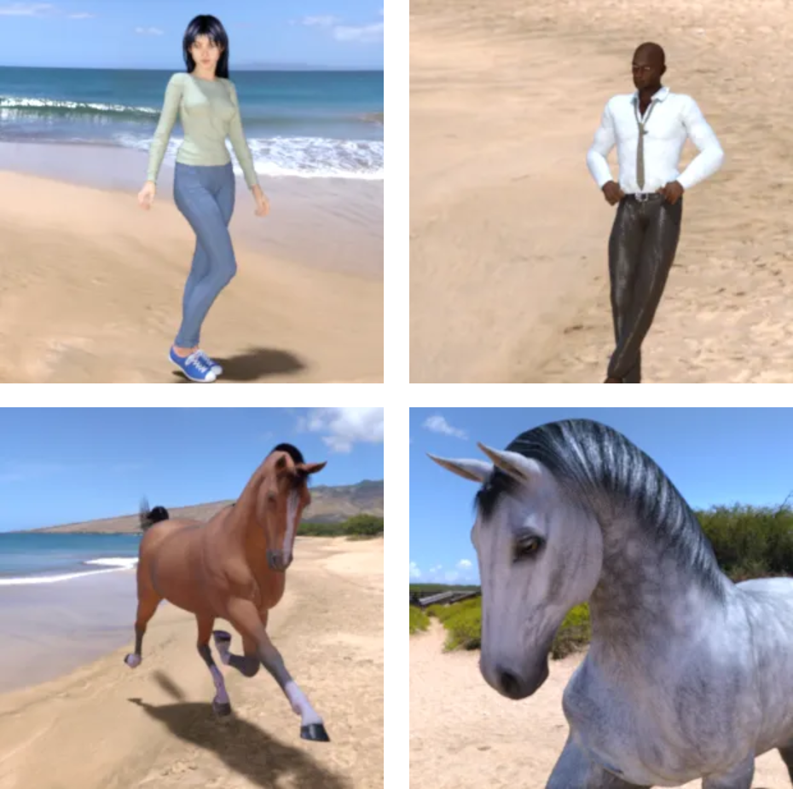

Figure 3-7. Horses and humans

As you can see, the subjects have different orientations and poses, and the image composition varies. Consider the two horses, for example—their heads are oriented differently, and one image is zoomed out (showing the complete animal), while the other is zoomed in (showing just the head and part of the body). Similarly, the humans are lit differently, have different skin tones, and are posed differently. The man has his hands on his hips, while the woman has hers outstretched. The images also contain backgrounds such as trees and beaches, so a classifier will have to determine which parts of the image are the important features that determine what makes a horse a horse and a human a human, without being affected by the background.

While the previous examples of predicting *y* = 2*x* – 1 or classifying small monochrome images of clothing *might* have been possible with traditional coding, it’s clear that this example is far more difficult and that you are crossing the line into where ML is essential to solve a problem.

An interesting side note is that these images are all computer generated. The theory is that features spotted in a CGI image of a horse should apply to a real image, and you’ll see how well this works later in this chapter.

**Handling the Data**

The Fashion MNIST dataset that you’ve been using up to this point comes with labels, and every image file has an associated file with the label details. Many image-based datasets do not have this, and “Horses or Humans” is no exception. Instead of labels, the images are sorted into subdirectories of each type, and with the DataLoader in PyTorch, you can use this structure to *automatically* assign labels to images.

First, you simply need to ensure that your directory structure has a set of named subdirectories, with each subdirectory being a label. For example, the “Horses or Humans” dataset is available as a set of ZIP files, one of which contains the training data (1,000+ images) and another of which contains the validation data (256 images). When you download and unpack them into a local directory for training and validation, you need to ensure that they are in a file structure like the one in [Figure 3-8](https://learning.oreilly.com/library/view/ai-and-ml/9781098199166/ch03.html#ch03_figure_8_1748570891060128).

Here’s the code to get the training data and extract it into the appropriately named subdirectories, as shown in [Figure 3-8](https://learning.oreilly.com/library/view/ai-and-ml/9781098199166/ch03.html#ch03_figure_8_1748570891060128):

import urllib.request

import zipfile

url = "https://storage.googleapis.com/learning-datasets/

horse-or-human.zip"

file_name = "horse-or-human.zip"

training_dir = 'horse-or-human/training/'

urllib.request.urlretrieve(url, file_name)

zip_ref = zipfile.ZipFile(file_name, 'r')

zip_ref.extractall(training_dir)

zip_ref.close()

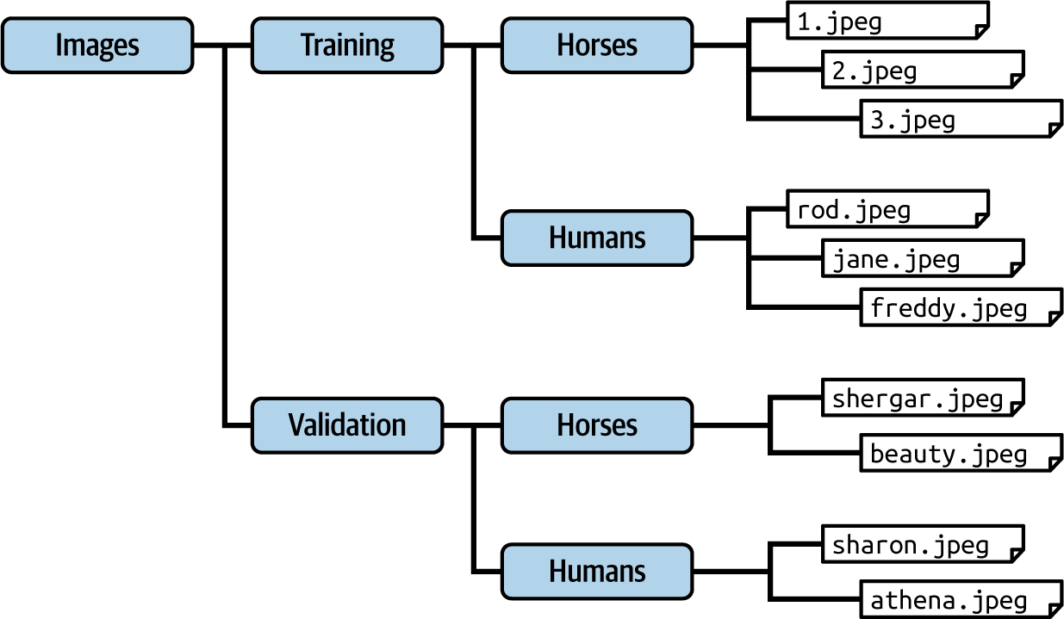

Figure 3-8. Ensuring that images are in named subdirectories

This code simply downloads the ZIP of the training data and unzips it into a directory at *horse-or-human/training*. (We’ll deal with downloading the validation data shortly.) This is the parent directory that will contain subdirectories for the image types.

Now, to use the DataLoader, we simply use the following code:

from torchvision import datasets, transforms

from torch.utils.data import DataLoader

# Define transformations

transform = transforms.Compose([

transforms.Resize((150, 150)),

transforms.ToTensor(),

transforms.Normalize(mean=[0.5, 0.5, 0.5], std=[0.5, 0.5, 0.5])

])

# Load the datasets

train_dataset = datasets.ImageFolder(root=training_dir,

transform=transform)

val_dataset = datasets.ImageFolder(root=validation_dir,

transform=transform)

# Data loaders

train_loader = DataLoader(train_dataset, batch_size=32, shuffle=True)

val_loader = DataLoader(val_dataset, batch_size=32, shuffle=False)

First, we create an instance of a transforms object that we’ll call transform. This will determine the rules for how we modify the images. It resizes the image to 150 × 150 and then normalizes it into a tensor. Note that the raw images are actually 300 × 300, but to make training quicker for the purposes of learning, I’ve resized them to 150 × 150.

Then, we specify the dataset objects to be datasets.ImageFolder types and point them to the required directory, and that will generate images for the training process by flowing them from that directory while applying the transform. The directory for training is training_dir, and the directory for validation is validation_dir, as specified earlier.

**CNN Architecture for “Horses or Humans”**

There are several major differences between this dataset and the Fashion MNIST one, and you have to take them into account when designing an architecture for classifying the images. First, the images are much larger—150 × 150 pixels—so more layers may be needed. Second, the images are in full color, not grayscale, so each image will have three channels instead of one. Third, there are only two image types, so we can actually classify them with only *one* output neuron. To do this, we’ll drive the value of that neuron toward 0 for one of the labels and toward 1 for the other. The sigmoid function is ideal for this process of driving the value to one of these extremes. You can see this at the bottom of the forward function:

class HorsesHumansCNN(nn.Module):

def __init__(self):

super(HorsesHumansCNN, self).__init__()

self.conv1 = nn.Conv2d(3, 16, kernel_size=3, padding=1)

self.conv2 = nn.Conv2d(16, 32, kernel_size=3, padding=1)

self.conv3 = nn.Conv2d(32, 64, kernel_size=3, padding=1)

self.pool = nn.MaxPool2d(2, 2)

self.fc1 = nn.Linear(64 * 18 * 18, 512)

self.drop = nn.Dropout(0.25)

self.fc2 = nn.Linear(512, 1)

def forward(self, x):

x = self.pool(F.relu(self.conv1(x)))

x = self.pool(F.relu(self.conv2(x)))

x = self.pool(F.relu(self.conv3(x)))

x = x.view(–1, 64 * 18 * 18)

x = F.relu(self.fc1(x))

x = self.drop(x)

x = self.fc2(x)

x = torch.sigmoid(x) # Use sigmoid to output probabilities

return x

There are a number of things to note here. First of all, take a look at the very first layer. We’re defining 16 filters, each of which has a kernel_size of 3, but the input shape is 3. Remember that this is because our input image is in color: there are three channels, instead of just one for the monochrome Fashion MNIST dataset we were using earlier.

At the other end, notice that there’s only one neuron in the output layer. This is because we’re using a binary classifier, and we can get a binary classification with just a single neuron if we activate it with a sigmoid function. The purpose of the sigmoid function is to drive one set of values toward 0 and the other toward 1, which is perfect for binary classification.

Next, notice how we stack several more convolutional layers. We do this because our image source is quite large and we want, over time, to have many smaller images, each with features highlighted. If we take a look at the results of a summary, we’ll see this in action:

----------------------------------------------------------------

Layer (type) Output Shape Param #

================================================================

Conv2d-1 [–1, 16, 150, 150] 448

MaxPool2d-2 [–1, 16, 75, 75] 0

Conv2d-3 [–1, 32, 75, 75] 4,640

MaxPool2d-4 [–1, 32, 37, 37] 0

Conv2d-5 [–1, 64, 37, 37] 18,496

MaxPool2d-6 [–1, 64, 18, 18] 0

Linear-7 [–1, 512] 10,617,344

Dropout-8 [–1, 512] 0

Linear-9 [–1, 1] 513

================================================================

Total params: 10,641,441

Trainable params: 10,641,441

Non-trainable params: 0

----------------------------------------------------------------

Input size (MB): 0.26

Forward/backward pass size (MB): 5.98

Params size (MB): 40.59

Estimated Total Size (MB): 46.83

----------------------------------------------------------------

Note that by the time the data has gone through all the convolutional and pooling layers, it ends up as 18 × 18 items. The theory is that these will be activated feature maps that are relatively simple because they will contain just 324 pixels. We can then pass these feature maps to the dense neural network to match them to the appropriate labels.

This, of course, leads this network to have many more parameters than the previous network, so it will be slower to train. With this architecture, we’re going to learn over 10 million parameters.

**Tip**

The code in this section, as well as in many other places in this book, may require you to import Python libraries. To find the correct imports, you can check out [the book’s repository](https://github.com/lmoroney/PyTorch-Book-FIles).

To train the network, we’ll have to compile it with a loss function and an optimizer. In this case, the loss function can be the BCELoss, where BCE stands for *binary cross entropy*. As the name suggests, because there are only two classes in this scenario, this is a loss function that is designed for it. For the optimizer, we can continue using the same Adam that we used earlier. Here’s the code:

criterion = nn.BCELoss()

optimizer = optim.Adam(model.parameters(), lr=0.001)

We then train in the usual way:

def train_model(num_epochs):

for epoch in range(num_epochs):

model.train()

running_loss = 0.0

for images, labels in train_loader:

images, labels = images.to(device), labels.to(device).float()

optimizer.zero_grad()

outputs = model(images).view(–1)

loss = criterion(outputs, labels)

loss.backward()

optimizer.step()

running_loss += loss.item()

One thing to note is that the labels are converted to floats because of the binary cross entropy, where the value of the final output node will be a float value.

Over just 15 epochs, this architecture gives us a very impressive 95%+ accuracy on the training set. Of course, this is just with the training data, and this performance isn’t an indication of the network’s potential performance on data that it hasn’t previously seen.

Next, we’ll look at adding the validation set and measuring its performance to give us a good indication of how this model might perform in real life.

**Adding Validation to the “Horses or Humans” Dataset**

To add validation, you’ll need a validation dataset that’s separate from the training one. In some cases, you’ll get a master dataset that you have to split yourself, but in the case of “Horses or Humans,” there’s a separate validation set that you can download. In the preceding code snippet, you’ve already downloaded the training and validation datasets, put them in directories, and set up data loaders for each of them. However, for training, you only used one of these datasets—the one that was set up to load the training data. So next, we’ll switch the model into evaluation mode and explore how well it did with the validation data.

**Note**

You may be wondering why we’re talking about a validation dataset here, rather than a test dataset, and whether the two are the same thing. For simple models like the ones developed in the previous chapters, it’s often sufficient to split the dataset into two parts: one for training and one for testing. But for more complex models like the one we’re building here, you’ll want to create separate validation and test sets.

What’s the difference? *Training data* is the data that is used to teach the network how the data and labels fit together, while *validation data* is used to see how the network is doing with previously unseen data *while* you are training (i.e., it isn’t used to fit data to labels but to inspect how well the fitting is going). Also, *test data* is used after training to evaluate how the network does with data it has never previously seen. Some datasets come with a three-way split, and in other cases, you’ll want to separate the test set into two parts for validation and testing. Here, you’ll download some additional images for testing the model.

To download the validation set and unzip it into a different directory, you can use code that’s very similar to that used for the training images.

Then, to perform the validation, you simply update your train_model method to perform a validation at the end of each training loop (or epoch) and report on the results. For example, you can do this:

def train_model(num_epochs):

for epoch in range(num_epochs):

model.train()

running_loss = 0.0

for images, labels in train_loader:

images, labels = images.to(device), labels.to(device).float()

optimizer.zero_grad()

outputs = model(images).view(–1)

loss = criterion(outputs, labels)

loss.backward()

optimizer.step()

running_loss += loss.item()

print(f'Epoch {epoch + 1}, Loss: {running_loss /

len(train_loader)}')

# Evaluate on training set

model.eval()

with torch.no_grad():

correct = 0

total = 0

for images, labels in train_loader:

images, labels = images.to(device),

labels.to(device).float()

outputs = model(images).view(–1)

predicted = outputs > 0.5 # Threshold predictions

total += labels.size(0)

correct += (predicted == labels).sum().item()

print(f'Test Set Accuracy: {100 * correct / total}%')

# Evaluate on validation set

model.eval()

with torch.no_grad():

correct = 0

total = 0

for images, labels in val_loader:

images, labels = images.to(device),

labels.to(device).float()

outputs = model(images).view(–1)

predicted = outputs > 0.5 # Threshold predictions

total += labels.size(0)

correct += (predicted == labels).sum().item()

print(f'Validation Set Accuracy: {100 * correct / total}%')

train_model(50)

I added code here to do *both* the training and the validation and report on accuracy. Note that this is really just for learning purposes, so you can compare. In a real-world scenario, checking the accuracy of training data is a waste of processing time!

After training for 10 epochs, you should see that your model is 99%+ accurate on the training set but only about 88% on the validation set:

Epoch 7, Loss: 0.0016404045829699512

Training Set Accuracy: 100.0%

Validation Set Accuracy: 88.28125%

Epoch 8, Loss: 0.0010613293736610378

Training Set Accuracy: 100.0%

Validation Set Accuracy: 89.0625%

Epoch 9, Loss: 0.0008372313717332979

Training Set Accuracy: 100.0%

Validation Set Accuracy: 86.328125%

Epoch 10, Loss: 0.0006578459407812646

Training Set Accuracy: 100.0%

Validation Set Accuracy: 87.5%

This is an indication that the model is overfitting, which is something we also saw in the previous chapter.It’s easy to be lulled into a false sense of security by the 100% accuracy, but the other figure is more representative of how your model will behave in the real world.

Still, the performance isn’t bad, considering how few images it was trained on and how diverse those images were. You’re beginning to hit a wall caused by lack of data, but there are some techniques that you can use to improve your model’s performance. We’ll explore them later in this chapter, but before that, let’s take a look at how to *use* this model.

**Testing “Horses or Humans” Images**

It’s all very well and good to be able to build a model, but of course, you want to try it out. A major frustration of mine when I was starting my AI journey was that I could find lots of code that showed me how to build models and charts of how those models were performing, but very rarely was there code to help me kick the tires of the model myself to try it out. I’ll try to help you avoid that problem in this book!

Testing the model is perhaps easiest using Colab. I’ve provided a “Horses or Humans” notebook on GitHub that you can open directly in [Colab](http://bit.ly/horsehuman).

Once you’ve trained the model, you’ll see a section called “Running the Model.” Before running it, you should find a few pictures of horses or humans online and download them to your computer. I recommend you go to [Pixabay.com](http://pixabay.com/), which is a really good site to check out for royalty-free images. It’s also a good idea to get your test images together first, because the node can time out while you’re searching.

[Figure 3-9](https://learning.oreilly.com/library/view/ai-and-ml/9781098199166/ch03.html#ch03_figure_9_1748570891060144) shows a few pictures of horses and humans that I downloaded from Pixabay to test the model.



Figure 3-9. Test images

When they were uploaded, as you can see in [Figure 3-10](https://learning.oreilly.com/library/view/ai-and-ml/9781098199166/ch03.html#ch03_figure_10_1748570891060159), the model correctly classified one image as a human and another as a horse—but despite the fact that the third image was obviously of a human, the model incorrectly classified it as a horse!

You can also upload multiple images simultaneously and have the model make predictions for all of them. You may also notice that it tends to overfit toward horses. If the human isn’t fully posed (i.e., if you can’t see their full body), the model can skew toward horses. That’s what happened in this case. The first human model is fully posed, and the image resembles many of the poses in the dataset, so the model was able to classify her correctly. On the other hand, the second human model is facing the camera, but only her upper half is in the image. There was no training data that looked like that, so the model couldn’t correctly identify her.

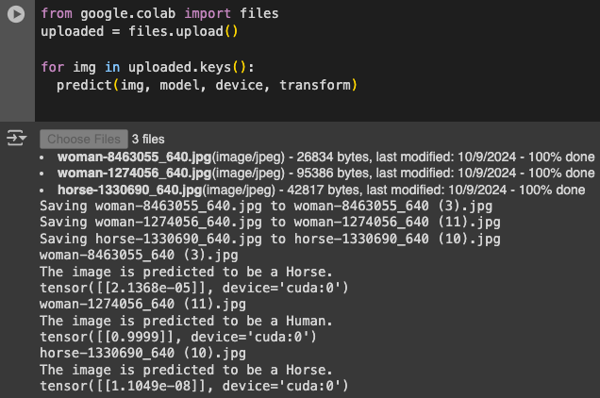

Figure 3-10. Executing the model

Let’s now explore the code to see what it’s doing. Perhaps the most important part is this chunk:

def load_image(image_path, transform):

# Load image

image = Image.open(image_path).convert('RGB') # Convert to RGB

# Apply transformations

image = transform(image)

# Add batch dimension, as the model expects batches

image = image.unsqueeze(0)

return image

Here, we are loading the image from the path that Colab wrote it to. Note that we specify a transform to apply to the image. The images being uploaded can be any shape, but if we are going to feed them into the model, they *must* be the same size that the model was trained on. So, if we use the same transform that we defined when performing the training, we’ll know it’s in the same dimensions.

At the end is this strange command: image = image.unsqueeze(0).

When you look back at how the model was trained, the DataLoader objects batched the images going into it. If you think of an image as a 2D array of pixels, then the batch is an array of 2D arrays, which of course is then a 3D array.

But when we’re using this code with one image at a time, there’s no batch, so to make this a 3D array (which is technically a batch with one item in it), we can just unsqueeze the image along axis 0 to simulate this.

With our image in the right format, it’s easy to do the classification:

with torch.no_grad():

output = model(image)

The model then returns an array containing the classifications for the batch. Because there’s only one classification in this case, it’s effectively an array containing an array. You can see this back in [Figure 3-10](https://learning.oreilly.com/library/view/ai-and-ml/9781098199166/ch03.html#ch03_figure_10_1748570891060159), where for the first human model, the array looks like tensor([[2.1368e-05]], device='cuda:0').

So now, it’s simply a matter of inspecting the value of the first element in that array. If it’s greater than 0.5, we’re looking at a human:

class_name = "Human" if prediction.item() == 1 else "Horse"

There are a few important points to consider here. First, even though the network was trained on synthetic, computer-generated imagery, it performs quite well at spotting horses and humans and differentiating them in real photographs. This is a potential boon in that you may not need thousands of photographs to train a model, and you can do it relatively cheaply with CGI.

But this dataset also demonstrates a fundamental issue you will face. Your training set cannot hope to represent *every* possible scenario your model might face in the wild, and thus, the model will always have some level of overspecialization toward the training set. We saw a clear and simple example of this earlier in this section, when the model mischaracterized the human in the center of [Figure 3-9](https://learning.oreilly.com/library/view/ai-and-ml/9781098199166/ch03.html#ch03_figure_9_1748570891060144). The training set didn’t include a human in that pose, and thus, the model didn’t “learn” that a human could look like that. As a result, there was every chance it might see the figure as a horse, and in this case, it did.

What’s the solution? The obvious one is to add more training data, with humans in that particular pose and others that weren’t initially represented. That isn’t always possible, though. Fortunately, there’s a neat trick in PyTorch that you can use to virtually extend your dataset—it’s called *image augmentation*, and we’ll explore that next.

Image Augmentation

In the previous section, you built a horse-or-human classifier model that was trained on a relatively small dataset. As a result, you soon began to hit problems classifying some previously unseen images, such as the miscategorization of a woman as a horse because the training set didn’t include any images of people in that pose.

One way to deal with such problems is with *image augmentation*. The idea behind this technique is that as PyTorch is loading your data, it can create additional new data by amending what it has using a number of transforms. For example, take a look at [Figure 3-11](https://learning.oreilly.com/library/view/ai-and-ml/9781098199166/ch03.html#fig-3-11). While there is nothing in the dataset that looks like the woman on the right, the image on the left is somewhat similar.



Figure 3-11. Dataset similarities

So, if you could, for example, zoom into the image on the left as you are training, as shown in [Figure 3-12](https://learning.oreilly.com/library/view/ai-and-ml/9781098199166/ch03.html#fig-3-12), you would increase the chances of the model being able to correctly classify the image on the right as a person.



Figure 3-12. Zooming in on the training set data

In a similar way, you can broaden the training set with a variety of other transformations, including the following:

* Rotation (turning the image)
* Shifting horizontally (moving the pixels horizontally with wrapping)
* Shifting vertically (moving the pixels vertically with wrapping)
* Shearing (moving the pixels either horizontally or vertically but offsetting so that the image would look like parallelogram)
* Zooming (magnifying a particular region)
* Flipping (vertically or horizontally)

Because you’ve been using the datasets.ImageFolder and a DataLoader to load the images, you’ve seen the model do a transform already—when it normalized the images like this:

# Define transformations

transform = transforms.Compose([

transforms.Resize((150, 150)),

transforms.ToTensor(),

transforms.Normalize(mean=[0.5, 0.5, 0.5], std=[0.5, 0.5, 0.5])

])

Many other transforms are easily available within the torchvision.transforms library, so, for example, you could do something like this:

# Transforms for the training data

train_transforms = transforms.Compose([

transforms.RandomHorizontalFlip(),

transforms.RandomRotation(20),

transforms.RandomResizedCrop(150),

transforms.ToTensor(),

transforms.Normalize(mean=[0.5, 0.5, 0.5], std=[0.5, 0.5, 0.5])

])

# Transforms for the validation data

val_transforms = transforms.Compose([

transforms.Resize(150),

transforms.CenterCrop(150),

transforms.ToTensor(),

transforms.Normalize(mean=[0.5, 0.5, 0.5], std=[0.5, 0.5, 0.5])

])

Here, in addition to rescaling the image to normalize it, you’re doing the following:

* Randomly flipping horizontally
* Randomly rotating up to 20 degrees left or right
* Randomly cropping a 150 × 150 window instead of resizing

In addition, the transforms.RandomAffine library gives you the facility to do all of these things, as well as adding stuff like scaling the image (zooming in or out), shearing the image, etc. Here’s an example:

transforms.RandomAffine(

degrees=0, # No rotation

translate=(0.2, 0.2), # Translate up to 20% vert and horizontally

scale=(0.8, 1.2), # Zoom in or out by 20%

shear=20, # Shear by up to 20 degrees

),

When you retrain with these parameters, one of the first things you’ll notice is that training takes longer because of all the image processing. Also, your model’s accuracy may not be as high as it was, because previously it was overfitting to a largely uniform set of data.

In my case, when I was training with these augmentations, my accuracy went down from 99% to 94% after 15 epochs, with validation much lower at 64%. This likely indicates overfitting in the model, but it warrants investigation by training with more epochs! One other thing to note is that random cropping might also be an issue—the CGI images generally center the subject, so random cropping will give partial subjects.

But what about the image from [Figure 3-9](https://learning.oreilly.com/library/view/ai-and-ml/9781098199166/ch03.html#ch03_figure_9_1748570891060144) that the model misclassified earlier? This time, the model gets it right. Thanks to the image augmentations, the training set now has sufficient coverage for the model to understand that this particular image is a human too (see [Figure 3-13](https://learning.oreilly.com/library/view/ai-and-ml/9781098199166/ch03.html#ch03_figure_11_1748570891060175)). This is just a single data point, and it may not be representative of the results for real data, but it’s a small step in the right direction.

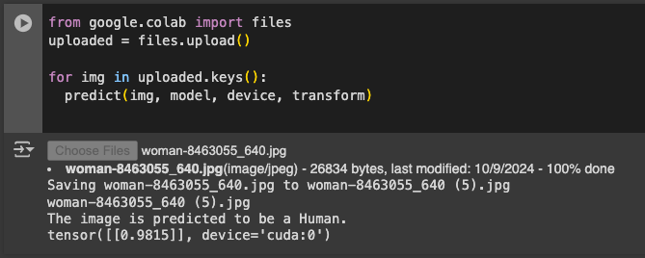

Figure 3-13. The woman is now correctly classified

As you can see, even with a relatively small dataset like “Horses or Humans,” you can start to build a pretty decent classifier. With larger datasets, you could take this further. Another way you can improve the model is by using features that the model has already learned elsewhere. Many researchers with massive resources (millions of images) and huge models that have been trained on thousands of classes have shared their models, and by using a concept called *transfer learning*, you can use the features those models learned and apply them to your data. We’ll explore that next!

Transfer Learning

As we’ve already seen in this chapter, the use of convolutions to extract features can be a powerful tool for identifying the contents of an image. If we use this tool, we can then feed the resulting feature maps into the dense layers of a neural network to match them to the labels and give us a more accurate way of determining the contents of an image. Using this approach with a simple fast-to-train neural network and some image augmentation techniques, we built a model that was 80–90% accurate at distinguishing between a horse and a human when it was trained on a very small dataset.

However, we can improve our model even further by using a method called *transfer learning*. The idea behind it is simple: instead of having our model learn a set of filters from scratch for our dataset, why not have it use a set of filters that were learned on a much larger dataset, with many more features than we can “afford” to build from scratch? We can place these filters in our network and then train a model with our data using the pre-learned filters. For example, while our “Horses or Humans” dataset has only two classes, we can use an existing model that has been pretrained for one thousand classes—but at some point, we’ll have to throw away some of the preexisting network and add the layers that will let us have a classifier for two classes.

[Figure 3-14](https://learning.oreilly.com/library/view/ai-and-ml/9781098199166/ch03.html#ch03_figure_12_1748570891060190) shows what a CNN architecture for a classification task like ours might look like. We have a series of convolutional layers that lead to a dense layer, which in turn leads to an output layer.

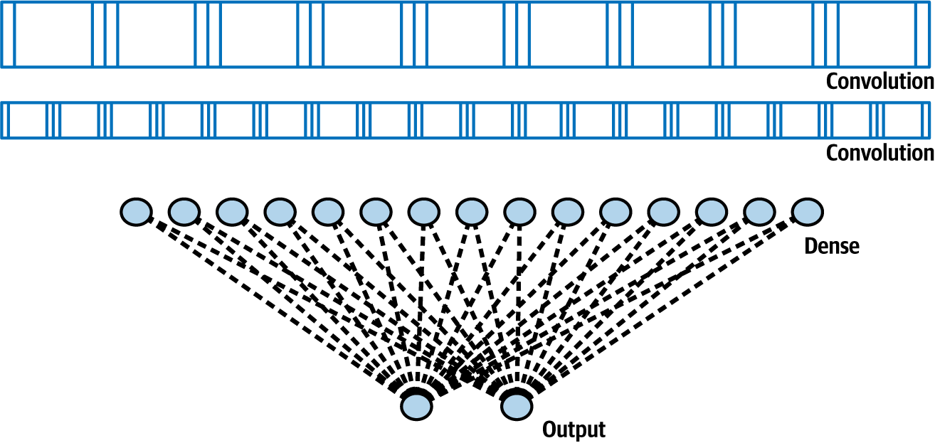

Figure 3-14. A CNN architecture

We’ve seen that we can build a pretty good classifier using this architecture. But what if we could use transfer learning to take the pre-learned layers from another model, freeze or lock them so that they aren’t trainable, and then put them on top of our model, like in [Figure 3-15](https://learning.oreilly.com/library/view/ai-and-ml/9781098199166/ch03.html#ch03_figure_13_1748570891060207)?

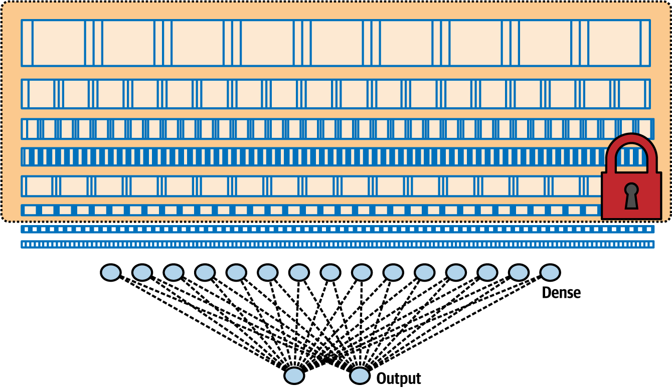

Figure 3-15. Taking and locking layers from another architecture via transfer learning

When we consider that once they’ve been trained, all these layers are just a set of numbers indicating the filter values, weights, and biases along with a known architecture (the number of filters per layer, the size of the filter, etc.), the idea of reusing them is pretty straightforward.

Let’s look at how this would appear in code. There are several pretrained models already available from a variety of sources, so we’ll use version 3 of the popular Inception model from Google, which is trained on more than a million images from a database called ImageNet. Inception has dozens of layers, and it can classify images into one thousand categories.

The torchvision.models library contains a number of models, including Inception V3, so we can easily get access to the pretrained model:

import torch

import torch.nn as nn

from torchvision import models, transforms

from torch.utils.data import DataLoader

from torchvision.datasets import ImageFolder

from torch.optim import RMSprop

# Load the pretrained Inception V3 model

pre_trained_model = models.inception_v3(pretrained=True, aux_logits=True)

Now, we have a full Inception model that’s pretrained. If you want to inspect its architecture, you can do so with this code:

def print_model_summary(model):

for name, module in model.named_modules():

print(f"{name} : {module.__class__.__name__}")

# Example of how to use the function with your pretrained model

print_model_summary(pre_trained_model)

Be warned—this model is huge! Still, you should take a look through it to see the layers and their names. I like to use the one called Mixed7_c because its output is nice and small—it consists of 8 × 8 images—but you should feel free to experiment with others.

Next, we’ll freeze the entire network from retraining and then set a variable to point to mixed7’s output as where we want to crop the network. We can do that with this code:

# Freeze all layers up to and including the 'Mixed_7c'

for name, parameter in pre_trained_model.named_parameters():

parameter.requires_grad = False

if 'Mixed_7c' in name:

break

You’ll notice that we’re printing the output shape of the last layer, and you’ll also see that we’re getting 8 × 8 images at this point. This indicates that by the time the images have been fed through to Mixed_7c, the output images from the filters are 8 × 8 in size, so they’re pretty easy to manage. Again, you don’t have to choose that specific layer; you’re welcome to experiment with others.

Now, let’s see how to modify the model for transfer learning. It’s pretty straightforward—if you go back to the output from the custom print_model_summary from a moment ago, you’ll see that the *last* layer in the model is called fc. As you might expect, *fc* stands for *fully connected*, which is effectively a Linear layer with our densely connected neurons.

So now, it becomes as simple as replacing that layer with a new layer called fc. We don’t need to *know* the input shape for it ahead of time—we can inspect its in_features property to find that. So now, to create a new layer of 1,024 neurons that outputs to another layer of two neurons and replace the fc from Inception, all we have to do is this:

# Modify the existing fully connected layer

num_ftrs = pre_trained_model.fc.in_features

pre_trained_model.fc = nn.Sequential(

nn.Linear(num_ftrs, 1024), # New fully connected layer

nn.ReLU(), # Activation layer

nn.Linear(1024, 2) # Final layer for binary classification

)

It’s as simple as creating a new set of Linear layers from the last output, because we’ll be feeding the results into a dense layer. So, we then add a Linear layer of 1,024 neurons and a dense layer with two neurons for our output. Also, you’ve probably noticed that in the previous model, we did it with one neuron and used sigmoid activation for the two classes—so you’re probably wondering why we’re going to two neurons in the output layer now. This was primarily a stylistic choice. Inception was designed for *n* neurons to output for *n* classes, and I wanted to keep that approach.

Training the model on this architecture over only three epochs gave us an accuracy of 99%+, with a validation accuracy of 95%+. Clearly, that’s a vast improvement. Also, remember that Inception learned a massive set of features that it could use to classify the many classes it was trained on. It turns out that that feature set is also incredibly useful for learning how to classify any other images—not least, those from “Horses or Humans.”

The results we got from this model are much better than those we got from our previous model, but you can continue to tweak and improve it. You can also explore how the model will work with a much larger dataset, like the famous “[Dogs vs. Cats”](https://oreil.ly/UhWMk) from Kaggle. It’s an extremely varied dataset consisting of 25,000 images of cats and dogs, often with the subjects somewhat obscured—for example, if they are held by a human.

Using the same algorithm and model design as before, you can train a “Dogs vs. Cats” classifier on Colab, using a GPU at about 3 minutes per epoch.

When I tested with very complex pictures like those in [Figure 3-16](https://learning.oreilly.com/library/view/ai-and-ml/9781098199166/ch03.html#ch03_figure_14_1748570891060222), this classifier got them all correct. I chose one picture of a dog with catlike ears and one with its back turned. Both pictures of cats were nontypical.

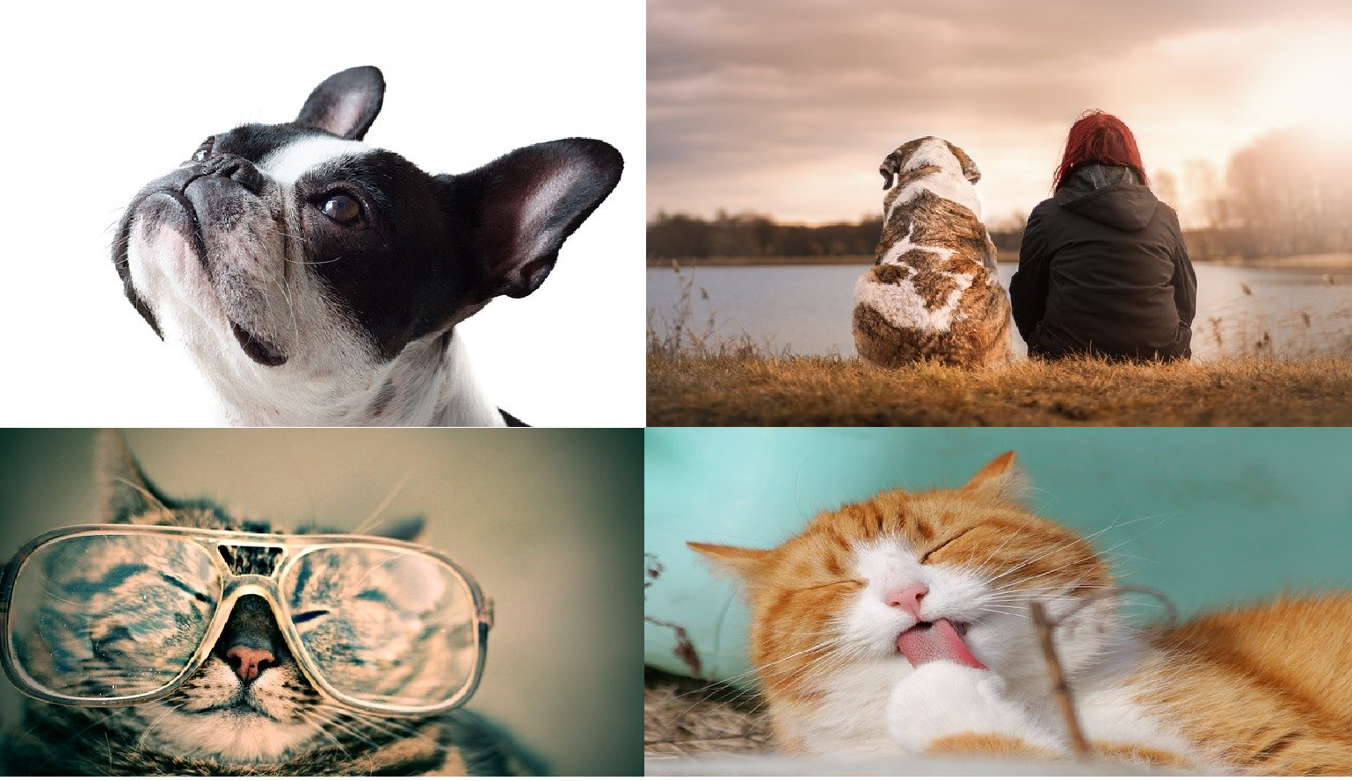

Figure 3-16. Unusual dogs and cats that the model classified correctly

To parse the results, you can use code like this:

def load_image(image_path, transform):

# Load image

image = Image.open(image_path).convert('RGB') # Convert to RGB

# Apply transformations

image = transform(image)

# Add batch dimension, as the model expects batches

image = image.unsqueeze(0)

return image

# Prediction function

def predict(image_path, model, device, transform):

model.eval()

image = load_image(image_path, transform)

image = image.to(device)

with torch.no_grad():

output = model(image)

print(output)

prediction = torch.max(output, 1)

print(prediction)

Note the lines where I’m printing the output of the image, calculating the prediction from that, and printing that.

When you upload some images to Colab, you can see how they predict in [Figure 3-17](https://learning.oreilly.com/library/view/ai-and-ml/9781098199166/ch03.html#ch03_figure_15_1748570891060236).

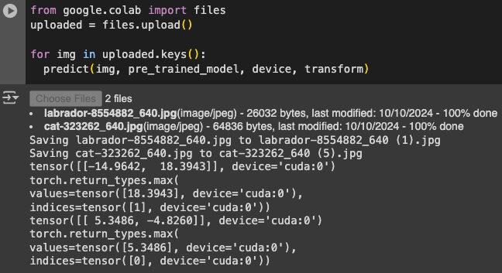

Figure 3-17. Classifying the cat washing its paw

The first image uploaded was “labrador,” which, as its name suggests, is of a dog. The tensor returned from the model contained [–14.9642, 18.3943], meaning a very low number for the first label and a very high one for the second. Given that we used an image directory when training, the labels ended up being in alphabetical order, so it was low for cat and high for dog. Then, when we called torch.max, it gave us [1]. That indicates that neuron 1 is the one for this classification—thus, the image is a dog.

The second image had [5.3486, –4.8260], with the first neuron being higher. Thus, it detected a cat. The size of these numbers indicates the strength of the prediction. For example, it was much surer that the first image is a dog than it was that the second image is a cat.

You can find the complete code for the “Horses or Humans” and “Dogs vs. Cats” classifiers in the book’s [GitHub repository](https://github.com/lmoroney/tfbook).

Multiclass Classification

In all of the examples so far, you’ve been building *binary* classifiers—ones that choose between two options (horses or humans, cats or dogs). On the other hand, when you’re building *multiclass classifiers*, the models are almost the same but there are a few important differences. Instead of a single neuron that is sigmoid activated or two neurons that are binary activated, your output layer will now require *n* neurons, where *n* is the number of classes you want to classify. You’ll also have to change your loss function to an appropriate one for multiple categories.

A neat feature of the nn.CrossEntropyLoss loss function in PyTorch is that it can handle multiple categories, so the “Cats vs. Dogs” and “Horses or Humans” transfer learning classifiers you’ve built thus far in this chapter can use it without modification. But the “Horses or Humans” classifier that you built at the beginning with a *single* output neuron will not be able to because it can’t handle more than two classes. This is always something to look out for, and it’s a common bug when you start writing code for classification.

To go beyond two-class classification, consider, for example, the game Rock, Paper, Scissors. If you wanted to train a dataset to recognize the different hand gestures used in this game, you’d need to handle three categories. Fortunately, there’s a [simple dataset](https://oreil.ly/VHhmS) you can use for this.

There are two downloads: a training set of many diverse hands, with different sizes, shapes, colors, and details such as nail polish; and a testing set of equally diverse hands, none of which are in the training set. You can see some examples in [Figure 3-18](https://learning.oreilly.com/library/view/ai-and-ml/9781098199166/ch03.html#ch03_figure_16_1748570891060251).

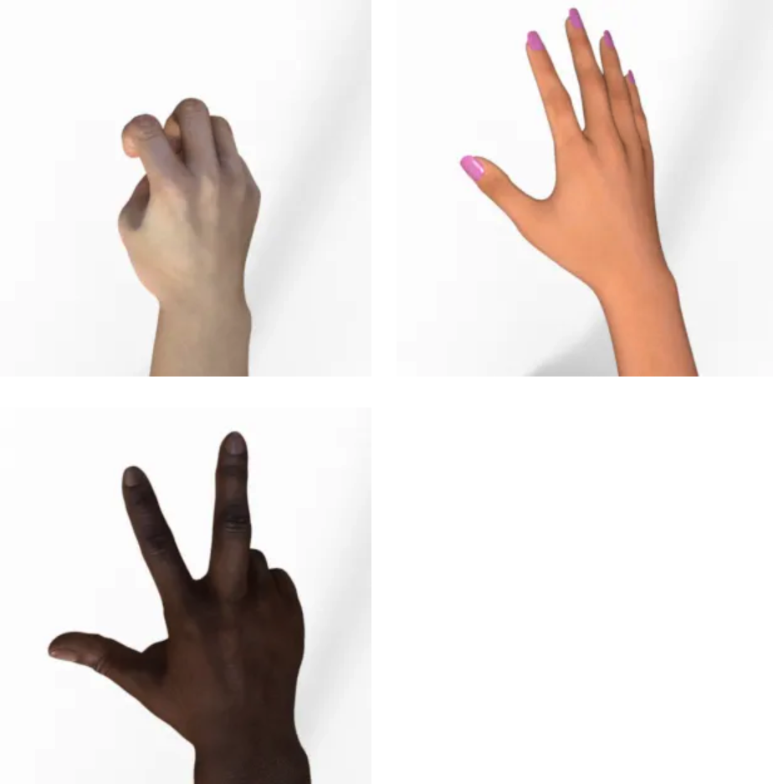

Figure 3-18. Examples of Rock, Paper, Scissors gestures

Using the dataset is simple. You can download and unzip it—the sorted subdirectories are already present in the ZIP file—and then use it to initialize an ImageFolder:

!wget --no-check-certificate \

https://storage.googleapis.com/learning-datasets/rps.zip \

-O /tmp/rps.zip

local_zip = '/tmp/rps.zip'

zip_ref = zipfile.ZipFile(local_zip, 'r')

zip_ref.extractall('/tmp/')

zip_ref.close()

training_dir = "/tmp/rps/"

train_dataset = ImageFolder(root=training_dir, transform=transform)

Be sure to use a transform that fits the input shape of your model. In the last few examples, we were using Inception, and it’s 299 × 299.

You can use the ImageFolder for your DataLoader in the usual way:

train_loader = DataLoader(train_dataset, batch_size=32, shuffle=True)

Earlier, when we tweaked the Inception model for “Horses or Humans” or “Cats vs. Dogs,” there were only *two* classes and thus *two* output neurons. Given that this data has *three* classes, we need to be sure that we change the new fully connected layer at the bottom accordingly:

# Modify the existing fully connected layer

num_ftrs = pre_trained_model.fc.in_features

pre_trained_model.fc = nn.Sequential(

nn.Linear(num_ftrs, 1024), # New fully connected layer

nn.ReLU(), # Activation layer

nn.Linear(1024, 3) # Final layer for binary classification

)

Now, training the model works as before: you specify the loss function and optimizer, and you call the train_model() function. For good repetition, this function is the same as the one used in the “Horses or Humans” and “Cats vs. Dogs” examples:

# Only optimize parameters that are set to be trainable

optimizer = RMSprop(filter(lambda p: p.requires_grad,

pre_trained_model.parameters()), lr=0.001)

criterion = nn.CrossEntropyLoss()

# Train the model

train_model(pre_trained_model, criterion, optimizer, train_loader, num_epochs=3)

Your code for testing predictions will also need to change somewhat. There are now three output neurons, and they will output a high value for the predicted class and lower values for the other classes.

Note also that when you’re using the ImageFolder, the classes are loaded in alphabetical order—so while you might expect the output neurons to be in the order of the name of the game, the order will in fact be Paper, Rock, Scissors.

Code that you can use to try out predictions in a Colab notebook will look like the following. It’s very similar to what you saw earlier:

def load_image(image_path, transform):

# Load image

image = Image.open(image_path).convert('RGB') # Convert to RGB

# Apply transformations

image = transform(image)

# Add batch dimension, as the model expects batches

image = image.unsqueeze(0)

return image

# Prediction function

def predict(image_path, model, device, transform):

model.eval()

image = load_image(image_path, transform)

image = image.to(device)

with torch.no_grad():

output = model(image)

print(output)

prediction = torch.max(output, 1)

print(prediction)

Note that it doesn’t parse the output; it just prints the classes. [Figure 3-19](https://learning.oreilly.com/library/view/ai-and-ml/9781098199166/ch03.html#ch03_figure_17_1748570891060264) shows what it looks like in actual use.

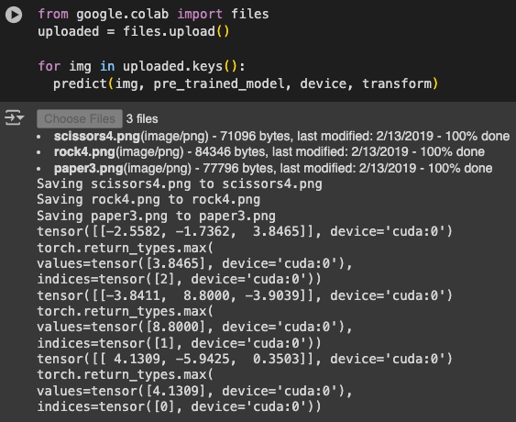

Figure 3-19. Testing the Rock, Paper, Scissors classifier

You can see from the filenames what the images were.

If you explore this a little deeper, you can see that the file named *scissors4.png* had an output of –2.5582, –1.7362, 3.8465]. The largest number is the third one, and if you think alphabetically, you can see that the third neuron represents scissors, so it was classified correctly. Similar results were achieved for the other files.

Some images that you can use to test the dataset [are available to download](https://oreil.ly/dEUpx). Alternatively, of course, you can try your own. Note that the training images are all done against a plain white background, though, so there may be some confusion if there is a lot of detail in the background of the photos you take.

Dropout Regularization

Earlier in this chapter, we discussed overfitting, in which a network may become too specialized in a particular type of input data and thus fare poorly on others. One technique to help overcome this is use of *dropout regularization*.

When a neural network is being trained, each individual neuron will have an effect on neurons in subsequent layers. Over time, particularly in larger networks, some neurons can become overspecialized—and that feeds downstream, potentially causing the network as a whole to become overspecialized and thus leading to overfitting. Additionally, neighboring neurons can end up with similar weights and biases, and if not monitored, this condition can lead the overall model to become overspecialized on the features activated by those neurons.

For example, consider the neural network in [Figure 3-20](https://learning.oreilly.com/library/view/ai-and-ml/9781098199166/ch03.html#ch03_figure_18_1748570891060278), in which there are layers of 2, 6, 6, and 2 neurons. The neurons in the middle layers might end up with very similar weights and biases.

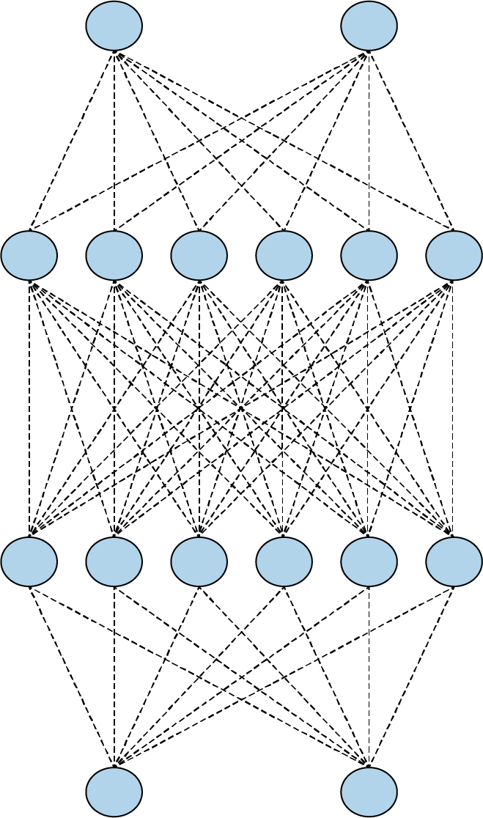

Figure 3-20. A simple neural network

While training, if you remove a random number of neurons and ignore them, then their contribution to the neurons in the next layer is temporarily blocked (see [Figure 3-21](https://learning.oreilly.com/library/view/ai-and-ml/9781098199166/ch03.html#ch03_figure_19_1748570891060292)). They are effectively dropped out, leading to the term *dropout regularization*.

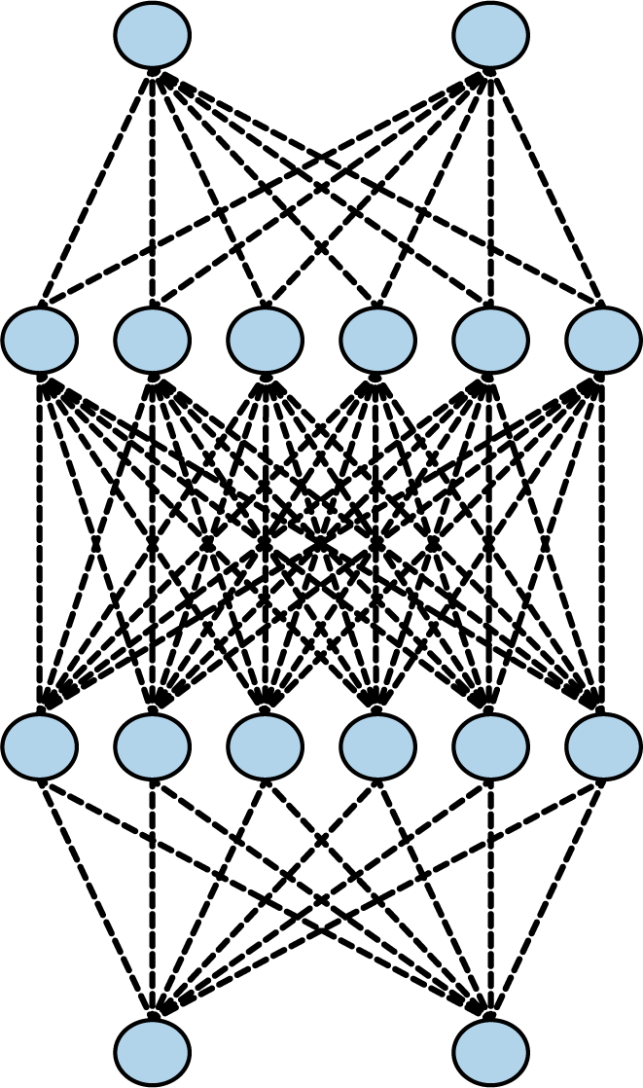

Figure 3-21. A neural network with dropouts

This reduces the chances of the neurons becoming overspecialized. The network will still learn the same number of parameters, but it should be better at generalization—that is, it should be more resilient to different inputs.

**Note**

The concept of dropouts was proposed by Nitish Srivastava et al. in their 2014 paper “[Dropout: A Simple Way to Prevent Neural Networks from Overfitting](https://oreil.ly/673CJ).”

To implement dropouts in PyTorch, you can just use a simple layer like this:

nn.Dropout(0.5)

This will drop out, at random, the specified percentage of neurons (here, 50%) in the specified layer. Note that it may take some experimentation to find the correct percentage for your network.

For a simple example that demonstrates this, consider the new fully connected layers we added to the bottom of Inception with the transfer learning example in this chapter.

Here it is for Rock, Paper, Scissors with three output neurons:

num_ftrs = pre_trained_model.fc.in_features

pre_trained_model.fc = nn.Sequential(

nn.Linear(num_ftrs, 1024), # New fully connected layer

nn.ReLU(), # Activation layer

nn.Linear(1024, 3) # Final layer for RPS

)

With dropout added, it would look like this:

num_ftrs = model.fc.in_features

model.fc = nn.Sequential(

nn.Dropout(0.5), # Adding dropout before the final FC layer

nn.Linear(num_ftrs, 1024), # Reduce dimensionality to 1024

nn.ReLU(),

nn.Dropout(0.5), # Adding another dropout layer after ReLU activation

nn.Linear(1024, 3) # Final layer for RPS

)

The examples that we used in this chapter for transfer learning are already learning really well without the use of dropouts. However, I’d recommend that you always consider dropouts when building your models because they can greatly reduce waste in the ML process—letting your model learn just as well but much faster!

Additionally, as you design your neural networks, keep in mind that getting great results on your training set is not always a good thing because it could be a sign of overfitting. Introducing dropouts can help you remove that problem so that you can optimize your network in other areas without that false sense of security.

Summary

This chapter introduced you to a more advanced way of achieving computer vision by using convolutional neural networks. You saw how to use convolutions to apply filters that can extract features from images, and you designed your first neural networks to deal with more complex vision scenarios than those you encountered with the MNIST and Fashion MNIST datasets. You also explored techniques to improve your network’s accuracy and avoid overfitting, such as the use of image augmentation and dropouts.

Before we explore further scenarios, in [Chapter 4](https://learning.oreilly.com/library/view/ai-and-ml/9781098199166/ch04.html#ch04_using_data_with_pytorch_1748548966496246), you’ll get an introduction to PyTorch data, which is a technology that makes it much easier for you to get access to data for training and testing your networks. In this chapter, you downloaded ZIP files and extracted images, but that’s not always going to be possible. With PyTorch datasets, you’ll be able to access lots of datasets with a standard API.

Chapter 4. Using Data with PyTorch

In the first three chapters of this book, you trained models using a variety of data, from the Fashion MNIST dataset that was conveniently bundled via an API to the image-based “Horses or Humans” and “Dogs vs. Cats” datasets, which were available as ZIP files that you had to download and preprocess. So by now, you’ve probably realized that there are lots of different ways of getting the data with which to train a model.

However, many public datasets require you to learn lots of different domain-specific skills before you begin to consider your model architecture. The goal behind PyTorch domains and the tools available at the torch.utils.data.Datasets namespace is to expose datasets in a way that’s easy to consume, where all the preprocessing steps of acquiring the data and getting it into PyTorch-friendly APIs are done for you.

You’ve already seen a little of this idea in how PyTorch handled Fashion MNIST back in [Chapter 2](https://learning.oreilly.com/library/view/ai-and-ml/9781098199166/ch02.html#ch02_introduction_to_computer_vision_1748548889076080). As a recap, all you had to do to get the data was this:

train_dataset = datasets.FashionMNIST(root='./data', train=True,

download=True, transform=transform)

In the case of this dataset, we also did an import from the torchvision library to get the datasets object that contained the reference to Fashion MNIST:

from torchvision import datasets

Given that it’s a computer vision–oriented dataset, it makes sense that it would be in the torchvision library.

PyTorch has many other datasets of different data types that can be loaded in the same way. These include the following:

*Vision*

Fashion MNIST is in the aforementioned torchvision library. It’s one of the “Image Classification” built-in datasets, but there are many more for other scenarios like Image Detection, Segmentation, Optical Flow, Stereo Matching, Image Pairing, Image Captioning, Video Classification, Video Predictions, and more.

*Text*

Common text datasets are available in the torchtext library. There are far too many to list here, but there are ones for Text Classification, Language Modeling, Machine Translation, Sequence Tagging, Question and Answer, and Unsupervised Learning. You can find more details on these in the [PyTorch documentation](https://oreil.ly/aFamN). Note that this library isn’t limited to the datasets; it also has many helper functions that you will use when processing text.

*Audio*

The torchaudio library contains many datasets that can be used in machine learning scenarios for sound or speech. Details can be found in the [PyTorch documentation](https://oreil.ly/tvDe4).

All datasets are subclasses of torch.utils.data.Dataset, so it’s important to take a look at this library and understand it well. That will help you not only consume existing datasets but also create your own to share with others.

Getting Started with Datasets

The torch.utils.data.Dataset is an abstract class that represents a dataset. To create a custom dataset, you just need to subclass it and implement these methods:

__len__(self)

This should return the total number of items in your dataset:

__getitem__(self, index)

This should return a single item from your dataset at the specified index. This item will be transformed before sending it to the model.

Here’s an example:

from torch.utils.data import Dataset

class CustomDataset(Dataset):

def __init__(self, data, transforms=None):

self.data = data

self.transforms = transforms

def __len__(self):

return len(self.data)

def __getitem__(self, idx):

sample = self.data[idx]

if self.transforms:

sample = self.transforms(sample)

return sample

That’s pretty much it at a very low level. The data itself is in an array called data[]. Now, imagine we want to create a dataset with a linear relationship between an *x* value and a *y* value like we had in [Chapter 1](https://learning.oreilly.com/library/view/ai-and-ml/9781098199166/ch01.html#ch01_introduction_to_pytorch_1748548870019566). How would we use it?

Let’s say we start with some simple synthetic data, like this:

# Generate synthetic data

torch.manual_seed(0) # For reproducibility

x = torch.arange(0, 100, dtype=torch.float32)

y = 2 * x – 1

Then, we could turn it into a dataset like this:

class CustomDataset(Dataset):

def __init__(self, x, y):

"""

Initialize the dataset with x and y values.

Arguments:

x (torch.Tensor): The input features.

y (torch.Tensor): The output labels.

"""

self.x = x

self.y = y

def __len__(self):

"""

Return the total number of samples in the dataset.

"""

return len(self.x)

def __getitem__(self, idx):

"""

Fetch the sample at index `idx` from the dataset.

Arguments:

idx (int): The index of the sample to retrieve.

"""

return self.x[idx], self.y[idx]

Then, to use the dataset, we simply create an instance of the class, initialize it with our *x* and *y*values, pass it to a DataLoader, and enumerate that:

# Create an instance of CustomDataset

dataset = CustomDataset(x, y)

# Use DataLoader to handle batching and shuffling

data_loader = DataLoader(dataset, batch_size=10, shuffle=True)

# Iterate over the DataLoader

for batch_idx, (inputs, labels) in enumerate(data_loader):

print(f"Batch {batch_idx+1}")

print("Inputs:", inputs)

print("Labels:", labels)

# Break after the first batch for demonstration

if batch_idx == 0:

break

With this foundation, you can now explore the dataset classes that have been made available in the various libraries we’ve mentioned since the beginning of this chapter. Given that they will build on or extend this class, the APIs should look familiar.

Exploring the FashionMNIST Class

Earlier in the book, we saw the FashionMNIST class—which provides access to the Fashion-MNIST dataset, which is a training set of 60,000 examples of 10 classes of clothing—and an accompanying test set of 10,000 examples. Each of these examples is a 28 × 28 grayscale image.

In the case of this dataset, you use the *same* class whether you’re using training data or test/validation data, and the data that you receive is based on the train parameter that you pass to it. Here’s an example:

# Create the FashionMNIST dataset

fashion_mnist_train = datasets.FashionMNIST(root='./data', train=True,

download=True, transform=transform)

When you set train=True, the code that overrides the class init method will take the 60,000 records and return them to the caller. Other parameters are there, like specifying the root for where the data should go and even whether or not to download the data. Finally, as you’ll commonly see when downloading data, there is the transform= parameter. As you saw in the preceding base class, this parameter will be available as an optional parameter for all datasets, and it will apply a transform when set.

Generic Dataset Classes

You may need to use some data that isn’t available in the dataset classes, like FashionMNIST, but you’ll also want to take advantage of everything in the data ecosystem—such as the ability to transform your data, things like splitting, and all the good stuff in the DataLoader class you’ll see later in this chapter. To that end, torch.utils.data provides a number of generic dataset classes you could use.

**ImageFolder**

In [Chapter 3](https://learning.oreilly.com/library/view/ai-and-ml/9781098199166/ch03.html#ch03_going_beyond_the_basics_detecting_features_in_ima_1748570891074912), we used the “Horses or Humans,” “Rock, Paper, Scissors,” and “Cats vs. Dogs” datasets, which are not available in a class directly but instead as a ZIP file containing the images. When we downloaded them and saved them into subdirectories for the different image types (e.g., one folder for “Horses” and another for “Humans”), the generic ImageFolder dataset class could act as a dataset for us.

In that case, the images were streamed (via a DataLoader) from the directory according to the batch size and other rules on the DataLoader. The labels were derived from the directory names, and the associated class indices were the labels in alphabetical order. So, “Horses” would be class 0, and “Humans” would be class 1. Please watch out for that when building and debugging because you might miss out on this ordering!

For example, we tend to say, “Rock, Paper, Scissors” in that order, and we would therefore expect them to be classes 0, 1, and 2, respectively. But in *alphabetical* order, Paper would be class 0, Rock would be class 1, and Scissors would be class 2!

**Tip**

One tool to use for this is to create a custom index like the one below:

custom_class_to_idx = {'rabbit': 0, 'dog': 1, 'cat': 2}

dataset = ImageFolder(

root='data/animals',

target_transform=

lambda x: custom_class_to_idx[dataset.classes[x]]

)

dataset.class_to_idx = custom_class_to_idx

print(dataset.class_to_idx)

**DatasetFolder**

ImageFolder is actually a subclass of the more generic DatasetFolder class, one that’s customized for images. The DatasetFolder class isn’t limited to image data, and you can use it for anything. It also allows you to use directories for labels. So, for example, say you have text files that contain text of different classes with a directory structure like this:

root/sarcasm/document1.txt

root/sarcasm/document2.txt

root/sarcasm/document3.txt

root/factual/factdoc1.rtf

root/factual/factdoc2.doc

You could then use a DatasetFolder to stream the documents according to the correct labels. Also, because this class is document based, you could apply a transform to extract from the file!

**FakeData**

FakeData is a useful generic dataset that, as its name suggests, provides you with fake data. At the time of writing, it only supports creating fake image data. It’s also very useful if you don’t have data on hand but want to experiment with different architectures, or if you want to benchmark your system.

You can use FakeData in the same way you’d use any of the datasets you’ve seen so far in this book. So, for example, if you wanted to create a set of FakeData for the MobileNet model, which uses 224 × 224 color images, you’d do it with code like this:

import torch

from torchvision.datasets import FakeData

import torchvision.transforms as transforms

from torch.utils.data import DataLoader

# Define transformations (if needed)

transform = transforms.Compose([

transforms.ToTensor(),

transforms.Normalize((0.5,), (0.5,))

])

# Create FakeData

fake_dataset = FakeData(size=100, image_size=(3, 224, 224),

num_classes=10, transform=transform)

# DataLoader

data_loader = DataLoader(fake_dataset, batch_size=10, shuffle=True)

This would create 100 images (containing just noise) of the desired size and span them across 10 classes. You could then use this data in a DataLoader in the same way you’d use any other dataset.

While FakeData only gives image types, you could relatively easily create your own CustomData (as we looked at earlier) to provide fake data in other formats, such as numeric or sequence data.

Using Custom Splits

Up to this point, all of the data you’ve been using to build models has been pre-split for you into training and test sets. For example, with Fashion MNIST, you had 60,000 and 10,000 records, respectively. But what if you don’t want to use those splits? What if you want to split the data yourself, according to your own needs?

Thankfully, when using datasets, you can generally do this with an easy and intuitive API.

So, for example, when you loaded the FashionMNIST class previously, you specified the train parameter to get it to give you the training data (60,000 records) or the test data (10,000 records).

To override this, you simply ignore it, and you’ll get all of the data:

# Load the entire Fashion-MNIST dataset

dataset = datasets.FashionMNIST(root='./data',

download=True, transform=transform)

To create your own split, you can use the torch.utils.data namespace, which contains a function called random_split. So, for example, if you want to have a validation set that FashionMNIST doesn’t provide, you can divide the dataset into three datasets with random_split. Here’s the code that will assign 70% of the data to a training set, 15% to a testing set, and 15% to a validation set:

from torch.utils.data import random_split

total_count = len(dataset)

train_count = int(0.7 * total_count)

val_count = int(0.15 * total_count)

# Ensures all data is used

test_count = total_count – train_count – val_count

train_dataset, val_dataset, test_dataset =

random_split(dataset, [train_count, val_count, test_count])

As you can see, this process is pretty straightforward. We get the number of records in the dataset as total_count and then calculate 70% of them (0.7 times the total count) to be the training count and 15% of them to be the validation count. When making calculations like this, you may end up with rounding errors that leave some records out—so instead of using 15% for the test count, you can just set the quotient for training to be the total minus the training and validation records. This will ensure all the data is used and none is wasted.

What’s really nice about this approach is that it gives you a really simple way to get new and different slices of your dataset. As you train models, it gives you a new way to evaluate them for accuracy.

For example, one slice of the dataset may train at high accuracy while another does so at low accuracy, indicating that there are likely issues in your model architecture that make it overfit on one dataset. On the other hand, if you try multiple different splits of your data and the model training and validation results are consistent, then you’ll have a signal that your architecture is sound.

I would definitely encourage you to use custom splits when training models, as it can really help you get over some gotchas!

One more thing to consider when using custom splits is that the name random doesn’t mean that this approach *shuffles* or randomizes your dataset. It merely slices the dataset at random points to give you different slices each time. Should you want to also shuffle the dataset, you can do it in the DataLoader, which we’ll explore in the next section.

The ETL Process for Managing Data in Machine Learning

*Extract, Transfer, Load* (ETL) is the core pattern for training ML models, regardless of scale. We’ve been exploring small-scale, single-computer model building in this book, but we can use the same technology for large-scale training across multiple machines with massive datasets.

The Extract, Transfer, Load process consists of the three phases that are in the process’s name:

*Extract phase*

This occurs when the raw data is loaded from wherever it is stored and prepared in a way that can be transformed.

*Transform phase*

This occurs when the data is manipulated in a way that makes it suitable or improved for training. For example, batching, image augmentation, mapping to feature columns, and other such logic applied to the data can be considered part of this phase.

*Load phase*

This occurs when the data is loaded into the neural network for training.

Consider the code from [Chapter 3](https://learning.oreilly.com/library/view/ai-and-ml/9781098199166/ch03.html#ch03_going_beyond_the_basics_detecting_features_in_ima_1748570891074912) that we used to train the “Horses or Humans” classifier. At the top of the code, you saw a chunk like this:

# Define transformations

train_transform = transforms.Compose([

transforms.Resize((150,150)),

transforms.RandomHorizontalFlip(),

transforms.RandomRotation(20),

transforms.RandomAffine(

degrees=0, # No rotation

translate=(0.2, 0.2), # Translate up to 20% x and y

scale=(0.8, 1.2), # Zoom in or out by 20%

shear=20, # Shear by up to 20 degrees

),

transforms.ToTensor(),

transforms.Normalize(mean=[0.5, 0.5, 0.5], std=[0.5, 0.5, 0.5]),

])

# Load the datasets

train_dataset = datasets.ImageFolder(root=training_dir,

transform=train_transform)

val_dataset = datasets.ImageFolder(root=validation_dir,

transform=train_transform)

# Data loaders

train_loader = DataLoader(train_dataset, batch_size=32, shuffle=True)

val_loader = DataLoader(val_dataset, batch_size=32, shuffle=True)

This is the ETL pattern embodied in code!

The code begins by defining the transform (the “T”), but the active code doesn’t begin until the lines under the Load the datasets comment. Look carefully here and you’ll see that the ImageFolder is being used to *extract* the data from its location at rest on disk.

Then, as the data is extracted, the transform that we defined is applied.

Then, under the Data loaders comment, we perform the *load* of the data using the train_loader and val_loader we’ve defined. Strictly speaking, the actual loading doesn’t take place until we execute the training loop to pull the data out of the loaders.

It’s important to know that using this process can make your data pipelines less susceptible to changes in the data and the underlying schema. When you use this approach to extract data, the same underlying structure is used regardless of whether the data is small enough to fit in memory or large enough that it cannot be contained even on a simple machine. The APIs for applying the transformation are also consistent, so you can use similar ones regardless of the underlying data source. And of course, once the data is transformed, the process of loading the data is also consistent, regardless of your training backend.

However, how you load the data can have a huge impact on your training speed. Let’s take a look at that next.

Optimizing the Load Phase

Let’s take a closer look at the ETL process when you’re training a model. We can consider the extraction and transformation of the data to be possible on any processor, including a CPU. In fact, the code you use in these phases to perform tasks like downloading data, unzipping it, and going through it record by record and processing those records is not what GPUs and TPUs are built for, so the code will likely execute on the CPU anyway. When it comes to training, however, you can get great benefits from a GPU or TPU, so it makes sense for you to use one for this phase if possible. Thus, in a situation where a GPU or TPU is available to you, you should ideally split the workload between the CPU and the GPU/TPU, with Extract and Transform taking place on the CPU and Load taking place on the GPU/TPU.

If you explore the code that you’ve been using in this book, you’ll notice that we’ve used the .to(device) methodology. Whenever you’re dealing with training or inference and you want the data or model to be on the accelerator, you’ll see something like .to(“cuda”), but for the extraction and transform, you won’t see it because it would be a waste of the GPU’s resources.

Suppose you’re working with a large dataset. Assuming it’s so large that you have to prepare the data (i.e., do the extraction and transformation) in batches, you’ll end up with a situation like that shown in [Figure 4-1](https://learning.oreilly.com/library/view/ai-and-ml/9781098199166/ch04.html#ch04_figure_1_1748548966489345). While the first batch is being prepared, the GPU or TPU is idle. Then, when that batch is ready, you can send it to the GPU/TPU for training, but then the CPU will be idle until the training is done and it can start preparing the second batch. There’s a lot of idle time here, so we can see that there’s room for optimization.

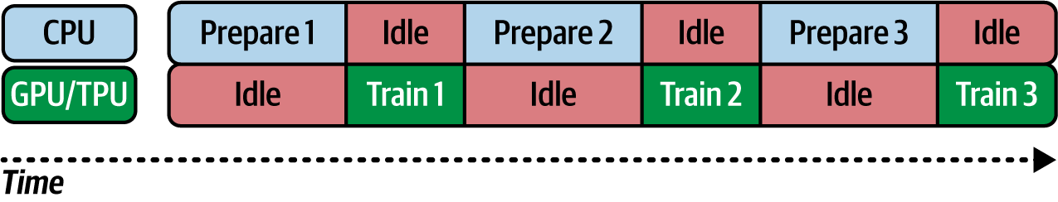

Figure 4-1. Training on a CPU or GPU/TPU

The logical solution is to do the work in parallel, preparing and training side by side. This process is called *pipelining* and is illustrated in [Figure 4-2](https://learning.oreilly.com/library/view/ai-and-ml/9781098199166/ch04.html#ch04_figure_2_1748548966489381).

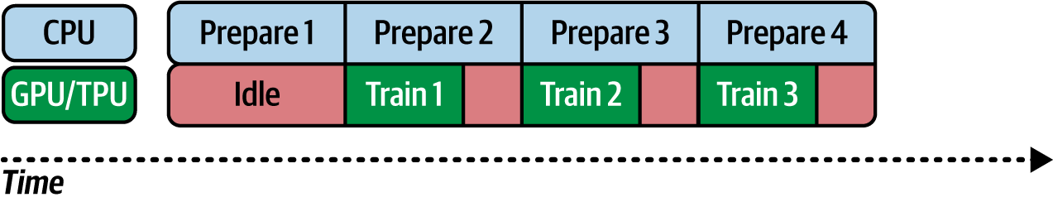

Figure 4-2. Pipelining

In this case, while the CPU is preparing the first batch, the GPU/TPU again has nothing to work on, so it’s idle. When the first batch is done, the GPU/TPU can start training—but in parallel with this, the CPU will prepare the second batch. Of course, the time it takes to train batch *n* – 1 and prepare batch *n* won’t always be the same, and if the training time is shorter, you’ll have periods of idle time on the GPU/TPU, and if the training time is longer, you’ll have periods of idle time on the CPU. Choosing the correct batch size can help you optimize here—and as GPU/TPU time is likely more expensive, you’ll probably want to reduce its idle time as much as possible.

This is one of the reasons why we use batching, even for the simple examples like MNIST: the pipelining model is in place so that regardless of how large your dataset is, you’ll continue to use a consistent pattern for ETL on it.

Using the DataLoader Class

We’ve seen the DataLoader class many times already, but it’s good to take a slightly deeper look at it now to help you get the most out of it in your ML workflows. It provides the following features that you can use.

**Batching**

Intuitively, you might think that the forward pass works one data item at a time. You *could* do that, but some optimizers, like stochastic gradient descent, do much better when inputs are passed in batches so that they can calculate more accurately. Batching can also speed up your training in larger scenarios, where you are using GPUs with fixed memory sizes. It’s most efficient to maximize the use of that memory by having a batch of data that fits it fully. If you’re using a DataLoader, batching is simply a matter of setting a parameter.

**Shuffling**

Shuffling the data is very important, particularly when you do batching. Consider the following scenario with something like Fashion MNIST.

You have 60,000 samples each for 10 classes, and they are not shuffled. You batch one thousand records at a time, so your first batch of one thousand is all for class 0, the second batch is all for class 1, and so on. In this scenario, the model may not effectively learn because each batch is biased toward a particular label—but the ability of your model to generalize will improve if the batches are shuffled, meaning your first thousand items will have varied labels, etc.

**Parallel Data Loading**

Often, and in particular with complex data, loading data into the model for the forward pass can be time-consuming. But the DataLoader class offers parallelism through Python’s multiprocessing model, which can significantly speed this up.

As you saw previously, you should consider your data loading/transformation and your model learning to be two separate processes. You want to avoid scenarios where the model training has no data to work with and is sitting idle, waiting for data to be loaded, and you also want to avoid scenarios where you have tons of data piled up in memory but the model can’t get to it. Parallel data loading, when well tuned, can be helpful here, and there’s a skill you can learn to ensure that you’re getting the most out of your training by running this at peak efficiency. You’ll learn how to do this in the next section.

**Custom Data Sampling**

In addition to shuffling for random data sampling, you can create custom data sampling, in which you can specify how the data will be loaded. The torch.utils.data.Sampler class provides a base class that you can build a custom sampler on. This process is beyond the scope of this book, but there are many excellent examples of it online.

Parallelizing ETL to Improve Training Performance

If you’re using the DataLoader class, you can easily perform parallelization by using the num_workers parameter. So, for example, say you want to train a model on the CIFAR10 dataset, and you want to use parallel training. Let’s take a look at how to do this, step-by-step.

First, we’ll explore the Extract and Transform steps:

import torchvision.transforms as transforms

from torchvision.datasets import CIFAR10

# Define transformations

transform = transforms.Compose([

transforms.ToTensor(),

transforms.Normalize((0.5, 0.5, 0.5), (0.5, 0.5, 0.5))

])

# Load CIFAR10 dataset

dataset = CIFAR10(root='./data', train=True, download=True, transform=transform)

Then, we’ll configure and create the DataLoader to the Load step:

from torch.utils.data import DataLoader

# DataLoader with multiple workers

data_loader = DataLoader(dataset, batch_size=64, shuffle=True,

**num_workers=4**)

Note the num_workers=4 parameter, which will create four subprocesses to load the data in parallel simultaneously. Based on the hardware you have available and the number of cores, the speed of your CPU, etc., you can experiment with this number to reduce the overall bottlenecks.

What’s really nice about this approach is that the ETL process is neatly encapsulated in it, so your model training loop doesn’t have to change in any way, even though you’re loading the data by using parallelism! Here’s the code for the simple CIFAR model that uses this data:

import torch

# Dummy model and optimizer setup

model = torch.nn.Sequential(

torch.nn.Linear(3 * 32 * 32, 500),

torch.nn.ReLU(),

torch.nn.Linear(500, 10)

)

optimizer = torch.optim.Adam(model.parameters(), lr=0.001)

criterion = torch.nn.CrossEntropyLoss()

# Training loop

def train(model, data_loader):

model.train()

for batch_idx, (inputs, targets) in enumerate(data_loader):

# Reshape inputs to match the model's expected input

inputs = inputs.view(inputs.size(0), –1)

# Forward pass

outputs = model(inputs)

loss = criterion(outputs, targets)

# Backward pass and optimize

optimizer.zero_grad()

loss.backward()

optimizer.step()

if batch_idx % 100 == 0:

print(f"Train Epoch: {batch_idx} Loss: {loss.item()}")

train(model, data_loader)

Parallelizing is another tool that’s available to you when you’re training your models. There’s no one-size-fits-all approach, but it’s a good tool to use when you experience training slowdowns. It’s easy to assume that training operates slowly just because of the network architecture, but you may be surprised at how much of that time is wasted by the forward pass waiting for new data! By adding this type of parallelism, you have the potential to greatly speed up training.

Summary

This chapter covered the data ecosystem in PyTorch and introduced you to the dataset and DataLoader classes. You saw how they use a common API and a common format to help reduce the amount of code you have to write to get access to data, and you also saw how to use the ETL process, which is at the heart of the common design patterns in training models with PyTorch. In particular, we explored parallelizing the extraction, transformation, and loading of data to improve training performance.

So now that you’ve had a chance to look at the process, see if you can create your own dataset! Maybe do it from some photos in your albums, or some test, or just random noise like we did here.

In the next chapter, you’ll take what you’ve learned so far and start applying it to natural language processing problems.

Chapter 5. Introduction to Natural Language Processing

Natural language processing (NLP) is a technique in AI that deals with the understanding of language. It involves programming techniques to create models that can understand language, classify content, and even generate and create new compositions in language. It’s also the underlying foundation to large language models (LLMs) such as GPT, Gemini, and Claude. We’ll explore LLMs in later chapters, but first, we’ll look at more basic NLP over the next few chapters to equip you for what’s to come.

There are also lots of services that use NLP to create applications such as chatbots, but that’s not in the scope of this book—instead, we’ll be looking at the foundations of NLP and how to model language so that you can train neural networks to understand and classify text. In later chapters, you’ll also learn how to use the predictive elements of an ML model to write some poetry. This isn’t just for fun—it’s also a precursor to learning how to use the transformer-based models that underpin generative AI!

We’ll start this chapter by looking at how you can decompose language into numbers and how you can then use those numbers in neural networks.

Encoding Language into Numbers

Ultimately, computers deal in numbers, so to handle language, you need to convert it into numerics in a process called *encoding.*

You can encode language into numbers in many ways. The most common is to encode by letters, as is done naturally when strings are stored in your program. In memory, however, you don’t store the letter *a* but an encoding of it—perhaps an ASCII or Unicode value or something else. For example, consider the word *listen*. You can encode it with ASCII into the numbers 76, 73, 83, 84, 69, and 78. This is good in that you can now use numerics to represent the word. But then consider the word *silent*, which is an anagram of *listen*. The same numbers represent that word, albeit in a different order, which might make building a model to understand the text much more difficult.

A better alternative might be to use numbers to encode entire words instead of the letters within them. In that case, *silent* could be the number *x* and *listen* could be the number *y*, and they wouldn’t overlap with each other.

Using this technique, consider a sentence like “I love my dog.” You could encode that with the numbers [1, 2, 3, 4]. If you then wanted to encode “I love my cat,” you could do it with [1, 2, 3, 5]. By now, you’ve probably gotten to the point where you can tell that the sentences have a similar meaning because they’re similar numerically—in other words, [1, 2, 3, 4] looks a lot like [1, 2, 3, 5].

The numbers representing words are also called *tokens*, and as a result, this process is called *tokenization*. You’ll explore how to do that in code next.

**Getting Started with Tokenization**

The PyTorch ecosystem contains many libraries for tokenization, which takes words and turns them into tokens. A common tokenizer you might see in code samples is torchtext, but this has been deprecated since 2023. So, be careful when using it, especially because PyTorch versions advance but it doesn’t. So, some alternatives are to use a custom tokenizer, a pretrained one from elsewhere, or (surprisingly) those from the Keras ecosystem.

**Using a custom tokenizer**

To give you a simple example, here’s some code I used to create a custom tokenizer to turn the words of a small corpus (two sentences) into tokens:

import torch

sentences = [

'Today is a sunny day',

'Today is a rainy day'

]

# Tokenization function

def tokenize(text):

return text.lower().split()

# Build the vocabulary

def build_vocab(sentences):

vocab = {}

for sentence in sentences:

tokens = tokenize(sentence)

for token in tokens:

if token not in vocab:

vocab[token] = len(vocab) + 1

return vocab

# Create the vocabulary index

vocab = build_vocab(sentences)

print("Vocabulary Index:", vocab)

**Note**

The word *corpus* is commonly used to denote a set of text items that you will use for training. It’s literally the *body* of text that you’ll use to train the model and create tokenizers for.

The output of this is as follows:

Vocabulary Index: {'today': 1, 'is': 2, 'a': 3, 'sunny': 4, 'day': 5, 'rainy': 6}

As you can see, the tokenizer did a really simple job of creating a list with my vocabulary, and every time it hit a unique word, it added it to the list. So the first sentence, “Today is a sunny day,” yielded five tokens for the five words: “today,” “is,” “a,” “sunny,” and “day.” The second sentence had *most* of these words in common, with “rainy” being the exception, so that became the sixth token.

On the other hand, you can imagine that for a very large corpus, this process would be very slow.

**Using a pretrained tokenizer from Hugging Face**

With that in mind, I’m going to use Hugging Face’s transformers library and pre-built tokenizers from within it. In this case, because the transformers library supports many language models and these language models need tokenizers to work with their corpus of text, the tokenizer, which is trained on many millions of words, is freely available for you to use. It has bigger coverage than one you might create, and it’s free and easy to use!

If you don’t have this library already, you can install it with this:

!pip install transformers

Now, let’s see it in action with a simple example:

from transformers import BertTokenizerFast

sentences = [

'Today is a sunny day',

'Today is a rainy day'

]

# Initialize the tokenizer

tokenizer = BertTokenizerFast.from_pretrained('bert-base-uncased')

# Tokenize the sentences and encode them

encoded_inputs = tokenizer(sentences, padding=True, truncation=True,

return_tensors='pt')

# To see the tokens for each input (helpful for understanding the output)

tokens = [tokenizer.convert_ids_to_tokens(ids)

for ids in encoded_inputs["input_ids"]]

# To get the word index similar to Keras' tokenizer

word_index = tokenizer.get_vocab()

print("Tokens:", tokens)

print("Token IDs:", encoded_inputs['input_ids'])

print("Word Index:", dict(list(word_index.items())[:10]))

# show only the first 10 for brevity

The output from it looks like this:

Tokens: [['[CLS]', 'today', 'is', 'a', 'sunny', 'day', '[SEP]'],

['[CLS]', 'today', 'is', 'a', 'rainy', 'day', '[SEP]']]

Token IDs: tensor([

[ 101, 2651, 2003, 1037, 11559, 2154, 102],

[ 101, 2651, 2003, 1037, 16373, 2154, 102]])

Word Index: {'protestant': 8330, 'initial': 3988, '##pt': 13876,

'charters': 23010, '243': 22884, 'ref': 25416, '##dies': 18389,

'##uchi': 15217, 'sainte': 16947, 'annette': 22521}

Now, let’s break this down. We start by importing the BertTokenizerFast from the transformers library. This can be initialized with a number of pretrained tokenizers, and we choose the 'bert-base-uncased' one. You might be wondering what on earth that is! Well, the idea here is that I wanted to take a pretrained tokenizer, and they are usually partnered with the model they were trained on. BERT (which stands for bidirectional encoder representations from transformers) is a model trained by Google on a large corpus, with a vocabulary of 30,000 words. You can find models like this in the Hugging Face model repository, and when you dig down into a model, you’ll often see the transformer’s code to get its tokenizer. For example, see [this page that I used](https://oreil.ly/Ok7L9)—and while I’m not using the model, I can still get its tokenizer instead of creating a custom one.

In this case, we create a tokenizer object and specify the number of words that it can tokenize. This will be the maximum number of tokens to generate from the corpus of words. We also have a very small corpus here, containing only six unique words, so we’ll be well under the maximum of one hundred specified.

Once I have the tokenizer, I can then just pass the text to it:

# Tokenize the sentences and encode them

encoded_inputs = tokenizer(sentences, padding=True, truncation=True,

return_tensors='pt')

We’ll explore padding and truncation a little later in this chapter, but for now, you should note the return_tensors='pt' parameter. This is a nice convenience for us PyTorch developers because the return values will be torch.Tensor objects, which are easy for us to handle.

The BERT model uses a number of overlays on the original tokenization, such as attention_masking, which means it works with IDs for each word instead of raw tokens. This is beyond the scope of this chapter, but where it impacts you right now is if you don’t need all that. If you just want the tokens, you have to extract the tokens in the following way, noting that your sentences were encoded as input_Ids within the BERT tokenizer:

# To see the tokens for each input (helpful for understanding the output)

tokens = [tokenizer.convert_ids_to_tokens(ids)

for ids in encoded_inputs["input_ids"]]

Once you’ve done that, you can easily print out the following Tokens collection:

Tokens: [['[CLS]', 'today', 'is', 'a', 'sunny', 'day', '[SEP]'],

['[CLS]', 'today', 'is', 'a', 'rainy', 'day', '[SEP]']]

Now, you may be wondering what [CLS] and [SEP] are—and how the BERT model has been trained to expect sentences to begin with [CLS] (for *classifier*) and end with or be separated by [SEP] (for *separator*). These two expressions are tokenized to values 101 and 102, respectively, so when you print out the token values for your sentences, you’ll see this:

Token IDs: tensor([

[ 101, 2651, 2003, 1037, 11559, 2154, 102],

[ 101, 2651, 2003, 1037, 16373, 2154, 102]])

From this, you can derive that *today* is token 2651 in BERT, *is* is token 2003, etc.

So, it really depends on you how you want to approach this. For learning with small datasets, the custom tokenizer is probably OK. But once you start getting into larger datasets, you may want to opt for a pretrained tokenizer. In that case, you may have to deal with some overhead—so for the rest of this chapter, I’m going to use custom code to tokenize and preprocess the text without the overhead of something like the BERT tokenizer.

Either way, once you have the words in your sentences tokenized, the next step is to convert your sentences into lists of numbers, with the number being the value where the word is the key. This process is called *sequencing*.

**Turning Sentences into Sequences**

Now that you’ve seen how to take words and tokenize them into numbers, the next step is to encode the sentences into sequences of numbers, which you can do as follows:

def text_to_sequence(text, vocab):

return [vocab.get(token, 0) for token in tokenize(text)]

# 0 for unknown words

Then, you’ll be given the sequences representing the three sentences. Remember that the word index is this:

Vocabulary Index: {'today': 1, 'is': 2, 'a': 3, 'sunny': 4, 'day': 5, 'rainy': 6}

And the output will look like this:

[1, 2, 3, 4, 5]

[1, 2, 3, 6, 5]

You can then substitute the words for the numbers, and you’ll see that the sentences make sense.

Now, consider what happens if you are training a neural network on a set of data. The typical pattern is that you have a set of data that’s used for training but that you know won’t cover 100% of your needs, but you hope it covers as much as possible. In the case of NLP, you might have many thousands of words in your training data that are used in many different contexts, but you can’t have every possible word in every possible context. So when you show your neural network some new, previously unseen text that contains previously unseen words, what might happen? You guessed it—the network will get confused because it simply has no context for those words, and as a result, any prediction it gives will be negatively affected.

**Using out-of-vocabulary tokens**

One tool you can use to handle these situations is an *out-of-vocabulary* (OOV) *token*, which can help your neural network understand the context of the data containing previously unseen text. For example, given the previous small example corpus, suppose you want to process sentences like these:

test_data = [

'Today is a snowy day',

'Will it be rainy tomorrow?'

]

Remember that you’re not adding this input to the corpus of existing text (which you can think of as your training data) but you’re considering how a pretrained network might view this text. Say you tokenize it with the words that you’ve already used and your existing tokenizer, like this:

for test_sentence in test_data:

test_seq = text_to_sequence(test_sentence, vocab)

print(test_seq)

Then, your results will look like this:

[1, 2, 3, 0, 5]

[0, 0, 0, 6, 0]

So, the new sentences, swapping back tokens for words, would be “today is a <UNK> day” and “<UNK> <UNK> <UNK> rainy <UNK>.”

Here I’m using the tag <UNK> (which stands for *unknown*) for token 0. If you check out the text_to_sequence code I showed previously, it uses 0 for words that aren’t in its dictionary. You can, of course, use any value you like.

**Understanding padding**

When training neural networks, you typically need all your data to be in the same shape. Recall from earlier chapters that when you were training with images, you reformatted the images to be the same width and height. With text, you face the same issue—once you’ve tokenized your words and converted your sentences into sequences, they can all be different lengths. But to get them to be the same size and shape, you can use *padding*.

All the sentences we have used so far are composed of five words, so you can see that our sequences are five tokens. But what would happen if you had some sentences that were longer. Say a few had 5 words, some had 8 words, and some had 10 words. To have a neural network handle them all, they would need to be of the same length! You could convert everything to 10 words by lengthening the sentences that are shorter, convert everything to 5 words by chopping off bits of the longer ones, or follow some other strategy!

To explore padding, let’s add another, much longer, sentence to the corpus:

sentences = [

'Today is a sunny day',

'Today is a rainy day',

'Is it sunny today?',

'I really enjoyed walking in the snow today'

]

When you sequence that, you’ll see that your lists of numbers have different lengths. Also note that if you haven’t retokenized to build the new vocabulary, the latter two sentences will be full of zeros:

[1, 2, 3, 4, 5]

[1, 2, 3, 6, 5]

[2, 0, 4, 0]

[0, 0, 0, 0, 0, 0, 0, 1]

So, don’t forget to call:

vocab = build_vocab(sentences)

And then you’ll have new tokens for the new words in your tokenizer, so the output will look like this:

[1, 2, 3, 4, 5]

[1, 2, 3, 6, 5]

[2, 7, 4, 8]

[9, 10, 11, 12, 13, 14, 15, 1]

Remember that when you were training neural networks in earlier chapters, your input layers of the neural network required images to have consistent sizes and shapes. It’s the same with NLP, for the most part. (There’s an exception for something called *ragged tensors*, but that’s beyond the scope of this chapter.) So, we need a way to make our sentences the same length.

Here’s a simple padding function:

def pad_sequences(sequences, maxlen):

return [seq + [0] * (maxlen - len(seq)) if len(seq) < maxlen

else seq[:maxlen] for seq in sequences]

This function will reshape every array in the sequence to be the same length as the maximum-length one. So, say we take our sentences and pad them after sequencing them with code like this:

for sentence in sentences:

seq = text_to_sequence(sentence, vocab)

padded_seq = pad_sequences([seq], maxlen=10) # Example maxlen

print(padded_seq)

Then, the output will look like this:

[[1, 2, 3, 4, 5, 0, 0, 0, 0, 0]]

[[1, 2, 3, 6, 5, 0, 0, 0, 0, 0]]

[[2, 7, 4, 8, 0, 0, 0, 0, 0, 0]]

[[9, 10, 11, 12, 13, 14, 15, 1, 0, 0]]

Now, each of the sequences has a length of 10 because of the maxlen parameter. It’s a pretty simple implementation that you would likely want to build on if you’re using this in a more serious way. For example, you might want to consider what would happen if you had a sequence that was longer than the maximum length. Right now, it would cut off everything *after* the maximum, but you might want it to exhibit different behavior!

Also note that if you’re using off-the-shelf tokenizers like the BERT one we showed you earlier, much of this functionality may already be available to you, so be sure to experiment.

Removing Stopwords and Cleaning Text

In the next section you’ll look at some real-world datasets, and you’ll find that there’s often text that you *don’t* want in your dataset. You may also want to filter out so-called *stopwords*—like “the,” “and,” and “but”—that are too common and don’t add any meaning. You may also encounter a lot of HTML tags in your text, and it would be good to have a clean way to remove them. Other things you may want to filter out include rude words, punctuation, or names. Later, we’ll explore a dataset of tweets that often have somebody’s user ID in them, and we’ll want to filter those out.

While every task is different based on your corpus of text, there are three main things that you can do to clean up your text programmatically.

**Stripping Out HTML Tags**

The first thing you can do is strip out HTML tags, and fortunately, there’s a library called BeautifulSoup that makes this straightforward. For example, if your sentences contain HTML tags such as <br>, then you can remove them by using this code:

from bs4 import BeautifulSoup

soup = BeautifulSoup(sentence)

sentence = soup.get_text()

**Stripping Out Stopwords**

The second thing to do is strip out stopwords, and a common way to do it is to have a stopwords list and preprocess your sentences by removing instances of stopwords. Here’s an abbreviated example:

stopwords = ["a", "about", "above", ... "yours", "yourself", "yourselves"]

You can find a full stopwords list in some of the [online examples for this chapter](https://github.com/lmoroney/PyTorch-Book-FIles).

Then, as you’re iterating through your sentences, you can use code like this to remove the stopwords from your sentences:

words = sentence.split()

filtered_sentence = ""

for word in words:

if word not in stopwords:

filtered_sentence = filtered_sentence + word + " "

sentences.append(filtered_sentence)

**Stripping Out Punctuation**

The third thing you can do is strip out punctuation, and you’ll want to do it because punctuation can fool a stopword remover. The one we just showed you looks for words surrounded by spaces, so it won’t spot a stopword that’s immediately followed by a period or a comma.

Fixing this problem is easy with the translation functions provided by the Python string library. But do be careful with this approach, as there are scenarios where it might impact NLP analysis, particularly when detecting sentiment.

The library also comes with a constant called string.punctuation that contains a list of common punctuation marks, so to remove them from a word, you can do the following:

import string

table = str.maketrans('', '', string.punctuation)

words = sentence.split()

filtered_sentence = ""

for word in words:

word = word.translate(table)

if word not in stopwords:

filtered_sentence = filtered_sentence + word + " "

sentences.append(filtered_sentence)

Here, before filtering for stopwords, the constant removes punctuation from each word in the sentence. So, if splitting a sentence gives you the word *it*, the word will be converted to *it* and then stripped out as a stopword. Note, however, that when doing this, you may have to update your stopwords list. It’s also common for these lists to have abbreviated words and contractions like *you’ll* in them, and the translator will change *you’ll* to *youll*. So if you want to have those words filtered out, you’ll need to update your stopwords list to include them.

Following these three steps will give you a much cleaner set of text to use. But of course, every dataset will have its idiosyncrasies that you’ll need to work with.

Working with Real Data Sources

Now that you’ve seen the basics of getting sentences, encoding them with a word index, and sequencing the results, you can take it to the next level by taking some well-known public datasets and using the tools Python provides to get them into a format where you can easily sequence them. We’ll start with a dataset in which a lot of the work has already been done for you: the IMDb dataset. After that, we’ll get a bit more hands-on by processing a JSON-based dataset and a couple of comma-separated values (CSV) datasets with emotion data in them.

**Getting Text Datasets**

We explored some datasets in [Chapter 4](https://learning.oreilly.com/library/view/ai-and-ml/9781098199166/ch04.html#ch04_using_data_with_pytorch_1748548966496246), so if you get stuck on any of the concepts in this section, you can get a quick review there. However, at the time of writing, accessing *text*-based datasets is a little unusual. Given that the torchtext library has been deprecated, it’s not clear what will happen with its built-in datasets, so we’ll get hands-on in dealing with raw data in this section.

We’ll start by exploring the IMDb reviews, which is a dataset of 50,000 labeled movie reviews from the Internet Movie Database (IMDb), each of which is determined to be positive or negative in sentiment.

This code will download the raw dataset and unzip it into folders where training and test splits are already pre-made for us. These will then be stored in subdirectories, and there are further subdirectories called pos and neg in each that determine the labels of the text files they contain:

import os

import urllib.request

import tarfile

def download_and_extract(url, destination):

if not os.path.exists(destination):

os.makedirs(destination, exist_ok=True)

file_path = os.path.join(destination, "aclImdb_v1.tar.gz")

if not os.path.exists(file_path):

print("Downloading the dataset...")

urllib.request.urlretrieve(url, file_path)

print("Download complete.")

if "aclImdb" not in os.listdir(destination):

print("Extracting the dataset...")

with tarfile.open(file_path, 'r:gz') as tar:

tar.extractall(path=destination)

print("Extraction complete.")

# URL for the dataset

dataset_url = "http://ai.stanford.edu/~amaas/data/sentiment/aclImdb_v1.tar.gz"

download_and_extract(dataset_url, "./data")

The file structure will look like the one in [Figure 5-1](https://learning.oreilly.com/library/view/ai-and-ml/9781098199166/ch05.html#ch05_figure_1_1748549080734915).

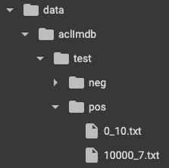

Figure 5-1. Exploring the IMDb dataset structure

In this figure you can see the *test/pos* directory and the first couple of files in it. Note that these are text files, so to create a tokenizer and vocabulary, we’re going to have to read files instead of in-memory strings like in the earlier example.

Let’s take a look at the code for a custom tokenizer for this:

from collections import Counter

import os

# Simple tokenizer

def tokenize(text):

return text.lower().split()

# Build vocabulary

def build_vocab(path):

counter = Counter()

for folder in ["pos", "neg"]:

folder_path = os.path.join(path, folder)

for filename in os.listdir(folder_path):

with open(os.path.join(folder_path, filename), 'r',

encoding='utf-8') as file:

counter.update(tokenize(file.read()))

return {word: i+1 for i, word in enumerate(counter)} # Starting index from 1

vocab = build_vocab("./data/aclImdb/train/")

It’s pretty straightforward code that just reads through each file and adds new words it discovers to the vocabulary, giving each word a new token value. Generally, you’ll only want to do this for the training data, with the understanding that there will be words in the test data that aren’t in the training data and that they would be tokenized with an OOV or unknown token.

The output should look like this (truncated):

{'a': 1, 'year': 2, 'or': 3, 'so': 4, 'ago,': 5, 'i': 6, 'was': 7…

This is a naive tokenizer in that the first word it sees gets the first token, the second gets the second, etc. For performance reasons, it’s often better for the more frequent words in the corpus to get the earlier tokens and the less frequent ones to get the later tokens. We’ll explore that in a moment.

You can then do sequencing and padding as you did earlier:

def text_to_sequence(text, vocab):

return [vocab.get(token, 0) for token in tokenize(text)] # 0 for unknown

def pad_sequences(sequences, maxlen):

return [seq + [0] * (maxlen - len(seq))

if len(seq) < maxlen else seq[:maxlen] for seq in sequences]

# Example use

text = "This is an example."

seq = text_to_sequence(text, vocab)

padded_seq = pad_sequences([seq], maxlen=256) # Example maxlen

print(seq)

So, for example, our sentence This is an example will output as [30, 56, 144, 16040] because those are the tokens assigned to those words. The padded sequence would have a tensor of 256 values, with these tokens as the first 4 and the next 252 being zeros!

Now, let’s update the tokenizer to do the words in order of frequency. This update changes the tokenizer so that we load all of the files into memory and count the instance of each word to get a frequency table:

# Build vocabulary

def build_vocab(path):

counter = Counter()

for folder in ["pos", "neg"]:

folder_path = os.path.join(path, folder)

for filename in os.listdir(folder_path):

with open(os.path.join(folder_path, filename), 'r',

encoding='utf-8') as file:

counter.update(tokenize(file.read()))

# Sort words by frequency in descending order

sorted_words = sorted(counter.items(), key=lambda x: x[1], reverse=True)

# Create vocabulary with indices starting from 1

vocab = {word: idx + 1 for idx, (word, _) in enumerate(sorted_words)}

vocab['<pad>'] = 0 # Add padding token with index 0

return vocab

We can then output the vocabulary as this frequency table. The vocabulary is too large to show the entire index, but here are the top 20 words. Note that the tokenizer lists them in order of frequency in the dataset, so common words like *the*, *and*, and *a* are indexed:

{'the': 1, 'a': 2, 'and': 3, 'of': 4, 'to': 5, 'is': 6, 'in': 7, 'i': 8,

'this': 9, 'that': 10, 'it': 11, '/><br': 12, 'was': 13, 'as': 14,

'for': 15, 'with': 16, 'but': 17, 'on': 18, 'movie': 19, 'his': 20,

These are stopwords, as described in the previous section. Having these present can impact your training accuracy because they’re the most common words and they’re nondistinct (i.e., they’re likely present in both positive and negative reviews), so they add noise to our training.

Also note that *br* is included in this list because it’s commonly used in this corpus as the <br> HTML tag.

You can also update the code to use BeautifulSoup to remove the HTML tags, and you can remove stopwords from the given list as follows. To do this, you can update the tokenizer to remove the HTML tags by using BeautifulSoup:

# Simple tokenizer

from bs4 import BeautifulSoup

# Note that the list of stopwords is defined in the source code.

# It’s an array of words. You can define your own or just get the one from

# the book’s github.

def tokenize(text):

soup = BeautifulSoup(text, "html.parser")

cleaned_text = soup.get_text() # Extract text from HTML

return [word.lower() for word in cleaned_text.split() if word.lower()

not in stopwords]

Now, when you print out your word index, you’ll see this:

{'movie': 1, 'not': 2, 'film': 3, 'one': 4, 'like': 5, 'just': 6, "it's": 7,

'even': 8, 'good': 9, 'no': 10, 'really': 11, 'can': 12, 'see': 13, '-': 14,

'get': 15, 'will': 16, 'much': 17, 'story': 18, 'also': 19, 'first': 20

You can see that this is much cleaner than before. There’s always room to improve, however, and one thing I noted when looking at the full index was that some of the less common words toward the end were nonsensical. Often, reviewers would combine words, for example with a dash (as in *annoying-conclusion*) or a slash (as in *him/her*), and the stripping of punctuation would incorrectly turn these combined words into a single word. Or, as you can see in the preceding code, the dash (*-*) character was common enough to be tokenized. You can strip that out by adding it as a stopword.

Now that you have a tokenizer for the corpus, you can encode your sentences. For example, the simple sentences we were looking at earlier in the chapter will come out like this:

sentences = [

'Today is a sunny day',

'Today is a rainy day',

'Is it sunny today?'

]

[[1094, 6112, 246, 0, 0, 0, 0, 0]]

[[1094, 6730, 246, 0, 0, 0, 0, 0]]

[[6112, 25065, 0, 0, 0, 0, 0, 0]]

If you decode these, you’ll see that the stopwords are dropped and you get the sentences encoded as today sunny day, today rainy day, and sunny today.

If you want to do this in code, you can create a new dict with the reversed keys and values (i.e., for a key/value pair in the word index, you can make the value the key and the key the value) and do the lookup from that. Here’s the code:

reverse_word_index = dict(

[(value, key) for (key, value) in vocab.items()])

decoded_review = ' '.join([reverse_word_index.get(i, '?') for i in seq])

print(decoded_review)

This will give the following result:

today sunny day

A common way to store labeled text data is in the comma-separated value (CSV) format. We’ll discuss that next.

**Getting Text from CSV Files**

NLP data is also commonly available in CSV file format. Over the next couple of chapters, you’ll use a CSV of data that I adapted from the open source [Sentiment Analysis in Text dataset](https://oreil.ly/7ZKEU). The creator of this dataset sourced it from Twitter (now called X). You will use two different datasets, one where the emotions have been reduced to “positive” or “negative” for binary classification and one where the full range of emotion labels is used. Both datasets use the same structure, so I’ll just show the binary version here.

While the name *CSV* seems to suggest a standard file format in which values are comma separated, there’s actually a wide diversity of formats that can be considered CSV, and there’s very little adherence to any particular standard. To solve this, the Python csv library makes handling CSV files straightforward. In this case, the data is stored with two values per line. The first value is a number (0 or 1) denoting whether the sentiment is negative or positive, and the second value is a string containing the text.

The following code snippet will read the CSV and do preprocessing that’s similar to what we saw in the previous section. For the full code, please check the repo for this book. The code adds spaces around the punctuation in compound words, uses BeautifulSoup to strip HTML content, and then removes all punctuation characters:

import csv

sentences=[]

labels=[]

with open('/tmp/binary-emotion.csv', encoding='UTF-8') as csvfile:

reader = csv.reader(csvfile, delimiter=",")

for row in reader:

labels.append(int(row[0]))

sentence = row[1].lower()

sentence = sentence.replace(",", " , ")

sentence = sentence.replace(".", " . ")

sentence = sentence.replace("-", " - ")

sentence = sentence.replace("/", " / ")

soup = BeautifulSoup(sentence)

sentence = soup.get_text()

words = sentence.split()

filtered_sentence = ""

for word in words:

word = word.translate(table)

if word not in stopwords:

filtered_sentence = filtered_sentence + word + " "

sentences.append(filtered_sentence)

This will give you a list of 35,327 sentences.

Note that this code is specific to this data. It’s intended to help you understand the types of tasks you may have to take on in order to make stuff work, and it’s not intended to be an exhaustive list of things that you’ll have to do for every task—so your mileage may vary.

**Creating training and test subsets**

Now that the text corpus has been read into a list of sentences, you’ll need to split it into training and test subsets for training a model. For example, if you want to use 28,000 sentences for training with the rest held back for testing, you can use code like this:

training_size = 28000

training_sentences = sentences[0:training_size]

testing_sentences = sentences[training_size:]

training_labels = labels[0:training_size]

testing_labels = labels[training_size:]

Now that you have a training set, you can edit the tokenizer and vocabulary builder to create the word index from this corpus. As the corpus is an in-memory array of strings (training_sentences), the process is a lot simpler:

from collections import Counter

# Assuming the tokenize function is defined elsewhere

def tokenize(text):

# Tokenization logic, removing HTML and stopwords as discussed earlier

soup = BeautifulSoup(text, "html.parser")

cleaned_text = soup.get_text()

tokens = cleaned_text.lower().split()

filtered_tokens = [token for token in tokens if token not in stopwords]

return filtered_tokens

def build_vocab(sentences):

counter = Counter()

for text in sentences:

counter.update(tokenize(text))

# Sort words by frequency in descending order

sorted_words = sorted(counter.items(), key=lambda x: x[1], reverse=True)

# Create vocabulary with indices starting from 1

vocab = {word: idx + 1 for idx, (word, _) in enumerate(sorted_words)}

vocab['<pad>'] = 0 # Add padding token with index 0

return vocab

vocab = build_vocab(training_sentences)

print(vocab)

You can use the same helper functions to turn the text into a sequence and then padding, like this:

print(testing_sentences[1])

seq = text_to_sequence(testing_sentences[1], vocab)

print(seq)

The results will be as follows:

made many new friends twitter around usa another bike across usa trip amazing

see people

[146, 259, 30, 110, 53, 198, 2161, 111, 752, 970, 2161, 407, 217, 26, 73]

Another common format for structured data, particularly in response to web calls, is JavaScript Object Notation (JSON). We’ll explore how to read JSON data next.

**Getting Text from JSON Files**

JSON is an open standard file format that’s used often for data interchange, particularly with web applications. It’s human readable and designed to use name/value pairs, and as such, it’s particularly well suited for labeled text. A quick search of Kaggle datasets for JSON yields over 2,500 results. For example, popular datasets such as the Stanford Question Answering Dataset (SQuAD) are stored in JSON.

JSON has very simple syntax in which objects are contained within braces as name/value pairs, each of which is separated by a comma. For example, a JSON object representing my name would be as follows:

{"firstName" : "Laurence",

"lastName" : "Moroney"}

JSON also supports arrays, which are a lot like Python lists and are denoted by the square bracket syntax. Here’s an example:

[

{"firstName" : "Laurence",

"lastName" : "Moroney"},

{"firstName" : "Sharon",

"lastName" : "Agathon"}

]

Objects can also contain arrays, so this is perfectly valid JSON:

[

{"firstName" : "Laurence",

"lastName" : "Moroney",

"emails": ["lmoroney@gmail.com", "lmoroney@galactica.net"]

},

{"firstName" : "Sharon",

"lastName" : "Agathon",

"emails": ["sharon@galactica.net", "boomer@cylon.org"]

}

]

A smaller dataset that’s stored in JSON and a lot of fun to work with is the “News Headlines Dataset for Sarcasm Detection” by [Rishabh Misra](https://oreil.ly/wZ3oD), which is available on [Kaggle](https://oreil.ly/_AScB). This dataset collects news headlines from two sources: *The Onion* for funny or sarcastic ones and the *HuffPost* for normal headlines.

The file structure in the sarcasm dataset is very simple:

{"is_sarcastic": 1 or 0,

"headline": String containing headline,

"article_link": String Containing link}

The dataset consists of about 26,000 items, one per line. To make it more readable in Python, I’ve created a version that encloses these items in an array so the dataset can be read as a single list, which is used in the source code for this chapter.

**Reading JSON files**

Python’s json library makes reading JSON files simple. Given that JSON uses name/value pairs, you can index the content based on the name. So, for example, for the sarcasm dataset, you can create a file handle to the JSON file, open it with the json library, and have an iterable go through, read each field line by line, and get the data item by using the name of the field.

Here’s the code:

import json

with open("/tmp/sarcasm.json", 'r') as f:

datastore = json.load(f)

for item in datastore:

sentence = item['headline'].lower()

label= item['is_sarcastic']

link = item['article_link']

This makes it simple for you to create lists of sentences and labels, as you’ve done throughout this chapter, and then tokenize the sentences. You can also do preprocessing on the fly as you read a sentence, removing stopwords, HTML tags, punctuation, and more.

Here’s the complete code to create lists of sentences, labels, and URLs while having the sentences cleaned of unwanted words and characters:

with open("/tmp/sarcasm.json", 'r') as f:

datastore = json.load(f)

sentences = []

labels = []

urls = []

for item in datastore:

sentence = item['headline'].lower()

sentence = sentence.replace(",", " , ")

sentence = sentence.replace(".", " . ")

sentence = sentence.replace("-", " - ")

sentence = sentence.replace("/", " / ")

soup = BeautifulSoup(sentence)

sentence = soup.get_text()

words = sentence.split()

filtered_sentence = ""

for word in words:

word = word.translate(table)

if word not in stopwords:

filtered_sentence = filtered_sentence + word + " "

sentences.append(filtered_sentence)

labels.append(item['is_sarcastic'])

urls.append(item['article_link'])

As before, you can split these into training and test sets. If you want to use 23,000 of the 26,000 items in the dataset for training, you can do the following:

training_size = 23000

training_sentences = sentences[0:training_size]

testing_sentences = sentences[training_size:]

training_labels = labels[0:training_size]

testing_labels = labels[training_size:]

Now that you have them as in_memory string arrays, tokenizing them and sequencing them will work exactly the same way as tokenizing and sequencing the sarcasm dataset.

Hopefully, the similar-looking code will help you see the pattern that you can follow when preparing text for neural networks to classify or generate. In the next chapter, you’ll learn how to build a classifier for text using embeddings, and in [Chapter 7](https://learning.oreilly.com/library/view/ai-and-ml/9781098199166/ch07.html#ch07_recurrent_neural_networks_for_natural_language_pro_1748549654891648) you’ll take that a step further by exploring recurrent neural networks. Then, in [Chapter 8](https://learning.oreilly.com/library/view/ai-and-ml/9781098199166/ch08.html#ch08_using_ml_to_create_text_1748549671852453), you’ll learn how to further enhance the sequence data to create a neural network that can generate new text!

**Tip**

Regular expressions (aka Regex) are terrific tools for sorting, filtering, and cleaning text. They have a syntax that’s often hard to understand and difficult to learn, but I have found that generative AI tools like Gemini, Claude, and ChatGPT are really useful here.

Summary

In earlier chapters, you used images to build a classifier. Images, by definition, have well-defined dimensions—you know their width, height, and format. Text, on the other hand, can be far more difficult to work with. It is often unstructured, can contain undesirable content such as formatting instructions, doesn’t always contain what you want, and often has to be filtered to remove nonsensical or irrelevant content.

In this chapter, you saw how to take text and convert it to numbers using word tokenization, and you then explored how to read and filter text in a variety of formats. With these skills in hand, you’re now ready to take the next step and learn how *meaning* can be inferred from words—which is the first step in understanding natural language.

Chapter 6. Making Sentiment Programmable by Using Embeddings

In [Chapter 5](https://learning.oreilly.com/library/view/ai-and-ml/9781098199166/ch05.html#ch05_introduction_to_natural_language_processing_1748549080743759), you saw how to take words and encode them into tokens. Then, you saw how to encode sentences full of words into sequences full of tokens, padding or truncating them as appropriate to end up with a well-shaped set of data that you can use to train a neural network. However, in none of that was there any type of modeling of the *meaning* of a word. And while it’s true that there’s no absolute numeric encoding that could encapsulate meaning, there are relative ones.

In this chapter, you’ll learn about techniques to encapsulate meaning, and in particular, the concept of *embeddings*, in which vectors in high-dimensional space are created to represent words. The directions of these vectors can be learned over time, based on the use of the words in the corpus. Then, when you’re given a sentence, you can investigate the directions of the word vectors, sum them up, and from the overall direction of the summation, establish the sentiment of the sentence as a product of its words. Also, related to this, as the model scans the sentences, the positioning of the words in the sentence can also help train an appropriate embedding.

In this chapter, we’ll also explore how that works. Using the News Headlines Dataset for Sarcasm Detection dataset from [Chapter 5](https://learning.oreilly.com/library/view/ai-and-ml/9781098199166/ch05.html#ch05_introduction_to_natural_language_processing_1748549080743759), you’ll build embeddings to help a model detect sarcasm in a sentence. You’ll also work with some cool visualization tools that help you understand how words in a corpus get mapped to vectors so you can see which words determine the overall classification.

Establishing Meaning from Words

Before we get into the higher-dimensional vectors for embeddings, let’s use some simple examples to try to visualize how meaning can be derived from numerics. Consider this: using the sarcasm dataset from [Chapter 5](https://learning.oreilly.com/library/view/ai-and-ml/9781098199166/ch05.html#ch05_introduction_to_natural_language_processing_1748549080743759), what would happen if you encoded all of the words that make up sarcastic headlines with positive numbers and those that make up realistic headlines with negative numbers?

**A Simple Example: Positives and Negatives**

Take, for example, this sarcastic headline from the dataset:

christian bale given neutered male statuette named oscar

Assuming that all words in our vocabulary start with a value of 0, we could add 1 to the value for each of the words in this sentence, and we would end up with this:

{ "christian" : 1, "bale" : 1, "given" : 1, "neutered": 1, "male" : 1,

"statuette": 1, "named" : 1, "oscar": 1}

**Note**

This isn’t the same as the *tokenization* of words that you did in the last chapter. You could consider replacing each word (e.g., *christian*) with the token representing it that is encoded from the corpus, but I’ll leave the words in for now to make the code easier to read.

Then, in the next step, consider an ordinary headline (not a sarcastic one), like this:

gareth bale scores wonder goal against germany

Because this is a different sentiment, we could instead subtract 1 from the current value of each word, so our value set would look like this:

{ "christian" : 1, "bale" : 0, "given" : 1, "neutered": 1, "male" : 1,

"statuette": 1, "named" : 1, "oscar": 1, "gareth" : –1, "scores": –1,

"wonder" : –1, "goal" : –1, "against" : –1, "germany" : –1}

Note that the sarcastic bale (from christian bale) has been offset by the nonsarcastic bale (from gareth bale), so its score ends up as 0. Repeat this process thousands of times and you’ll end up with a huge list of words from your corpus that are scored based on their usage.

Now, imagine we want to establish the sentiment of this sentence:

neutered male named against germany, wins statuette!

Using our existing value set, we could look at the scores of each word and add them up. We would get a score of 2, indicating (because it’s a positive number) that this is a sarcastic sentence.

**Note**

For what it’s worth, the word *bale* is used five times in the Sarcasm dataset, twice in a normal headline and three times in a sarcastic one. So, in a model like this, the word *bale* would be scored –1 across the whole dataset.

**Going a Little Deeper: Vectors**

Hopefully, the previous example has helped you understand the mental model of establishing some form of *relative* meaning for a word, through its association with other words in the same “direction.” In our case, while the computer doesn’t understand the meanings of individual words, it can move labeled words from a known sarcastic headline in one direction (by adding 1) and move labeled words from a known normal headline in another direction (by subtracting 1). This gives us a basic understanding of the meaning of the words, but it does lose some nuance.

But what if we increased the dimensionality of the direction to try to capture some more information? For example, suppose we were to look at characters from the Jane Austen novel *Pride and Prejudice*, considering the dimensions of gender and nobility. We could plot the former on the *x*-axis and the latter on the *y*-axis, with the length of the vector denoting each character’s wealth (see [Figure 6-1](https://learning.oreilly.com/library/view/ai-and-ml/9781098199166/ch06.html#ch06_clean_figure_1_1748752380714921)).

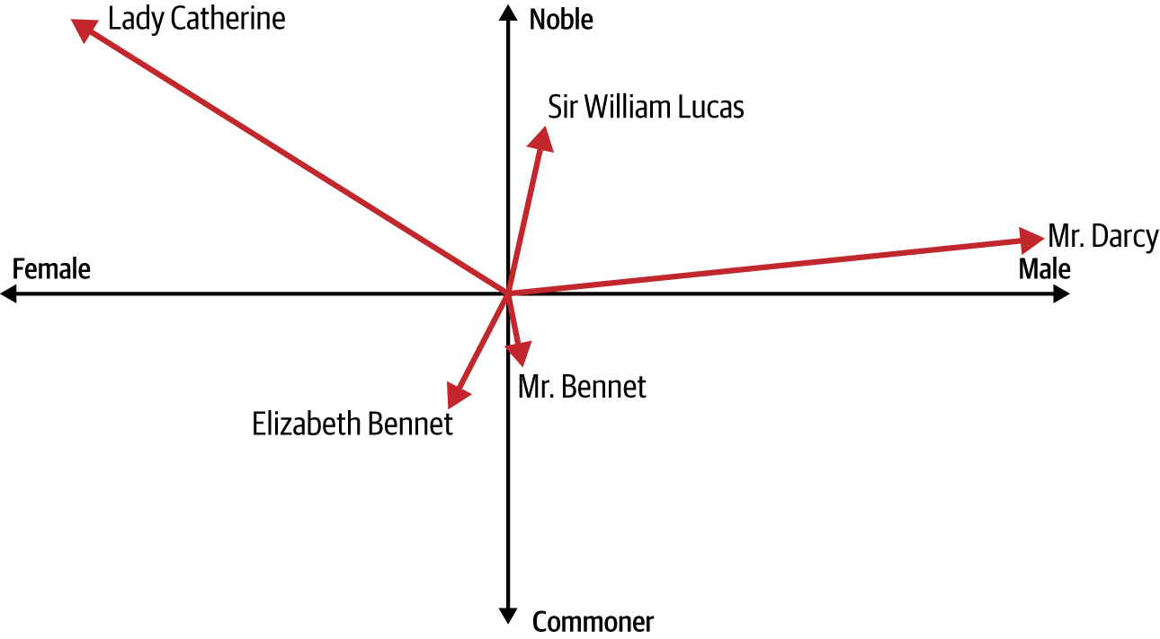

Figure 6-1. Characters in Pride and Prejudice as vectors

From an inspection of the graph, you can derive a fair amount of information about each character. Three of them are male. Mr. Darcy is extremely wealthy, but his nobility isn’t clear (he’s called “Mister,” unlike the less wealthy but apparently more noble Sir William Lucas). The other “Mister,” Mr. Bennet, is clearly not nobility and is struggling financially. Elizabeth Bennet, his daughter, is similar to him but female. Lady Catherine, the other female character in our example, is noble and incredibly wealthy. The romance between Mr. Darcy and Elizabeth causes tension—with *prejudice* coming from the noble side of the vectors toward the less-noble.

As this example shows, by considering multiple dimensions, we can begin to see real meaning in the words (which are character names here). Again, we’re not talking about concrete definitions but more about a *relative* meaning based on the axes and the relationship between the vector for one word and the other vectors.

This leads us to the concept of an *embedding*, which is simply a vector representation of a word that is learned while training a neural network. We’ll explore that next.

Embeddings in PyTorch

Much like you’ve seen with Linear and Conv2D, PyTorch implements embeddings by using a layer. This creates a lookup table that maps from an integer to an embedding table, the contents of which are the coefficients of the vector representing the word identified by that integer. So, in the *Pride and Prejudice* example from the previous section, the *x* and *y* coordinates would give us the embeddings for a particular character from the book. Of course, in a real NLP problem, we’ll use far more than two dimensions. Thus, the direction of a vector in the vector space could be seen as encoding the “meaning” of a word, and words with similar vectors (i.e., pointing in roughly the same direction) could be considered related to that word.

The embedding layer will be initialized randomly—that is, the coordinates of the vectors will be completely random to start with and will be learned during training by using backpropagation. When training is complete, the embeddings will roughly encode similarities between words, allowing us to identify words that are somewhat similar based on the direction of the vectors for those words.

This is all quite abstract, so I think the best way to understand how to use embeddings is to roll up your sleeves and give them a try. Let’s start with a sarcasm detector using the Sarcasm dataset from [Chapter 5](https://learning.oreilly.com/library/view/ai-and-ml/9781098199166/ch05.html#ch05_introduction_to_natural_language_processing_1748549080743759).

**Building a Sarcasm Detector by Using Embeddings**

In [Chapter 5](https://learning.oreilly.com/library/view/ai-and-ml/9781098199166/ch05.html#ch05_introduction_to_natural_language_processing_1748549080743759), you loaded and did some preprocessing on a JSON dataset called the News Headlines Dataset for Sarcasm Detection (the sarcasm dataset, for short). By the time you were done, you had lists of training and testing data and labels:

training_size = 28000

training_sentences = sentences[0:training_size]

testing_sentences = sentences[training_size:]

training_labels = labels[0:training_size]

testing_labels = labels[training_size:]

For the training data, you created a build_vocab helper function to create a dictionary of the frequency of each word, sorted in order of the most frequent. The size of this dictionary is the vocab_size.

To get an embedding layer in PyTorch, you can use the nn.Embedding layer type, like this, by specifying the desired vocab size and the number of embedding dimensions:

nn.Embedding(vocab_size, embedding_dim)

This will initialize a vector with embedding_dim axes for each word. So, for example, if embedding_dim is 16, then every word in the vocabulary will be assigned a 16-dimensional vector.

Over time, the attributes for each token (encoded as values for the vector in each of its dimensions) will be learned through backpropagation as the network learns by matching the training data to its labels.

An important next step is feeding the output of the embedding layer into a dense layer. The easiest way to do this, similar to how you would when using a convolutional neural network, is to use pooling. In this instance, the dimensions of the embeddings are averaged out to produce a fixed-length output vector, and Adaptive​A⁠ve​Pool1d(1) reduces the input along the length of the sequence to a fixed vector size of 1.

As an example, consider this model architecture:

self.embedding = nn.Embedding(vocab_size, embedding_dim)

self.global_pool = nn.AdaptiveAvgPool1d(1)

self.fc1 = nn.Linear(embedding_dim, 24)

self.fc2 = nn.Linear(24, 1)

self.relu = nn.ReLU()

self.sigmoid = nn.Sigmoid()

Here, an embedding layer is defined, and it’s given the vocab size and an embedding dimension. Let’s take a look at the number of trainable parameters in the network, using torchinfo.summary:

==========================================================================

Layer (type:depth-idx) Output Shape Param #

==========================================================================

TextClassificationModel [32, 1] --

├─Embedding: 1-1 [32, 100, 100] 2,429,200

├─AdaptiveAvgPool1d: 1-2 [32, 100, 1] --

├─Linear: 1-3 [32, 24] 2,424

├─ReLU: 1-4 [32, 24] --

├─Linear: 1-5 [32, 1] 25

├─Sigmoid: 1-6 [32, 1] --

==========================================================================

Total params: 2,431,649

Trainable params: 2,431,649

Non-trainable params: 0

Total mult-adds (M): 77.81

==========================================================================

Input size (MB): 0.03

Forward/backward pass size (MB): 2.57

Params size (MB): 9.73

Estimated Total Size (MB): 12.32

==========================================================================

The vocabulary size is 24,292 words, and as the embedding has 100 dimensions, the total number of trainable parameters in the embedding layer will be 2,429,200. The first linear layer has 100 values in with 24 values out, so that’s a total of 2,400 weights, but each of the neurons also has a bias, so add 24 to get to 24, 24.

Similarly, the last linear has 24 values in, with just a single neuron out. For a total of 24 parameters, plus one for the bias, this equals 25. The entire network has 2,431,649 parameters to learn. Note that the average pooling layer has 0 trainable parameters, as it’s just averaging the parameters in the embedding layer before it to get a single 16-value vector.

If we train this model, we’ll get a pretty decent training accuracy of 99%+ after 30 epochs—but our validation accuracy will be below 80% (see [Figure 6-2](https://learning.oreilly.com/library/view/ai-and-ml/9781098199166/ch06.html#ch06_clean_figure_2_1748752380714952)).

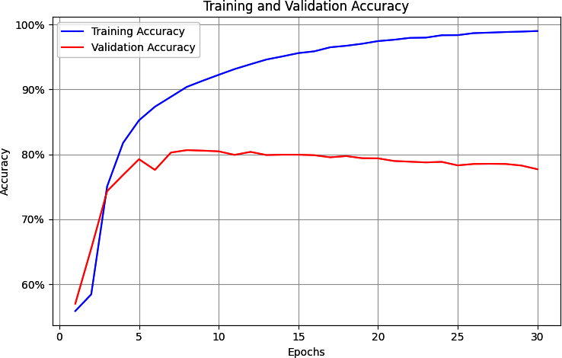

Figure 6-2. Training accuracy versus validation accuracy

That might seem to be a reasonable curve, given that the validation data likely contains many words that aren’t present in the training data. However, if you examine the loss curves for training versus validation over one hundred epochs, you’ll see a problem. Although you would expect to see that the training accuracy is higher than the validation accuracy, a clear indicator of overfitting is that while the validation accuracy is dropping a little over time (as shown in [Figure 6-2](https://learning.oreilly.com/library/view/ai-and-ml/9781098199166/ch06.html#ch06_clean_figure_2_1748752380714952)), its loss is increasing sharply, as shown in [Figure 6-3](https://learning.oreilly.com/library/view/ai-and-ml/9781098199166/ch06.html#ch06_clean_figure_3_1748752380714977).

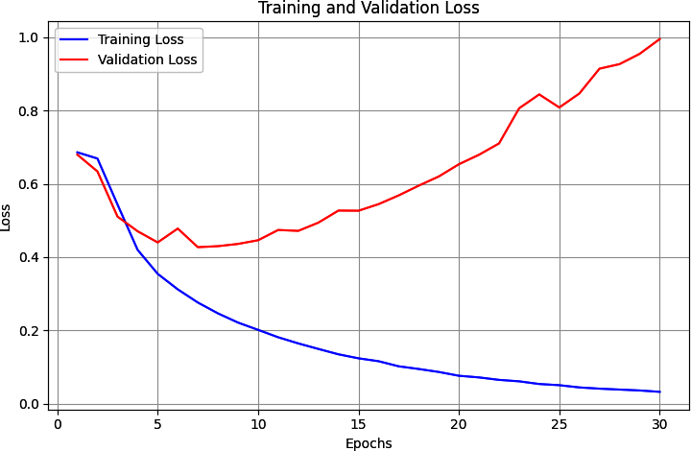

Figure 6-3. Training loss versus validation loss

Overfitting like this is common with NLP models, due to the somewhat unpredictable nature of language. In the next sections, we’ll look at how to reduce this effect by using a number of techniques.

**Reducing Overfitting in Language Models**

Overfitting happens when the network becomes overspecialized to the training data, and one part of this involves the network becoming very good at matching patterns in “noisy” data in the training set that doesn’t exist anywhere else. Because this particular noise isn’t present in the validation set, the better the network gets at matching it, the worse the loss of the validation set will be. This can result in the escalating loss that you saw in [Figure 6-3](https://learning.oreilly.com/library/view/ai-and-ml/9781098199166/ch06.html#ch06_clean_figure_3_1748752380714977).

In this section, we’ll explore several ways to generalize the model and reduce overfitting.

**Adjusting the learning rate**

A hyperparameter of the optimizer is the learning rate (LR). The details of this parameter are beyond the scope of this chapter, but consider it to be a value that if too high will cause the network to potentially learn too quickly and miss nuance. The flipside is also true—if you set it too low, your network may not learn effectively.

Perhaps the biggest factor that can lead to overfitting is whether the LR of your optimizer is too high. If it is, then your network learns *too quickly*. For this example, the code to define the optimizer was as follows:

optimizer = optim.Adam(model.parameters(), lr=0.001,

betas=(0.9, 0.999), amsgrad=False)

These are the defaults for the Adam optimizer. One thing to experiment with is the learning rate parameter (lr), and in the following code, you’ll see the results of an instance when I reduced by an order of 10 to 0.0001, like this:

optimizer = optim.Adam(model.parameters(), **lr=0.0001**,

betas=(0.9, 0.999), amsgrad=False)

The betas values stay at their defaults, as does amsgrad. Also note that both beta values must be between 0 and 1, and typically, both are close to 1. Amsgrad is an alternative implementation of the Adam optimizer that was introduced in the paper [“On the Convergence of Adam and Beyond” by Sashank Reddi, Satyen Kale, and Sanjiv Kumar](https://oreil.ly/FhTDi).

This much lower LR has a profound impact on the network. [Figure 6-4](https://learning.oreilly.com/library/view/ai-and-ml/9781098199166/ch06.html#ch06_clean_figure_4_1748752380714997) shows the accuracy of the network over one hundred epochs. The lower LR can be seen in the first 10 epochs or so, where it appears that the network isn’t learning, before it “breaks out” and starts to learn quickly.

Exploring the loss (as illustrated in [Figure 6-5](https://learning.oreilly.com/library/view/ai-and-ml/9781098199166/ch06.html#ch06_clean_figure_5_1748752380715014)), we can see that even while the accuracy wasn’t going up for the first few epochs, the loss was going down. You could therefore be confident that the network would eventually start to learn, if you were watching it epoch by epoch.

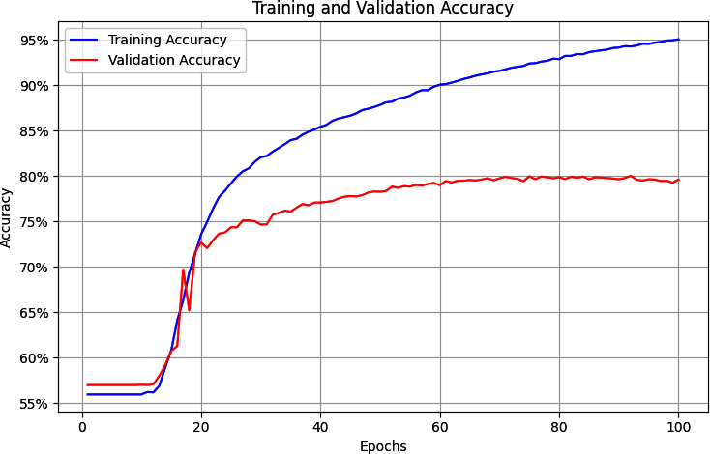

Figure 6-4. Accuracy with a lower LR

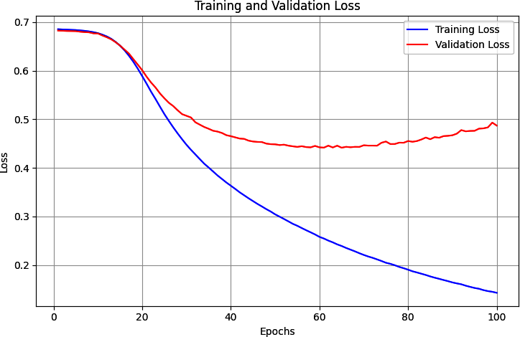

Figure 6-5. Loss with a lower LR

And while the loss does start to show the same curve of overfitting that you saw in [Figure 6-3](https://learning.oreilly.com/library/view/ai-and-ml/9781098199166/ch06.html#ch06_clean_figure_3_1748752380714977), note that it happens much later and at a much lower rate. By epoch 30, the loss is at about 0.49, whereas with the higher LR in [Figure 6-3](https://learning.oreilly.com/library/view/ai-and-ml/9781098199166/ch06.html#ch06_clean_figure_3_1748752380714977), it was more than double that amount. And while it takes the network longer to get to a good accuracy rate, it does so with less loss, so you can be more confident in the results. With these hyperparameters, the loss on the validation set started to increase at about epoch 60, at which point, the training set had 90% accuracy and the validation set had about 81% accuracy, showing that we have quite an effective network.

Of course, it’s easy to just tweak the optimizer and then declare victory, but there are a number of other methods you can use to improve your model. You’ll learn about those in the next few sections, and for them, I’ve reverted back to using the default Adam optimizer so the effects of tweaking the LR won’t hide the benefits offered by these other techniques.

**Exploring vocabulary size**

The sarcasm dataset deals with words, so if you explore the words in the dataset and in particular their frequency, you might get a clue that helps fix the overfitting issue.

I’ve provided a word_frequency helper function that lets you explore the frequency of words in the vocabulary. It looks like this:

def word_frequency(sentences, word_dict):

frequency = {word: 0 for word in word_dict}

for sentence in sentences:

words = sentence.lower().split()

for word in words:

if word in frequency:

frequency[word] += 1

return frequency

You can run it with code like this:

word_freq = word_frequency(training_sentences, word_index)

print(word_freq)

You’ll then see results like this: a dictionary containing the frequency of each word, starting with the most frequently used one, and moving on from there. Here are the first few words:

{'new': 1318, 'trump': 1117, 'man': 1075, 'not': 634, 'just': 501,

'will': 484, 'one': 469, 'year': 440, …

If you want to plot this, you can iterate through each item in the list and make the *x* value the ordinal of where you are (1 for the first item, 2 for the second item, etc.). The *y* value will then be a newlist[item], which you can plot with matplotlib. Here’s the code:

import matplotlib.pyplot as plt

from collections import OrderedDict

newlist = (OrderedDict(sorted(word_freq.items(), key=lambda t: t[1],

reverse=True)))

xs=[]

ys=[]

curr_x = 1

for item in newlist:

xs.append(curr_x)

curr_x=curr_x+1

ys.append(newlist[item])

print(ys)

plt.plot(xs,ys)

The result is shown in [Figure 6-6](https://learning.oreilly.com/library/view/ai-and-ml/9781098199166/ch06.html#ch06_clean_figure_6_1748752380715030).

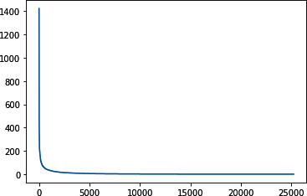

Figure 6-6. Exploring the frequency of words

This “hockey stick” curve shows us that very few words are used many times, whereas most words are used very few times. But every word is effectively weighted equally because every word has an “entry” in the embedding. Given that we have a relatively large training set in comparison with the validation set, we’re ending up in a situation where there are many words present in the training set that aren’t present in the validation set.

You can zoom in on the data by changing the axis of the plot just before calling plt.show. For example, to look at the volume of words from 300 to 10,000 on the *x*-axis with the scale from 0 to 100 on the *y*-axis, you can use this code:

plt.plot(xs,ys)

plt.axis([300,10000,0,100])

plt.show()

The result is in [Figure 6-7](https://learning.oreilly.com/library/view/ai-and-ml/9781098199166/ch06.html#ch06_clean_figure_7_1748752380715045).

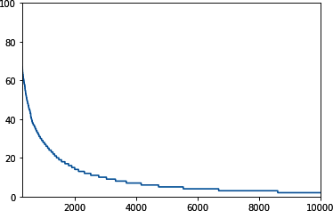

Figure 6-7. Frequency of words from 300 to 10,000

There are almost 25,000 words in the corpus, and the code is set up to only train for all of them! But if we look at the words in positions 2,000 onward, which is over 90% of our vocabulary, we’ll see that they’re each used fewer than 20 times in the entire corpus!

This could explain the overfitting, so the logical next step is to see if we can reduce the vocabulary we are training for. Within the build_vocab helper function, we can add a parameter for the maximum vocab size we’re interested in, like this:

def build_vocab(sentences, max_vocab_size=10000):

counter = Counter()

for text in sentences:

counter.update(tokenize(text))

# Take only the top max_vocab_size-1 most frequent words

# (leave room for special tokens)

most_common = counter.most_common(max_vocab_size – 2)

# -2 for <pad> and <unk>

# Create vocabulary with indices starting from 2

vocab = {word: idx + 2 for idx, (word, _) in enumerate(most_common)}

vocab['<pad>'] = 0 # Add padding token

vocab['<unk>'] = 1 # Add unknown token

return vocab

Then, when building our word_index, we can specify a maximum vocab size that we’re interested in exploring:

vocab_size = 2000

word_index = build_vocab(training_sentences, max_vocab_size=vocab_size)

The embedding layer was already initialized with the vocab size, so the model architecture doesn’t need to change. Indeed, with the reduced vocab size, the number of learned parameters drops sharply, giving us a simpler network that learns faster:

==========================================================================

Layer (type:depth-idx) Output Shape Param #

==========================================================================

TextClassificationModel [32, 1] --

├─Embedding: 1-1 [32, 100, 100] 200,100

├─AdaptiveAvgPool1d: 1-2 [32, 100, 1] --

├─Linear: 1-3 [32, 24] 2,424

├─ReLU: 1-4 [32, 24] --

├─Linear: 1-5 [32, 1] 25

├─Sigmoid: 1-6 [32, 1] --

==========================================================================

Total params: 202,549

Trainable params: 202,549

Non-trainable params: 0

Total mult-adds (M): 6.48

==========================================================================

Input size (MB): 0.03

Forward/backward pass size (MB): 2.57

Params size (MB): 0.81

Estimated Total Size (MB): 3.40

==========================================================================

The model has shrunk from 2.4 million parameters to only 202,549.

After retraining and exploring the smaller model, we can see that the results have changed.

[Figure 6-8](https://learning.oreilly.com/library/view/ai-and-ml/9781098199166/ch06.html#ch06_clean_figure_8_1748752380715056) shows the accuracy metrics. Now, the training set accuracy is about 82% and the validation accuracy is about 76%. They’re closer to each other and not diverging, which is a good sign that we’ve gotten rid of most of the overfitting.

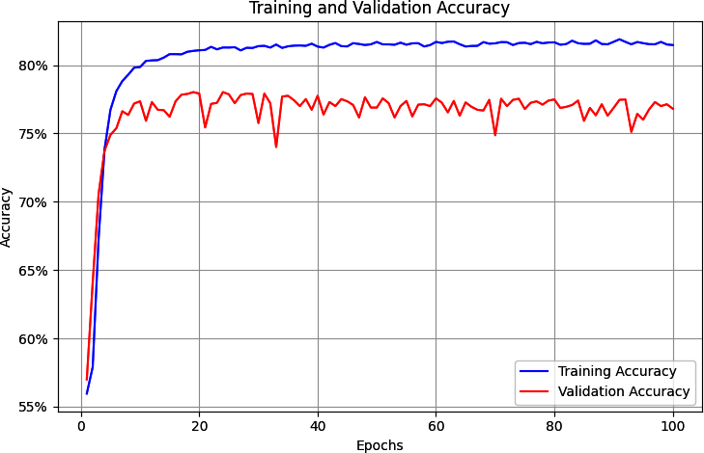

Figure 6-8. Accuracy with a two thousand–word vocabulary

This is somewhat reinforced by the loss plot in [Figure 6-9](https://learning.oreilly.com/library/view/ai-and-ml/9781098199166/ch06.html#ch06_clean_figure_9_1748752380715067). The loss on the validation set is rising but much slower than before, so reducing the size of the vocabulary to prevent the training set from overfitting on low-frequency words that were possibly only present in the training set appears to have worked.

It’s worth experimenting with different vocab sizes, but remember that you can also have too small of a vocab size and overfit to that. You’ll need to find a balance. In this case, my choice of taking words that appear 20 times or more was purely arbitrary.

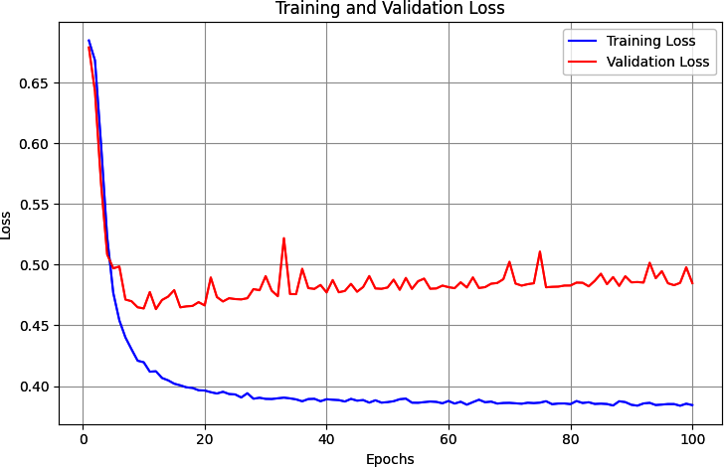

Figure 6-9. Loss with a two thousand–word vocabulary

**Exploring embedding dimensions**

For this example, I arbitrarily chose an embedding dimension of 16. In this instance, words are encoded as vectors in 16-dimensional space, with their directions indicating their overall meaning. But is 16 a good number? With only two thousand words in our vocabulary, it might be on the high side, leading to a high degree of sparseness of direction.

**Note**

I believe that the best way to think about sparseness is to project into three dimensions. Think of it like the earth, with one thousand vectors pointing from the core to a place on the surface. The vectors are in three dimensions, *x*, *y*, and *z*. There’s a lot of surface area for them to cover, but if many of them are missing *x* and *y*, meaning they’re just zero, a lot of them will be pointing to (0, 0, *z*) and a whole lot of the earth’s surface will be untouched! Thus, there will be a total lack of distinctiveness.

Research has shown that a best practice for embedding size is to have it be the fourth root of the vocabulary size. The fourth root of 2,000 is 6.687, so let’s explore what happens if we round this up and change the embedding dimension to 7.

You can see the result of training for one hundred epochs in [Figure 6-10](https://learning.oreilly.com/library/view/ai-and-ml/9781098199166/ch06.html#ch06_clean_figure_10_1748752380715076). The training set’s accuracy stabilized at about 83%, and the validation set’s accuracy stabilized at about 77%. Despite some jitters, the lines are pretty flat, showing that the model has converged. This isn’t much different from the results in [Figure 6-8](https://learning.oreilly.com/library/view/ai-and-ml/9781098199166/ch06.html#ch06_clean_figure_8_1748752380715056), but reducing the embedding dimensionality allows the model to train significantly faster.

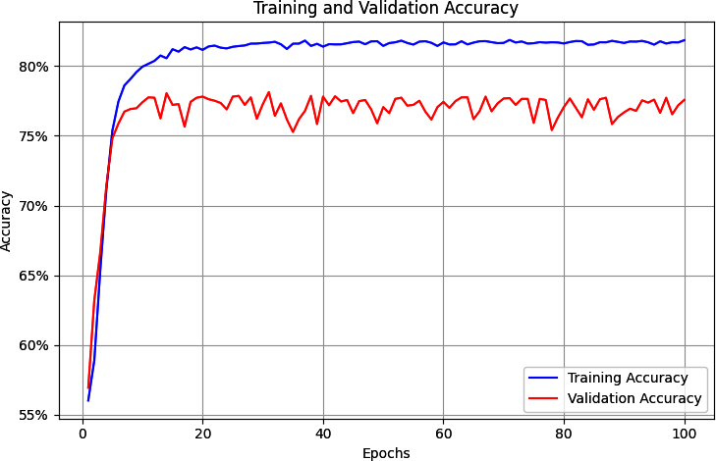

Figure 6-10. Training versus validation accuracy for seven dimensions

[Figure 6-11](https://learning.oreilly.com/library/view/ai-and-ml/9781098199166/ch06.html#ch06_clean_figure_11_1748752380715085) shows the loss in training and validation. While it initially appeared that the loss was climbing at about epoch 20, it soon flattened out. Again, a good sign!

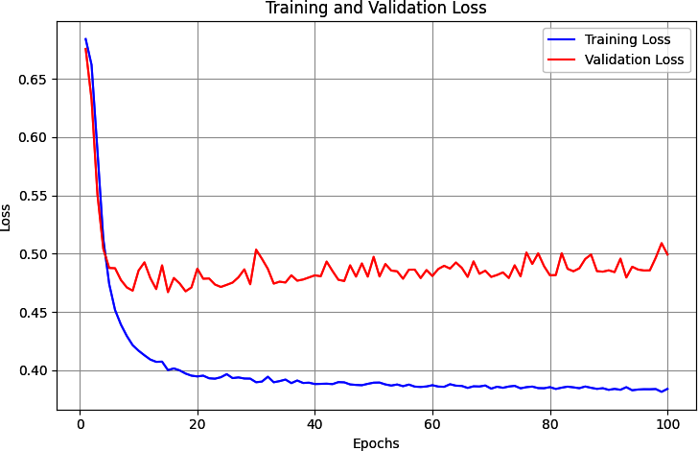

Figure 6-11. Training versus validation loss for seven dimensions

Now that the dimensionality has been reduced, we can do a bit more tweaking of the model architecture.

**Exploring the model architecture**

After the optimizations in the previous sections, the model architecture looks like this:

class TextClassificationModel(nn.Module):

def __init__(self, vocab_size, embedding_dim, hidden_dim=24):

super(TextClassificationModel, self).__init__()

self.embedding = nn.Embedding(vocab_size, embedding_dim)

self.global_pool = nn.AdaptiveAvgPool1d(1)

self.fc1 = nn.Linear(embedding_dim, hidden_dim)

self.fc2 = nn.Linear(hidden_dim, 1)

self.relu = nn.ReLU()

self.sigmoid = nn.Sigmoid()

One thing that comes to mind is the dimensionality—the GlobalAveragePooling1D layer now emits just 7 dimensions, but they’re being fed into a hidden layer of 24 neurons, which is overkill. Let’s explore what happens when this is reduced to 8 neurons and trained for 100 epochs.

You can see the training versus validation accuracy in [Figure 6-12](https://learning.oreilly.com/library/view/ai-and-ml/9781098199166/ch06.html#ch06_clean_figure_12_1748752380715093). When compared to [Figure 6-7](https://learning.oreilly.com/library/view/ai-and-ml/9781098199166/ch06.html#ch06_clean_figure_7_1748752380715045), where 24 neurons were used, the overall result is quite similar, but the model was somewhat faster to train.

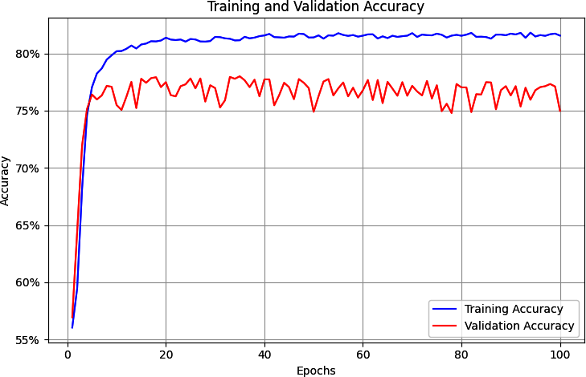

Figure 6-12. Reduced dense-architecture accuracy results

The loss curves in [Figure 6-13](https://learning.oreilly.com/library/view/ai-and-ml/9781098199166/ch06.html#ch06_clean_figure_13_1748752380715102) show similar results.

By following these exercises, we were able to reduce the model architecture significantly, reducing the number of parameters while improving the quality and mitigating overfitting. But there are a few more things we can do—starting with dropout.

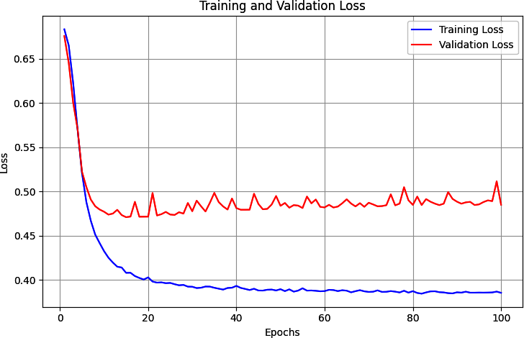

Figure 6-13. Reduced dense architecture loss results

**Using dropout**

A common technique for reducing overfitting is to add dropout to a dense neural network. We explored this for convolutional neural networks back in [Chapter 3](https://learning.oreilly.com/library/view/ai-and-ml/9781098199166/ch03.html#ch03_going_beyond_the_basics_detecting_features_in_ima_1748570891074912), so it’s tempting to go straight to it here to see its effects on overfitting. But in this case, I want to wait until the vocabulary size, embedding size, and architecture complexity have been addressed. Those changes can often have a much larger impact than using dropout, and we’ve already seen some nice results.

Now that our architecture has been simplified to have only eight neurons in the middle dense layer, the effect of dropout may be minimized—but let’s explore it anyway. Here’s the updated code for the model architecture to add a dropout of 0.25 (which equates to two of our eight neurons):

class TextClassificationModel(nn.Module):

def __init__(self, vocab_size, embedding_dim, hidden_dim=8,

**dropout_rate=0.25):**

super(TextClassificationModel, self).__init__()

self.embedding = nn.Embedding(vocab_size, embedding_dim)

self.global_pool = nn.AdaptiveAvgPool1d(1)

self.fc1 = nn.Linear(embedding_dim, hidden_dim)

self.dropout = nn.Dropout(p=dropout_rate) # Add dropout layer

self.fc2 = nn.Linear(hidden_dim, 1)

self.relu = nn.ReLU()

self.sigmoid = nn.Sigmoid()

def forward(self, x):

x = self.embedding(x)

x = x.transpose(1, 2) # Change for pooling layer

x = self.global_pool(x).squeeze(2)

**x = self.dropout**(self.relu(self.fc1(x)))

x = self.sigmoid(self.fc2(x))

return x

[Figure 6-14](https://learning.oreilly.com/library/view/ai-and-ml/9781098199166/ch06.html#ch06_clean_figure_14_1748752380715110) shows the accuracy results when trained for one hundred epochs. This time, we see that the training accuracy and validation accuracy are converging, with the training accuracy now lower than before. Similarly, the loss curves in [Figure 6-15](https://learning.oreilly.com/library/view/ai-and-ml/9781098199166/ch06.html#fig-6-15) show convergence, so while dropout is making our network a little *less* accurate, it appears to generalize it better.

But do exercise caution before declaring victory! A close examination of the curves shows that the losses have nicely converged but that they *are* higher than previously. The training loss is above 0.5 with dropout but was around 0.3 without. It is also trending downward, so it’s worth experimenting to see whether longer training will produce a better result.

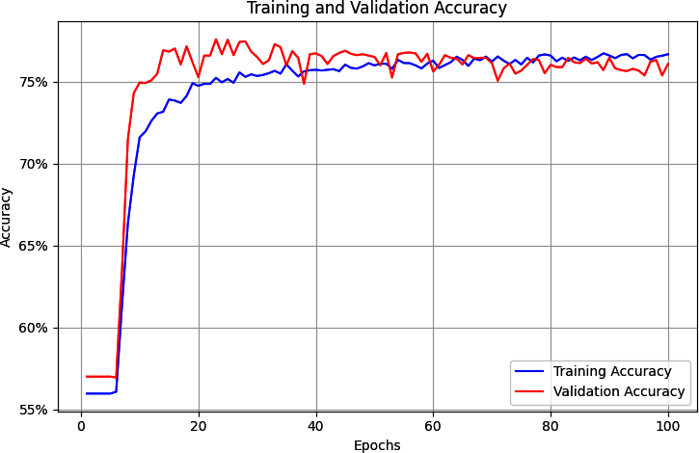

Figure 6-14. Accuracy with added dropout

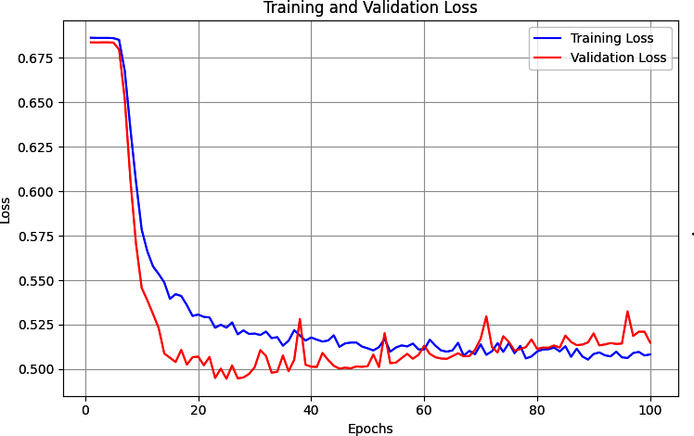

Figure 6-15. Loss with added dropout

You can also see that the model is heading back to its previous pattern of increasing validation loss over time. It’s not nearly as bad as before, but it’s heading in the wrong direction.

In this case, when there were very few neurons, introducing dropout probably wasn’t the right idea. It’s still good to have this tool in your arsenal, though, so be sure to keep it in mind for more sophisticated architectures than this one.

**Using regularization**

*Regularization* is a technique that helps prevent overfitting by reducing the polarization of weights. If the weights on some of the neurons are too heavy, regularization effectively punishes them. Broadly speaking, there are two types of regularization:

*L1 regularization*

This is often called *least absolute shrinkage* and *selection operator* (*lasso*) regularization. It effectively helps us ignore the zero or close-to-zero weights when calculating a result in a layer.

*L2 regularization*

This is often called *ridge* regression because it pushes values apart by taking their squares. This tends to amplify the differences between nonzero values and zero or close-to-zero ones, creating a ridge effect.

The two approaches can also be combined into what is sometimes called *elastic* regularization.

For NLP problems like the one we’re considering, L2 is most commonly used. It can be added as the weight_decay attribute to the optimizer. Here’s an example:

optimizer = optim.Adam(model.parameters(), lr=0.001, betas=(0.9, 0.999),

amsgrad=False, **weight_decay=0.01**)

This will apply the weight_decay of 0.01. (Usually, you’ll have a value between 0.01 and 0.001 here). Alternatively, a neat trick you can do with PyTorch is to define different weight decays for different layers by specifying them within the Adam declaration call, like this:

# Different weight decay for different layers

optimizer = torch.optim.Adam([

# L2 reg on fc1

{'params': model.fc1.parameters(), 'weight_decay': 0.01},

# No L2 reg on other layers

{'params': [p for name, p in model.named_parameters()

if 'fc1' not in name]}

], lr=0.0001)

The impact of adding regularization in a simple model like this isn’t particularly large, but it does smooth out our training loss and validation loss somewhat. It might be overkill for this scenario, but as with dropout, it’s a good idea to understand how to use regularization to prevent your model from getting overspecialized.

**Other optimization considerations**

While the modifications we’ve made have given us a much-improved model with less overfitting, there are other hyperparameters that you can experiment with. For example, we chose to make the maximum sentence length one hundred words, but that was purely arbitrary and probably not optimal. It’s a good idea to explore the corpus and see what a better sentence length might be. Here’s a snippet of code that looks at the sentences and plots the lengths of each one, sorted from low to high:

xs=[]

ys=[]

current_item=1

for item in sentences:

xs.append(current_item)

current_item=current_item+1

ys.append(len(item))

newys = sorted(ys)

import matplotlib.pyplot as plt

plt.plot(xs,newys)

plt.show()

See [Figure 6-16](https://learning.oreilly.com/library/view/ai-and-ml/9781098199166/ch06.html#ch06_clean_figure_15_1748752380715124) for the results of this.

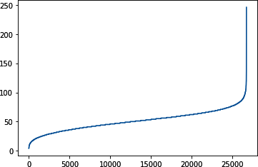

Figure 6-16. Exploring sentence length

Less than 200 sentences in the total corpus of 26,000+ have a length of 100 words or greater, so by choosing this as the maximum length, we’re introducing a lot of padding that isn’t necessary and thus affecting the model’s performance. Reducing the maximum to 85 words would still keep 26,000 of the sentences (99%+) with greatly reduced padding.

**Putting It All Together**

Taking all of the preceding optimizations into effect and retraining the model for three hundred epochs gives you the results in [Figure 6-17](https://learning.oreilly.com/library/view/ai-and-ml/9781098199166/ch06.html#ch06_clean_figure_16_1748752380715140) for training and validation accuracies. Given that their curves are roughly matched, it shows that we’ve taken huge steps toward avoiding overfitting and that we have a network that’s learning effectively.

Similarly, the training and validation loss curves over three hundred epochs are showing remarkable similarity, as depicted in [Figure 6-18](https://learning.oreilly.com/library/view/ai-and-ml/9781098199166/ch06.html#ch06_clean_figure_17_1748752380715155), which indicates that the optimizations are a step in the right direction to prevent overfitting for this model.

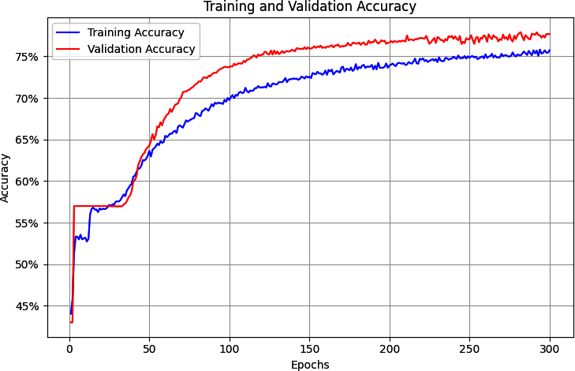

Figure 6-17. Optimized training and validation accuracy

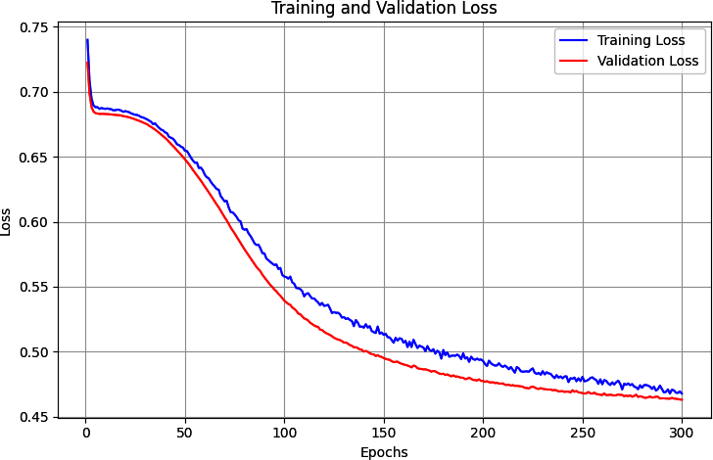

Figure 6-18. Optimized training and validation loss

**Using the Model to Classify a Sentence**

Now that you’ve created the model, trained it, and optimized it to remove a lot of the problems that caused the overfitting, the next step is to run the model and inspect its results. To do this, you’ll create an array of new sentences. Consider, for example:

test_sentences = [

"granny starting to fear spiders in the garden might be real",

"game of thrones season finale showing this sunday night",

"PyTorch book will be a best seller"]

You can then encode these by using the same tokenizer that you used when creating the vocabulary for training:

print(texts_to_sequences(test_sentences, word_index))

It’s important to use this tokenizer because it has the tokens for the words that the network was trained on!

The output of the print statement will be the sequences for the preceding sentences:

[

[1, 803, 753, 1, 1, 312, 97],

[123, 1183, 160, 1, 1, 1543, 152],

[1, 235, 7, 47, 1]

]

There are a lot of 1 tokens here (“<OOV>”), because words like *granny* and *spiders* don’t appear in the dictionary. The sequences are also shorter because the stopwords have been removed.

Next, before you can pass the sequences to the model, you’ll need to put them in the shape that the model expects—that is, the desired length. You can do this with pad_sequences in the same way you did when training the model:

padded = pad_sequences(sequences, max_len)

This will output the sentences as sequences of length 85, so the output for the first sequence will be as follows:

[1, 803, 753, 1, 1, 312, 97, 0, 0, 0, 0, 0, 0, 0, 0, 0, 0, 0, 0, 0, 0, 0, 0, 0,

0, 0, 0, 0, 0, 0, 0, 0, 0, 0, 0, 0, 0, 0, 0, 0, 0, 0, 0, 0, 0, 0, 0, 0, 0, 0, 0,

0, 0, 0, 0, 0, 0, 0, 0, 0, 0, 0, 0, 0, 0, 0, 0, 0, 0, 0, 0, 0, 0, 0, 0, 0, 0, 0,

0, 0, 0, 0, 0, 0, 0]

It was a very short sentence, so it’s padded up to 85 characters with a lot of zeros!

Now that you’ve padded and tokenized the sentences to fit the model’s expectations for the input dimensions, it’s time to pass them to the model and get predictions back.

This involves multiple steps. First, convert the padded sequence into an input tensor:

# Convert to tensor

input_ids = torch.tensor(padded, dtype=torch.long).to(device)

Next, put the model into evaluation mode to get the predictions, and then simply pass the input_ids to it to get the outputs:

# Get predictions

model.eval()

with torch.no_grad():

outputs = model(input_ids)

The results will be passed back as a list and printed, with high values indicating likely sarcasm. Here are the results for our sample sentences:

tensor([[0.5516],

[0.0765],

[0.0987]], device='cuda:0')

The high score for the first sentence (“granny starting to fear spiders in the garden might be real”), despite it having a lot of stopwords and being padded with a lot of zeros, indicates that there is a level of sarcasm there. The other two sentences scored much lower, indicating a lower likelihood of sarcasm in them.

To get the probabilities, you can call the squeeze() method to retrieve the tensor values. And if you want to make a comparison to a threshold to get your prediction—for example, above 0.5 indicates sarcasm and below 0.5 indicates no sarcasm—then you can use code like this:

probabilities = outputs.squeeze().cpu().numpy()

predictions = (probabilities >= threshold).astype(int)

Based on your network tuning, you could also establish what you think the appropriate threshold should be. Running this with a 0.5 threshold gives us the following:

Text: granny starting to fear spiders in the garden might be real

Probability: 0.5516

Classification: **Sarcastic**

Confidence: 0.5516

--------------------------------------------------------------------------

Text: game of thrones season finale showing this sunday night

Probability: 0.0765

Classification: Not Sarcastic

Confidence: 0.9235

--------------------------------------------------------------------------

Text: PyTorch book will be a best seller

Probability: 0.0987

Classification: **Not Sarcastic**

Confidence: 0.9013

--------------------------------------------------------------------------

So, with these test sentences, we’re beginning to get a good indication that our network is performing as desired. You should test it with other data to see if you can break it, and if you break it consistently, then it’ll be time to try a different model architecture, use transfer learning from an existing working network, or explore using pretrained embeddings.

We’ll learn about this in the next section, but before that, I’d like to show you how you can visualize the custom embeddings that this network learned.

Visualizing the Embeddings

To visualize embeddings, you can use an online tool called the [Embedding Projector](http://projector.tensorflow.org/). It comes preloaded with many existing datasets, but in this section, you’ll see how to take the data from the model you’ve just trained and visualize it by using this tool.

But first, you’ll need a function to reverse the word index. It currently has the word as the token and the key as the value, but you need to invert it so you’ll have word values to plot on the projector. Here’s the code to do this:

reverse_word_index = dict([(value, key)

for (key, value) in word_index.items()])

You’ll also need to extract the weights of the vectors in the embeddings:

embedding_weights = model.embedding.weight.data.cpu().numpy()

print(embedding_weights.shape)

If you’ve followed the optimizations in this chapter, the output of this will be (2000,7) because we used a 2,000 word vocabulary and 7 dimensions for the embedding. If you want to explore a word and its vector details, you can do so with code like this:

print(reverse_word_index[2])

print(embedding_weights[2])

This will produce the following output:

new

[–0.27116913 –1.3026129 1.6390767 0.4922502 –0.6025921 1.4584142

0.05054485]

So, the word *new* is represented by a vector with those seven coefficients on its axes.

The Embedding Projector uses two tab-separated values (TSV) files, one for the vector dimensions and one for metadata. This code will generate them for you:

import io

out_v = io.open('vecs.tsv', 'w', encoding='utf-8')

out_m = io.open('meta.tsv', 'w', encoding='utf-8')

for word_num in range(1, vocab_size):

word = reverse_word_index[word_num]

embeddings = embedding_weights[word_num]

out_m.write(word + "\n")

out_v.write('\t'.join([str(x) for x in embeddings]) + "\n")

out_v.close()

out_m.close()

Alternatively, if you are using Google Colab, you can download the TSV files with the following code or from the Files pane:

try:

from google.colab import files

except ImportError:

pass

else:

files.download('vecs.tsv')

files.download('meta.tsv')

Once you have the files, you can press the Load button on the projector to visualize the embeddings (see [Figure 6-19](https://learning.oreilly.com/library/view/ai-and-ml/9781098199166/ch06.html#ch06_clean_figure_18_1748752380715170)).

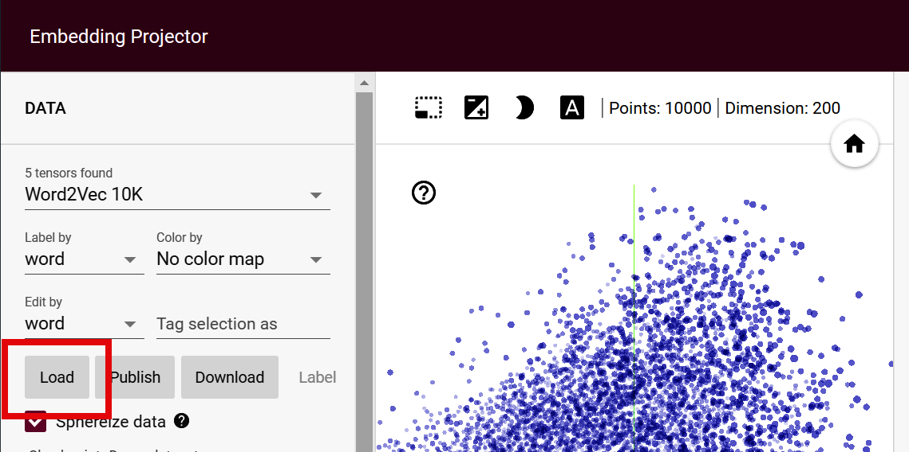

Figure 6-19. Using the Embeddings Projector

You can also use the vectors and meta TSV files where recommended in the resulting dialog and then click Sphereize Data on the projector. This will cause the words to be clustered in a sphere and will give you a clear visualization of the binary nature of this classifier. It’s only been trained on sarcastic and nonsarcastic sentences, so words tend to cluster toward one label or another (see [Figure 6-20](https://learning.oreilly.com/library/view/ai-and-ml/9781098199166/ch06.html#ch06_clean_figure_19_1748752380715184)).

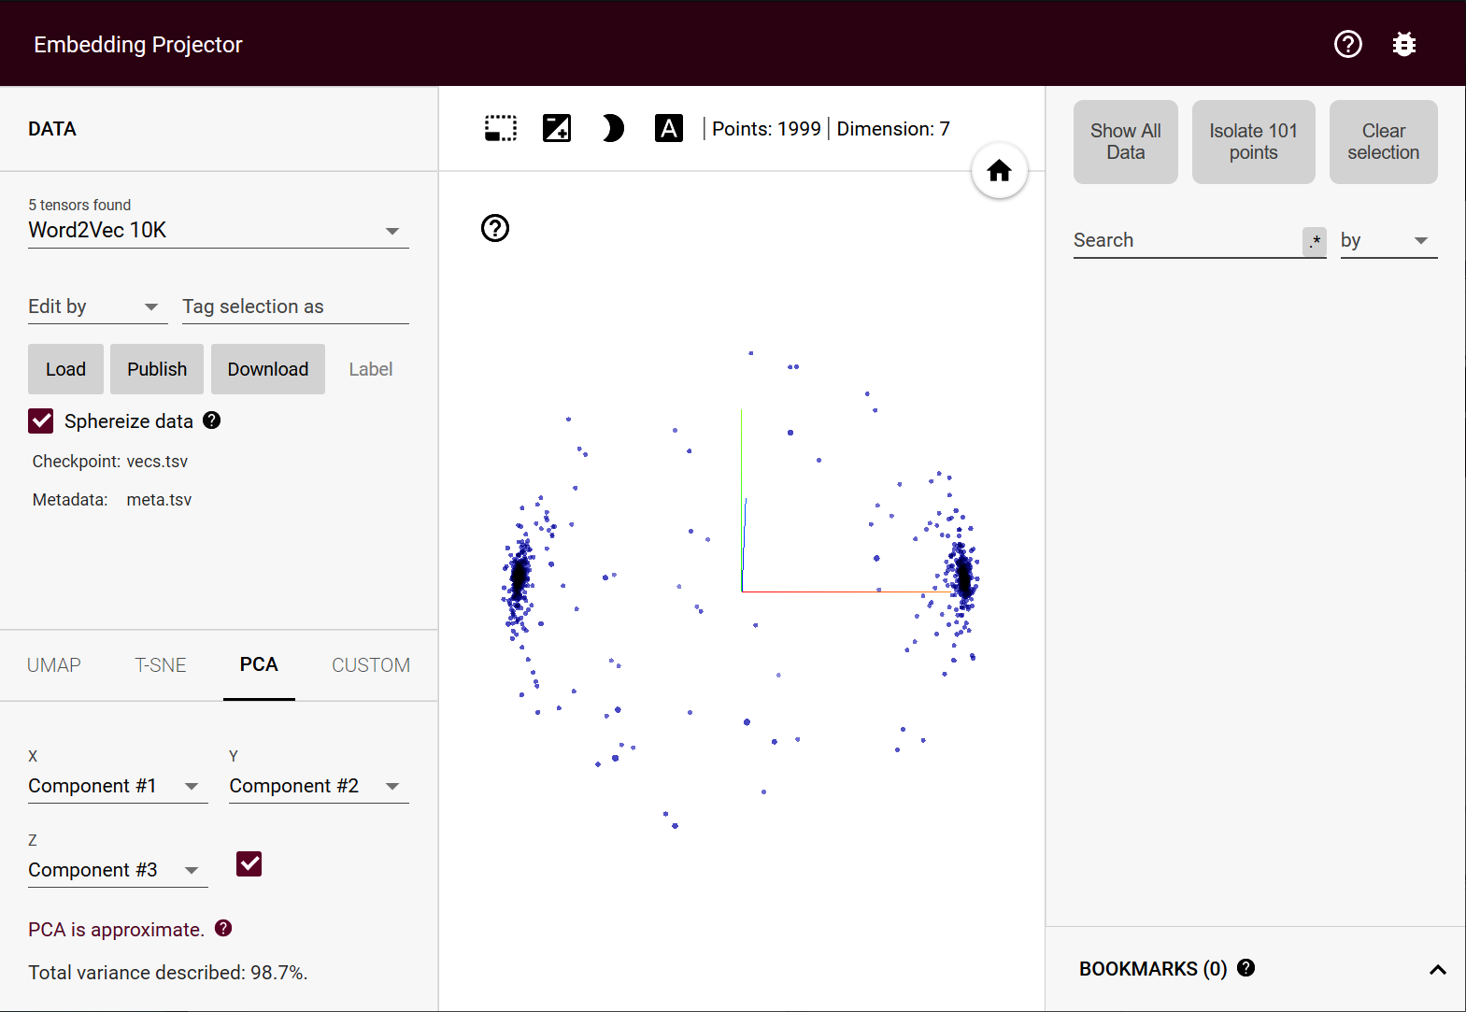

Figure 6-20. Visualizing the sarcasm embeddings

Screenshots don’t do all of this justice—you should try it for yourself! You can rotate the center sphere and explore the words on each “pole” to see the impact they have on the overall classification, and you can also select words and show related ones in the righthand pane. Have a play and experiment!

Using Pretrained Embeddings

An alternative to training your own embeddings is to use ones that have been pretrained by others on your behalf. There are many sources where you can find these, including Kaggle and Hugging Face. You can even find pretrained embeddings posted alongside research results. One such set of pretrained embeddings is the [Stanford GloVe embeddings](https://oreil.ly/s1YWw), and we’ll explore those here.

Note, however, that when using embeddings that have been pretrained, you should also consider updating and changing your tokenizer to match any rules used with the pretrained embeddings.

For example, with the GloVE pretrained embeddings—which simply comprise a large text file of words with their pretrained embedding in a number of dimensions from 50 to 300—the rules used to tokenize words are a little different from those for the handmade tokenizer we’ve been using for raw data. So, for GloVe, you should consider rules such as all of the words being lowercase or numbers being normalized to 0.

Once you’ve done this (I’ve provided code for GloVe in the downloads, and I discuss it in a little more detail in the next chapter), then it’s simply a matter of loading the weights of the pretrained embeddings to your model definition like this:

# Initialize embedding layer

self.embedding = nn.Embedding(vocab_size, embedding_dim)

# Load pretrained embeddings if provided

if pretrained_embeddings is not None:

self.embedding.weight.data.copy_(pretrained_embeddings)

if freeze_embeddings:

self.embedding.weight.requires_grad = False

If you don’t want to learn from these embeddings and you want to just use them, then you should set freeze_embeddings to True. Otherwise, the network will fine-tune by using the pre-loaded embedding weights as a starting point.

This model will rapidly reach peak accuracy in training, and it will not overfit as much as we saw previously. The accuracy over three hundred epochs shows that training and validation are very much in step with each other (see [Figure 6-22](https://learning.oreilly.com/library/view/ai-and-ml/9781098199166/ch06.html#ch06_clean_figure_21_1748752380715231)). The loss values are also in step, which shows that we are fitting very nicely over the first couple of hundred epochs. However, they also begin to diverge (see [Figure 6-22](https://learning.oreilly.com/library/view/ai-and-ml/9781098199166/ch06.html#ch06_clean_figure_21_1748752380715231)).

On the other hand, it is worth noting that the overall accuracy (at about 70%) is quite low, considering that a coin flip would have a 50% chance of getting it right! So, while using pretrained embeddings can make for much faster training with less overfitting, you should also understand what it is that they’re useful for and that they may not always be best for your scenario. You may therefore need to explore optimization methods or alternatives where appropriate.

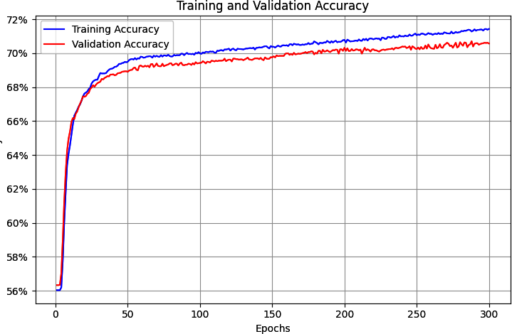

Figure 6-21. Accuracy metrics using GloVe embeddings

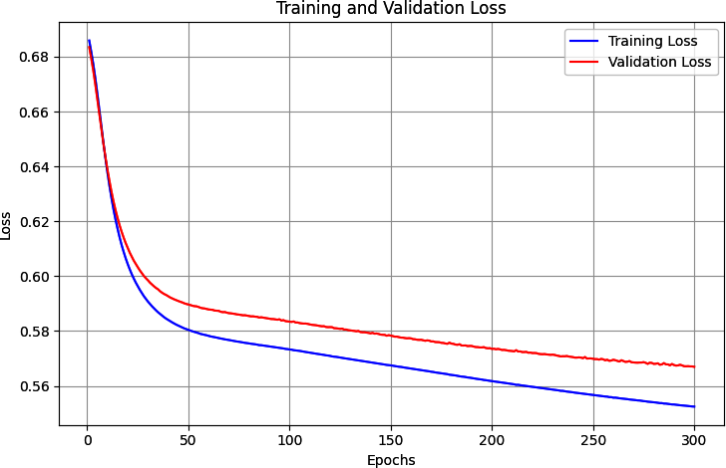

Figure 6-22. Loss metrics using GloVe embeddings

Summary

In this chapter, you built your first model that can understand sentiment in text. It did this by taking the tokenized text from [Chapter 5](https://learning.oreilly.com/library/view/ai-and-ml/9781098199166/ch05.html#ch05_introduction_to_natural_language_processing_1748549080743759) and mapping it to vectors. Then, using backpropagation, it learned the appropriate “direction” for each vector based on the label for the sentence containing it. Finally, it was able to use all of the vectors for a collection of words to build up an idea of the sentiment within the sentence.

You also explored ways to optimize your model to avoid overfitting, and you saw a neat visualization of the final vectors representing your words. But while this was a nice way to classify sentences, it simply treated each sentence as a bunch of words. There was no inherent sequence involved, and the order of appearance of words is very important in determining the real meaning of a sentence.

Therefore, it’s a good idea to see if we can improve our models by taking sequence into account. We’ll explore that in the next chapter with the introduction of a new layer type: a *recurrent* layer, which is the foundation of recurrent neural networks.

Chapter 7. Recurrent Neural Networks for Natural Language Processing

In [Chapter 5](https://learning.oreilly.com/library/view/ai-and-ml/9781098199166/ch05.html#ch05_introduction_to_natural_language_processing_1748549080743759), you saw how to tokenize and sequence text, turning sentences into tensors of numbers that could then be fed into a neural network. You then extended that in [Chapter 6](https://learning.oreilly.com/library/view/ai-and-ml/9781098199166/ch06.html#ch06_clean_making_sentiment_programmable_by_using_embeddings_1748752380728888) by looking at embeddings, which constitute a way to have words with similar meanings cluster together to enable the calculation of sentiment. This worked really well, as you saw by building a sarcasm classifier. But there’s a limitation to that: namely, sentences aren’t just collections of words—and often, the *order* in which the words appear will dictate their overall meaning. Also, adjectives can add to or change the meaning of the nouns they appear beside. For example, the word *blue* might be meaningless from a sentiment perspective, as might *sky*, but when you put them together to get *blue sky*, it indicates a clear sentiment that’s usually positive. Finally, some nouns may qualify others, such as in *rain cloud*, *writing desk*, and *coffee mug*.

To take sequences like this into account, you need to take an additional approach: you need to factor *recurrence* into the model architecture. In this chapter, you’ll look at different ways of doing this. We’ll explore how sequence information can be learned and how you can use this information to create a type of model that is better able to understand text: the *recurrent neural network* (RNN).

The Basis of Recurrence

To understand how recurrence might work, let’s first consider the limitations of the models used thus far in the book. Ultimately, creating a model looks a little bit like [Figure 7-1](https://learning.oreilly.com/library/view/ai-and-ml/9781098199166/ch07.html#ch07_figure_1_1748549654877957). You provide data and labels and define a model architecture, and the model learns the rules that fit the data to the labels. Those rules then become available to you as an application programming interface (API) that will give you back predicted labels for future data.

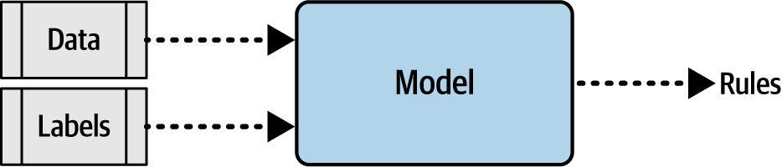

Figure 7-1. High-level view of model creation

But, as you can see, the data is lumped in wholesale. There’s no granularity involved and no effort to understand the sequence in which that data occurs. This means the words *blue* and *sky* have no different meaning in sentences such as, “Today I am blue, because the sky is gray,” and “Today I am happy, and there’s a beautiful blue sky.” To us, the difference in the use of these words is obvious, but to a model, with the architecture shown here, there really is no difference.

So, how do we fix this? Let’s first explore the nature of recurrence, and from there, you’ll be able to see how a basic RNN can work.

Consider the famous Fibonacci sequence of numbers. In case you aren’t familiar with it, I’ve put some of them into [Figure 7-2](https://learning.oreilly.com/library/view/ai-and-ml/9781098199166/ch07.html#ch07_figure_2_1748549654878009).



Figure 7-2. The first few numbers in the Fibonacci sequence

The idea behind this sequence is that every number is the sum of the two numbers preceding it. So if we start with 1 and 2, the next number is 1 + 2, which is 3. The one after that is 2 + 3, which is 5, and then there’s 3 + 5, which is 8, and so on.

We can place this in a computational graph to get [Figure 7-3](https://learning.oreilly.com/library/view/ai-and-ml/9781098199166/ch07.html#ch07_figure_3_1748549654878036).

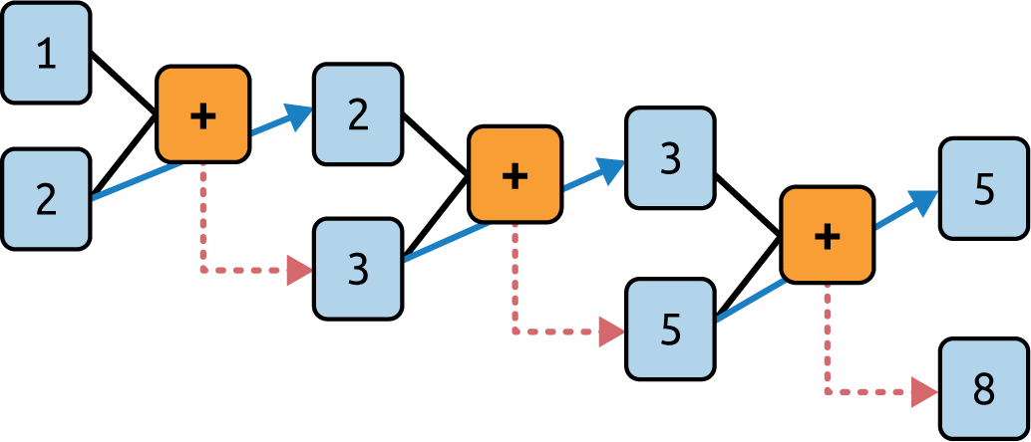

Figure 7-3. A computational graph representation of the Fibonacci sequence

Here, you can see that we feed 1 and 2 into the function and get 3 as the output. We then carry the second parameter (2) over to the next step and feed it into the function along with the output from the previous step (3). The output of this is 5, and it gets fed into the function with the second parameter from the previous step (3) to produce an output of 8. This process continues indefinitely, with every operation depending on those before it. The 1 at the top left sort of “survives” through the process—it’s an element of the 3 that gets fed into the second operation, it’s an element of the 5 that gets fed into the third operation, and so on. Thus, some of the essence of the 1 is preserved throughout the sequence, though its impact on the overall value is diminished.

This is analogous to how a recurrent neuron is architected. You can see the typical representation of a recurrent neuron in [Figure 7-4](https://learning.oreilly.com/library/view/ai-and-ml/9781098199166/ch07.html#ch07_figure_4_1748549654878060).

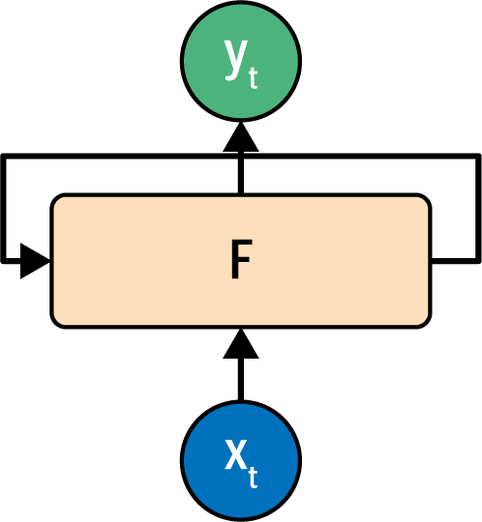

Figure 7-4. A recurrent neuron

A value *x* is fed into the function *F* at a time step, so it’s typically labeled *x****t***. This produces an output *y* at that time step, which is typically labeled *y****t***. It also produces a value that is fed forward to the next step, which is indicated by the arrow from *F* to itself.

This is made a little clearer if you look at how recurrent neurons work beside one another across time steps, which you can see in [Figure 7-5](https://learning.oreilly.com/library/view/ai-and-ml/9781098199166/ch07.html#ch07_figure_5_1748549654878082).

Here, *x***0** is operated on to get *y***0** and a value that’s passed forward. The next step gets that value and *x***1** and produces *y***1** and a value that’s passed forward. The next one gets that value and *x***2** and produces *y***2** and a passed-forward value, and so on down the line. This is similar to what we saw with the Fibonacci sequence, and I always find it to be a handy mnemonic when trying to remember how an RNN works.

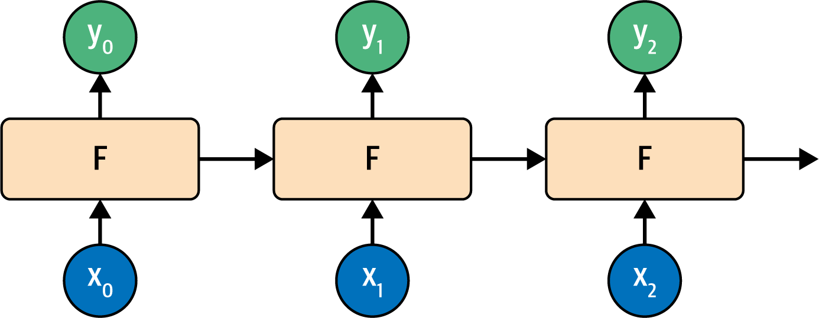

Figure 7-5. Recurrent neurons in time steps

Extending Recurrence for Language

In the previous section, you saw how an RNN operating over several time steps can help maintain context across a sequence. Indeed, we’ll use RNNs for sequence modeling later in this book—but there’s a nuance when it comes to language that you can miss when using a simple RNN like those shown in [Figure 7-4](https://learning.oreilly.com/library/view/ai-and-ml/9781098199166/ch07.html#ch07_figure_4_1748549654878060) and [Figure 7-5](https://learning.oreilly.com/library/view/ai-and-ml/9781098199166/ch07.html#ch07_figure_5_1748549654878082). As in the Fibonacci sequence example mentioned earlier, the amount of context that’s carried over will diminish over time. The effect of the output of the neuron at step 1 is huge at step 2, smaller at step 3, smaller still at step 4, and so on. So, if we have a sentence like “Today has a beautiful blue <something>,” the word *blue* will have a strong impact on what the next word could be: we can guess that it’s likely to be *sky*. But what about context that comes from earlier in a sentence? For example, consider the sentence “I lived in Ireland, so in high school, I had to learn how to speak and write <something>.”

That <something> is *Gaelic*, but the word that really gives us that context is *Ireland*, which is much earlier in the sentence. Thus, for us to be able to recognize what <something> should be, we need a way to preserve context across a longer distance. The short-term memory of an RNN needs to get longer, and in recognition of this, an enhancement to the architecture called *long short-term memory* (LSTM) was invented.

While I won’t go into detail on the underlying architecture of how LSTMs work, the high-level diagram shown in [Figure 7-6](https://learning.oreilly.com/library/view/ai-and-ml/9781098199166/ch07.html#ch07_figure_6_1748549654878103) gets the main point across. To learn more about the internal operations of LSTM, check out Christopher Olah’s excellent [blog post on the subject](https://oreil.ly/6KcFA).

The LSTM architecture enhances the basic RNN by adding a “cell state” that enables context to be maintained not just from step to step but across the entire sequence of steps. Remembering that these are neurons that learn in the way neurons do, you can see that this enhancement ensures that the context that is important will be learned over time.

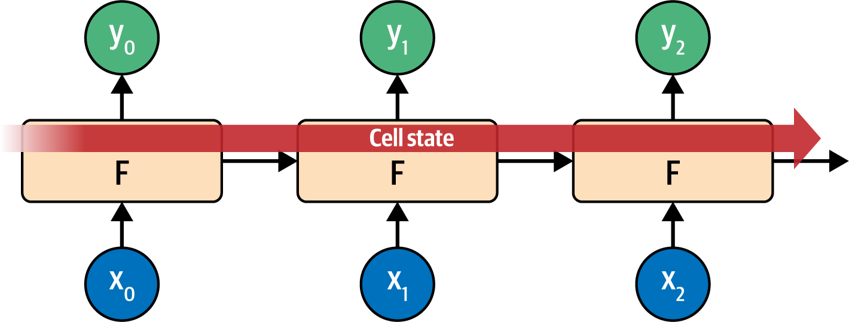

Figure 7-6. High-level view of LSTM architecture

An important part of an LSTM is that it can be *bidirectional*—the time steps can be iterated both forward and backward so that context can be learned in both directions. Often, context for a word can come *after* it in the sentence and not just before.

See [Figure 7-7](https://learning.oreilly.com/library/view/ai-and-ml/9781098199166/ch07.html#ch07_figure_7_1748549654878124) for a high-level view of this.

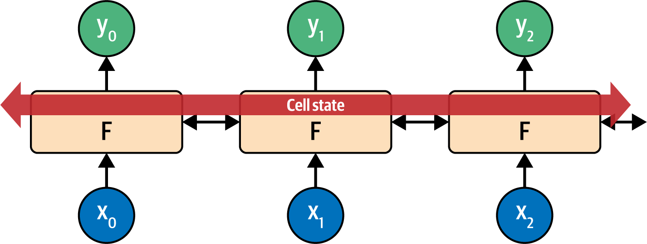

Figure 7-7. High-level view of LSTM bidirectional architecture

This is how evaluation in the direction from 0 to number_of_steps is done, and it’s also how evaluation from number_of_steps to 0 is done. At each step, the *y* result is an aggregation of the “forward” pass and the “backward” pass. You can see this in [Figure 7-8](https://learning.oreilly.com/library/view/ai-and-ml/9781098199166/ch07.html#ch07_figure_8_1748549654878143).

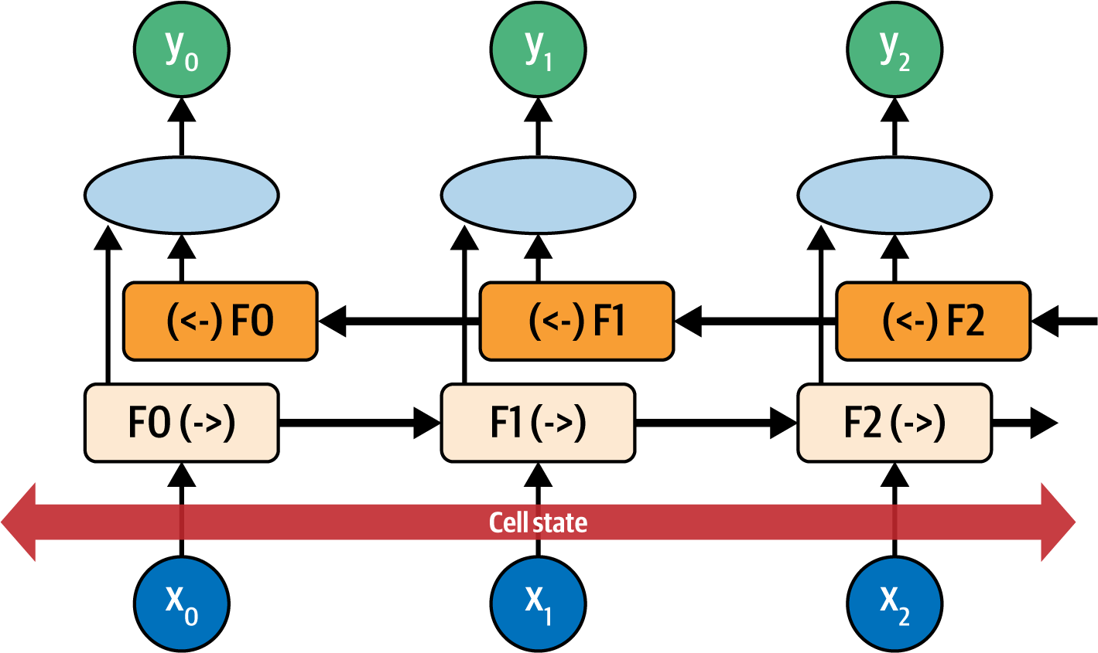

Figure 7-8. Bidirectional LSTM

It’s easy to confuse the bidirectional nature of the LSTM with the terms *forward* and *backward* when it comes to the training of the network, but they’re very different. When I refer to the forward and backward pass, I’m referring to the setting of the parameters of the neurons and their updating from the learning process, respectively. Don’t confuse this with the values that the LSTM is paying attention to as being the next or previous tokens in the sequence.

Also, consider each neuron at each time step to be F0, F1, F2, etc. The direction of the time step is shown, so the calculation at F1 in the forward direction is F1(->), and in the reverse direction, it’s (<-)F1. The values of these are aggregated to give the *y* value for that time step. Additionally, the cell state is bidirectional, and this can be really useful for managing context in sentences. Again, considering the sentence “I lived in Ireland, so in high school, I had to learn how to speak and write <something>,” you can see how the <something> was qualified to be *Gaelic* by the context word *Ireland*. But what if it were the other way around: “I lived in <this country>, so in high school, I had to learn how to speak and write Gaelic”? You can see that by going *backward* through the sentence, we can learn about what <this country> should be. Thus, using bidirectional LSTMs can be very powerful for understanding sentiment in text. (And as you’ll see in [Chapter 8](https://learning.oreilly.com/library/view/ai-and-ml/9781098199166/ch08.html#ch08_using_ml_to_create_text_1748549671852453), they’re really powerful for generating text, too!)

Of course, there’s a lot going on with LSTMs, in particular bidirectional ones, so expect training to be slow. Here’s where it’s worth investing in a GPU or at the very least using a hosted one in Google Colab if you can.

Creating a Text Classifier with RNNs

In [Chapter 6](https://learning.oreilly.com/library/view/ai-and-ml/9781098199166/ch06.html#ch06_clean_making_sentiment_programmable_by_using_embeddings_1748752380728888), you experimented with creating a classifier for the Sarcasm dataset by using embeddings. In that case, you turn words into vectors before aggregating them and then feeding them into dense layers for classification. But when you’re using an RNN layer such as an LSTM, you don’t do the aggregation, and you can feed the output of the embedding layer directly into the recurrent layer. When it comes to the dimensionality of the recurrent layer, a rule of thumb you’ll often see is that it’s the same size as the embedding dimension. This isn’t necessary, but it can be a good starting point. Also note that while in [Chapter 6](https://learning.oreilly.com/library/view/ai-and-ml/9781098199166/ch06.html#ch06_clean_making_sentiment_programmable_by_using_embeddings_1748752380728888) I mentioned that the embedding dimension is often the fourth root of the size of the vocabulary, when using RNNs, you’ll often see that that rule may be ignored because it would make the size of the recurrent layer too small.

For this example, I have used the number of neurons in the hidden layer as a starting point, and you can experiment from there.

So, for example, you could update the simple model architecture for the sarcasm classifier you developed in [Chapter 6](https://learning.oreilly.com/library/view/ai-and-ml/9781098199166/ch06.html#ch06_clean_making_sentiment_programmable_by_using_embeddings_1748752380728888) to the following to use a bidirectional LSTM:

class TextClassificationModel(nn.Module):

def __init__(self, vocab_size, embedding_dim,

hidden_dim=24, lstm_layers=1):

super(TextClassificationModel, self).__init__()

# Embedding layer

self.embedding = nn.Embedding(vocab_size, embedding_dim)

# LSTM layer

self.lstm = nn.LSTM(

input_size=embedding_dim,

hidden_size=hidden_dim,

num_layers=lstm_layers,

batch_first=True,

bidirectional=True

)

# Global pooling

self.global_pool = nn.AdaptiveAvgPool1d(1)

# Fully connected layers

self.fc1 = nn.Linear(hidden_dim * 2, hidden_dim)

self.fc2 = nn.Linear(hidden_dim, 1)

# Activation functions

self.relu = nn.ReLU()

self.sigmoid = nn.Sigmoid()

def forward(self, x):

# x shape: (batch_size, sequence_length)

# Get embeddings

embedded = self.embedding(x)

# Shape: (batch_size, sequence_length, embedding_dim)

# Pass through LSTM

lstm_out, _ = self.lstm(embedded)

# Shape: (batch_size, sequence_length, hidden_dim)

# Transpose for global pooling

# (expecting: batch, channels, sequence_length)

lstm_out = lstm_out.transpose(1, 2)

# Shape: (batch_size, hidden_dim, sequence_length)

# Apply global pooling

pooled = self.global_pool(lstm_out)

# Shape: (batch_size, hidden_dim, 1)

pooled = pooled.squeeze(–1) # Shape: (batch_size, hidden_dim)

# Pass through fully connected layers

x = self.relu(self.fc1(pooled))

x = self.sigmoid(self.fc2(x))

return x

You can then set the loss function and classifier to this. (Note that the LR is 0.001, or 1e–3.):

# Define loss function and optimizer

criterion = nn.BCELoss()

optimizer = optim.Adam(model.parameters(), lr=0.001,

betas=(0.9, 0.999), amsgrad=False)

When you print out the model architecture summary, you’ll see something like the following:

==========================================================================

Layer (type:depth-idx) Output Shape Param #

==========================================================================

TextClassificationModel [32, 1] --

├─Embedding: 1-1 [32, 85, 7] 14,000

├─LSTM: 1-2 [32, 85, 48] 6,336

├─AdaptiveAvgPool1d: 1-3 [32, 48, 1] --

├─Linear: 1-4 [32, 24] 1,176

├─ReLU: 1-5 [32, 24] --

├─Linear: 1-6 [32, 1] 25

├─Sigmoid: 1-7 [32, 1] --

==========================================================================

Total params: 21,537

Trainable params: 21,537

Non-trainable params: 0

Total mult-adds (M): 17.72

==========================================================================

Input size (MB): 0.02

Forward/backward pass size (MB): 1.20

Params size (MB): 0.09

Estimated Total Size (MB): 1.31

==========================================================================

Note that the vocab size is 2,000 and the embedding dimension is 7. This gives 14,000 parameters in the embedding layer, and the bidirectional layer will have 48 neurons (24 out, 24 back) with a sequence length of 85 characters

[Figure 7-9](https://learning.oreilly.com/library/view/ai-and-ml/9781098199166/ch07.html#ch07_figure_9_1748549654878164) shows the results of training with this over three hundred epochs.

This gives us a network with only 21,537 parameters. As you can see, the accuracy of the network on training data rapidly climbs toward 85%, but the validation data plateaus at around 75%. This is similar to the figures we got earlier, but inspecting the loss chart in [Figure 7-10](https://learning.oreilly.com/library/view/ai-and-ml/9781098199166/ch07.html#ch07_figure_10_1748549654878185) shows that while the loss for the test set diverged after 15 epochs, the validation loss turned to increase, indicating we have overfitting.

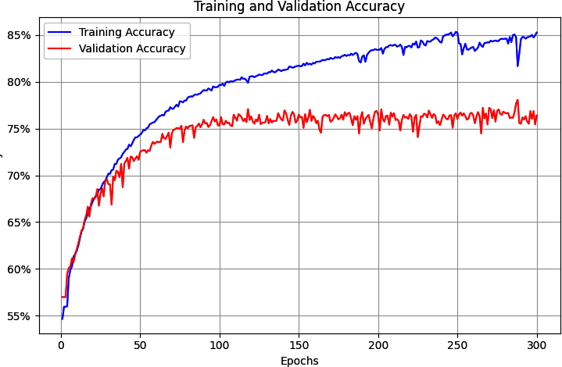

Figure 7-9. Accuracy for LSTM over 30 epochs

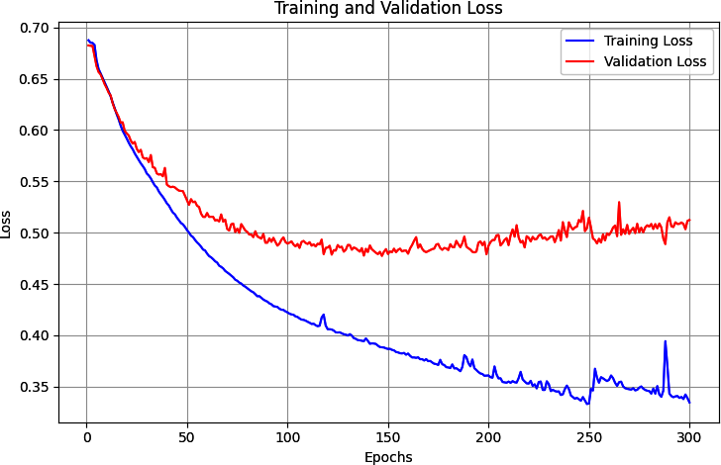

Figure 7-10. Loss with LSTM over 30 epochs

However, this was just using a single LSTM layer with a hidden layer of 24 neurons. In the next section, you’ll see how to use stacked LSTMs and explore the impact on the accuracy of classifying this dataset.

**Stacking LSTMs**

In the previous section, you saw how to use an LSTM layer after the embedding layer to help classify the contents of the sarcasm dataset. But LSTMs can be stacked on top of one another, and this approach is used in many state-of-the-art NLP models.

Stacking LSTMs with PyTorch is pretty straightforward. You add them as extra layers just like you would with any other layer, but you will need to be careful in specifying the dimensions. So, for example, if the first LSTM has *x* number of hidden layers, then the next LSTM will have *x*number of inputs. If the LST is bidirectional, then the next will need to double the size. Here’s an example:

# First LSTM layer

self.lstm1 = nn.LSTM(

input_size=embedding_dim,

hidden_size=hidden_dim,

num_layers=lstm_layers,

batch_first=True,

bidirectional=True

)

# Second LSTM layer

# Note: Input size is hidden_dim*2 because first LSTM is bidirectional.

self.lstm2 = nn.LSTM(

input_size=hidden_dim * 2,

hidden_size=hidden_dim,

num_layers=lstm_layers,

batch_first=True,

bidirectional=True

)

Note that the input_size for the first layer is the embedding dimension because it’s preceded by the embedding layer. The second LSTM then has its input size as (hidden_dim * 2) because the output from the first LSTM is that size, given that it’s bidirectional.

The model architecture will look like this:

==========================================================================

Layer (type:depth-idx) Output Shape Param #

==========================================================================

TextClassificationModel [32, 1] --

├─Embedding: 1-1 [32, 85, 7] 14,000

├─LSTM: 1-2 [32, 85, 48] 6,336

├─LSTM: 1-3 [32, 85, 48] 14,208

├─AdaptiveAvgPool1d: 1-4 [32, 48, 1] --

├─Linear: 1-5 [32, 24] 1,176

├─ReLU: 1-6 [32, 24] --

├─Linear: 1-7 [32, 1] 25

├─Sigmoid: 1-8 [32, 1] --

==========================================================================

Total params: 35,745

Trainable params: 35,745

Non-trainable params: 0

Total mult-adds (M): 56.37

==========================================================================

Input size (MB): 0.02

Forward/backward pass size (MB): 2.25

Params size (MB): 0.14

Estimated Total Size (MB): 2.41

==========================================================================

Adding the extra layer will give us roughly 14,000 extra parameters that need to be learned, which is an increase of about 75%. So, it might slow the network down, but the cost is relatively low if there’s a reasonable benefit.

After training for three hundred epochs, the result looks like [Figure 7-11](https://learning.oreilly.com/library/view/ai-and-ml/9781098199166/ch07.html#ch07_figure_11_1748549654878205). While the accuracy on the validation set is flat, examining the loss (shown in [Figure 7-12](https://learning.oreilly.com/library/view/ai-and-ml/9781098199166/ch07.html#ch07_figure_12_1748549654878225)) tells a different story. As you can see in [Figure 7-12](https://learning.oreilly.com/library/view/ai-and-ml/9781098199166/ch07.html#ch07_figure_12_1748549654878225), while the accuracy for both training and validation looked good, the validation loss quickly took off upward, which is a clear sign of overfitting.

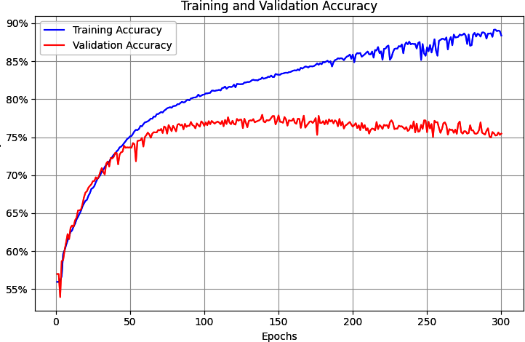

Figure 7-11. Accuracy for stacked LSTM architecture

This overfitting (which is indicated by the training accuracy climbing toward 100% as the loss falls smoothly while the validation accuracy is relatively steady and the loss increases drastically) is a result of the model getting overspecialized for the training set. As with the examples in [Chapter 6](https://learning.oreilly.com/library/view/ai-and-ml/9781098199166/ch06.html#ch06_clean_making_sentiment_programmable_by_using_embeddings_1748752380728888), this shows that it’s easy to be lulled into a false sense of security if you just look at the accuracy metrics without examining the loss.

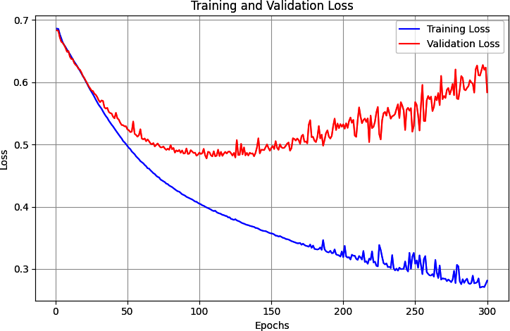

Figure 7-12. Loss for stacked LSTM architecture

**Optimizing stacked LSTMs**

In [Chapter 6](https://learning.oreilly.com/library/view/ai-and-ml/9781098199166/ch06.html#ch06_clean_making_sentiment_programmable_by_using_embeddings_1748752380728888), you saw that a very effective method of reducing overfitting was to reduce the LR. It’s worth exploring here whether that will have a positive effect on an RNN, too.

For example, the following code reduces the LR by 50%, from 0.0001 to 0.00005:

# Define loss function and optimizer

criterion = nn.BCELoss()

optimizer = optim.Adam(model.parameters(), **lr=0.00005**,

betas=(0.9, 0.999), amsgrad=False)

[Figure 7-13](https://learning.oreilly.com/library/view/ai-and-ml/9781098199166/ch07.html#ch07_figure_13_1748549654878247) demonstrates the impact of this on training. As you can see, there’s a small difference in the validation accuracy, indicating that we’re overfitting a bit less.

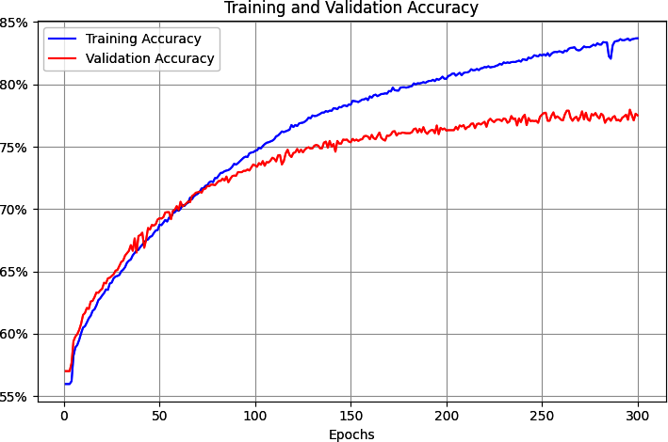

Figure 7-13. Impact of reduced LR on accuracy with stacked LSTMs

While an initial look at [Figure 7-14](https://learning.oreilly.com/library/view/ai-and-ml/9781098199166/ch07.html#ch07_figure_14_1748549654878268) similarly suggests a decent impact on loss due to the reduced LR, with the curve not moving up so sharply, it’s worth looking a little closer. We see that the loss on the training set is actually a little higher (~0.35 versus ~0.27) than the previous example, while the loss on the validation set is lower (~0.5 versus 0.6).

Adjusting the LR hyperparameter certainly seems worth investigation.

Indeed, further experimentation with the LR showed a marked improvement in getting training and validation curves to converge, indicating that while the network was less accurate after training, we could tell that it was generalizing better. Figures [7-15](https://learning.oreilly.com/library/view/ai-and-ml/9781098199166/ch07.html#ch07_figure_15_1748549654878288) and [7-16](https://learning.oreilly.com/library/view/ai-and-ml/9781098199166/ch07.html#ch07_figure_16_1748549654878310) show the impact of using a lower LR (.0003 rather than .0005).

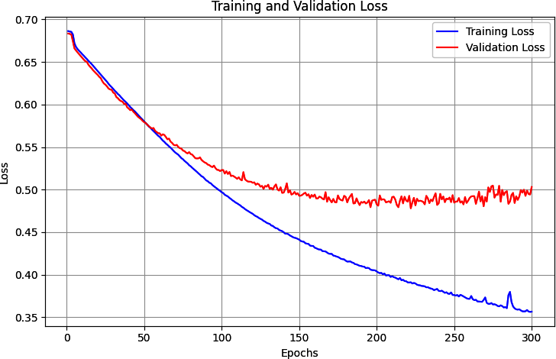

Figure 7-14. Impact of reduced LR on loss with stacked LSTMs

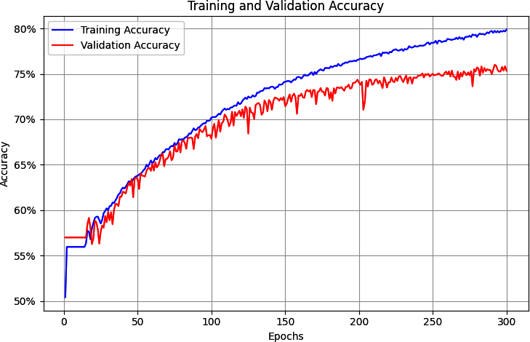

Figure 7-15. Accuracy with further-reduced LR with stacked LSTM

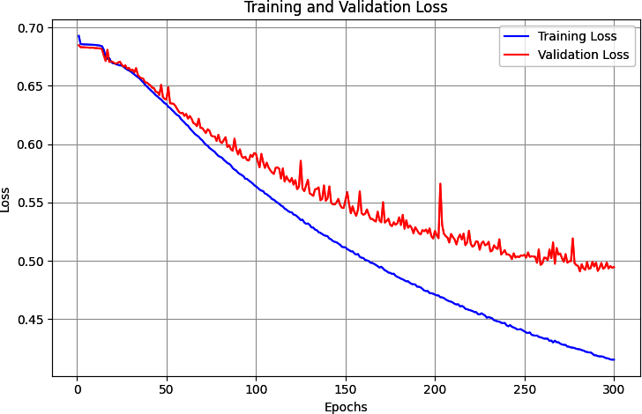

Figure 7-16. Loss with further-reduced LR and stacked LSTM

Indeed, reducing the LR even further, to .00001, gave potentially even better results, as shown in Figures [7-17](https://learning.oreilly.com/library/view/ai-and-ml/9781098199166/ch07.html#ch07_figure_17_1748549654878331) and [7-18](https://learning.oreilly.com/library/view/ai-and-ml/9781098199166/ch07.html#ch07_figure_18_1748549654878358). As with the previous diagrams, while the overall accuracy isn’t as good and the loss is higher, that’s an indication that we’re getting closer to a “realistic” result for this network architecture and not being led into having a false sense of security by overfitting on the training data.

In addition to changing the LR parameter, you should also consider using dropout in the LSTM layers. It works exactly the same as for dense layers, as discussed in [Chapter 3](https://learning.oreilly.com/library/view/ai-and-ml/9781098199166/ch03.html#ch03_going_beyond_the_basics_detecting_features_in_ima_1748570891074912), where random neurons are dropped to prevent a proximity bias from impacting the learning. That being said, you should be careful about setting it *too* low, because when you start tweaking with different architectures, you might freeze the ability of the network to learn.

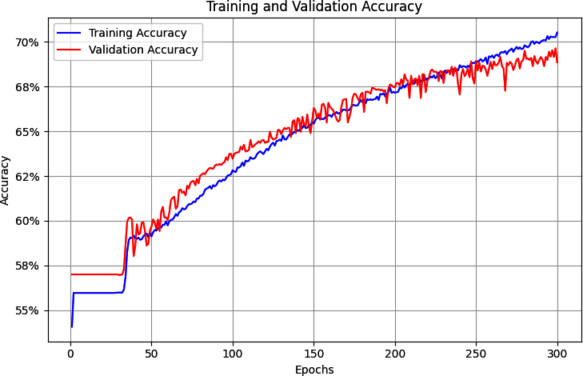

Figure 7-17. Accuracy with lower LR

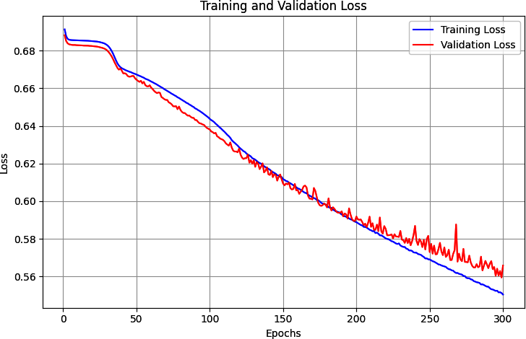

Figure 7-18. Loss with lower LR

**Using dropout**

In addition to changing the LR parameter, you should also consider using dropout in the LSTM layers. It works exactly the same as for dense layers, as discussed in [Chapter 3](https://learning.oreilly.com/library/view/ai-and-ml/9781098199166/ch03.html#ch03_going_beyond_the_basics_detecting_features_in_ima_1748570891074912), where random neurons are dropped to prevent a proximity bias from impacting the learning.

You can implement dropout by using nn.Dropout. Here’s an example:

self.embedding_dropout = nn.Dropout(dropout_rate)

self.lstm_dropout = nn.Dropout(dropout_rate)

self.final_dropout = nn.Dropout(dropout_rate)

Then, in your forward pass, you can apply the dropouts at the appropriate levels, like this:

def forward(self, x):

# Get embeddings

embedded = self.embedding(x)

# Apply first dropout after embedding layer

embedded = self.embedding_dropout(embedded)

lstm1_out, _ = self.lstm1(embedded)

# Apply dropout between LSTM layers

lstm1_out = self.lstm_dropout(lstm1_out)

lstm2_out, _ = self.lstm2(lstm1_out)

# Apply final dropout

lstm2_out = self.final_dropout(lstm2_out)

lstm_out = lstm2_out.transpose(1, 2)

pooled = self.global_pool(lstm_out)

pooled = pooled.squeeze(–1)

x = self.relu(self.fc1(pooled))

x = self.sigmoid(self.fc2(x))

return x

When I ran this with the lowest LR I had tested prior to dropout, the network didn’t learn. So, I moved the LR back up to 0.0003 and ran for 300 epochs using this dropout (note that the dropout rate is 0.2, so about 20% of neurons are dropped at random). The accuracy results can be seen in [Figure 7-19](https://learning.oreilly.com/library/view/ai-and-ml/9781098199166/ch07.html#ch07_figure_19_1748549654878378). The curves for training and validation are still close to each other, but they’re hitting greater than 75% accuracy, whereas without dropout, it was hard to get above 70%.

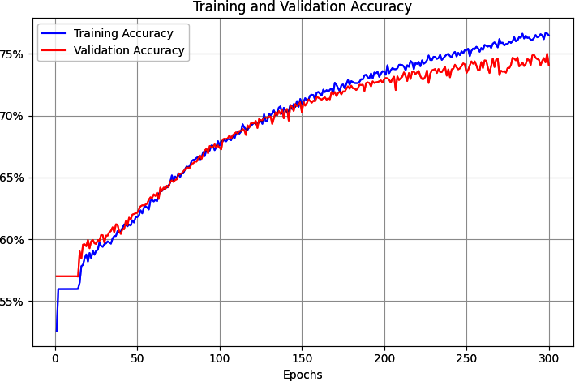

Figure 7-19. Accuracy of stacked LSTMs using dropout

As you can see, using dropout can have a positive impact on the accuracy of the network, which is good! There’s always a worry that losing neurons will make your model perform worse, but as we can see here, that’s not the case. But do be careful when using dropout because it can lead to underfitting or overfitting if not used appropriately.

There’s also a positive impact on loss, as you can see in [Figure 7-20](https://learning.oreilly.com/library/view/ai-and-ml/9781098199166/ch07.html#ch07_figure_20_1748549654878397). While the curves are clearly diverging, they are closer than they were previously, and the validation set is flattening out at a loss of about 0.45, which also demonstrates an improvement! As this example shows, dropout is another handy technique that you can use to improve the performance of LSTM-based RNNs.

It’s worth exploring these techniques for avoiding overfitting in your data, and it’s also worth exploring the techniques for preprocessing your data that we covered in [Chapter 6](https://learning.oreilly.com/library/view/ai-and-ml/9781098199166/ch06.html#ch06_clean_making_sentiment_programmable_by_using_embeddings_1748752380728888). But there’s one thing that we haven’t yet tried: a form of transfer learning in which you can use pre-learned embeddings for words instead of trying to learn your own. We’ll explore that next.

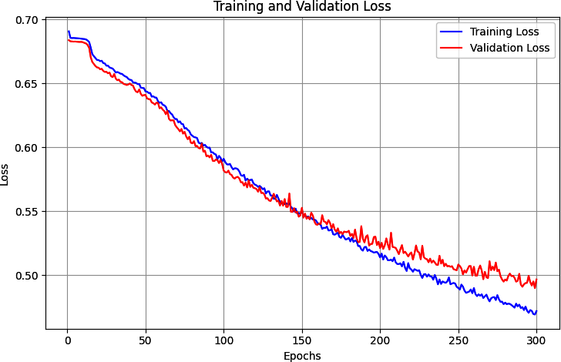

Figure 7-20. Loss curves for dropout-enabled LSTMs

Using Pretrained Embeddings with RNNs

In all the previous examples, you gathered the full set of words to be used in the training set and then trained embeddings with them. You initially aggregated them before feeding them into a dense network, and in this chapter, you explored how to improve the results using an RNN. While doing this, you were restricted to the words in your dataset and how their embeddings could be learned by using the labels from that dataset.

Now, think back to [Chapter 4](https://learning.oreilly.com/library/view/ai-and-ml/9781098199166/ch04.html#ch04_using_data_with_pytorch_1748548966496246), where we discussed transfer learning. What if instead of learning the embeddings for yourself, you could use pre-learned embeddings, where researchers have already done the hard work of turning words into vectors and those vectors are proven? One example of this, as we saw in [Chapter 6](https://learning.oreilly.com/library/view/ai-and-ml/9781098199166/ch06.html#ch06_clean_making_sentiment_programmable_by_using_embeddings_1748752380728888), is the [GloVe (Global Vectors for Word Representation) model](https://oreil.ly/4ENdQ) developed by Jeffrey Pennington, Richard Socher, and Christopher Manning at Stanford.

In this case, the researchers have shared their pretrained word vectors for a variety of datasets:

* A 6-billion-token, 400,000-word vocabulary set in 50, 100, 200, and 300 dimensions with words taken from Wikipedia and Gigaword
* A 42-billion-token, 1.9-million-word vocabulary in 300 dimensions from a common crawl
* An 840-billion-token, 2.2-million-word vocabulary in 300 dimensions from a common crawl
* A 27-billion-token, 1.2-million-word vocabulary in 25, 50, 100, and 200 dimensions from a Twitter crawl of 2 billion tweets

Given that the vectors are already pretrained, it’s simple for you to reuse them in your PyTorch code, instead of learning them from scratch. First, you’ll have to download the GloVe data. I’ve opted to use the 6-billion-word version, in 50 dimensions, using this code to download and unzip it:

import urllib.request

import zipfile

# Download GloVe embeddings

url = "https://nlp.stanford.edu/data/glove.6B.zip"

urllib.request.urlretrieve(url, "glove.6B.zip")

# Unzip

with zipfile.ZipFile("glove.6B.zip", 'r') as zip_ref:

zip_ref.extractall()

# You can use glove.6B.50d.txt (50 dimensions)

# or glove.6B.100d.txt (100 dimensions)

Each entry in the file is a word, followed by the dimensional coefficients that were learned for it. The easiest way to use this is to create a dictionary where the key is the word and the values are the embeddings. You can set up this dictionary like this:

import numpy as np

glove_embeddings = dict()

f = open('glove.6B.50d.txt')

for line in f:

values = line.split()

word = values[0]

coefs = np.asarray(values[1:], dtype='float32')

glove_embeddings[word] = coefs

f.close()

At this point, you’ll be able to look up the set of coefficients for any word simply by using it as the key. So, for example, to see the embeddings for the word *frog*, you could use this:

glove_embeddings['frog']

With these pretrained embeddings in hand, you can now load them into the embeddings layer in your neural architecture and use them as pretrained embeddings instead of learning them from scratch. See the following model architecture definition. If the pretrained_embeddings value is not null, then the weights for the embedding layer will be loaded from that. If freeze_embeddings is True, then they’ll be frozen; otherwise, they’ll be used as the starting point for learning (i.e., you’ll fine-tune the embeddings based on your corpus):

class TextClassificationModel(nn.Module):

def __init__(self, vocab_size, embedding_dim=100, hidden_dim=16,

dropout_rate=0.25, pretrained_embeddings=None,

freeze_embeddings=True, lstm_layers=2):

super(TextClassificationModel, self).__init__()

# Initialize embedding layer

self.embedding = nn.Embedding(vocab_size, embedding_dim)

# Load pretrained embeddings if provided

if pretrained_embeddings is not None:

self.embedding.weight.data.copy_(pretrained_embeddings)

if freeze_embeddings:

self.embedding.weight.requires_grad = False

# LSTM layer

self.lstm = nn.LSTM(

input_size=embedding_dim,

hidden_size=hidden_dim,

num_layers=lstm_layers,

batch_first=True

)

# Global pooling

self.global_pool = nn.AdaptiveAvgPool1d(1)

# Fully connected layers

self.fc1 = nn.Linear(hidden_dim, hidden_dim)

self.fc2 = nn.Linear(hidden_dim, 1)

# Activation functions

self.relu = nn.ReLU()

self.sigmoid = nn.Sigmoid()

This model shows a total of 406.817 parameters of which only 6,817 are trainable, so training will be fast!

==========================================================================

Layer (type:depth-idx) Output Shape Param #

==========================================================================

TextClassificationModel [32, 1] --

├─Embedding: 1-1 [32, 60, 50] (400,000)

├─Dropout: 1-2 [32, 60, 50] --

├─LSTM: 1-3 [32, 60, 16] 6,528

├─Dropout: 1-4 [32, 60, 16] --

├─AdaptiveAvgPool1d: 1-5 [32, 16, 1] --

├─Linear: 1-6 [32, 16] 272

├─ReLU: 1-7 [32, 16] --

├─Dropout: 1-8 [32, 16] --

├─Linear: 1-9 [32, 1] 17

├─Sigmoid: 1-10 [32, 1] --

==========================================================================

Total params: 406,817

Trainable params: 6,817

Non-trainable params: 400,000

Total mult-adds (M): 25.34

==========================================================================

Input size (MB): 0.02

Forward/backward pass size (MB): 1.02

Params size (MB): 1.63

Estimated Total Size (MB): 2.66

==========================================================================

You can now train as before, and you can see how this architecture, with the pretrained embeddings and stacked LSTMs, reduces overfitting really nicely! [Figure 7-21](https://learning.oreilly.com/library/view/ai-and-ml/9781098199166/ch07.html#ch07_figure_21_1748549654878419) shows the Training versus Validation accuracy on the sarcasm dataset using LSTMs and pretrained GloVe embeddings, while [Figure 7-22](https://learning.oreilly.com/library/view/ai-and-ml/9781098199166/ch07.html#ch07_figure_22_1748549654878440) shows the loss on training versus validation, where the closeness of the curves demonstrates that we’re not overfitting.

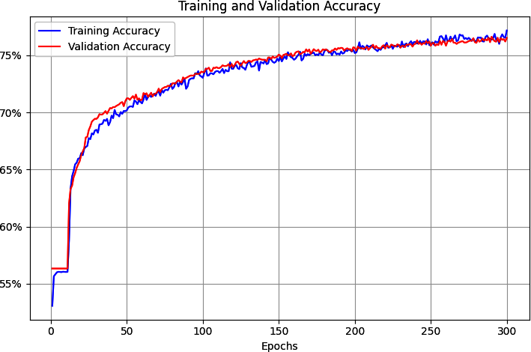

Figure 7-21. Training versus validation accuracy on the sarcasm dataset with LSTMs and GloVe

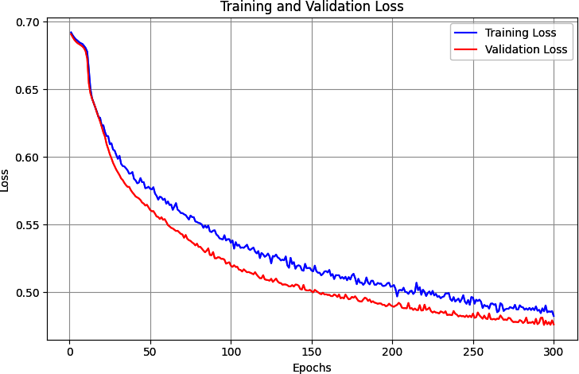

Figure 7-22. Training and validation loss on the sarcasm dataset with LSTMs and GloVe

For further analysis, you’ll want to consider your vocab size. One of the optimizations you did in the previous chapter to avoid overfitting was intended to prevent the embeddings becoming overburdened with learning low-frequency words: you avoided overfitting by using a smaller vocabulary of frequently used words. In this case, as the word embeddings have already been learned for you with GloVe, you could expand the vocabulary—but by how much?

The first thing to explore is how many of the words in your corpus are actually in the GloVe set. It has 1.2 million words, but there’s no guarantee it has *all* of your words.

When building the word_index, you can call build_vocab_glove with a *really* large number and it will ignore any words over the total amount. So, for example, say you call this:

word_index = build_vocab_glove(training_sentences, max_vocab_size=100,000)

With the sarcasm dataset, you’ll get a vocab_size of 22,457 returned. If you like, you can then explore the GloVe embeddings to see just how many of these words are present in GloVE. Start by creating a dictionary for the embeddings and reading the GloVE file into it:

embeddings_dict = {}

embedding_dim = 50

glove_file = f'glove.6B.{embedding_dim}d.txt'

# Read GloVe embeddings

print(f"Loading GloVe embeddings from {glove_file}...")

with open(glove_file, 'r', encoding='utf-8') as f:

for line in f:

values = line.split()

word = values[0]

vector = np.asarray(values[1:], dtype='float32')

embeddings_dict[word] = vector

Then, you can compare this with your word_index that you created from the entire corpus with the preceding line:

found_words = 0

for word, idx in word_index.items():

if word in embeddings_dict:

found_words += 1

print(found_words)

In the case of sarcasm, 21,291 of the words were found in GloVE, which is the vast majority, so the principles you used in [Chapter 6](https://learning.oreilly.com/library/view/ai-and-ml/9781098199166/ch06.html#ch06_clean_making_sentiment_programmable_by_using_embeddings_1748752380728888) to choose how many you should train on (i.e., picking those with sufficient frequency to have a signal) will still apply!

Using this method, I chose to use a vocabulary size of 8,000 (instead of the 2,000 that was previously used to avoid overfitting) to get the results you saw just now. I then tested it with headlines from *The Onion*, the source of the sarcastic headlines in the sarcasm dataset, against other sentences, as shown here:

test_sentences = ["It Was, For, Uh, Medical Reasons, Says Doctor To

Boris Johnson, Explaining Why They Had To Give Him Haircut",

"It's a beautiful sunny day",

"I lived in Ireland, so in high school they made me

learn to speak and write in Gaelic",

"Census Foot Soldiers Swarm Neighborhoods, Kick Down

Doors To Tally Household Sizes"]

The results for these headlines are as follows—remember that values close to 50% (0.5) are considered neutral, those close to 0 are considered nonsarcastic, and those close to 1 are considered sarcastic:

tensor([[0.9316],

[0.1603],

[0.6959],

[0.9594]], device='cuda:0')

Text: It Was, For, Uh, Medical Reasons, Says Doctor To Boris Johnson,

Explaining Why They Had To Give Him Haircut

Probability: 0.9316

Classification: Sarcastic

--------------------------------------------------------------------------

Text: It's a beautiful sunny day

Probability: 0.1603

Classification: Not Sarcastic

--------------------------------------------------------------------------

Text: I lived in Ireland, so in high school they made me learn to speak

and write in Gaelic

Probability: 0.6959

Classification: Sarcastic

--------------------------------------------------------------------------

Text: Census Foot Soldiers Swarm Neighborhoods, Kick Down Doors To Tally

Household Sizes

Probability: 0.9594

Classification: Sarcastic

--------------------------------------------------------------------------

The first and fourth sentences, which are taken from *The Onion*, showed 93%+ likelihood of sarcasm. The statement about the weather was strongly nonsarcastic (16%), and the sentence about going to high school in Ireland was deemed to be potentially sarcastic but not with high confidence (69%).

Summary

This chapter introduced you to recurrent neural networks, which use sequence-oriented logic in their design and can help you understand the sentiment in sentences based not only on the words they contain but also on the order in which they appear. You saw how a basic RNN works, as well as how an LSTM can build on this to enable context to be preserved over the long term. These models are the precursors to the popular and famous “transformers” models used to underpin generative AI.

You also used LSTMs to improve the sentiment analysis model you’ve been working on, and you then looked into overfitting issues with RNNs and techniques to improve them, including by using transfer learning from pretrained embeddings.

In [Chapter 8](https://learning.oreilly.com/library/view/ai-and-ml/9781098199166/ch08.html#ch08_using_ml_to_create_text_1748549671852453), you’ll use what you’ve learned so far to explore how to predict words, and from there, you’ll be able to create a model that creates text and writes poetry for you!

Chapter 8. Using ML to Create Text

With the release of ChatGPT in 2022, the words *generative AI* entered the common lexicon. This simple application that allowed you to chat with a cloud-based AI seemed almost miraculous in how it could answer your queries with knowledge of almost everything in human experience. It worked by using a very advanced evolution beyond the recurrent neural networks you saw in the last chapter, by using a technique called *transformers*.

A *transformer* learns the patterns that turn one piece of text into another. With a large enough transformer architecture and a large enough set of text to learn from, the GPT model (GPT stands for generative pretrained transformers) could predict the next tokens to follow a piece of text. When GPT was wrapped in an application that made it more user friendly, a whole new industry was born.

While creating models with transformers is beyond the scope of this book, we will look at their architecture in detail in [Chapter 15](https://learning.oreilly.com/library/view/ai-and-ml/9781098199166/ch15.html#ch15_transformers_and_transformers_1748549808974580).

The principles involved in training models with transformers can be replicated with smaller, simpler, architectures like RNNs or LSTM. We’ll explore that in this chapter and with a much smaller corpus of text—traditional Irish songs.

So, for example, consider this line of text from a famous TV show:

*You know nothing, Jon Snow.*

A next-token-predictor model, created with RNNs, came up with these song lyrics in response:

* You know nothing, Jon Snow
* the place where he’s stationed
* be it Cork or in the blue bird’s son
* sailed out to summer
* old sweet long and gladness rings
* so I’ll wait for the wild Colleen dying

This text was generated by a very simple model that was trained on a small corpus. I’ve enhanced it a little by adding line breaks and punctuation, but other than the first line, all of the lyrics were generated by the model you’ll learn how to build in this chapter. It’s kind of cool that it mentions a *wild Colleen dying*—if you’ve watched the show that Jon Snow comes from, you’ll understand why!

In the last few chapters, you saw how you can use PyTorch with text-based data—first tokenizing it into numbers and sequences that can be processed by a neural network, then using embeddings to simulate sentiment using vectors, and finally using deep and recurrent neural networks to classify text. We used the sarcasm dataset, a small and simple one, to illustrate how all this works.

In this chapter we’re going to shift gears: instead of classifying existing text, you’ll create a neural network that can *predict* text and thus *generate* text.

Given a corpus of text, the network will attempt to learn and understand the *patterns* of words within the text so that it can, given a new piece of text called a *seed*, predict what word should come next. Once the network has that, the seed and the predicted word become the new seed, and it can predict the next word. Thus, when trained on a corpus of text, a neural network can attempt to write new text in a similar style. To create the preceding piece of poetry, I collected lyrics from a number of traditional Irish songs, trained a neural network with them, and used it to predict words.

We’ll start simple, using a small amount of text to illustrate how to build up to a predictive model, and we’ll end by creating a full model with a lot more text. After that, you can try it out to see what kind of poetry it can create!

To get started, you’ll have to treat the text a little differently from how you’ve been treating it thus far. In the previous chapters, you took sentences and turned them into sequences that were then classified based on the embeddings for the tokens within them. But when it comes to creating data that can be used to train a predictive model like this one, there’s an additional step in which you need to transform the sequences into *input sequences* and *labels*, where the input sequence is a group of words and the label is the next word in the sentence. You can then train a model to match the input sequences to their labels, so that future predictions can pick a label that’s close to the input sequence.

Turning Sequences into Input Sequences

When predicting text, you need to train a neural network with an input sequence (feature) that has an associated label. Matching sequences to labels is the key to predicting text. In this case, you won’t have explicit labels like you do when you are classifying, but instead, you’ll split the sentence, and for a block of *n* words, the next word in the sentence will be the label.

So, for example, if in your corpus you had the sentence “Today has a beautiful blue sky,” then you could split it into “Today has a beautiful blue” as the feature and “sky” as the label. Then, if you were to get a prediction for the text “Today has a beautiful blue,” it would likely be “sky.” If, in the training data, you also had “Yesterday had a beautiful blue sky,” you would split it in the same way, and if you were to get a prediction for the text “Tomorrow will have a beautiful blue,” then there’s a high probability that the next word would be “sky.”

If you train a network with lots of sentences, where you remove the last word and make it the label, you can quickly build up a predictive model in which the most likely next word in the sentence can be predicted from an existing body of text.

We’ll start with a very small corpus of text—an excerpt from a traditional Irish song from the 1860s, some of the lyrics of which are as follows:

* In the town of Athy one Jeremy Lanigan
* Battered away ’til he hadn’t a pound.
* His father died and made him a man again
* Left him a farm and ten acres of ground.
* He gave a grand party for friends and relations
* Who didn’t forget him when come to the wall,
* And if you’ll but listen I’ll make your eyes glisten
* Of the rows and the ructions of Lanigan’s Ball.
* Myself to be sure got free invitation,
* For all the nice girls and boys I might ask,
* And just in a minute both friends and relations
* Were dancing round merry as bees round a cask.
* Judy O’Daly, that nice little milliner,
* She tipped me a wink for to give her a call,
* And I soon arrived with Peggy McGilligan
* Just in time for Lanigan’s Ball.

You’ll want to create a single string with all the text and set that to be your data. Use \n for the line breaks. Then, this corpus can be easily loaded and tokenized. First, the tokenize function will split the text into individual words, and then the create_word_dictionary will create a dictionary with an index for each individual word in the text:

def tokenize(text):

tokens = text.lower().split()

return tokens

def create_word_dictionary(word_list):

# Create an empty dictionary

word_dict = {}

word_dict["UNK"] = 0

# Counter for unique values

counter = 1

# Iterate through the list and assign numbers to unique words

for word in word_list:

if word not in word_dict:

word_dict[word] = counter

counter += 1

return word_dict

Note that this is a very simplistic approach for the purpose of learning how these work. In production systems, you’d likely either use off-the-shelf components that have been built for scale or greatly enhance them for scale and exception checking.

With these functions, you can then create a word_index of the simple corpus, like this:

data="In the town of Athy one Jeremy Lanigan \n

Battered away til he hadnt a pound. ..."

tokens = tokenize(data)

word_index = create_word_dictionary(tokens)

total_words = len(tokenizer.word_index) + 1

The result of this process is to replace the words with their token values (see [Figure 8-1](https://learning.oreilly.com/library/view/ai-and-ml/9781098199166/ch08.html#ch08_figure_1_1748549671837881)).

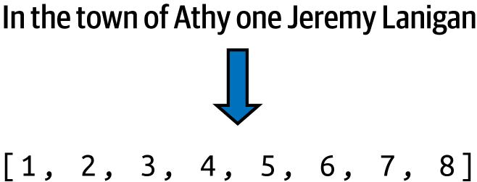

Figure 8-1. Tokenizing a sentence

To train a predictive model, we should take a further step here: splitting the sentence into multiple smaller sequences so, for example, we can have one sequence consisting of the first two tokens, another consisting of the first three, etc. We would then pad these out to be the same length as the input sequence by prepending zeros (see [Figure 8-2](https://learning.oreilly.com/library/view/ai-and-ml/9781098199166/ch08.html#ch08_figure_2_1748549671837934)).

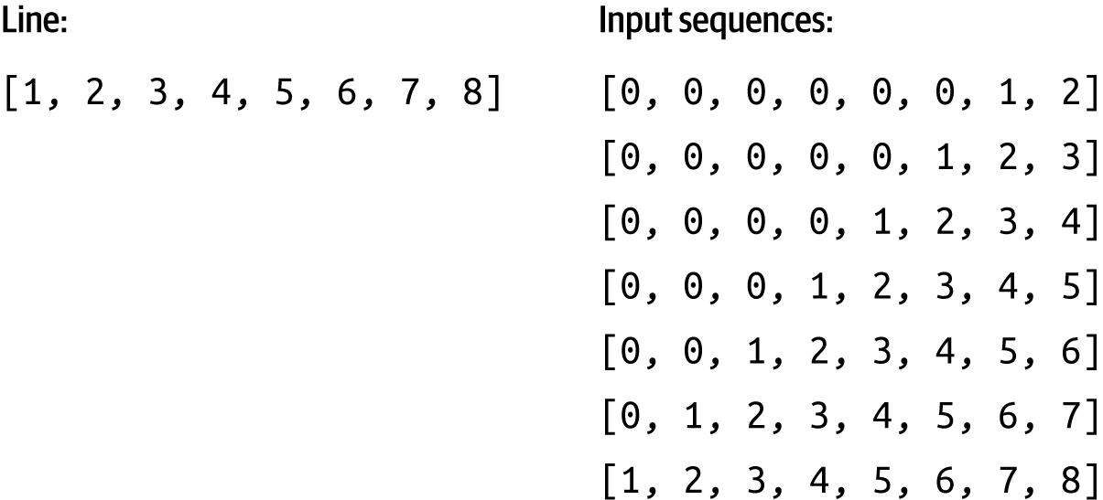

Figure 8-2. Turning a sequence into a number of input sequences

To do this, you’ll need to go through each line in the corpus and turn it into a list of tokens, using functions to convert the text words into an array of their lookup values in the word dictionary, and then to create the padded versions of the subsequences. To assist you with this task, I’ve provided these functions: text_to_sequence and pad_sequence.

def text_to_sequence(sentence, word_dict):

# Convert sentence to lowercase and split into words

words = sentence.lower().strip().split()

# Convert each word to its corresponding number

number_sequence = [word_dict[word] for word in words]

return number_sequence

def pad_sequences(sequences, max_length=None):

# If max_length is not specified, find the length of the longest sequence

if max_length is None:

max_length = max(len(seq) for seq in sequences)

# Pad each sequence with zeros at the beginning

padded_sequences = []

for seq in sequences:

# Calculate number of zeros needed

num_zeros = max_length – len(seq)

# Create padded sequence

padded_seq = [0] * num_zeros + list(seq)

padded_sequences.append(padded_seq)

return padded_sequences

You can then create the input sequences using these helper functions like this:

corpus = data.lower().split("\n")

input_sequences = []

for line in corpus:

token_list = text_to_sequence(line, word_index)

for i in range(1, len(token_list)):

n_gram_sequence = token_list[:i+1]

input_sequences.append(n_gram_sequence)

max_sequence_len = max([len(x) for x in input_sequences])

input_sequences = pad_sequences(input_sequences, max_sequence_len)

Finally, once you have a set of padded input sequences, you can split them into features and labels, where each label is simply the last token in each input sequence (see [Figure 8-3](https://learning.oreilly.com/library/view/ai-and-ml/9781098199166/ch08.html#ch08_figure_3_1748549671837963)).

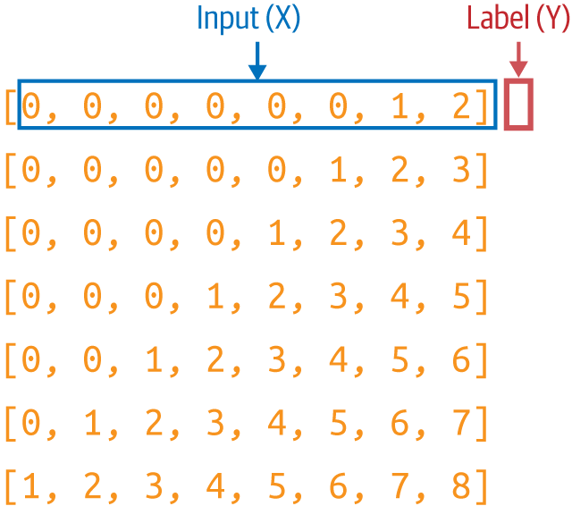

Figure 8-3. Turning the padded sequences into features (x) and labels (y)

When you’re training a neural network, you’re going to match each feature to its corresponding label. So, for example, the label for [0 0 0 0 0 0 1] will be [2].

Here’s the code you use to separate the labels from the input sequences:

def split_sequences(sequences):

# Create xs by removing the last element from each sequence

xs = [seq[:–1] for seq in sequences]

# Create labels by taking just the last element from each sequence

labels = [seq[–1:] for seq in sequences]

# Using [–1:] to keep it as a single-element list

# Alternative if you want labels as single numbers instead of lists:

# labels = [seq[–1] for seq in sequences]

return xs, labels

xs, labels = split_sequences(input_sequences)

Next, you need to encode the labels. Right now, they’re just tokens—for example, the number 2 at the top of [Figure 8-3](https://learning.oreilly.com/library/view/ai-and-ml/9781098199166/ch08.html#ch08_figure_3_1748549671837963) is a token. But if you want to use a token as a label in a classifier, you’ll have to map it to an output neuron. Thus, if you’re going to classify *n* words, with each word being a class, you’ll need to have *n* neurons. Here’s where it’s important to control the size of the vocabulary, because the more words you have, the more classes you’ll need. Remember back in Chapter [2](https://learning.oreilly.com/library/view/ai-and-ml/9781098199166/ch02.html#ch02_introduction_to_computer_vision_1748548889076080) and [3](https://learning.oreilly.com/library/view/ai-and-ml/9781098199166/ch03.html#ch03_going_beyond_the_basics_detecting_features_in_ima_1748570891074912), when you were classifying fashion items with the Fashion MNIST dataset and you had 10 types of items of clothing? That required you to have 10 neurons in the output layer—but in this case, what if you want to predict up to 10,000 vocabulary words? You’ll need an output layer with 10,000 neurons!

Additionally, you need to one-hot encode your labels so that they match the desired output from a neural network. Consider [Figure 8-3](https://learning.oreilly.com/library/view/ai-and-ml/9781098199166/ch08.html#ch08_figure_3_1748549671837963) again. If a neural network is fed the input *x* consisting of a series of 0s followed by a 1, you’ll want the prediction to be 2—but how the network delivers that is by having an output layer of vocabulary_size neurons, where the second one has the highest probability.

To encode your labels into a set of *Y*s that you can then use to train, you can use this code:

def one_hot_encode_with_checks(value, corpus_size):

# Check if value is within valid range

if not 0 <= value < corpus_size:

raise ValueError(f"Value {value} is out of range for corpus size

{corpus_size}")

# Create and return one-hot encoded list

encoded = [0] * corpus_size

encoded[value] = 1

return encoded

Note that there are many libraries and helper functions out there that can do this for you, so feel free to use them instead of the simple code in this chapter. But I want to put these methodologies in here, so you can see how it works under the hood.

You can see this visually in [Figure 8-4](https://learning.oreilly.com/library/view/ai-and-ml/9781098199166/ch08.html#ch08_figure_4_1748549671837985).

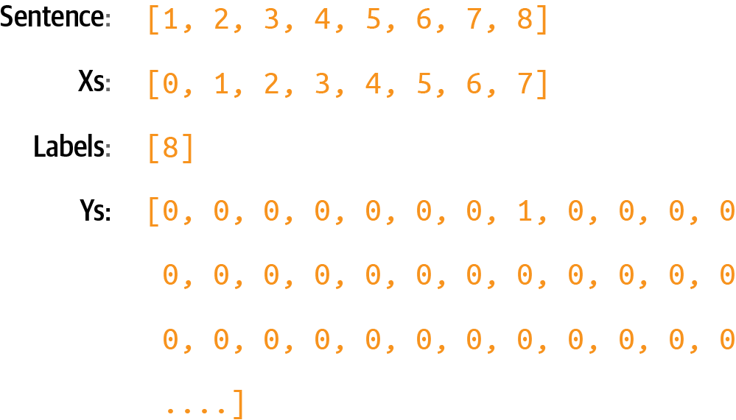

Figure 8-4. One-hot encoding labels

This is a very sparse representation that, if you have a lot of training data and a lot of potential words, will eat memory very quickly! Suppose you had 100,000 training sentences, with a vocabulary of 10,000 words—you’d need 1,000,000,000 bytes just to hold the labels! But that’s the way we have to design our network if we’re going to classify and predict words.

Creating the Model

Let’s now create a simple model that can be trained with this input data. It will consist of just an embedding layer, followed by an LSTM, followed by a dense layer.

For the embedding, you’ll need one vector per word, so the parameters will be the total number of words and the number of dimensions you want to embed on. In this case, we don’t have many words, so eight dimensions should be enough.

You can make the LSTM bidirectional, and the number of steps can be the length of a sequence, which is our max length minus 1 (because we took one token off the end to make the label).

Finally, the output layer will be a dense layer with the total number of words as a parameter, activated by Softmax. Each neuron in this layer will be the probability that the next word matches the word for that index value:

class LSTMPredictor(nn.Module):

def __init__(self, total_words, embedding_dim=8, hidden_dim=None):

super(LSTMPredictor, self).__init__()

# If hidden_dim not specified, use max_sequence_len-1 as in TF version

if hidden_dim is None:

hidden_dim = max_sequence_len–1

# Embedding layer

self.embedding = nn.Embedding(total_words, embedding_dim)

# Bidirectional LSTM

self.lstm = nn.LSTM(

input_size=embedding_dim,

hidden_size=hidden_dim,

bidirectional=True,

batch_first=True

)

# Final dense layer (accounting for bidirectional LSTM)

self.fc = nn.Linear(hidden_dim * 2, total_words)

# Softmax activation

self.softmax = nn.Softmax(dim=1)

def forward(self, x):

# Embedding layer

x = self.embedding(x)

# LSTM layer

lstm_out, _ = self.lstm(x)

# Take the output from the last time step

lstm_out = lstm_out[:, –1, :]

# Dense layer

out = self.fc(lstm_out)

# Softmax activation

out = self.softmax(out)

return out

Next, you compile the model with a categorical loss function such as categorical cross entropy and an optimizer like Adam. You can also specify that you want to capture metrics:

# Training setup

total_words = len(word_index)

model = LSTMPredictor(total_words)

criterion = nn.CrossEntropyLoss()

optimizer = torch.optim.Adam(model.parameters())

It’s a very simple model without a lot of data, and it trains quickly. Here are the results of training for about 15,000 epochs, which takes maybe 10 minutes. In the real world, you’ll likely be training with a lot more data and thus taking a lot more time, so you’ll have to consider some of the techniques we saw in [Chapter 7](https://learning.oreilly.com/library/view/ai-and-ml/9781098199166/ch07.html#ch07_recurrent_neural_networks_for_natural_language_pro_1748549654891648) to ensure greater accuracy and potentially less time to train.

You’ll see that it has reached very high accuracy, and there may be room for more (see [Figure 8-5](https://learning.oreilly.com/library/view/ai-and-ml/9781098199166/ch08.html#ch08_figure_5_1748549671838006)).

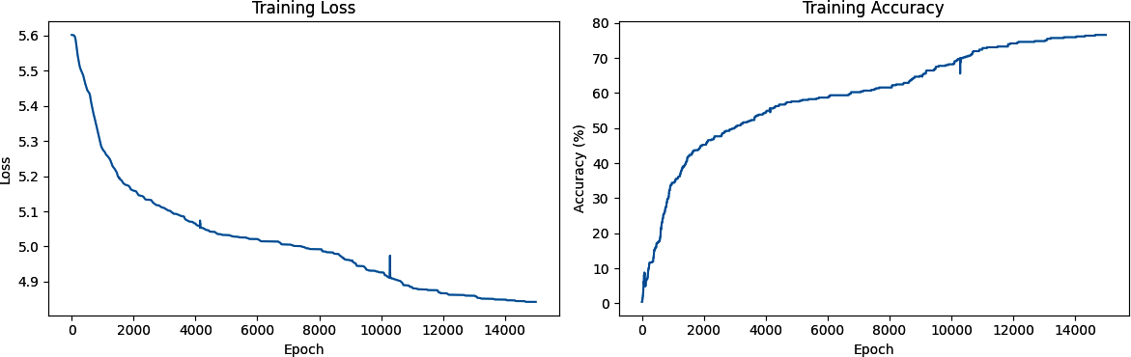

Figure 8-5. Training loss and accuracy

With the model at 80%+ accuracy, we can be assured that if we have a string of text that it has already seen, it will predict the next word accurately about 80% of the time.

Note, however, that when generating text, it will continually see words that it hasn’t previously seen, so despite this good number, you’ll find that the network will rapidly end up producing nonsensical text. We’ll explore this in the next section.

Generating Text

Now that you’ve trained a network that can predict the next word in a sequence, the next step is to give it a sequence of text and have it predict the next word. Let’s take a look at how to do that.

**Predicting the Next Word**

You’ll start by creating a phrase called the *seed text*. This is the initial expression on which the network will base all the content it generates, and it will do this by predicting the next word.

Start with a phrase that the network has *already* seen, such as “in the town of Athy”:

input_text = "In the town of Athy"

Next, you need to tokenize this and turn it into a sequence of tokens of the same length as used for training:

# Convert text to lowercase and split into words

words = input_text.lower().strip().split()

# Convert words to numbers using the word dictionary, use 0 for unknown words

number_sequence = [word_dict.get(word, 0) for word in words]

# Pad the sequence

padded_sequence = [0] * (sequence_length – len(number_sequence))

+ number_sequence

Then, you need to pad that sequence to get it into the same shape as the data used for training by converting it to a tensor:

input_tensor = torch.LongTensor([padded_sequence])

Now, you can predict the next word for this token list by passing this input tensor to the model to get the output. This will be a tensor that contains the probabilities for each of the words in the dictionary and the likelihood that it will be the next token.

# Get prediction

with torch.no_grad(): # No need to track gradients for prediction

output = model(input_tensor)

This will return the probabilities for each word in the corpus, so you should pass the results to torch.argmax to get the most likely one:

# Get the predicted word index (highest probability)

predicted_idx = torch.argmax(output[0]).item()

This should give you the value 6. If you look at the word index, you’ll see that it’s the word “one”:

{'UNK': 0, 'in': 1, 'the': 2, 'town': 3, 'of': 4, 'Athy': 5,

**'one': 6,** 'Jeremy': 7, 'Lanigan': 8,

You can also look it up in code by searching through the word index items until you find the predicted word and printing it out. You can do this by creating a reverse dictionary (mapping the value to the word, instead of vice-versa):

# Create reverse dictionary to convert number back to word

reverse_dict = {v: k for k, v in word_dict.items()}

# Convert predicted index to word

predicted_word = reverse_dict[predicted_idx]

So, starting from the text “in the town of Athy,” the network predicted that the next word should be “one”—which, if you look at the training data, is correct because the song begins with this line:

* *In the town of Athy* one Jeremy Lanigan
* Battered away til he hadn’t a pound

Indeed, if you check the top five predictions based on their values in the index, you’ll get something like this:

Top 5 predictions:

one: 0.9999

youll: 0.0000

didnt: 0.0000

creature: 0.0000

nelly: 0.0000

Now that you’ve confirmed that the model is working, you can get creative and use different seed text. For example, when I used the seed text “sweet Jeremy saw Dublin,” the next word it predicted was “his.”

Top 5 predictions:

his: 0.7782

go: 0.1393

bellows,: 0.0605

accident: 0.0090

til: 0.0048

This text was chosen because all of those words are in the corpus. In such cases, you should expect more accurate results, at least at the beginning, for the predicted words.

**Compounding Predictions to Generate Text**

In the previous section, you saw how to use the model to predict the next word given a seed text. Now, to have the neural network create new text, you simply repeat the prediction, adding new words each time.

For example, earlier, when I used the phrase “sweet Jeremy saw Dublin,” it predicted that the next word would be “his.” You can build on this by appending “his” to the seed text to get “sweet Jeremy saw Dublin his” and getting another prediction. Repeating this process will give you an AI-created string of text.

Here’s the updated code from the previous section that performs this loop a number of times, with the number set by the num_words parameter:

def generate_sequence(model, initial_text, word_dict,

sequence_length, num_words=10):

# Set model to evaluation mode

model.eval()

# Start with the initial text

current_text = initial_text

generated_sequence = initial_text

# Create reverse dictionary for converting numbers back to words

reverse_dict = {v: k for k, v in word_dict.items()}

print(f"Initial text: {initial_text}")

for i in range(num_words):

# Convert current text to lowercase and split into words

words = current_text.lower().strip().split()

# Take the last 'sequence_length' words if we exceed it

if len(words) > sequence_length:

words = words[-sequence_length:]

# Convert words to numbers using the word dictionary, use 0 for unknown

number_sequence = [word_dict.get(word, 0) for word in words]

# Pad the sequence

padded_sequence = [0] * (sequence_length – len(number_sequence))

+ number_sequence

# Convert to PyTorch tensor and add batch dimension

input_tensor = torch.LongTensor([padded_sequence])

# Get prediction

with torch.no_grad():

output = model(input_tensor)

# Get the predicted word index (highest probability)

predicted_idx = torch.argmax(output[0]).item()

# Convert predicted index to word

predicted_word = reverse_dict[predicted_idx]

# Add the predicted word to the sequence

generated_sequence += " " + predicted_word

# Update current text for next prediction

current_text = generated_sequence

# Print progress

print(f"Generated word {i+1}: {predicted_word}")

# Optionally print top 5 predictions for each step

_, top_indices = torch.topk(output[0], 5)

print(f"\nTop 5 predictions for step {i+1}:")

for idx in top_indices:

word = reverse_dict[idx.item()]

probability = output[0][idx].item()

print(f"{word}: {probability:.4f}")

print("\n" + "-"*50 + "\n")

return generated_sequence

# Example usage:

initial_text = "sweet Jeremy saw Dublin"

generated_text = generate_sequence(

model=model,

initial_text=initial_text,

word_dict=word_index,

sequence_length=max_sequence_len,

num_words=10

)

print("\nFinal generated sequence:")

print(generated_text)

This will end up creating a string something like this:

sweet jeremy saw dublin his right leg acres of the nolans, dolans, daughter, of

It rapidly descends into gibberish. Why? The first reason is that the body of training text is really small, so it has very little context to work with. The second is that the prediction of the next word in the sequence depends on the previous words in the sequence, and if there is a poor match on the previous ones, even the best “next” match will have a low probability of being accurate. When you add this to the sequence and predict the next word after that, the likelihood of it having a low probability of accuracy is even higher—thus, the predicted words will seem semirandom.

So, for example, while all of the words in the phrase “sweet Jeremy saw Dublin” exist in the corpus, they never exist in that order. When the model made the first prediction, it chose the word “his” as the most likely candidate, and it had quite a high probability of accuracy (78%):

Initial text: sweet Jeremy saw Dublin

Generated word 1: his

Top 5 predictions for step 1:

his: 0.7782

go: 0.1393

bellows,: 0.0605

accident: 0.0090

til: 0.0048

When the model added that word to the seed to get “sweet Jeremy saw Dublin his,” we had another phrase not seen in the training data, so the prediction gave the highest probability to the word “right,” at 44%:

Generated word 2: right

Top 5 predictions for step 2:

right: 0.7678

pipes,: 0.1376

creature: 0.0458

didnt: 0.0136

youll: 0.0113

While occasionally there will be high certainty of a token following another (like “leg” following “right”), over time, you’ll see that continuing to add words to the sentence reduces the likelihood of a match in the training data, and as such, the prediction accuracy will suffer—leading to there being a more random “feel” to the words being predicted.

This leads to the phenomenon of AI-generated content getting increasingly nonsensical over time.

For an example, check out the excellent sci-fi short [*Sunspring*](https://oreil.ly/hTBtJ), which was written entirely by an LSTM-based network (like the one you’re building here) that was trained on science fiction movie scripts. The model was given seed content and tasked with generating a new script. The results were hilarious, and you’ll see that while the initial content makes sense, as the movie progresses, it becomes less and less comprehensible.

This is also the basis of *hallucination* in LLMs, a common phenomenon that reduces trust in them.

Extending the Dataset

You can easily extend the same pattern that you used for the hardcoded dataset to use a text file. I’ve hosted a text file containing about 1,700 lines of text gathered from a number of songs that you can use for experimentation. With a little modification, you can use this instead of the single hardcoded song.

To download the data in Colab, use the following code:

!wget --no-check-certificate \

https://storage.googleapis.com/learning-datasets/ \

irish-lyrics-eof.txt-O /tmp/irish-lyrics-eof.txt

Then, you can simply load the text from it into your corpus like this:

data = open('/tmp/irish-lyrics-eof.txt').read()

corpus = data.lower().split("\n")

The rest of your code will then work with very little modification!

Training this for 50,000 epochs—which takes about 30 minutes on a T4 Colab instance—brings you to about 30% accuracy, with the curve flattening out (see [Figure 8-6](https://learning.oreilly.com/library/view/ai-and-ml/9781098199166/ch08.html#ch08_figure_6_1748549671838028)).

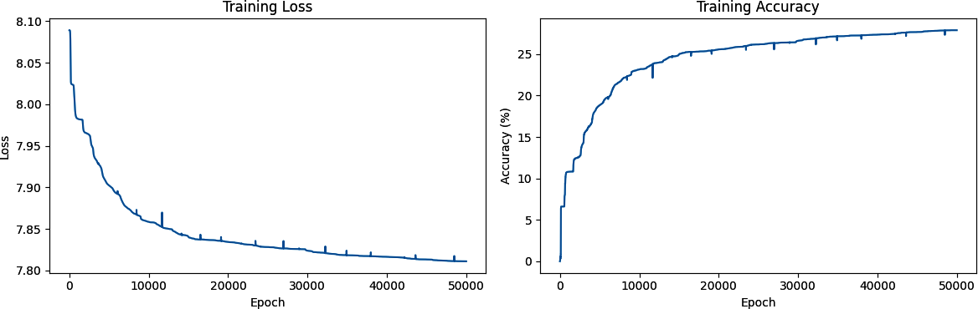

Figure 8-6. Training on a larger dataset

**Note**

When using Google Colab, you can choose various accelerators on the backend, which can make your training go much faster. In this case, as noted, I used a T4. To do this for yourself, when in Colab, under the Connect menu, you’ll see a Change Runtime Type option. Select that, and you’ll see the accelerators available for you to use.

Trying the phrase “in the town of Athy” again yields a prediction of “one” but this time with just over 83% probability:

Initial text: in the town of Athy

Using device: cuda

Generated word 1: one

Top 5 predictions for step 1:

one: 0.8318

is: 0.1648

she: 0.0016

thee: 0.0013

that: 0.0003

--------------------------------------------------

Generated word 2: my

Top 5 predictions for step 2:

my: 0.9377

of: 0.0622

is: 0.0001

that: 0.0000

one: 0.0000

Running for a few more tokens, we can see output like the following. It’s beginning to create songs, though it’s quite quickly descending into gibberish!

in the town of athy one my heart

was they were the a reflections

on me all the frivolity;

of me and me and me and the

there was my heart was

on the a over the frivolity;

For “sweet Jeremy saw Dublin,” the predicted next word is “she,” with a probability of 80%. Predicting the next few words yields this:

sweet jeremy saw dublin she of his on the frivolity; of a heart is the ground

It’s looking a little better! But can we improve it further?

Improving the Model Architecture

One way that you can improve the model is to change its architecture, using multiple stacked LSTMs and some other optimization techniques. Given that there’s no clear benchmark for accuracy with a dataset like this one—there’s no right or wrong classification, nor is there a target regression—it’s difficult to establish when a model is good or bad. Therefore, accuracy results can be very subjective.

That being said, they’re still a good yardstick, so in this section, I’m going to explore some additions you can make to the architecture to improve the accuracy metric.

**Embedding Dimensions**

In [Chapter 6](https://learning.oreilly.com/library/view/ai-and-ml/9781098199166/ch06.html#ch06_clean_making_sentiment_programmable_by_using_embeddings_1748752380728888), we discussed the fact that the optimal dimension for embeddings is the fourth root of the number of words. In this scenario, the vocabulary has 3,259 words, and the fourth root of this is approximately 8. Another rule of thumb is the log of this number—and log(3259) is a little over 32. So, if the network is learning slowly, you have the option to pick a number between these two values. That gives you enough “room” to capture the relationships between words.

**Initializing the LSTMs**

Often, parameters in a neural network are initialized to zero. You can give learning a little bit of a kickstart by initializing different layers to different types supported by various research findings. We briefly cover these types of layers in the following subsections.

**Embedding layers**

Embedding layers can be initialized with a normal distribution, with a standard deviation scaled by 1/sqrt(embedding_dim) for better gradient flow. That’s similar to word2vec-style initialization.

**LSTM layers**

LSTM has four internal neural types—input, forget, cell, and output—and their weight matrix is a bunch of them stacked together. The different types benefit from different initializations. Two great papers that discuss this are [“An Empirical Exploration of Recurrent Network Architectures” by Rafal Jozefowicz et al.](https://oreil.ly/UuvQO) and [“On the Difficulty of Training Recurrent Neural Networks”](https://oreil.ly/Ttvll) by Razvan Pascanu et al. The specifics of LSTM are beyond the scope of this chapter, but check the associated code for one methodology to initialize them.

**Final linear layer**

In their 2015 paper “[Delving Deep into Rectifiers,” Kaiming He et al.](https://oreil.ly/_MM6A) explored initialization of linear layers and proposed “Kaiming” initialization (aka “He” initialization). A detailed explanation of this is beyond the scope of this book, but the code is available in the notebooks in the [GitHub repository](https://github.com/lmoroney/PyTorch-Book-FIles).

**Variable Learning Rate**

In every example we’ve seen so far, we’ve explored different learning rates and their impact on the network—but you can actually *vary* the learning rate as the network learns. Values that work well in early epochs may not work so well in later ones, so putting together a scheduler that adjusts this learning rate epoch by epoch can help you create networks that learn more effectively.

For this, PyTorch provides a torch.optim.lr_scheduler that you can program to change over the course of the training:

scheduler = torch.optim.lr_scheduler.OneCycleLR(

optimizer,

max_lr=0.01, # Peak learning rate

epochs=20000, # Total epochs

steps_per_epoch=1, # Steps per epoch

pct_start=0.1, # Percentage of training spent increasing lr

div_factor=10.0, # Initial lr = max_lr/10

final_div_factor=1000.0 # Final lr = initial_lr/1000

)

In [Chapter 7](https://learning.oreilly.com/library/view/ai-and-ml/9781098199166/ch07.html#ch07_recurrent_neural_networks_for_natural_language_pro_1748549654891648), we looked at the idea of a *learning rate* (LR), which is a hyperparameter that, if set to be too large, will cause the network to overlearn, and if set to be too small will prevent the network from learning effectively. The nice thing about this is that you can set it as a variable rate, which we do here. In the early epochs, we want the network to learn fast, so we have a large LR—and in the later epochs, we don’t want it to overfit, so we gradually reduce the LR.

The pct_start parameter defines a warm-up period as the first 10% of the training, during which the learning rate gradually increases up to the maximum (in this case, 0.01) and then decreases to 1/1000 of the initial learning rate (determined by final_div_factor).

You can see the impact this has on training in [Figure 8-7](https://learning.oreilly.com/library/view/ai-and-ml/9781098199166/ch08.html#ch08_figure_7_1748549671838042), where it reached ~90% accuracy in 6,800 epochs before triggering early stopping.

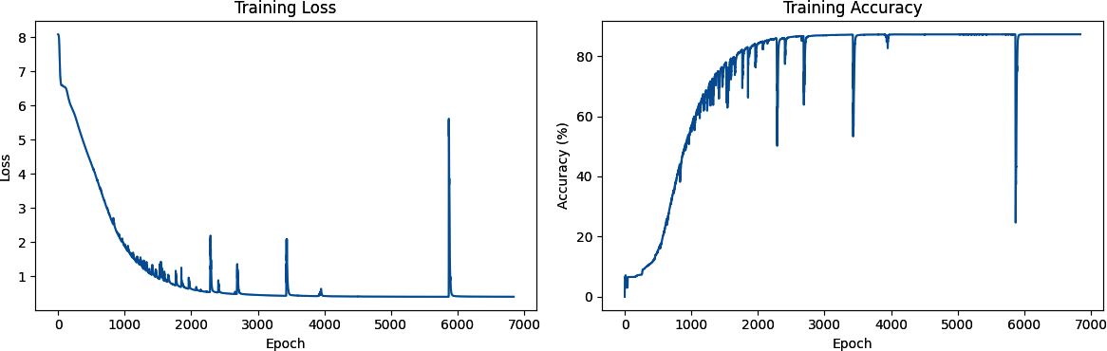

Figure 8-7. Adding a second LSTM layer

This time, when testing with the same phrases as before, I got “little” as the next word after “in the town of Athy” with a 26% probability, and I got “one” as the next word after “sweet Jeremy saw Dublin” with a 32% probability. Again, when predicting more words, the output quickly descended into gibberish.

Here are some examples:

sweet jeremy saw dublin one evening two white ever we once to raise you,

tis young i was told my heart as found has

you know nothing jon snow you should laugh all the while at me curious style,

twould set your heart a bubblin will lámh. you that

in the town of athy one jeremy lanigan do lámh. pretty generation her soul,

fell on the stony ground red we were feeble was down

**Note**

The word lámh shows up in this text, and it’s Gaelic for *hand*. And do lámh means *your hand*.

If you get different results, don’t worry—you didn’t do anything wrong, but the random initialization of the neurons will impact the final scores.

Improving the Data

There’s a little trick that you can use to extend the size of this dataset without adding any new songs. It’s called *windowing* the data. Right now, every line in every song is read as a single line and then turned into input sequences, as you saw in [Figure 8-2](https://learning.oreilly.com/library/view/ai-and-ml/9781098199166/ch08.html#ch08_figure_2_1748549671837934). While humans read songs line by line to hear rhyme and meter, the model doesn’t have to, in particular when using bidirectional LSTMs.

So, instead of taking the line “In the town of Athy, one Jeremy Lanigan,” processing that, and then moving to the next line (“Battered away ‘til he hadn’t a pound”) and processing that, we could treat all the lines as one long, continuous text. We could then create a “window” into that text of *n* words, process that, and then move the window forward one word to get the next input sequence (see [Figure 8-8](https://learning.oreilly.com/library/view/ai-and-ml/9781098199166/ch08.html#ch08_figure_8_1748549671838067)).

In this case, far more training data can be yielded in the form of an increased number of input sequences. Moving the window across the entire corpus of text would give us ((*number_of_words* – *window_size*) × *window_size*) input sequences that we could train with.

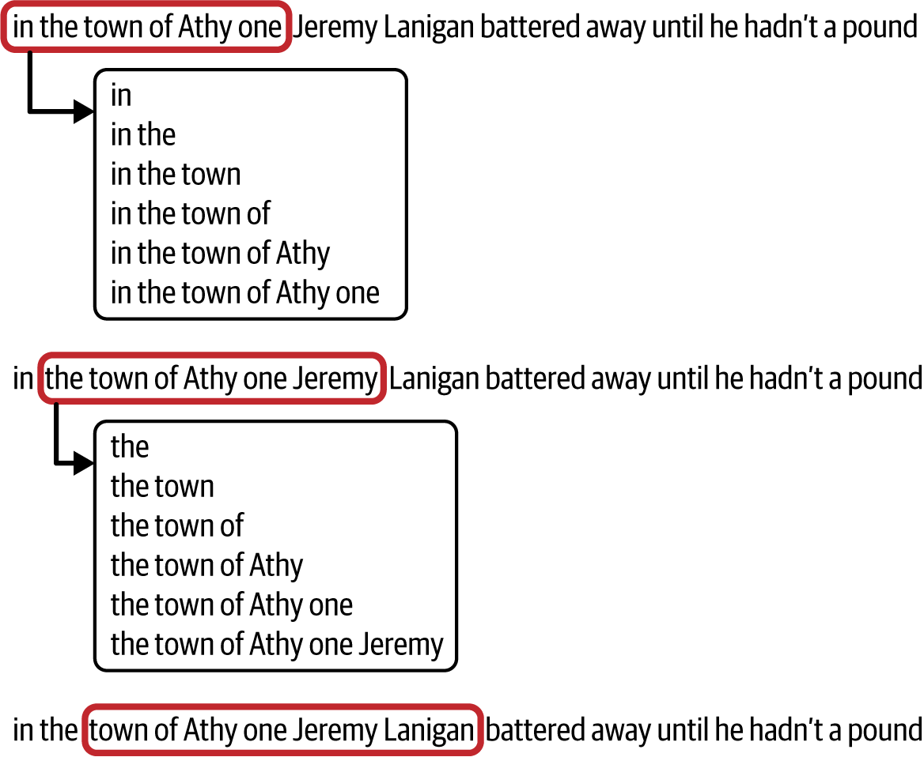

Figure 8-8. A moving word window

The code is pretty simple—when loading the data, instead of splitting each song line into a “sentence,” we can create them on the fly from the words in the corpus:

window_size=10

sentences=[]

alltext=[]

data = open('/tmp/irish-lyrics-eof.txt').read()

corpus = data.lower()

words = corpus.split(" ")

range_size = len(words)-max_sequence_len

for i in range(0, range_size):

thissentence=""

for word in range(0, window_size-1):

word = words[i+word]

thissentence = thissentence + word

thissentence = thissentence + " "

sentences.append(thissentence)

In this case, because we no longer have sentences and we’re creating sequences that are the same size as the moving window, max_sequence_len is the size of the window. The full file is read, converted to lowercase, and split into an array of words using string splitting. The code then loops through the words and makes sentences of each word from the current index up to the current index plus the window size, adding each of those newly constructed sentences to the sentences array.

**Note**

To train this, you’ll likely need a higher-memory GPU. I used the 40Gb A100 that’s available in Colab.

When training, you’ll notice that the extra data makes training much slower per epoch, but the results are greatly improved and the generated text descends into gibberish much more slowly.

Here’s an example that caught my eye—particularly the last line:

you know nothing jon snow

tell the loved ones and the friends

we would neer see again.

and the way of their guff again

and high tower might ask,

not see night unseen

There are many hyperparameters you can try to tune. Changing the window size will change the amount of training data—a smaller window size can yield more data, but there will be fewer words to give to a label, so if you set it too small, you’ll end up with nonsensical poetry. You can also change the dimensions in the embedding, the number of LSTMs, or the size of the vocabulary to use for training. Given that percentage accuracy isn’t the best measurement—you’ll want to make a more subjective examination of how much “sense” the poetry makes—there’s no hard-and-fast rule to follow to determine whether your model is “good” or not. Of course, you *will* be limited by the amount of data you have and the compute that’s available to you—the bigger the model, the more power you will need.

Ultimately, the important thing is to experiment and have fun!

Character-Based Encoding

For the last few chapters, we’ve been looking at NLP using word-based encoding. I find that much easier to get started with, but when it comes to generating text, you might also want to consider *character-based encoding* because the number of unique *characters* in a corpus tends to be a lot less than the number of unique *words*. If you use this approach, you can have a lot fewer neurons in your output layer, and your output predictions can be spread across fewer probabilities. For example, if you look at the dataset of [the complete works of Shakespeare](https://oreil.ly/XW_ab), you’ll see that there are only 65 unique characters in the entire set. Basically, Shakespeare only really used uppercase and lowercase letters and some punctuation to give a unique set of 65 characters!

So, when you are making predictions with this dataset, instead of looking at the probabilities for the next word across 2,700 words as in the Irish songs dataset, you’re only looking at 65. This makes your model a bit simpler!

What’s also nice about character-based encoding is that punctuation characters are also included, so line breaks, etc., can be predicted. As an example, when I used an RNN that was trained on the Shakespeare corpus to predict the text following on from my favorite *Game of Thrones* line, I got the following:

* YGRITTE:
  + You know nothing, Jon Snow.
  + Good night, we’ll prove those body’s servants to
  + *The traitor be these mine:*
  + *So diswarl his body in hope in this resceins,*
  + I cannot judg appeal’t.

MENENIUS:

* + Why, ’tis pompetsion.

KING RICHARD II:

* + I think he make her thought on mine;
  + She will not: suffer up thy bonds:
  + How doched it, I pray the gott,
  + We’ll no fame to this your love, and you were ends

It’s kind of cool that she identifies him as a traitor and wants to tie him up (“diswarl his body”), but I have no idea what “resceins” means! If you watch the show, this is part of the plot, so maybe Shakespeare was on to something without realizing it!

Of course, I do think we tend to be a little more forgiving when using something like Shakespeare’s texts as our training data, because the language is already a little unfamiliar.

As with the Irish songs model, the output from the Shakespeare dataset does quickly degenerate into nonsensical text, but it’s still fun to play with. To try it for yourself, you can check out the [Colab](https://oreil.ly/cbz9c). This Colab is TensorFlow based, not PyTorch based. [See the GitHub repository](https://oreil.ly/kQ7aa) for a similar example that gives different results but is PyTorch based.

Summary

In this chapter, we explored how to do basic text generation using a trained LSTM-based model. You learned how you can split text into training features and labels by using words as labels, and you also learned how create a model that, when given seed text, can predict the next likely word. Then, you iterated on this to improve the model for better results by exploring a dataset of traditional Irish songs. Hopefully, this was a fun introduction to how ML models can synthesize text and also gave you the knowledge you need to understand the foundational principles of generative AI. This approach was massively improved with the transformer architecture that underpins how LLM models like GPT and Gemini work!

Chapter 9. Understanding Sequence and Time Series Data

Time series are everywhere. You’ve probably seen them in things like weather forecasts, stock prices, and historic trends like Moore’s law. If you’re not familiar with *Moore’s law*, it predicts that the number of transistors on a microchip will roughly double every two years—and for almost 50 years, it has proven to be an accurate predictor of the future of computing power and cost (see [Figure 9-1](https://learning.oreilly.com/library/view/ai-and-ml/9781098199166/ch09.html#ch09_figure_1_1748549698128120)).

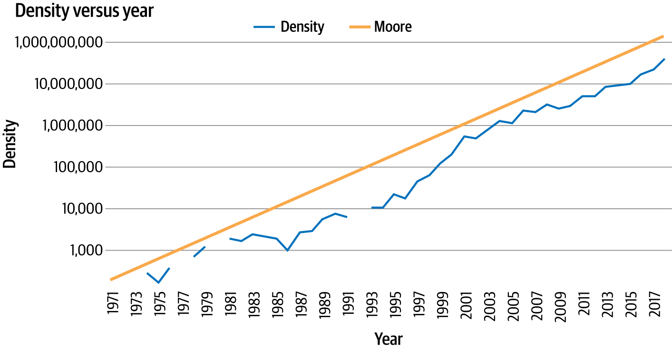

Figure 9-1. Moore’s law

**Note**

The gaps in [Figure 9-1](https://learning.oreilly.com/library/view/ai-and-ml/9781098199166/ch09.html#ch09_figure_1_1748549698128120) are missing data for that period of time, but the general trend still holds.

*Time series data* is a set of values that are spaced over time, usually in a particular order or denoting values of a thing at a timestamped point in time. When a time series is plotted on a graph, the *x*-axis is usually temporal in nature. Often, there are a number of values plotted on the time axis, such as in the example shown in [Figure 9-1](https://learning.oreilly.com/library/view/ai-and-ml/9781098199166/ch09.html#ch09_figure_1_1748549698128120), where the number of transistors is one plot and the predicted value from Moore’s law is the other. This is called a *multivariate* time series. If there’s just a single value—for example, the volume of rainfall over time—then it’s called a *univariate* time series.

With Moore’s law, predictions are simple because there’s a fixed and simple rule that allows us to roughly predict the future—a rule that has held for about 50 years.

But what about a time series like the one shown in [Figure 9-2](https://learning.oreilly.com/library/view/ai-and-ml/9781098199166/ch09.html#ch09_figure_2_1748549698128170)?

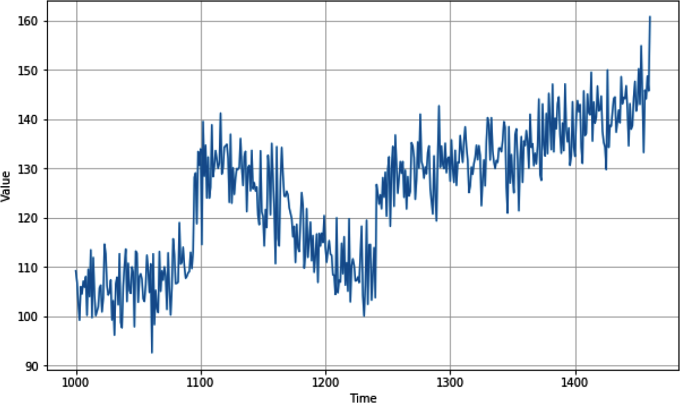

Figure 9-2. A real-world time series

While this time series was artificially created (and you’ll see how to do that later in this chapter), it has all the attributes of a complex real-world time series, like a stock chart or a chart depicting seasonal rainfall. Despite their seeming randomness, time series have some common attributes that are helpful in designing ML models that can predict them, as described in the next section.

Common Attributes of Time Series

While time series might appear random and noisy, they often have common attributes that are predictable. In this section, we’ll explore some of them.

**Trend**

Time series typically move in a specific direction. In the case of Moore’s law, it’s easy to see that over time, the values on the *y*-axis increase and there’s an upward trend. There’s also an upward trend in the time series in [Figure 9-2](https://learning.oreilly.com/library/view/ai-and-ml/9781098199166/ch09.html#ch09_figure_2_1748549698128170). Of course, this won’t always be the case: some time series may be roughly level over time, despite seasonal changes, and others may have a downward trend. For example, this is the case in the inverse version of Moore’s law that predicts the price per transistor.

**Seasonality**

Many time series have a repeating pattern over time, with the repeats happening at regular intervals called *seasons*. Consider, for example, temperature in weather. We typically have four seasons per year, with the temperature being highest in summer. So, if you plotted weather over several years, you’d see peaks happening every four seasons, giving us the concept of seasonality. But this phenomenon isn’t limited to weather—consider, for example, [Figure 9-3](https://learning.oreilly.com/library/view/ai-and-ml/9781098199166/ch09.html#ch09_figure_3_1748549698128196), which is a plot of traffic to a website.



Figure 9-3. Website traffic

It’s plotted week by week, and you can see regular dips. Can you guess what they are? The site in this case is one that provides information for software developers, and as you would expect, it gets less traffic on weekends! Thus, the time series has a seasonality of five high days and two low days. The data is plotted over several months, with the Christmas and New Year’s holidays roughly in the middle, so you can see an additional seasonality there. If I had plotted it over some years, you’d clearly see the additional end-of-year dip.

There are many ways that seasonality can manifest in a time series. Traffic to a retail website, for instance, might peak on the weekends.

**Autocorrelation**

Another feature that you may see in time series is predictable behavior after an event. You can see this in [Figure 9-4](https://learning.oreilly.com/library/view/ai-and-ml/9781098199166/ch09.html#ch09_figure_4_1748549698128218), in which there are clear spikes, but after each spike, there’s a deterministic decay. This is called *autocorrelation*.

In this case, we can see a particular set of behavior that is repeated. Autocorrelations may be hidden in a time series pattern, but they have inherent predictability, so a time series containing many autocorrelations may be predictable.

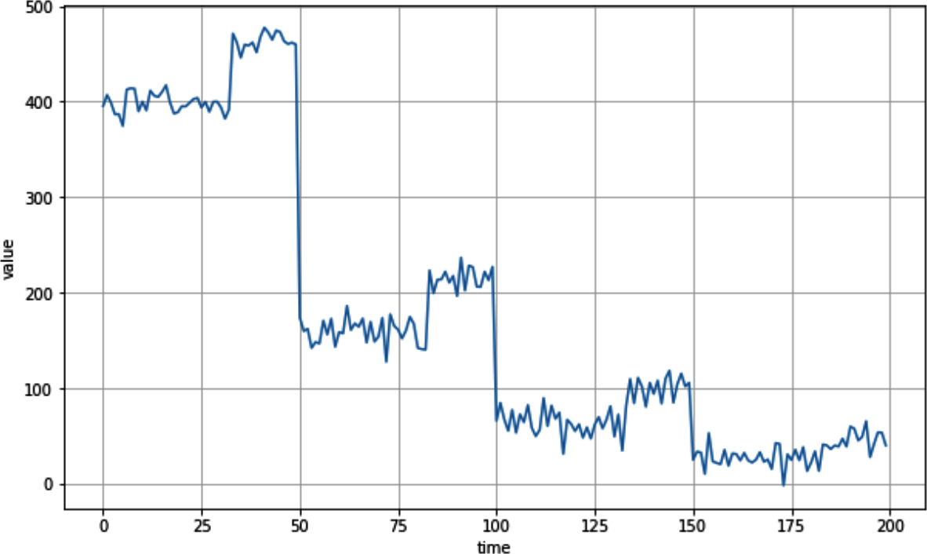

Figure 9-4. Autocorrelation

**Noise**

As its name suggests, *noise* is a set of seemingly random perturbations in a time series. These perturbations lead to a high level of unpredictability and can mask trends, seasonal behavior, and autocorrelation. For example, [Figure 9-5](https://learning.oreilly.com/library/view/ai-and-ml/9781098199166/ch09.html#ch09_figure_5_1748549698128240) shows the same autocorrelation from [Figure 9-4](https://learning.oreilly.com/library/view/ai-and-ml/9781098199166/ch09.html#ch09_figure_4_1748549698128218) but with a little noise added. Suddenly, it’s much harder to see the autocorrelation and predict values.

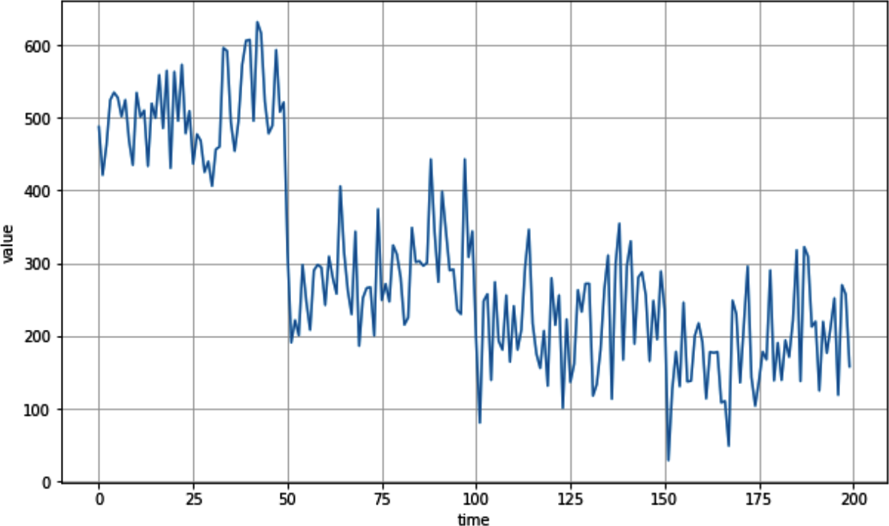

Figure 9-5. Autocorrelated series with added noise

Given all of these factors, let’s explore how you can make predictions on time series that contain these attributes.

Techniques for Predicting Time Series

Before we get into ML-based prediction—which is the topic of the next few chapters—we’ll explore some more naive prediction methods. These will enable you to establish a baseline that you can use to measure the accuracy of your ML predictions.

**Naive Prediction to Create a Baseline**

The most basic method to predict a time series is to say that the predicted value at time *t* + 1 is the same as the value from time *t*, effectively shifting the time series by a single period.

Let’s begin by creating a time series that has trend, seasonality, and noise:

def plot_series(time, series, format="-", start=0, end=None):

plt.plot(time[start:end], series[start:end], format)

plt.xlabel("Time")

plt.ylabel("Value")

plt.grid(True)

def trend(time, slope=0):

return slope * time

def seasonal_pattern(season_time):

"""Just an arbitrary pattern, you can change it if you wish"""

return np.where(season_time < 0.4,

np.cos(season_time * 2 * np.pi),

1 / np.exp(3 * season_time))

def seasonality(time, period, amplitude=1, phase=0):

"""Repeats the same pattern at each period"""

season_time = ((time + phase) % period) / period

return amplitude * seasonal_pattern(season_time)

def noise(time, noise_level=1, seed=None):

rnd = np.random.RandomState(seed)

return rnd.randn(len(time)) * noise_level

time = np.arange(4 * 365 + 1, dtype="float32")

baseline = 10

series = trend(time, .05)

baseline = 10

amplitude = 15

slope = 0.09

noise_level = 6

# Create the series

series = baseline + trend(time, slope)

+ seasonality(time, period=365, amplitude=amplitude)

# Update with noise

series += noise(time, noise_level, seed=42)

After plotting this, you’ll see something like [Figure 9-6](https://learning.oreilly.com/library/view/ai-and-ml/9781098199166/ch09.html#ch09_figure_6_1748549698128263).

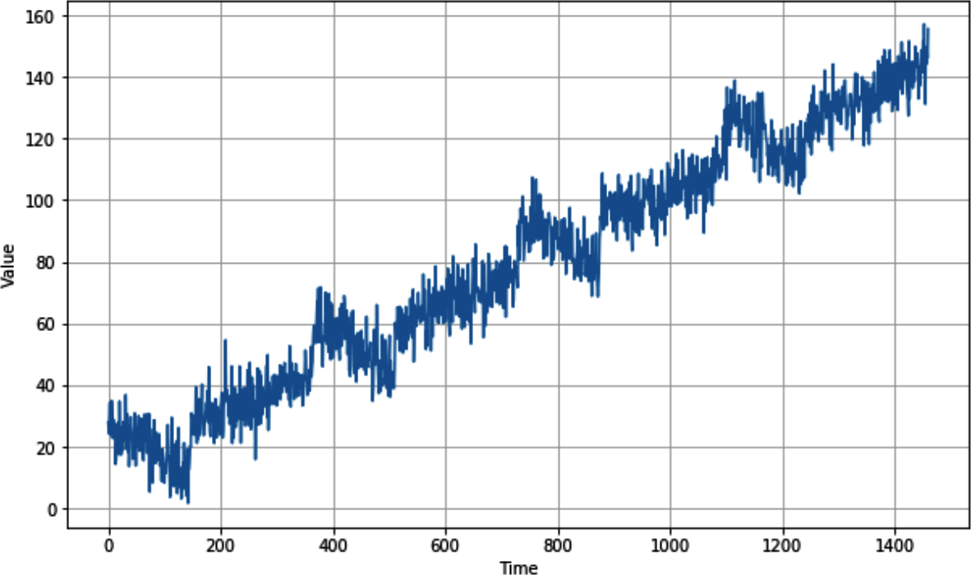

Figure 9-6. A time series showing trend, seasonality, and noise

Now that you have the data, you can split it like any data source into a training set, a validation set, and a test set. When there’s some seasonality in the data, as you can see in this case, it’s a good idea when splitting the series to ensure that there are whole seasons in each split. So, for example, if you wanted to split the data in [Figure 9-6](https://learning.oreilly.com/library/view/ai-and-ml/9781098199166/ch09.html#ch09_figure_6_1748549698128263) into training and validation sets, a good place to do this might be at time step 1,000, which would give you training data up to step 1,000 and validation data after step 1,000.

However, you don’t actually need to do the split here because you’re just doing a naive forecast where each value *t* is simply the value at step *t* – 1, but for the purposes of illustration in the next few figures, we’ll zoom in on the data from time step 1,000 onward.

To predict the series from a split time period onward, where the period that you want to split from is in the variable split_time, you can use code like this:

naive_forecast = series[split_time – 1:–1]

[Figure 9-7](https://learning.oreilly.com/library/view/ai-and-ml/9781098199166/ch09.html#ch09_figure_7_1748549698128284) shows the validation set (from time step 1,000 onward, which you get by setting split_time to 1000) with the naive prediction overlaid.

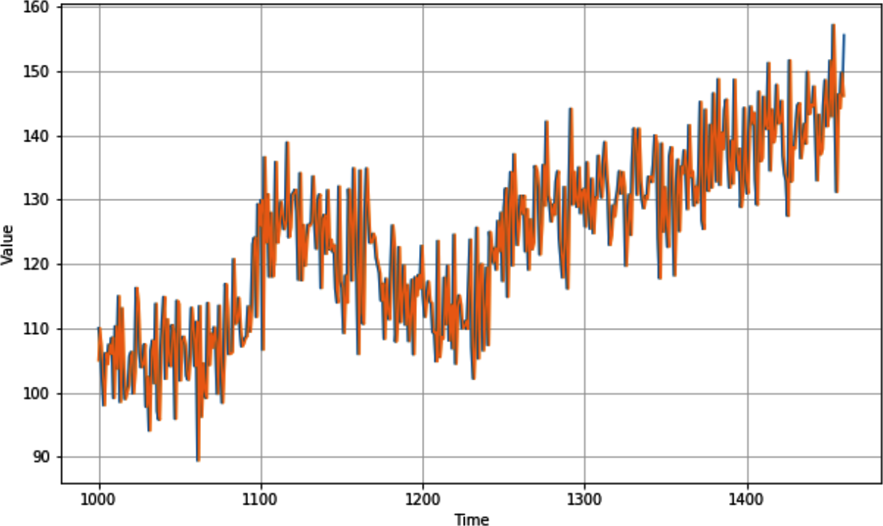

Figure 9-7. Naive forecast on time series

It looks pretty good—there is a relationship between the values—and, when charted over time, the predictions appear to closely match the original values. But how would you measure the accuracy?

**Measuring Prediction Accuracy**

There are a number of ways to measure prediction accuracy, but we’ll concentrate on two of them: the *mean squared error* (MSE) and *mean absolute error* (MAE).

With MSE, you simply take the difference between the predicted value and the actual value at time *t*, square it (to remove negatives), and then find the average of all of them.

With MAE, you calculate the difference between the predicted value and the actual value at time *t*, take its absolute value to remove negatives (instead of squaring), and find the average of all of them.

For the naive forecast you just created based on our synthetic time series, you can get the MSE and MAE like this:

import torch

import torch.nn.functional as F

# Mean Squared Error

mse = F.mse_loss(torch.tensor(x_valid), torch.tensor(naive_forecast)).item()

print(mse)

# Mean Absolute Error

mae = F.l1_loss(torch.tensor(x_valid), torch.tensor(naive_forecast)).item()

print(mae)

I got an MSE of 76.47 and an MAE of 6.89. As with any prediction, if you can reduce the error, you can increase the accuracy of your predictions. We’ll look at how to do that next.

**Less Naive Predictions: Using a Moving Average for Prediction**

The previous naive prediction took the value at time *t* – 1 to be the forecasted value at time *t*. Using a *moving average* is similar, but instead of just taking the value from *t* – 1, it takes a group of values (say, 30), averages them out, and sets that average value to be the predicted value at time *t*. Here’s the code:

def moving_average_forecast(series, window_size):

"""Forecasts the mean of the last few values.

If window_size=1, then this is equivalent to naive forecast"""

forecast = []

for time in range(len(series) – window_size):

forecast.append(series[time:time + window_size].mean())

return np.array(forecast)

moving_avg = moving_average_forecast(series, 30)[split_time - 30:]

plt.figure(figsize=(10, 6))

plot_series(time_valid, x_valid)

plot_series(time_valid, moving_avg)

[Figure 9-8](https://learning.oreilly.com/library/view/ai-and-ml/9781098199166/ch09.html#ch09_figure_8_1748549698128303) shows the plot of the moving average against the data.

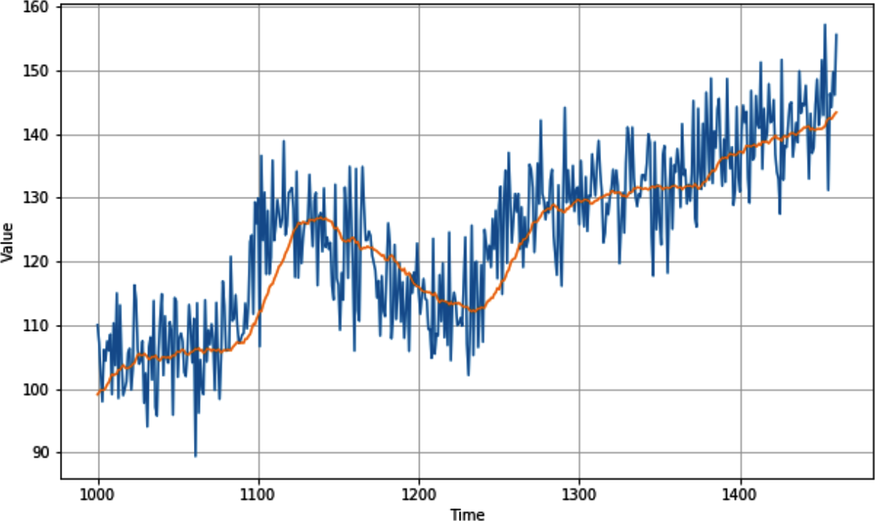

Figure 9-8. Plotting the moving average

When I plotted this time series, I got an MSE and MAE of 49 and 5.5, respectively, so it definitely improved the prediction a little. But this approach doesn’t take into account the trend or the seasonality, so we may be able to improve it further with a little analysis.

**Improving the Moving-Average Analysis**

Given that the seasonality in this time series is 365 days, you can smooth out the trend and seasonality by using a technique called *differencing*, which just subtracts the value at *t* – 365 from the value at *t*. This will flatten out the diagram. Here’s the code:

diff_series = (series[365:] – series[:-365])

diff_time = time[365:]

You can now calculate a moving average of *these* values and add back in the past values:

diff_moving_avg =

moving_average_forecast(diff_series, 50)[split_time – 365 – 50:]

diff_moving_avg_plus_smooth_past =

moving_average_forecast(series[split_time – 370:–360], 10) +

diff_moving_avg

When you plot this (see [Figure 9-9](https://learning.oreilly.com/library/view/ai-and-ml/9781098199166/ch09.html#ch09_figure_9_1748549698128324)), you can already see an improvement in the predicted values: the trend line is very close to the actual values, albeit with the noise smoothed out. Seasonality seems to work, as does the trend.

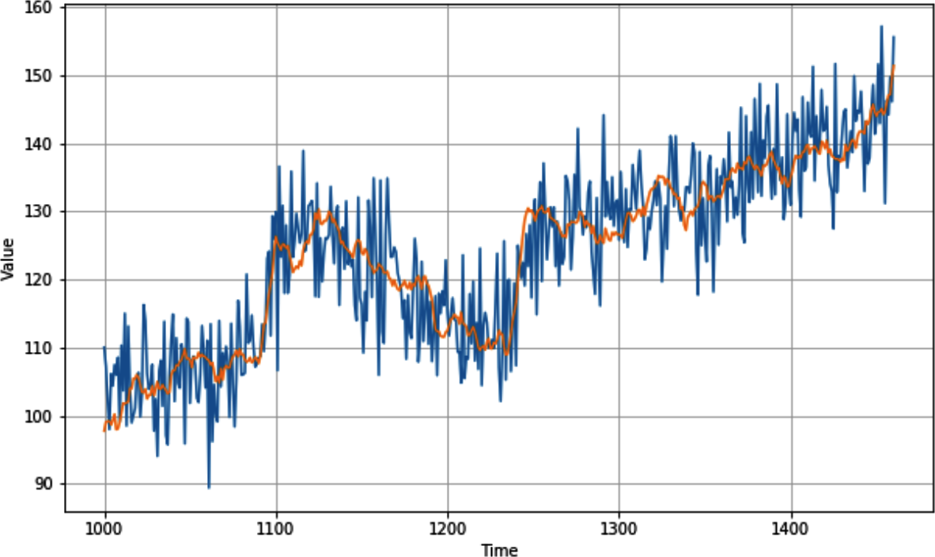

Figure 9-9. Improved moving average

This impression is confirmed when you calculate the MSE and MAE—in this case, I got 40.9 and 5.13, respectively, showing a clear improvement in the predictions.

Summary

This chapter introduced time series data and some of the common attributes of time series. You created a synthetic time series and saw how you can start making naive predictions on it, and from these predictions, you established baseline measurements using MSE and MAE. Synthetic data is also a really cool area for exploration—and hopefully, some of the techniques you explored in this chapter will be useful on your learning journey.

This chapter was a nice break from PyTorch and ML, but in the next chapter, you’ll go back to using ML to see if it can improve prediction

Chapter 10. Creating ML Models to Predict Sequences

[Chapter 9](https://learning.oreilly.com/library/view/ai-and-ml/9781098199166/ch09.html#ch09_understanding_sequence_and_time_series_data_1748549698134578) introduced sequence data and the attributes of a time series, including seasonality, trend, autocorrelation, and noise. You created a synthetic series to use for predictions, and you explored how to do basic statistical forecasting.

Over the next couple of chapters, you’ll learn how to use ML for forecasting. But before you start creating models, you need to understand how to structure the time series data for training predictive models by creating what we’ll call a *windowed dataset.*

To understand why you need to do this, consider the time series you created in [Chapter 9](https://learning.oreilly.com/library/view/ai-and-ml/9781098199166/ch09.html#ch09_understanding_sequence_and_time_series_data_1748549698134578). You can see a plot of it in [Figure 10-1](https://learning.oreilly.com/library/view/ai-and-ml/9781098199166/ch10.html#ch10_figure_1_1748549713788310).

If at any point, you want to predict a value at time *t*, you’ll want to predict it as a function of the values preceding time *t*. For example, say you want to predict the value of the time series at time step 1,200 as a function of the 30 values preceding it. In this case, the values from time steps 1,170 to 1,199 would determine the value at time step 1,200 (see [Figure 10-2](https://learning.oreilly.com/library/view/ai-and-ml/9781098199166/ch10.html#ch10_figure_2_1748549713788360)).

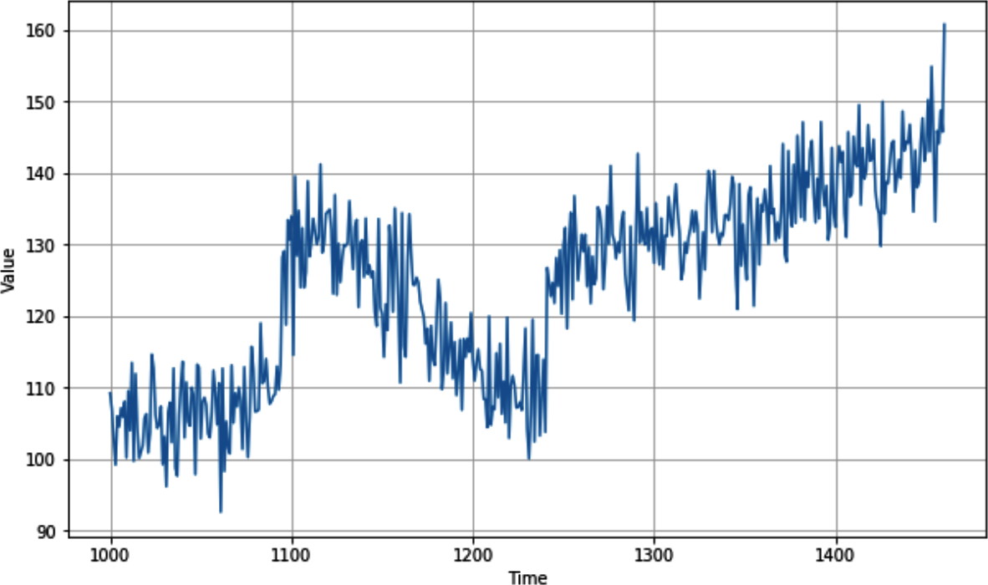

Figure 10-1. Synthetic time series

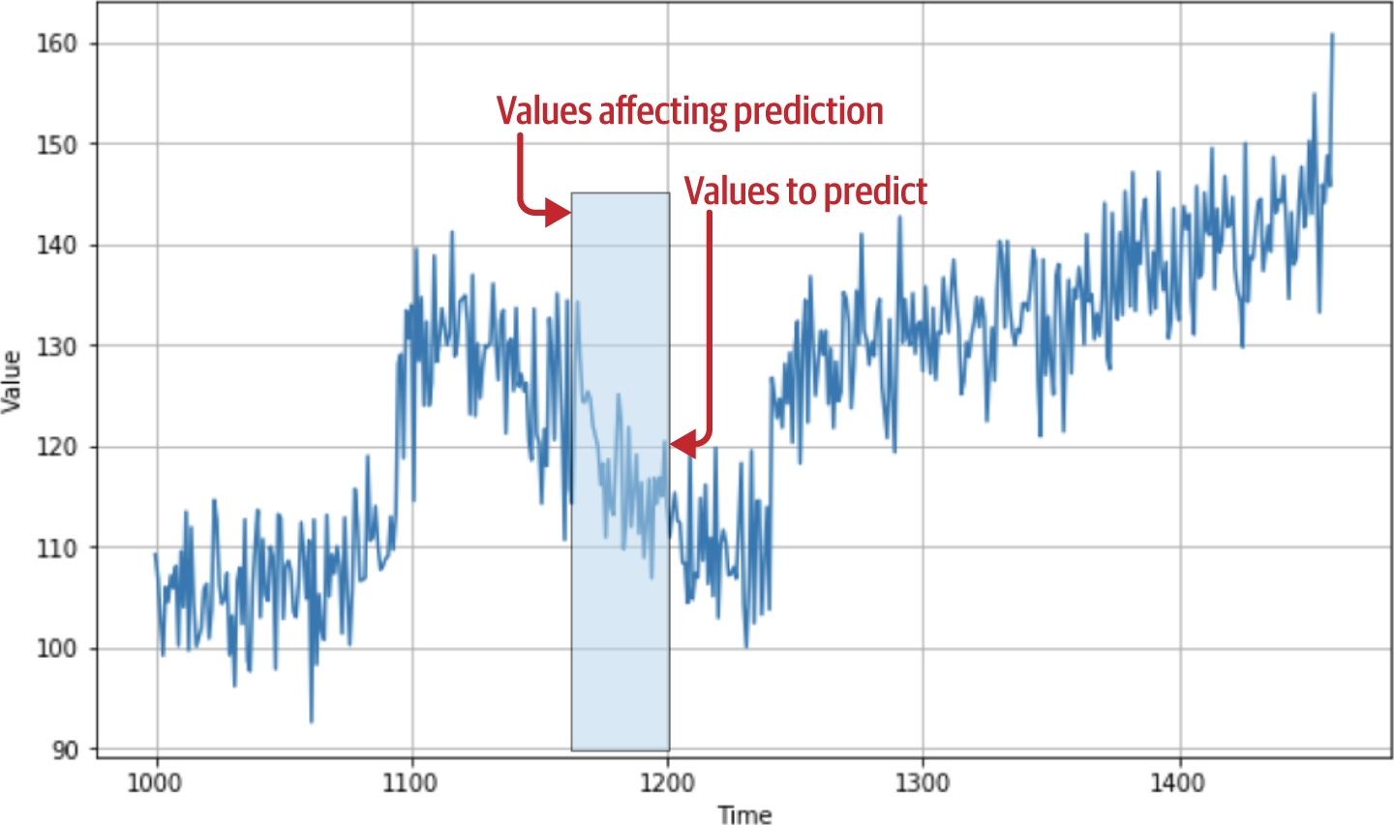

Figure 10-2. Previous values impacting prediction

Now, this begins to look familiar: you can consider the values from 1,170 to 1,199 to be your *features* and the value at 1,200 to be your *label*. If you can get your dataset into a condition where you have a certain number of values as features and the following value as the label, and if you do this for every known value in the dataset, then you’ll end up with a pretty decent set of features and labels that you can use to train a model.

Before doing this for the time series dataset from [Chapter 9](https://learning.oreilly.com/library/view/ai-and-ml/9781098199166/ch09.html#ch09_understanding_sequence_and_time_series_data_1748549698134578), let’s create a very simple dataset that has all the same attributes but a much smaller amount of data.

Creating a Windowed Dataset

PyTorch has a lot of APIs that are useful for manipulating data. For example, you can use torch.arange(10) to create a basic dataset containing the numbers 0–9, thus emulating a time series. You can then turn that dataset into the beginnings of a windowed dataset. Here’s the code:

import torch

def create_sliding_windows(data, window_size, shift=1):

# Convert input to tensor if it isn't already

if not isinstance(data, torch.Tensor):

data = torch.tensor(data)

# Calculate number of valid windows

n = len(data)

num_windows = max(0, (n – window_size) // shift + 1)

# Create strided view of data

windows = data.unfold(0, window_size, shift)

return windows

# Example usage:

data = torch.arange(10)

windows = create_sliding_windows(data, window_size=5, shift=1)

# Print each window

for window in windows:

print(window.numpy())

First, it creates the dataset by using a range, which simply makes the dataset contain the values 0 to *n* – 1, where *n* is, in this case, 10.

Next, calling create_sliding_windows and passing a parameter of 5 specifies that the network should split the dataset into windows of five items. Specifying shift=1 causes each window to then be shifted one spot from the previous one: the first window will contain the five items beginning at 0, the next window will contain the five items beginning at 1, etc.

Running this code will give you the following result:

[0 1 2 3 4]

[1 2 3 4 5]

[2 3 4 5 6]

[3 4 5 6 7]

[4 5 6 7 8]

[5 6 7 8 9]

Earlier, you saw that we want to make training data out of this, where there are *n* values defining a feature and there is a subsequent value giving a label. You can do this with some simple Python list slicing that splits each window into two things: everything before the last value and the last value only.

This uses the unfold technique on tensor data, which creates a sliding window over your data to turn it into sets like those outlined previously.

It also takes three parameters:

*Dimension (0 in this case)*

This is the dimension along which to unfold.

*window_size*

This is the size of each sliding window.

*shift*

This is the stride/step size between windows.

This process gives us an *x* and a *y* dataset, as shown here:

import torch

def create_sliding_windows_with_target(data, window_size, shift=1):

# Convert input to tensor if it isn't already

if not isinstance(data, torch.Tensor):

data = torch.tensor(data, dtype=torch.float32)

# Create windows using unfold

windows = data.unfold(0, window_size, shift)

# Split each window into features

features = windows[:, :–1] # All elements except the last

targets = windows[:, –1:] # Just the last element

return features, targets

# Example usage:

data = torch.arange(10)

features, targets = create_sliding_windows_with_target(data, window_size=5,

shift=1)

# Print each window's features and target

for x, y in zip(features, targets):

print(f"Features: {x.numpy()}, Target: {y.numpy()}")

The results are now in line with what you’d expect. The first four values in the window can be thought of as the features, with the subsequent value being the label:

[0 1 2 3] [4]

[1 2 3 4] [5]

[2 3 4 5] [6]

[3 4 5 6] [7]

[4 5 6 7] [8]

[5 6 7 8] [9]

Now, with the PyTorch TensorDataset type, you can turn this into a dataset and do things like shuffling and batching natively.

Note that when shuffling data, it’s good practice to ensure that the validation and test datasets are separated first. In time series data, shuffling before the split can cause information from the training set to bleed into the test set, which would compromise the evaluation process.

Here, it’s been shuffled and batched with a batch size of 2:

from torch.utils.data import TensorDataset, DataLoader

# Create dataset

data = torch.arange(10)

features, targets = create_sliding_windows_with_target(data, window_size=5,

shift=1)

# Combine features and targets into a dataset

dataset = TensorDataset(features, targets)

# Create DataLoader with shuffling and batching

batch_size = 2

dataloader = DataLoader(dataset, batch_size=batch_size, shuffle=True)

# Example iteration

for batch_features, batch_targets in dataloader:

print(f"Batch features shape: {batch_features.shape}")

print(f"Features:\n{batch_features}")

print(f"Targets:\n{batch_targets}\n")

The results show that the first batch has two sets of *x* (starting at 5 and 0, respectively) with their labels, the second batch has two sets of *x* (starting at 1 and 3, respectively) with their labels, and so on:

tensor([[5, 6, 7, 8],

[0, 1, 2, 3]])

Targets:

tensor([[9],

[4]])

Features:

tensor([[1, 2, 3, 4],

[3, 4, 5, 6]])

Targets:

tensor([[5],

[7]])

Features:

tensor([[4, 5, 6, 7],

[2, 3, 4, 5]])

Targets:

tensor([[8],

[6]])

With this technique, you can now turn any time series dataset into a set of training data for a neural network. In the next section, you’ll explore how to take the synthetic data from [Chapter 9](https://learning.oreilly.com/library/view/ai-and-ml/9781098199166/ch09.html#ch09_understanding_sequence_and_time_series_data_1748549698134578) and create a training set from it. From there, you’ll move on to creating a simple DNN that is trained on this data and can be used to predict future values.

**Creating a Windowed Version of the Time Series Dataset**

As a recap, here’s the code we used in the previous chapter to create a synthetic time series dataset:

import numpy as np

def trend(time, slope=0):

return slope * time

def seasonal_pattern(season_time):

return np.where(season_time < 0.4,

np.cos(season_time * 2 * np.pi),

1 / np.exp(3 * season_time))

def seasonality(time, period, amplitude=1, phase=0):

season_time = ((time + phase) % period) / period

return amplitude * seasonal_pattern(season_time)

def noise(time, noise_level=1, seed=None):

rnd = np.random.RandomState(seed)

return rnd.randn(len(time)) * noise_level

time = np.arange(4 * 365 + 1, dtype="float32")

series = trend(time, 0.1)

baseline = 10

amplitude = 20

slope = 0.09

noise_level = 5

series = baseline + trend(time, slope)

series += seasonality(time, period=365, amplitude=amplitude)

series += noise(time, noise_level, seed=42)

This will create a time series that looks like the one in [Figure 10-3](https://learning.oreilly.com/library/view/ai-and-ml/9781098199166/ch10.html#ch10_figure_3_1748549713788388). If you want to change it, feel free to tweak the values of the various constants.

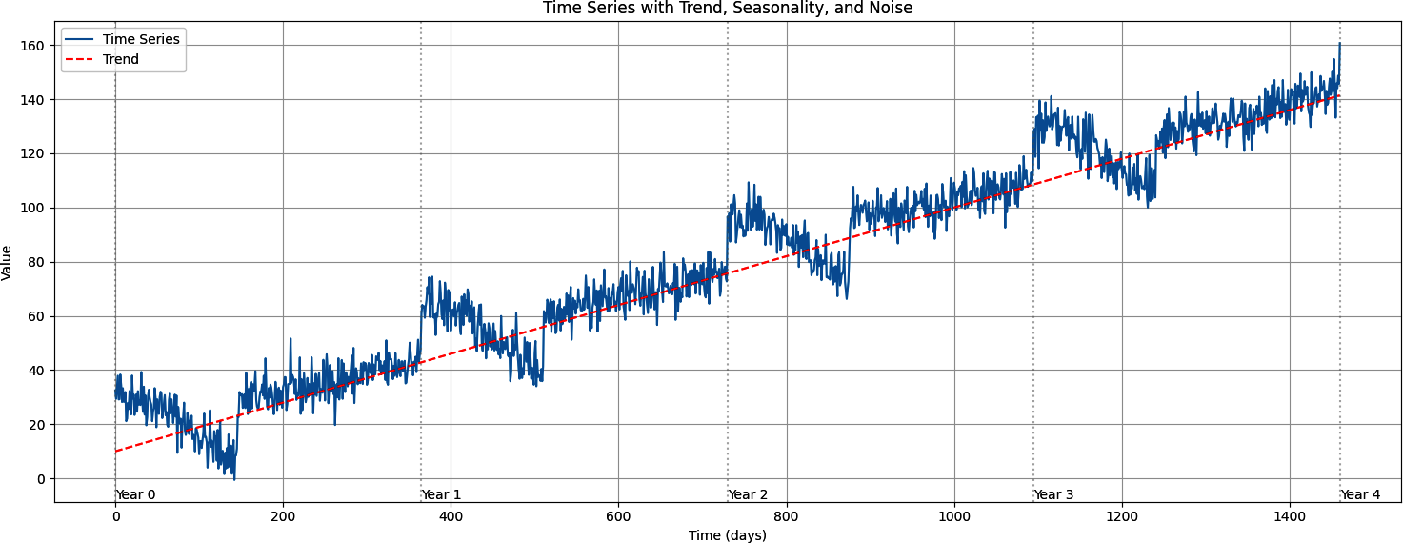

Figure 10-3. Plotting the time series with trend, seasonality, and noise

Once you have the series, you can turn it into a windowed dataset with code similar to that in the previous section:

import torch

from torch.utils.data import TensorDataset, DataLoader

# Convert the numpy series to a PyTorch tensor

series_tensor = torch.tensor(series, dtype=torch.float32)

# Create windowed dataset with 30-day windows (predicting next day)

window_size = 30

features, targets = create_sliding_windows_with_target(

series_tensor, window_size=window_size, shift=1)

# Create PyTorch Dataset and DataLoader

dataset = TensorDataset(features, targets)

batch_size = 32

train_loader = DataLoader(dataset, batch_size=batch_size, shuffle=True)

# Print some information about the dataset

print(f"Series length: {len(series)}")

print(f"Number of windows: {len(features)}")

print(f"Feature shape: {features.shape}") # Should be (num_windows,

window_size-1)

print(f"Target shape: {targets.shape}") # Should be (num_windows, 1)

# Show a few examples

print("\nFirst few windows:")

for i in range(3):

print(f"\nWindow {i+1}:")

print(f"Features (previous {window_size-1} days): {features[i].numpy()}")

print(f"Target (next day): {targets[i].item():.2f}")

You can see the output here:

Series length: 1461

Number of windows: 1432

Feature shape: torch.Size([1432, 29])

Target shape: torch.Size([1432, 1])

First few windows:

Window 1:

Features (previous 29 days): [32.48357 29.395714 33.40659 37.858486

29.14184 29.20528 38.32948 34.322147 28.183279 33.283253 28.287313

28.303862 31.864614 21.104889 22.057411 27.875519 25.622026 32.25094

26.127428 23.588236 37.95459 29.468477 30.900469 23.39905 27.755371

30.980967 24.615065 32.186863 27.23822 ]

Target (next day): 28.71

Window 2:

Features (previous 29 days): [29.395714 33.40659 37.858486 29.14184

29.20528 38.32948 34.322147 28.183279 33.283253 28.287313 28.303862

31.864614 21.104889 22.057411 27.875519 25.622026 32.25094 26.127428

23.588236 37.95459 29.468477 30.900469 23.39905 27.755371 30.980967

24.615065 32.186863 27.23822 28.710733]

Target (next day): 27.08

Window 3:

Features (previous 29 days): [33.40659 37.858486 29.14184 29.20528

38.32948 34.322147 28.183279 33.283253 28.287313 28.303862 31.864614

21.104889 22.057411 27.875519 25.622026 32.25094 26.127428 23.588236

37.95459 29.468477 30.900469 23.39905 27.755371 30.980967 24.615065

32.186863 27.23822 28.710733 27.083256]

Target (next day): 39.27

To train a model with this data, you’ll split the series into training and validation datasets. In this case, we’ll train on 1,000 records by splitting the list and turning it into train_dataset and val_dataset subsets. This uses the Subset class from torch.utils.data.

You can then load these with a DataLoader, as we saw in [Chapter 3](https://learning.oreilly.com/library/view/ai-and-ml/9781098199166/ch03.html#ch03_going_beyond_the_basics_detecting_features_in_ima_1748570891074912):

train_size = 1000

total_windows = len(full_dataset)

train_indices = list(range(train_size))

val_indices = list(range(train_size, total_windows))

# Create training and validation datasets using Subset

train_dataset = Subset(full_dataset, train_indices)

val_dataset = Subset(full_dataset, val_indices)

# Create DataLoaders

batch_size = 32

train_loader = DataLoader(train_dataset, batch_size=batch_size, shuffle=True)

val_loader = DataLoader(val_dataset, batch_size=batch_size, shuffle=False)

The important thing to remember now is that your data is a dataset, so you can easily use it in model training without further coding.

If you want to inspect what the data looks like, you can do so with code like this:

features, target = train_dataset[0]

print("First window:")

print(f"Features shape: {features.shape}")

print(f"Features: {features.numpy()}")

print(f"Target: {target.item()}\n")

Here, the batch_size is set to 1, just to make the results more readable. You’ll therefore end up with output like this, in which a single set of data is in the batch:

First window:

Features shape: torch.Size([29])

Features: [32.48357 29.395714 33.40659 37.858486 29.14184 29.20528 38.32948

34.322147 28.183279 33.283253 28.287313 28.303862 31.864614 21.104889

22.057411 27.875519 25.622026 32.25094 26.127428 23.588236 37.95459

29.468477 30.900469 23.39905 27.755371 30.980967 24.615065 32.186863

27.23822 ]

Target: 28.71073341369629

The first batch of numbers are the features. We’ve set the window size to 30, so it’s a 1 × 30 tensor. The second number is the label (28.710 in this case), which the model will try to fit the features to. You’ll see how that works in the next section.

Creating and Training a DNN to Fit the Sequence Data

Now that you have the data, creating a neural network model becomes very straightforward. Let’s first explore a simple DNN. Here’s the model definition:

# Define the model

class TimeSeriesModel(nn.Module):

def __init__(self, window_size):

super(TimeSeriesModel, self).__init__()

# window_size-1 because our features are window_size-1

self.network = nn.Sequential(

nn.Linear(window_size-1, 10),

nn.ReLU(),

nn.Linear(10, 10),

nn.ReLU(),

nn.Linear(10, 1)

)

def forward(self, x):

return self.network(x)

It’s a super-simple model with three linear layers, the first of which accepts the input shape of window_size and then a hidden layer of 10 neurons, before an output layer that will contain the predicted value.

The model is initialized with a loss function and optimizer, as before:

# Initialize model, loss function, and optimizer

model = TimeSeriesModel(window_size)

criterion = nn.MSELoss()

optimizer = optim.Adam(model.parameters())

In this case, the loss function is specified as MSELoss, which stands for “mean squared error” and is commonly used in regression problems (which is what this ultimately boils down to). For the optimizer, Adam is a good fit. I won’t go into detail on these types of functions in this book, but any good resource on ML will teach you about them—Andrew Ng’s seminal “[Deep Learning Specialization](https://oreil.ly/A8QzN)” on Coursera is a great place to start.

Training is then pretty standard. It’s composed of loading the batches from the training loader and performing a forward pass with them, followed by a backward pass with optimization:

for batch_features, batch_targets in train_loader:

batch_features = batch_features.to(device)

batch_targets = batch_targets.to(device)

# Forward pass

outputs = model(batch_features)

loss = criterion(outputs, batch_targets)

# Backward pass and optimize

optimizer.zero_grad()

loss.backward()

optimizer.step()

train_loss += loss.item()

Given that we also have a validation dataset, we can also perform a validation pass for each epoch:

# Validation phase

model.eval()

val_loss = 0

with torch.no_grad():

for batch_features, batch_targets in val_loader:

batch_features = batch_features.to(device)

batch_targets = batch_targets.to(device)

outputs = model(batch_features)

val_loss += criterion(outputs, batch_targets).item()

# Calculate average losses

train_loss /= len(train_loader)

val_loss /= len(val_loader)

train_losses.append(train_loss)

val_losses.append(val_loss)

As you train, you’ll see the loss function report a number that will start high but decline steadily. [Figure 10-4](https://learning.oreilly.com/library/view/ai-and-ml/9781098199166/ch10.html#ch10_figure_4_1748549713788413) shows the loss over 100 epochs.

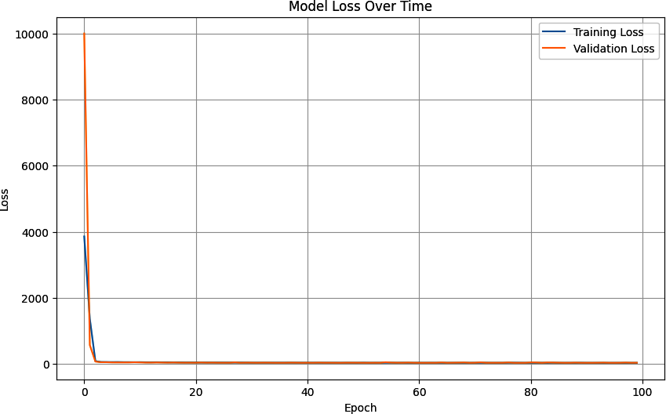

Figure 10-4. The DNN predictor of model loss over time for the time series data

Evaluating the Results of the DNN

Once you have a trained DNN, you can start predicting with it. But remember, you have a windowed dataset, so the prediction for a given point is based on the values of a certain number of time steps before it.

Also, given that the dataset is batched, we can easily use the loaders to access batches and explore what it looks like to predict on them.

Here’s the code. We iterate through each batch in the loader and get the features and targets, and then we can get the predictions for the batch by sending the batch to the model:

for batch_features, batch_targets in val_loader:

batch_features = batch_features.to(device)

predictions = model(batch_features)

val_predictions.extend(predictions.cpu().numpy())

val_targets.extend(batch_targets.numpy())

The predictions are then converted from PyTorch tensors into NumPy arrays using .numpy(), and then the batches are turned into a single list with the extend() call.

You might have also noticed the .cpu() in this code. PyTorch allows you to designate *where* your code runs, and if you have a GPU or other accelerator available, you can push the intense calculations of ML to it. You can also use a CPU to do other things like processing and preprocessing data to save accelerator time. This code allows you to explicitly express that.

So, you can then compare your predictions with the actual values quite easily. Here’s the code you use to plot the predicted values against the actual ones using matplotlib:

# Make predictions

model.eval()

with torch.no_grad():

# Get predictions for validation set

val_predictions = []

val_targets = []

for batch_features, batch_targets in val_loader:

batch_features = batch_features.to(device)

outputs = model(batch_features)

val_predictions.extend(outputs.cpu().numpy())

val_targets.extend(batch_targets.numpy())

# Plot predictions vs actual for validation set

plt.figure(figsize=(15, 6))

plt.plot(val_targets, label='Actual', color="lightgrey")

plt.plot(val_predictions, label='Predicted', color="red")

plt.title('Predictions vs Actual Values (Validation Set)')

plt.xlabel('Time')

plt.ylabel('Value')

plt.legend()

plt.grid(True)

plt.show()

You can see the results of this in [Figure 10-5](https://learning.oreilly.com/library/view/ai-and-ml/9781098199166/ch10.html#ch10_figure_5_1748549713788437). The line for the predicted values (in red) closely matches the overall pattern of the original data, but it’s less noisy, with a lot less variance.

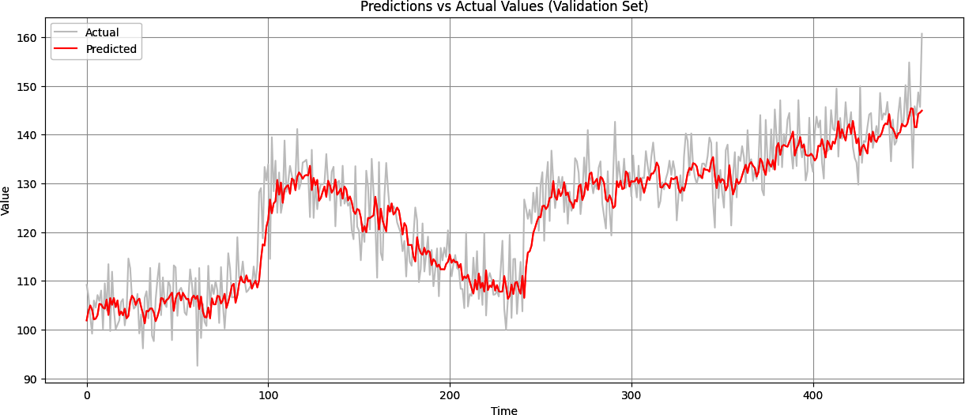

Figure 10-5. Predicted versus actual values in the validation set

From a quick visual inspection, you can see that the prediction isn’t bad because it’s generally following the curve of the original data. When there are rapid changes in the data, the prediction takes a little time to catch up, but on the whole, it isn’t bad.

However, it’s hard to be precise when eyeballing the curve. It’s best to have a good metric, and in [Chapter 9](https://learning.oreilly.com/library/view/ai-and-ml/9781098199166/ch09.html#ch09_understanding_sequence_and_time_series_data_1748549698134578) you learned about one—the MAE. Now that you have the valid data and the results, you can measure the MAE with this code by using torch.mean and torch.abs:

val_predictions_tensor = torch.tensor(val_predictions)

val_targets_tensor = torch.tensor(val_targets)

mae_torch = torch.mean(torch.abs(

val_predictions_tensor – val_targets_tensor))

print(f"Validation MAE (PyTorch): {mae_torch:.4f}")

Randomness has been introduced into the data, so your results may vary, but when I tried it, I got a value of 4.57 as the MAE.

You could also argue that at this point, the process of getting the predictions as accurate has become the process of minimizing that MAE. There are some techniques that you can use to do this, including the obvious changing of the window size. I’ll leave you to experiment with that, but in the next section, you’ll do some basic hyperparameter tuning on the optimizer to improve how your neural network learns, and see what impact that will have on the MAE.

Tuning the Learning Rate

In the previous example, you might recall that you compiled the model with an optimizer that looked like this:

optimizer = optim.Adam(model.parameters())

In that case, you didn’t specify an LR, so the model used the default LR of 1 × 10**–3**. But that seemed to be a really arbitrary number. What if you changed it, and how should you go about changing it? It would take a lot of experimentation to find the best rate.

One way to experiment with this is by using a torch.optim.lr_scheduler, which can change the LR on the fly, epoch by epoch, as the model trains.

A good practice is to start with a higher LR and gradually reduce it as the network learns. Here’s an example:

optimizer = optim.Adam(model.parameters(), lr=0.01)

In this case, you’re going to start the LR at 1e – 2, which is really high. However, you can set a scheduler to multiply the LR rate by a “gamma” amount every *n* epochs. So, for example, the following code will change it every 30 epochs. We’ll start at 0.01, and then, after the thirtieth epoch, it will multiply the LR by .1 to get 0.001. After 60, it will be 0.0001, etc.:

scheduler = lr_scheduler.StepLR(optimizer, step_size=30, gamma=0.1)

When we run the scheduler like this, the performance improves a little—giving MAE of 4.36.

You can continue to explore like this by tweaking the LR and also the size of the window—30 days of data to predict 1 day may not be enough, so you might want to try a window of 40 days. Also, try training for more epochs. With a bit of experimentation, you could get an MAE of close to 4, which isn’t bad.

Summary

In this chapter, you took the statistical analysis of the time series from [Chapter 9](https://learning.oreilly.com/library/view/ai-and-ml/9781098199166/ch09.html#ch09_understanding_sequence_and_time_series_data_1748549698134578) and applied ML to try to do a better job of prediction. ML really is all about pattern matching, and, as expected, you were able to quickly create a deep neural network to spot the patterns with low error before exploring some hyperparameter tuning to improve the accuracy further.

In [Chapter 11](https://learning.oreilly.com/library/view/ai-and-ml/9781098199166/ch11.html#ch11_using_convolutional_and_recurrent_methods_for_sequ_1748549734762226), you’ll go beyond a simple DNN and examine the implications of using an RNN to predict sequential values.

Chapter 11. Using Convolutional and Recurrent Methods for Sequence Models

The last few chapters introduced you to sequence data. You saw how to predict it, first by using statistical methods and then by using basic ML methods with a deep neural network. You also explored how to tune the model’s hyperparameters for better performance.

In this chapter, you’ll look at additional techniques that may further enhance your ability to predict sequence data by using convolutional neural networks as well as recurrent neural networks.

Convolutions for Sequence Data

In [Chapter 3](https://learning.oreilly.com/library/view/ai-and-ml/9781098199166/ch03.html#ch03_going_beyond_the_basics_detecting_features_in_ima_1748570891074912), you were introduced to convolutions in which a two-dimensional (2D) filter was passed over an image to modify it and potentially extract features. Over time, the neural network learned which filter values were effective at matching the modifications that had been made to the pixels to their labels, thus effectively extracting features from the image. The same technique can be applied to numeric time series data, but with one modification: the convolution will be one dimensional (1D) instead of two dimensional.

Consider, for example, the series of numbers in [Figure 11-1](https://learning.oreilly.com/library/view/ai-and-ml/9781098199166/ch11.html#ch11_figure_1_1748549734749083).



Figure 11-1. A sequence of numbers

A 1D convolution could operate on these as follows. Consider the convolution to be a 1 × 3 filter with filter values of –0.5, 1, and –0.5, respectively. In this case, the first value in the sequence will be lost and the second value will be transformed from 8 to –1.5 (see [Figure 11-2](https://learning.oreilly.com/library/view/ai-and-ml/9781098199166/ch11.html#ch11_figure_2_1748549734749133)).

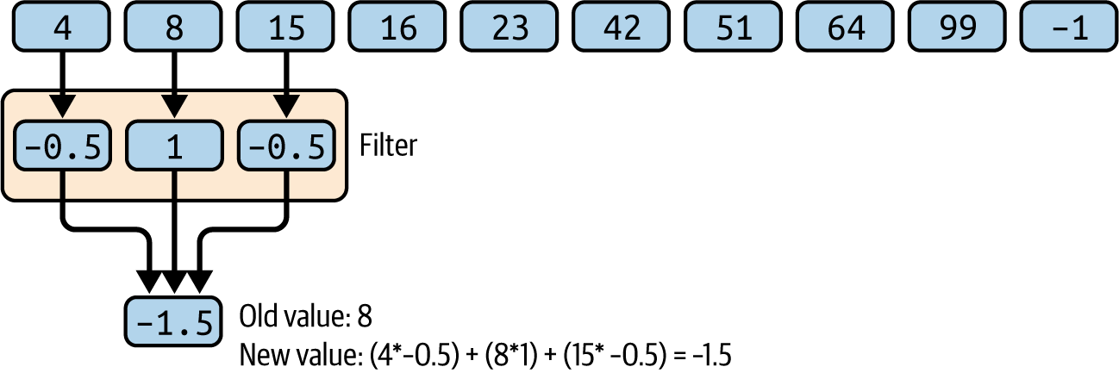

Figure 11-2. Using a convolution with the number sequence

The filter will then stride across the values, calculating new ones as it goes. So, for example, in the next stride, 15 will be transformed into 3 (see [Figure 11-3](https://learning.oreilly.com/library/view/ai-and-ml/9781098199166/ch11.html#ch11_figure_3_1748549734749161)).

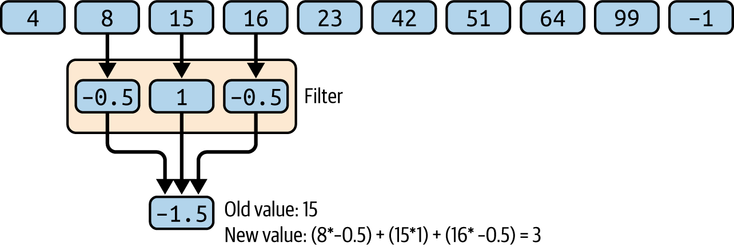

Figure 11-3. An additional stride in the 1D convolution

Using this method, it’s possible to extract the patterns between values and learn the filters that extract them successfully, in much the same way that convolutions on the pixels in images can extract features. In this instance, there are no labels, but the convolutions that minimize overall loss can be learned.

**Coding Convolutions**

Before coding convolutions, you’ll need to use the *sliding windows* technique to create a dataset, as shown in [Chapter 10](https://learning.oreilly.com/library/view/ai-and-ml/9781098199166/ch10.html#ch10_creating_ml_models_to_predict_sequences_1748549713795870). The code is available [on this book’s GitHub page](https://oreil.ly/pytorch_ch11).

Once you have that dataset, you can add a convolutional layer before the dense layers that you had previously. Here’s the code, which we’ll look at line by line:

class CNN1D(nn.Module):

def __init__(self, input_size):

super(CNN1D, self).__init__()

self.conv1 = nn.Conv1d(in_channels=1,

out_channels=128,

kernel_size=3,

padding=1)

conv_output_size = input_size # Same padding maintains input size

self.relu = nn.ReLU()

self.flatten = nn.Flatten()

self.dense1 = nn.Linear(128 * conv_output_size, 28)

self.dense2 = nn.Linear(28, 10)

self.dense3 = nn.Linear(10, 1)

def forward(self, x):

# Transpose input from [batch_size, sequence_length]

# to [batch_size, 1, sequence_length]

if len(x.shape) == 2:

x = x.unsqueeze(1)

elif len(x.shape) == 3 and x.shape[1] != 1:

x = x.transpose(1, 2)

x = self.relu(self.conv1(x))

x = self.flatten(x)

x = self.relu(self.dense1(x))

x = self.relu(self.dense2(x))

x = self.dense3(x)

return x

First, notice the new line that defines a 1D convolutional layer:

self.conv1 = nn.Conv1d(in_channels=1,

out_channels=128,

kernel_size=3,

padding=1)

The in_channels parameter defines the dimensionality of the input data. As we have a single sequence of numbers with a single value per data point, this is 1. If we were using multiple features per time step, such as perhaps an RGB color value, this would be 3.

The out_channels parameter is the number of filters (aka convolutions) that the network will learn.

The kernel_size parameter determines the size of the convolution (i.e., the number of data points on the line that a convolution will filter). Refer back to [Figure 11-2](https://learning.oreilly.com/library/view/ai-and-ml/9781098199166/ch11.html#ch11_figure_2_1748549734749133) and [Figure 11-3](https://learning.oreilly.com/library/view/ai-and-ml/9781098199166/ch11.html#ch11_figure_3_1748549734749161) and you’ll see a convolution there with a kernel size of 3.

The padding parameter adds elements to the beginning and end of your list of data. So, for example, the list of numbers in [Figure 11-1](https://learning.oreilly.com/library/view/ai-and-ml/9781098199166/ch11.html#ch11_figure_1_1748549734749083) is [4 8 15 16 23 42 51 64 99 –1]. When the filter of kernel size 3 looks at this list, it begins with [4 8 15], and *4* never gets to be the “middle” number. The filter effectively ignores the numbers at the beginning and end of the list. With padding, a 0 will be added at the front and back of the list to make it [0 4 8 15 16 23 42 51 64 99 –1 0], and you can now see that the filter will look first at [0 4 8].

Next, we see a line that looks like this:

conv_output_size = input_size # Same padding maintains input size

This helps us to know the size of the output from the convolutional layer to inform the “next” layer in the sequence.

Why is it the input size, you might wonder. This is the idea of “same padding” that comes about from setting the padding=1 parameter.

If you consider what would happen if you slid a kernel of size 3 across a list of values as in Figures [11-2](https://learning.oreilly.com/library/view/ai-and-ml/9781098199166/ch11.html#ch11_figure_2_1748549734749133) and [11-3](https://learning.oreilly.com/library/view/ai-and-ml/9781098199166/ch11.html#ch11_figure_3_1748549734749161), you’d see an odd effect. Because the kernel starts with its left side aligned with the first value and its center at the second value, and because it slides across to the end of the list where the center of the kernel will be aligned to the second-to-last value, the result of the calculations against the values in the list will give us n – 2 answers, where *n* is the length of the list. But if we pad the list with padding=1, then the kernel sliding across the list will give us *n* answers, so the output size from the layer will be the *same* as the input size.

So now, after ReLUing and flattening the results, we can see the next line:

self.dense1 = nn.Linear(128 * conv_output_size, 28)

The input to this will be a number of values: the size of the list, multiplied by 128, where 128 is the number of kernels. It will then output 28 values, which will be fed into the next linear layer.

Now, when you get to the forward function, it begins with this line:

if len(x.shape) == 2:

x = x.unsqueeze(1)

elif len(x.shape) == 3 and x.shape[1] != 1:

x = x.transpose(1, 2)

This looks quite unusual, but it’s necessary for dealing with the convolutions. First of all, consider what the input to a convolution should look like. There’ll be batches of them being fed in, each batch will have 1 dimension, and each item in the batch will have a number of items in it. If we are learning from sequences of 20 items, for example, and if we batch them 32 at a time, then the dimensionality of data being fed into the neural network will be [32, 1, 20].

But if our dataset isn’t giving us that—and if, for example, there are only two dimensions [32, 20]—then we want to use unsqueeze to slip in another dimension. When we pass a 1 into it, it will be put at position 1, so we’ll get [32, 1, 20] as desired.

The other case might be if we haven’t put our dimension in correctly and added it on the end, like in [32, 20, 1], so the x = x.transpose(1, 2) will flip these around and make the dimension [32, 1, 20] again.

Now, these are two specific cases I hardcoded for. You may encounter others, so watch out for issues with your data when feeding it into the neural network. This is likely a place where you can fix them.

The rest of the forward pass is pretty straightforward; it’s just passing the data through the different layers.

The loss function and optimizer are going to be pretty straightforward, too, using a mean-squared-error loss and an Adam optimizer:

criterion = nn.MSELoss()

optimizer = optim.Adam(model.parameters(), lr=learning_rate)

Training with this will give you a model as before, and to get predictions from the model, you can just use the loader in the same way as you did for training the model. So, for example, you can do this:

# Create DataLoaders

batch_size = 32

train_loader = DataLoader(train_dataset, batch_size=batch_size,

shuffle=True)

val_loader = DataLoader(val_dataset, batch_size=batch_size, shuffle=False)

And here’s a helper function that can predict an entire series, batch by batch:

def predict(model, loader):

device = torch.device("cuda" if torch.cuda.is_available() else "cpu")

model.eval()

predictions = []

with torch.no_grad():

for inputs, _ in loader:

inputs = inputs.to(device)

batch_predictions = model(inputs)

predictions.append(batch_predictions.cpu().numpy())

return np.concatenate(predictions)

You can then get the full set of predictions like this:

# Make predictions

train_predictions = predict(model, train_loader)

val_predictions = predict(model, val_loader)

Similarly, if you want to plot them, you could extend on this a little to pass in a loader and get back arrays of the predictions and the targets as well as an analytic, such as the MAE:

def evaluate_predictions(model, loader):

"""Generate predictions and calculate metrics"""

model.eval()

device = torch.device("cuda" if torch.cuda.is_available() else "cpu")

all_predictions = []

all_targets = []

with torch.no_grad():

for inputs, targets in loader:

inputs = inputs.to(device)

outputs = model(inputs)

all_predictions.extend(outputs.cpu().numpy())

all_targets.extend(targets.cpu().numpy())

predictions = np.array(all_predictions)

targets = np.array(all_targets)

# Calculate metrics

mae = mean_absolute_error(targets, predictions)

return predictions, targets, mae

And then you’d call this to get back the multiple responses like this:

# Generate predictions

val_predictions, val_targets, val_mae

= evaluate_predictions(model, val_loader)

This is now nice and easy to plot:

def plot_predictions(val_pred, val_true):

"""Plot the predictions against actual values"""

plt.figure(figsize=(15, 6))

# Plot validation data

offset = len(val_true)

plt.plot(range(offset, offset + len(val_true)),

val_true, 'b-', label='Validation Actual')

plt.plot(range(offset, offset + len(val_pred)),

val_pred, 'r-', label='Validation Predicted')

plt.title('Time Series Prediction vs Actual')

plt.xlabel('Time Step')

plt.ylabel('Value')

plt.legend()

plt.grid(True)

plt.show()

A plot of the results against the series is in [Figure 11-4](https://learning.oreilly.com/library/view/ai-and-ml/9781098199166/ch11.html#ch11_figure_4_1748549734749177).

The MAE in this case is 5.33, which is slightly worse than for the previous prediction. This could be because we haven’t tuned the convolutional layer appropriately, or it could be that convolutions simply don’t help. This is the type of experimentation you’ll need to do with your data.

Do note that this data has a random element in it, so values will change across sessions. If you’re using code from [Chapter 10](https://learning.oreilly.com/library/view/ai-and-ml/9781098199166/ch10.html#ch10_creating_ml_models_to_predict_sequences_1748549713795870) and then running this code separately, you will, of course, have random fluctuations affecting your data and thus your MAE.

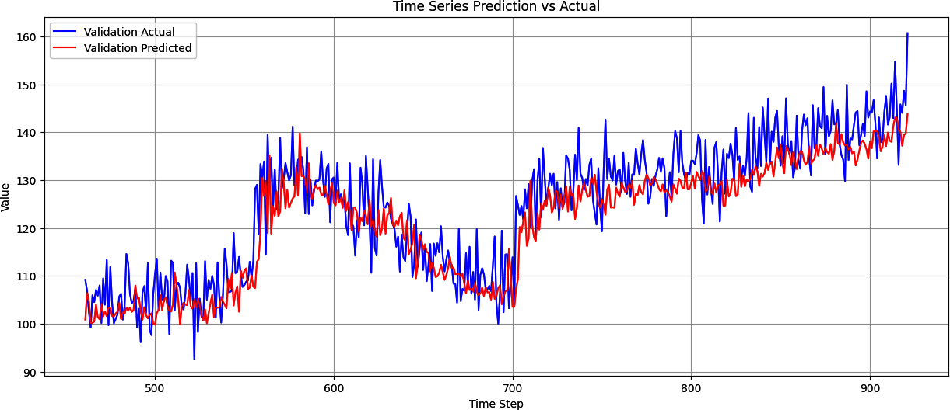

Figure 11-4. Convolutional neural network with time sequence data prediction versus actual

But when using convolutions, questions always come up. Why choose the parameters that we chose? Why 128 filters? Why size 3 × 1? The good news is that you can experiment with these things easily to explore different results.

**Experimenting with the Conv1D Hyperparameters**

In the previous section, you saw a 1D convolution that was hardcoded with parameters for things like filter number, kernel size, number of strides, etc. When you were training the neural network with it, it appeared that the MAE went up slightly, so you got no benefit from using the Conv1D. This may not always be the case, depending on your data, but it could be because of suboptimal hyperparameters. So, in this section, you’ll see how you can do a neural architecture search to find the best results.

One of the nice things about how verbose PyTorch is, in particular for defining the neural network and the forward pass, is that it becomes pretty straightforward to change up the parameters that you use. The idea with a *neural architecture search* is to come up with sets of different parameters to try and then explore the impact that they have on the results by training for a short time and finding those that give the best results.

So, for example, here, we used a single Conv1D layer. But what if there were more? Similarly, we hardcoded a number of channels and a kernel size, and we also hardcoded the size of the dense layers and the LR for the optimizer. But what if, instead of hardcoding them, we created a set of options like this?

# Define the search space

num_conv_layers_options = [1, 2] # Reduced for initial testing

conv_channels_options = [

[32],

[64],

[32, 16],

[64, 32],

]

kernel_sizes = [3, 5]

dense_sizes_options = [

[16],

[32, 16],

[64, 32],

]

learning_rates = [0.001, 0.0001]

With 4 options for the conv layers, 2 for the kernel sizes, 3 for the dense dimensions, and 2 for the LR, we have 4 × 2 × 3 × 2 options total, which is 48 combinations. This is called the *search space*.

Note that in this case, you might think it would be 96 because there are 2 layers options and 4 channels options. But in the code to define the search space, which you’ll see in a moment, I only allowed conv channel options that match the number of layers, so there will just be 4 options in total for the conv layers.

These options will be loaded into a configurations array, with name-value pairs set up for the parameters, like this:

# Generate valid configurations

configurations = []

for num_conv_layers in num_conv_layers_options:

for channels in conv_channels_options:

# Only use channel configs that match layer count

if len(channels) == num_conv_layers:

for kernel_size in kernel_sizes:

for dense_sizes in dense_sizes_options:

for lr in learning_rates:

configurations.append({

'num_conv_layers': num_conv_layers,

'conv_channels': channels,

'kernel_size': kernel_size,

'dense_sizes': dense_sizes,

'learning_rate': lr

})

So now, we can loop through these configurations and set up our CNN1D model by using them like this. Note the use of the config[] array:

for idx, config in enumerate(configurations):

print(f"\nTrying configuration {idx + 1}/{len(configurations)}:")

print(config)

try:

model = CNN1D(

input_size=input_size,

num_conv_layers=config['num_conv_layers'],

conv_channels=config['conv_channels'],

kernel_size=config['kernel_size'],

dense_sizes=config['dense_sizes']

).to(device)

criterion = nn.MSELoss()

optimizer = torch.optim.Adam(model.parameters(),

lr=config['learning_rate'])

It would be really time-consuming to train each of the 48 combinations for the full set of epochs (say, 100), so we’ve introduced the idea of *early stopping*. First, let’s train the model with the parameters we loaded from the configuration and a new parameter: early stopping patience:

trained_model, val_loss = train_model(

model, train_loader, val_loader, criterion, optimizer,

epochs=100, device=device, early_stopping_patience=10

)

Then, within the training loop, we can implement an early stopping like this:

# Early stopping check

if val_loss < best_val_loss:

best_val_loss = val_loss

best_model = deepcopy(model)

patience_counter = 0

else:

patience_counter += 1

if patience_counter >= early_stopping_patience:

print(f'Early stopping triggered after {epoch} epochs')

break

This keeps track of the loss for the best model and compares the current model with the best one. If the current model “loses” more times than our patience parameter (in this case, 10), then we’ll throw it out and move to the next one. If it “wins,” then we’ll keep the current model as the best one.

Starting from this code, you can try to experiment with the hyperparameters for the number of filters, the size of the kernel, and the size of the stride, keeping the other parameters static.

After some experimentation, I discovered that 2 convolutional layers, with 64 and 32 filters (respectively), a kernel size of 5, two dense layers of 64 and 32, and an LR of .0001 gave the best MAE on the validation set, giving me a final result of 4.4439 MAE.

After training with this, the model had improved accuracy compared with both the naive CNN created earlier *and* the original DNN, giving the results shown in [Figure 11-5](https://learning.oreilly.com/library/view/ai-and-ml/9781098199166/ch11.html#ch11_figure_5_1748549734749203).

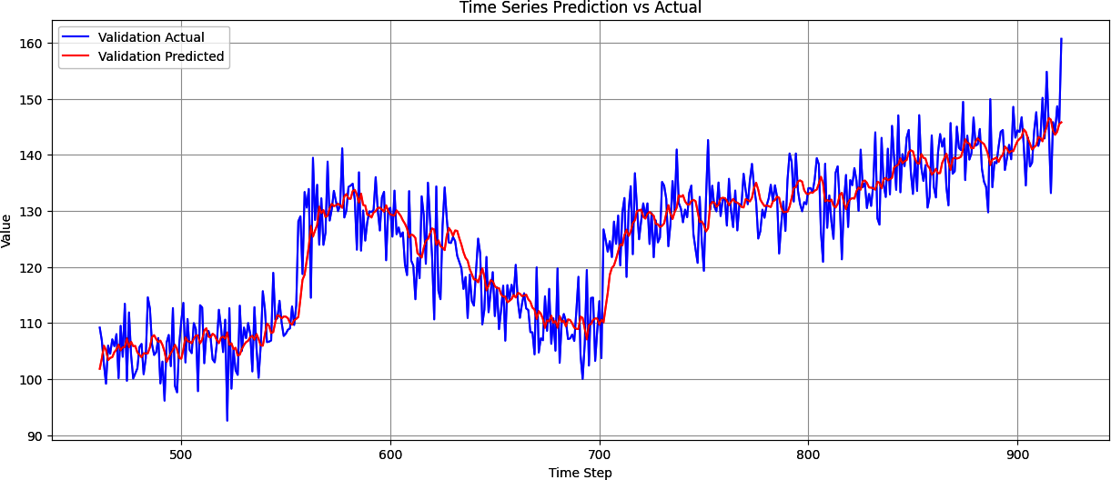

Figure 11-5. Optimized CNN time series predictions versus actual

Further experimentation with the CNN hyperparameters may improve this further.

Beyond convolutions, the techniques we explored in the chapters on NLP with RNNs, including LSTMs, may be powerful when working with sequence data. By their very nature, RNNs are designed for maintaining context, so previous values can have an effect on later ones. You’ll explore using RNNs for sequence modeling next. But first, let’s move on from a synthetic dataset and start looking at real data. In this case, we’ll consider weather data.

Using NASA Weather Data

One great resource for time series weather data is the [NASA Goddard Institute for Space Studies (GISS) Surface Temperature Analysis](https://oreil.ly/6IixP). If you follow the [Station Data link](https://oreil.ly/F9Hmw), on the right side of the page, you can pick a weather station to get data from. For example, I chose the Seattle Tacoma (SeaTac) airport and was taken to the page shown in [Figure 11-6](https://learning.oreilly.com/library/view/ai-and-ml/9781098199166/ch11.html#ch11_figure_6_1748549734749227).



Figure 11-6. Surface temperature data from GISS

You can also see a link to download monthly data as CSV at the bottom of this page. If you select this link, a file called *station.csv* will be downloaded to your device, and if you open it, you’ll see that it’s a grid of data with a year in each row and a month in each column (see [Figure 11-7](https://learning.oreilly.com/library/view/ai-and-ml/9781098199166/ch11.html#ch11_figure_7_1748549734749249)).

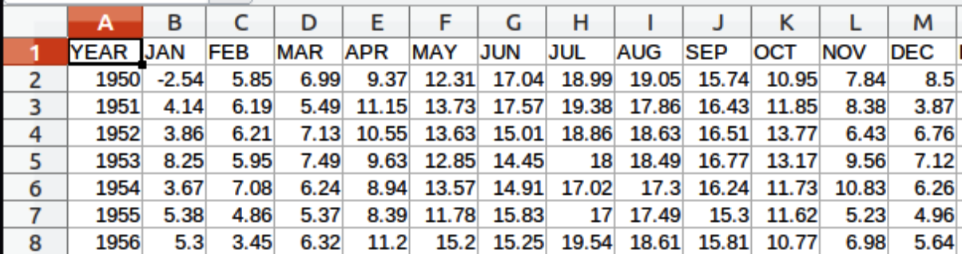

Figure 11-7. Exploring the data

As this is CSV data, it’s pretty easy to process in Python, but as with any dataset, do note the format. When reading CSV, you tend to read it line by line, and often, each line has one data point that you’re interested in. In this case, there are at least 12 data points of interest per line, so you’ll have to consider this when reading the data.

**Reading GISS Data in Python**

The code to read the GISS data is shown here:

def get_data():

data_file = "station.csv"

f = open(data_file)

data = f.read()

f.close()

lines = data.split('\n')

header = lines[0].split(',')

lines = lines[1:]

temperatures=[]

for line in lines:

if line:

linedata = line.split(',')

linedata = linedata[1:13]

for item in linedata:

if item:

temperatures.append(float(item))

series = np.asarray(temperatures)

time = np.arange(len(temperatures), dtype="float32")

return time, series

This will open the file at the indicated path (yours will, of course, differ) and read in the entire file as a set of lines, where the line split is the new line character (\n). It will then loop through each line, ignoring the first line, and split them on the comma character into a new array called linedata. The items from 1 through 13 in this array will indicate the values for the months January through February as strings, and these values will then be converted into floats and added to the array called temperatures. Once it’s completed, it will be turned into a NumPy array called series, and another NumPy array called time will be created that’s the same size as series. As it is created using np.arange, the first element will be 1, the second will be 2, etc. Thus, this function will return time in steps from 1 to the number of data points and will return series as the data for that time.

I have noticed that often, there will be “unfilled” data in some of the columns, and these are represented by the value 999.9. This will, of course, skew any predictive results you want to create. But fortunately, 999.9 values are usually at the *end* of the dataset, so they can easily be cropped. Here’s a helper function to normalize the series while cropping out the 999.9 values:

import numpy as np

def normalize_series(data, missing_value=999.9):

# Convert to numpy array if not already

data = np.array(data, dtype=np.float64)

# Create mask for valid values (not NaN and not missing_value)

valid_mask = (data != missing_value) & (~np.isnan(data))

# Keep only valid values

clean_data = data[valid_mask]

# Normalize using only valid values

mean = np.mean(clean_data)

std = np.std(clean_data)

normalized = (clean_data - mean) / std

return normalized

time, series = get_data()

series_normalized = normalize_series(series)

You can now load this into a torch.tensor and turn it into a set of sliding windows with a target value as before. We discussed the helper function in [Chapter 10](https://learning.oreilly.com/library/view/ai-and-ml/9781098199166/ch10.html#ch10_creating_ml_models_to_predict_sequences_1748549713795870):

series_tensor = torch.tensor(series_normalized, dtype=torch.float32)

window_size = 48

features, targets = create_sliding_windows_with_target(series_tensor,

window_size=window_size, shift=1)

Once we have that, we can turn it into a TensorDataset and split it into subsets for training and validation:

split_location = 800

# Create the full dataset

full_dataset = TensorDataset(features, targets)

# Calculate split indices

# Note: Since we're using windows, we need to account for the overlap

train_size = 800 - window_size + 1 # Adjust for window overlap

total_windows = len(full_dataset)

train_indices = list(range(train_size))

val_indices = list(range(train_size, total_windows))

# Create training and validation datasets using Subset

train_dataset = Subset(full_dataset, train_indices)

val_dataset = Subset(full_dataset, val_indices)

Now that we have the splits as datasets, we can create loaders for them that the neural network will use:

batch_size = 32

train_loader = DataLoader(train_dataset, batch_size=batch_size,

shuffle=True)

val_loader = DataLoader(val_dataset, batch_size=batch_size, shuffle=False)

And now, we’re ready to train with this data. We can inspect the split by charting the data, and we can see this with the training/validation split in [Figure 11-8](https://learning.oreilly.com/library/view/ai-and-ml/9781098199166/ch11.html#ch11_figure_8_1748549734749270).

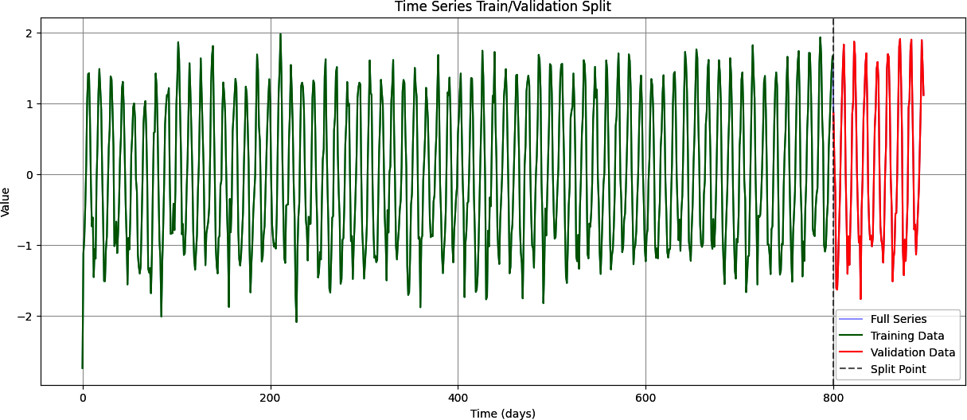

Figure 11-8. The time series train/validation split

In the next section, we’ll explore creating a simple RNN-based neural network to see if we can predict the next values in the sequence.

Using RNNs for Sequence Modeling

Now that you have the data from the NASA CSV in a windowed dataset, it’s relatively easy to create a model to train a predictor for it. (However, it’s a bit more difficult to train a *good* one!) Let’s start with a simple, naive model using RNNs. Here’s the code:

class SimpleRNNModel(nn.Module):

def __init__(self, input_size=1, hidden_size=100,

output_size=1, dropout_rate=0.3):

super(SimpleRNNModel, self).__init__()

self.rnn1 = nn.RNN(input_size=input_size,

hidden_size=hidden_size,

batch_first=True,

dropout=dropout_rate) # Add dropout to RNN

self.rnn2 = nn.RNN(input_size=hidden_size,

hidden_size=hidden_size,

batch_first=True,

dropout=dropout_rate) # Add dropout to RNN

self.dropout = nn.Dropout(dropout_rate) # Additional dropout layer

self.linear = nn.Linear(hidden_size, output_size)

def forward(self, x):

out1, _ = self.rnn1(x)

out2, _ = self.rnn2(out1)

last_out = out2[:, –1, :]

last_out = self.dropout(last_out) # Add dropout before final layer

output = self.linear(last_out)

return output

In this case, as you can see, we use a basic RNN. RNNs are a class of neural networks that are powerful for exploring sequence models, and you first saw them in [Chapter 7](https://learning.oreilly.com/library/view/ai-and-ml/9781098199166/ch07.html#ch07_recurrent_neural_networks_for_natural_language_pro_1748549654891648), when you were looking at NLP. I won’t go into detail on how they work here, but if you’re interested and you skipped that chapter, take a look back at it now. Notably, an RNN has an internal loop that iterates over the time steps of a sequence while maintaining an internal state of the time steps it has seen so far.

While training, you can use a loss function and optimizer like this:

criterion = nn.MSELoss()

optimizer = torch.optim.Adam(model.parameters(), lr=learning_rate)

The full code is available in this book’s [GitHub repository](https://oreil.ly/pytorch_ch11). Even one hundred epochs of training is enough to get an idea of how the model can predict values. [Figure 11-9](https://learning.oreilly.com/library/view/ai-and-ml/9781098199166/ch11.html#ch11_figure_9_1748549734749285) shows the results.

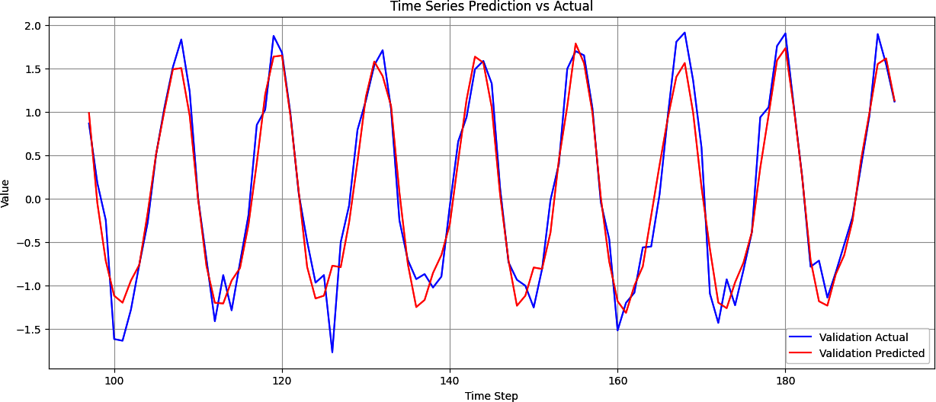

Figure 11-9. Results of the SimpleRNN time series prediction versus actual

As you can see, the results were pretty good. It may be a little off in the peaks and when the pattern changes unexpectedly (like at time steps 160–170), but on the whole, it’s not bad. Now, let’s see what happens if we train it for 1,500 epochs (see [Figure 11-10](https://learning.oreilly.com/library/view/ai-and-ml/9781098199166/ch11.html#ch11_figure_10_1748549734749297)).

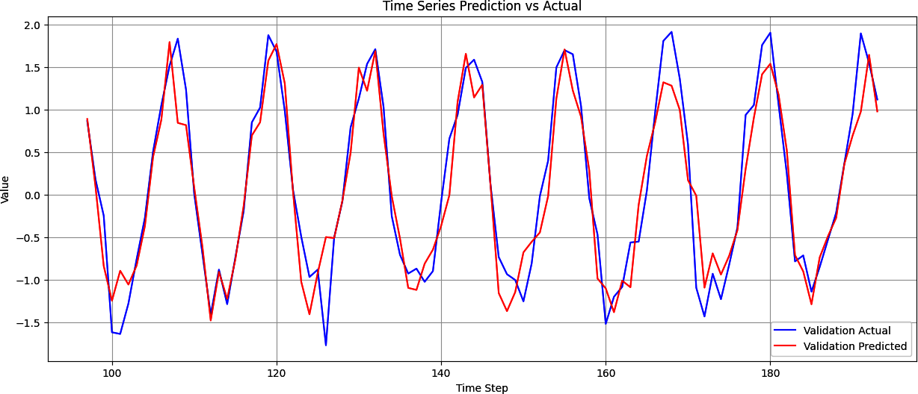

Figure 11-10. Time series prediction versus actual for RNN trained over 1,500 epochs

There’s not much of a difference, except that some of the peaks are smoothed out. If you look at the history of loss on both the validation set and the training set, it looks like [Figure 11-11](https://learning.oreilly.com/library/view/ai-and-ml/9781098199166/ch11.html#ch11_figure_11_1748549734749310).

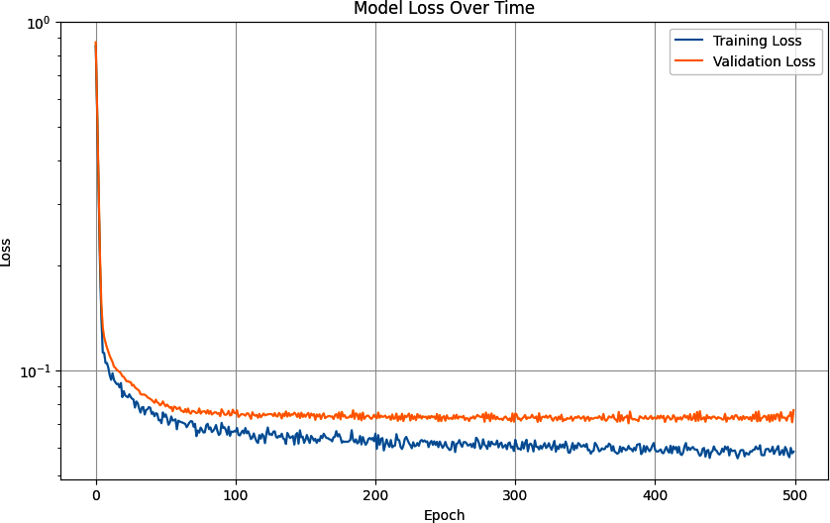

Figure 11-11. Training and validation model loss over time for the SimpleRNN

As you can see, there’s a healthy match between the training loss and the validation loss, but as the epochs increase, the model begins to overfit on the training set. Perhaps a better number of epochs would be around five hundred.

One reason for this could be the fact that the data, being monthly weather data, is highly seasonal. Another is that there is a very large training set and a relatively small validation set.

Next, we’ll explore using a larger climate dataset.

**Exploring a Larger Dataset**

The [KNMI Climate Explorer](https://oreil.ly/J8CP0) allows you to explore granular climate data from many locations around the world. [I downloaded a dataset](https://oreil.ly/Ci9DI) consisting of daily temperature readings from the center of England from the years 1772 to 2020. This data is structured differently from the GISS data, with the date as a string, followed by a number of spaces, followed by the reading. Go back to [Chapter 4](https://learning.oreilly.com/library/view/ai-and-ml/9781098199166/ch04.html#ch04_using_data_with_pytorch_1748548966496246) to check the details on handling and managing large datasets.

I’ve prepared the data, stripping the headers and removing the extraneous spaces, so that there’s only one space between the date and the reading. That way, it’s easy to read with code like this:

import numpy as np

def get_data():

data_file = "tdaily_cet.dat.txt"

f = open(data_file)

data = f.read()

f.close()

lines = data.split('\n')

temperatures=[]

for line in lines:

if line:

linedata = line.split(' ')

temperatures.append(float(linedata[1]))

series = np.asarray(temperatures)

time = np.arange(len(temperatures), dtype="float32")

return time, series

This dataset has 91,502 data points in it, so before training your model, be sure to split it appropriately. I used a split time of 80,000, leaving 10,663 records for validation:

split_location = 80000

features = features.unsqueeze(1)

# Create the full dataset

full_dataset = TensorDataset(features, targets)

# Calculate split indices

# Note: Since we're using windows, we need to account for the overlap

train_size = split_location - window_size + 1 # Adjust for window overlap

total_windows = len(full_dataset)

train_indices = list(range(train_size))

val_indices = list(range(train_size, total_windows))

# Create training and validation datasets using Subset

train_dataset = Subset(full_dataset, train_indices)

val_dataset = Subset(full_dataset, val_indices)

Everything else can remain the same. As you can see in [Figure 11-12](https://learning.oreilly.com/library/view/ai-and-ml/9781098199166/ch11.html#ch11_figure_12_1748549734749322), after training for one hundred epochs, the plot of the predictions against the validation set looks pretty good.

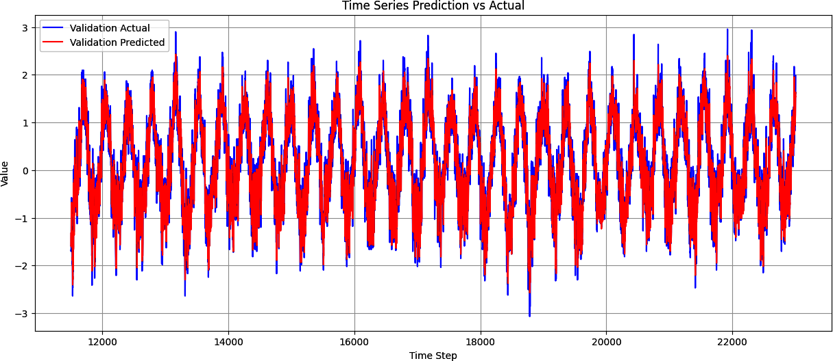

Figure 11-12. Plot of predictions against real data

There’s a lot of data here, so let’s zoom in to the last hundred days’ worth (see [Figure 11-13](https://learning.oreilly.com/library/view/ai-and-ml/9781098199166/ch11.html#ch11_figure_13_1748549734749335)).

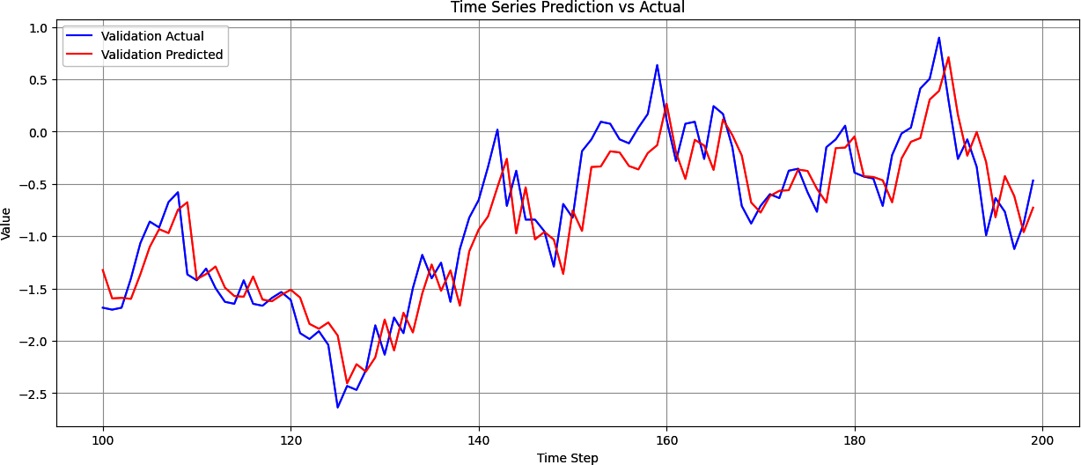

Figure 11-13. Results of time series prediction versus actual for one hundred days’ worth of data

While the chart generally follows the curve of the data and is getting the trends roughly correct, it is pretty far off, particularly at the extreme ends, so there’s room for improvement.

It’s also important to remember that we normalized the data, so while our loss and MAE may look low, that’s because they are based on the loss and MAE of normalized values that have a much lower variance than the real ones. As [Figure 11-14](https://learning.oreilly.com/library/view/ai-and-ml/9781098199166/ch11.html#ch11_figure_14_1748549734749347) shows, a tiny amount of loss might lead you into having a false sense of security.

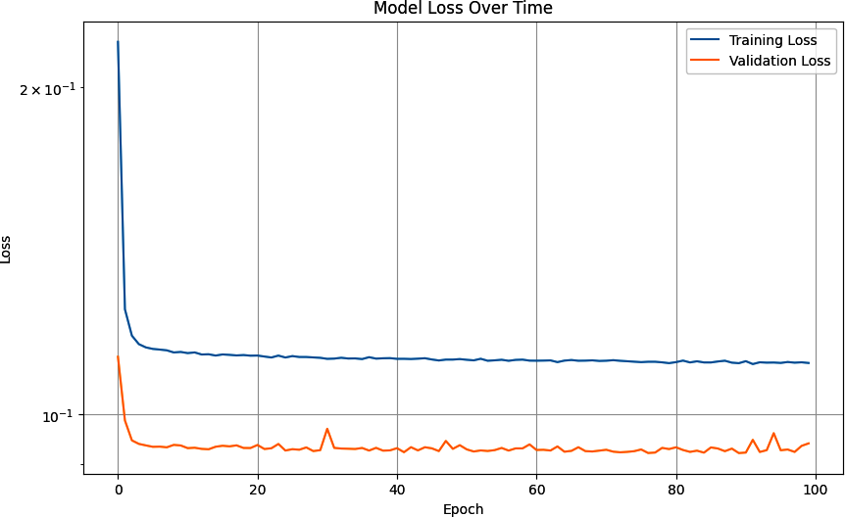

Figure 11-14. Training and validation model loss over time for large dataset

To denormalize the data, you can do the inverse of normalization: first, multiply by the standard deviation, and then add back the mean. At that point, if you wish, you can calculate the real MAE for the prediction set as you’ve done previously.

Using Other Recurrent Methods

In addition to the RNN, PyTorch has other recurrent layer types, such as gated recurrent units (GRUs) and long short-term memory layers (LSTMs), which we discussed in [Chapter 7](https://learning.oreilly.com/library/view/ai-and-ml/9781098199166/ch07.html#ch07_recurrent_neural_networks_for_natural_language_pro_1748549654891648). It is relatively simple to just drop in these RNN types if you want to experiment.

So, for example, if you consider the simple, naive RNN that you created earlier, replacing it with a GRU becomes as easy as using nn.GRU:

class SimpleRNNModel(nn.Module):

def __init__(self, input_size=1, hidden_size=100,

output_size=1, dropout_rate=0.3):

super(SimpleRNNModel, self).__init__()

self.rnn1 = nn.GRU(input_size=input_size,

hidden_size=hidden_size,

batch_first=True,

dropout=dropout_rate)

self.rnn2 = nn.GRU(input_size=hidden_size,

hidden_size=hidden_size,

batch_first=True,

dropout=dropout_rate)

self.dropout = nn.Dropout(dropout_rate)

self.linear = nn.Linear(hidden_size, output_size)

With an LSTM, it’s similar:

# LSTM Optional Architecture

import torch.nn as nn

class SimpleLSTMModel(nn.Module):

def __init__(self, input_size=1, hidden_size=100,

output_size=1, dropout_rate=0.3):

super(SimpleLSTMModel, self).__init__()

self.lstm1 = nn.LSTM(input_size=input_size,

hidden_size=hidden_size,

batch_first=True,

dropout=dropout_rate) # Add dropout to LSTM

self.lstm2 = nn.LSTM(input_size=hidden_size,

hidden_size=hidden_size,

batch_first=True,

dropout=dropout_rate) # Add dropout to LSTM

# Add more layers before final output

self.fc1 = nn.Linear(hidden_size, hidden_size)

self.relu = nn.ReLU()

self.linear = nn.Linear(hidden_size, output_size)

def forward(self, x):

out1, _ = self.lstm1(x) # LSTM returns (output, (h_n, c_n))

out2, _ = self.lstm2(out1) # We ignore both hidden and cell states with _

last_out = out2[:, –1, :]

output = self.linear(last_out)

return output

It’s worth experimenting with these layer types as well as with different hyperparameters, loss functions, and optimizers. There’s no one-size-fits-all solution, so what works best for you in any given situation will depend on your data and your requirements for prediction with that data.

Using Dropout

If you encounter overfitting in your models, where the MAE or loss for the training data is much better than with the validation data, you can use dropout. As discussed in earlier chapters, with dropout, neighboring neurons are randomly dropped out (ignored) during training to avoid a familiarity bias. When you’re using RNNs, there’s also a *recurrent dropout* parameter that you can use.

What’s the difference? Recall that when using RNNs, you typically have an input value and the neuron calculates an output value and a value that gets passed to the next time step. Dropout will randomly drop out the input values, and recurrent dropout will randomly drop out the recurrent values that get passed to the next step.

For example, consider the basic RNN architecture shown in [Figure 11-15](https://learning.oreilly.com/library/view/ai-and-ml/9781098199166/ch11.html#ch11_figure_15_1748549734749377).

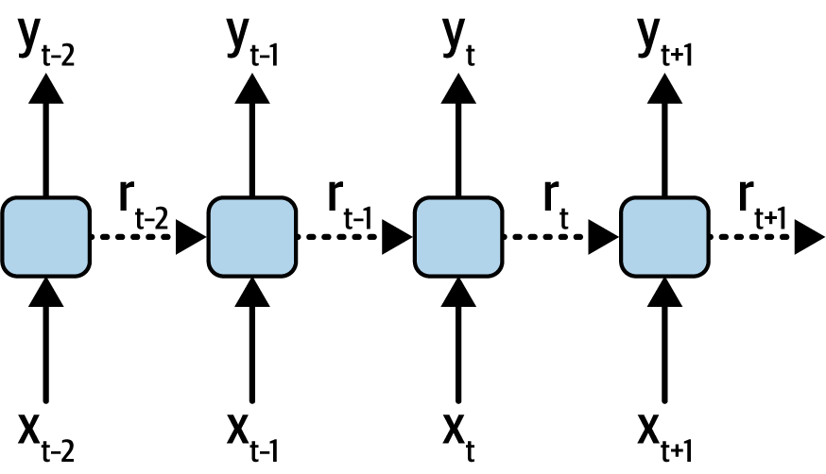

Figure 11-15. A recurrent neural network

Here, you can see the inputs into the layers at different time steps (*x*). The current time is *t*, and the steps shown are *t* – 2 through *t* + 1. The relevant outputs at the same time steps (*y*) are also shown, and the recurrent values passed between time steps are indicated by the dotted lines and labeled as *r*.

Using *dropout* will randomly drop out the *x* inputs, while using *recurrent dropout* will randomly drop out the *r* recurrent values.

You can learn more about how recurrent dropout works from a deeper mathematical perspective in the paper [“A Theoretically Grounded Application of Dropout in Recurrent Neural Networks” by Yarin Gal and Zoubin Ghahramani](https://oreil.ly/MqqRR). One other thing to consider when using recurrent dropout is discussed by Gal in his research around [uncertainty in deep learning](https://oreil.ly/3v8IB), in which he demonstrates that the same pattern of dropout units should be applied at every time step and that a similar constant dropout mask should also be applied at every time step.

To add dropout and recurrent dropout, you use the relevant parameters on your layers. For example, adding them to the basic GRU from earlier was as simple as using a parameter in the recurrent layers and adding another layer between the RNNs and the linears:

class SimpleRNNModel(nn.Module):

def __init__(self, input_size=1, hidden_size=100,

output_size=1, dropout_rate=0.1):

super(SimpleRNNModel, self).__init__()

self.rnn1 = nn.GRU(input_size=input_size,

hidden_size=hidden_size,

batch_first=True,

**dropout=dropout_rate)**

self.rnn2 = nn.GRU(input_size=hidden_size,

hidden_size=hidden_size,

batch_first=True,

**dropout=dropout_rate)**

self.dropout = nn.Dropout(dropout_rate)

self.linear = nn.Linear(hidden_size, output_size)

Each parameter takes a value between 0 and 1 that indicates the proportion of values to drop out. For example, a value of 0.1 will drop out 10% of the requisite values.

Training a model with dropout like this shows a much steeper learning curve, which is still trending downward at 100 epochs. The validation is quite flat, indicating that a larger validation set may be necessary. It’s also quite noisy, and you’ll often see noise like this in the loss when using dropout. It’s an indication that you may want to tweak the amount of dropout as well as the parameters of the loss function and optimizer, such as the LR. You can see this in [Figure 11-16](https://learning.oreilly.com/library/view/ai-and-ml/9781098199166/ch11.html#ch11_figure_16_1748549734749392).

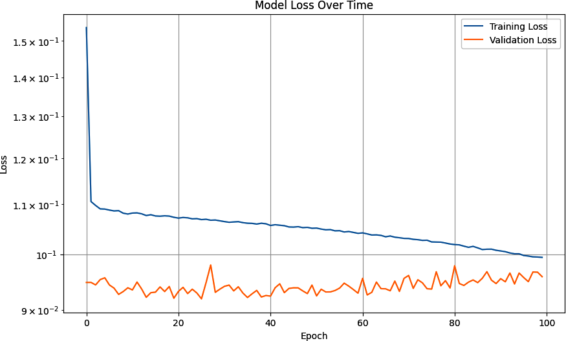

Figure 11-16. Training and validation loss over time using a GRU with dropout

As you’ve seen in this chapter, predicting time sequence data using neural networks is a difficult proposition, but tweaking their hyperparameters can be a powerful way to improve your model and its subsequent predictions.

Using Bidirectional RNNs

Another technique to consider when classifying sequences is to use bidirectional training. This may seem counterintuitive at first, as you might wonder how future values could impact past ones. But recall that time series values can contain seasonality, where values repeat over time, and when using a neural network to make predictions, all we’re doing is sophisticated pattern matching. Given that data repeats, a signal for how data can repeat might be found in future values—and when using bidirectional training, we can train the network to try to spot patterns going from time *t* to time *t* + *x*, as well as going from time *t* + *x* to time *t*.

Fortunately, coding this is simple. For example, consider the GRU from the previous section. To make this bidirectional, you simply add a bidirectional parameter. This will effectively train twice on each step—once with the sequence data in the original order and once with it in reverse order. The results are then merged before proceeding to the next step.

Here’s an example:

class BidirectionalGRUModel(nn.Module):

def __init__(self, input_size=1, hidden_size=100,

output_size=1, dropout_rate=0.1):

super(BidirectionalGRUModel, self).__init__()

self.gru1 = nn.GRU(input_size=input_size,

hidden_size=hidden_size,

batch_first=True,

dropout=dropout_rate,

bidirectional=True)

self.gru2 = nn.GRU(input_size=hidden_size * 2,

hidden_size=hidden_size,

batch_first=True,

dropout=dropout_rate,

bidirectional=True)

# Additional layers

self.fc1 = nn.Linear(hidden_size * 2, hidden_size)

self.relu = nn.ReLU()

self.dropout = nn.Dropout(dropout_rate)

self.linear = nn.Linear(hidden_size, output_size)

def forward(self, x):

out1, _ = self.gru1(x)

out2, _ = self.gru2(out1)

last_out = out2[:, –1, :]

# Additional processing

x = self.fc1(last_out)

x = self.relu(x)

x = self.dropout(x)

output = self.linear(x)

return output

A plot of the results of training with a bidirectional GRU with dropout on the time series is shown in [Figure 11-17](https://learning.oreilly.com/library/view/ai-and-ml/9781098199166/ch11.html#ch11_figure_17_1748549734749407). While the MAE has improved slightly, the bigger impact is that the predicted curve has lost the “lag” compared with the single direction version.

Additionally, tweaking the training parameters—particularly window_size, to get multiple seasons—can have a pretty big impact.

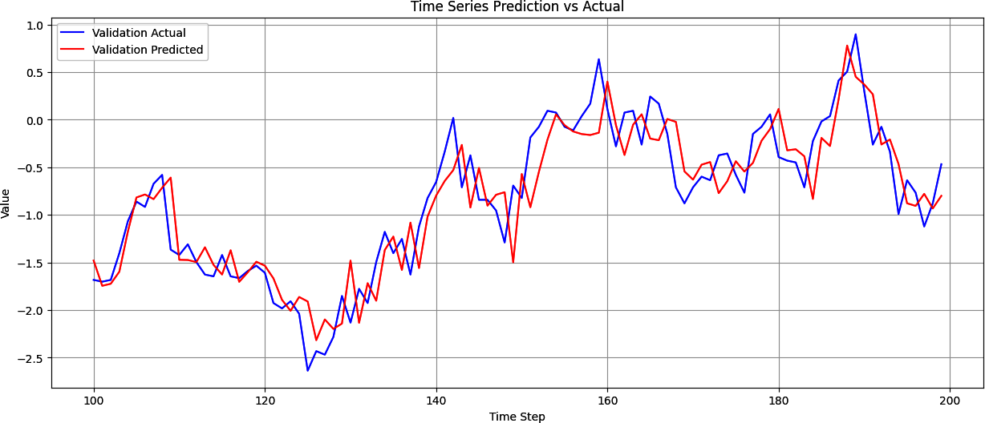

Figure 11-17. Time series prediction training with a bidirectional GRU

As you can see, you can experiment with different network architectures and different hyperparameters to improve your overall predictions. The ideal choices are very much dependent on the data, so the skills you’ve learned in this chapter will help you with your specific datasets!

Summary

In this chapter, you explored different network types for building models to predict time series data. You built on the simple DNN from [Chapter 10](https://learning.oreilly.com/library/view/ai-and-ml/9781098199166/ch10.html#ch10_creating_ml_models_to_predict_sequences_1748549713795870), adding convolutions, and you experimented with recurrent network types such as simple RNNs, GRUs, and LSTMs. You also learned how to tweak hyperparameters and the network architecture to improve your model’s accuracy, and you practiced working with some real-world datasets, including one massive dataset with hundreds of years’ worth of temperature readings.

Now, you’re ready to get started building networks for a variety of datasets, and you have a good understanding of what you need to know to optimize them!

Chapter 12. Concepts of Inference

In the previous chapters of this book, you focused on *training* models using PyTorch and on how to create models that manage images (aka Computer Vision), text content (aka NLP), and sequence modelling. For the rest of this book, you’ll cover a lot of content around *using trained models* to make predictions from new data (aka *inference*) and in particular using large generative models for text-to-text and text-to-image generative AI.

But before you jump into that, it’s important for you to understand the underlying data transfer technology. We’ve touched on it a little in the training chapters, but as you go deeper into ML—in either training or inference—it’s important for you to be able to understand the underlying concepts of tensors.

Ultimately, no matter what data type you have, you’ll convert it into tensors to pass it *into* the model. Similarly, no matter the data type in which you want to present answers from the model to your users, you’ll get them back as tensors as well!

In many cases, you’ll have helper functions, such as the *transformers* that you’ll see in [Chapter 15](https://learning.oreilly.com/library/view/ai-and-ml/9781098199166/ch15.html#ch15_transformers_and_transformers_1748549808974580) (which covers LLMs) and the *diffusers* that you’ll see in [Chapter 19](https://learning.oreilly.com/library/view/ai-and-ml/9781098199166/ch19.html#ch19_using_generative_models_with_hugging_face_diffuser_1748573005765373) (which handles image generation). And while you won’t be touching tensors with them, you’ll still be using them under the hood.

Tensors

A *tenso*r is an array that can have any number of dimensions. Tensors are typically used to represent numerical data for deep-learning algorithms; they’re containers that can hold numbers in multiple dimensions.

Tensors can be simple scalar values (in zero dimensions), vectors (in one dimension), matrices (in two dimensions), and beyond (in three dimensions or more). In PyTorch, they’re the fundamental data structure for all computation.

Tensors are also the source of the name *TensorFlow*for the alternative deep-learning framework from Google.

Here are some examples of tensors in PyTorch, which were created using torch.​ten⁠sor:

import torch

# Scalar (0D tensor)

scalar = torch.tensor(42) # Single number

# Vector (1D tensor)

vector = torch.tensor([1, 2, 3, 4]) # Array of numbers

# Matrix (2D tensor)

matrix = torch.tensor([[1, 2, 3],

[4, 5, 6]]) # 2x3 grid of numbers

# 3D tensor

cube = torch.tensor([[[1, 2], [3, 4]],

[[5, 6], [7, 8]]]) # 2x2x2 cube of numbers

What makes tensors so useful for ML is this flexibility to hold different value types. Numbers can be 0D tensors, the embedding vectors representing text can be 1D, and images can be 3D, with dimensions for height, width, and pixel value. Plus, all of these can have an additional dimension added for batches. So, for example, a single image can be a 3D matrix, but 100 images instead of 100 3D matrices could be a single 4D tensor, with the fourth dimension being the index of the image!

When you’re using torch.tensor, keep in mind that a lot of work and investment has been put into optimizing them to run on GPUs, which makes them extremely efficient for deep learning computation.

Image Data

Images are typically stored in formats like JPEG or PNG, which are optimized for *human* viewing as well as storage efficiency. Each dot (or pixel) in the image is usually composed of a number of values, with each value being the intensity of a color channel. Typically, an image will have 24 bits of data, with 8 bits assigned each to red, green, and blue channels. If you see 32 bits, then the additional 8 are for an alpha, or transparency, channel.

So, for example, a green pixel might have values 0 on the red, blue, and alpha channels and 255 on the green channel. If it’s semi-transparent, it might still have a value of 0 on red and blue, 128 on alpha, and 255 on green.

An image file is typically *compressed*, which means that mathematical transforms have been applied to it to avoid wasted data and make the image smaller. An image can also contain metadata, file headers, and more. Then, once the image is loaded into memory, it is usually uncompressed to the 32-bits-per-pixel previously described.

ML models typically use values between –1 and 1, and not 0 to 255, as the native values of the image are stored. If we want to learn the details of an image, it’s good for us to standardize the values by focusing on the meaningful *variations* between the pixel intensities as opposed to just their values. So, one method is to standardize by figuring out how far the pixel value is from the mean and standard deviations. This gives a broader spectrum of values that can lead to smoother loss curves and more effective learning.

In PyTorch, you achieve this with code like this:

import torch

from torchvision import transforms

from PIL import Image

def prepare_image(image_path):

# Load the image using PIL

raw_image = Image.open(image_path)

# Define the transformations

preprocess = transforms.Compose([

transforms.Resize(256),

transforms.CenterCrop(224),

transforms.ToTensor(),

transforms.Normalize(

mean=[0.485, 0.456, 0.406],

std=[0.229, 0.224, 0.225]

)

])

# Apply transformations

input_tensor = preprocess(raw_image)

# Add batch dimension

input_batch = input_tensor.unsqueeze(0)

return input_batch

This code uses a very popular Python library called Pillow, or just PIL.

In this case, the PIL Image.open will read the image, decompress it into pixels, and then apply a set of transforms to those pixels. The transforms normalize the channels into ML-friendly values, as described earlier, and then convert them into tensors.

The input_tensor is then a 3D matrix/tensor, but if we want to have a number of them in a single batch, we can *unsqueeze* this tensor to add a new dimension, making it a 4D tensor.

You can see a single image in [Figure 12-1](https://learning.oreilly.com/library/view/ai-and-ml/9781098199166/ch12.html#ch12_figure_1_1748549754439352) as a 3D tensor, with one dimension for each color depth.

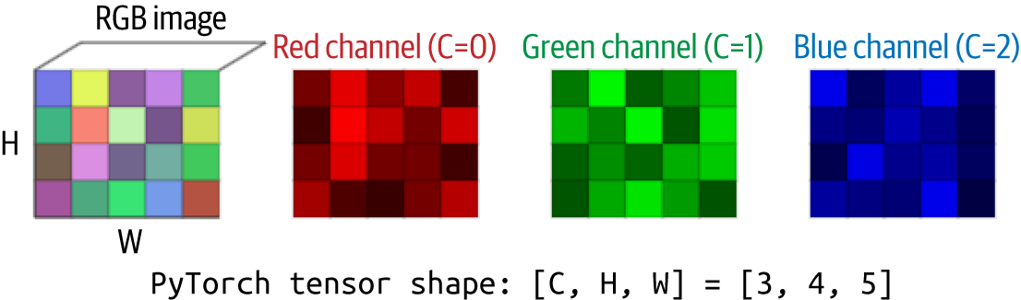

Figure 12-1. Tensor representing a full-color image

And then, if there’s a batch of images, you can see it as a fourth dimension in [Figure 12-2](https://learning.oreilly.com/library/view/ai-and-ml/9781098199166/ch12.html#ch12_figure_2_1748549754439405).

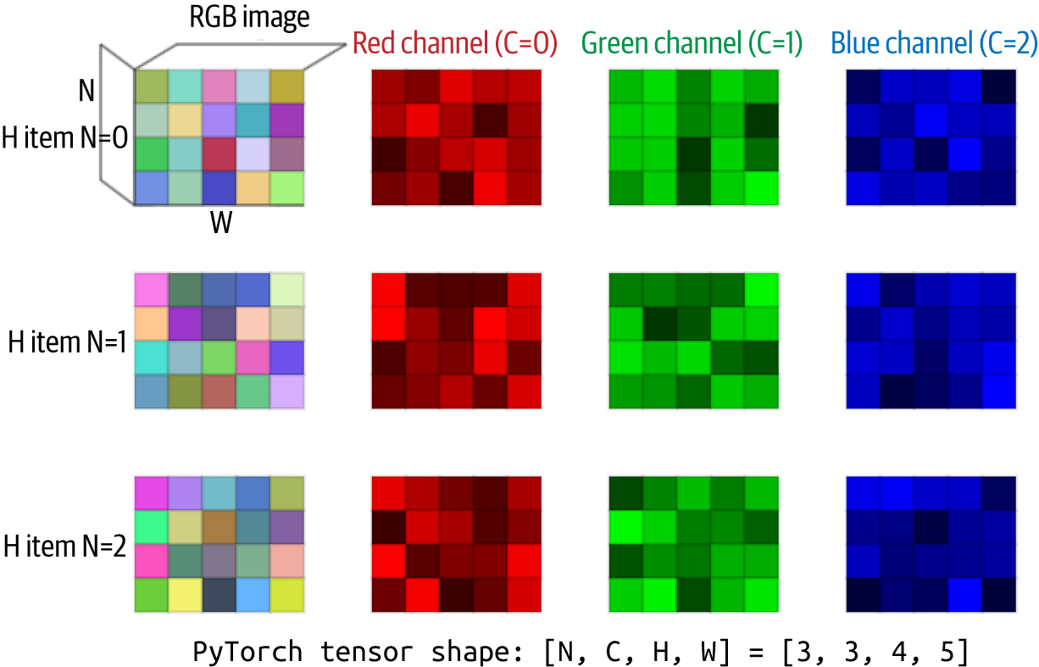

Figure 12-2. Tensor representing a batch of colored images

Text Data

Typically, text is stored in a string, like “The cat sat on the mat,” but training a model or passing text like this to a pretrained model is unfeasible. Models, as you saw in earlier chapters, are trained on numeric data—and the best way to do that is to either *tokenize* the text, by turning words or subwords into numbers, or to *calculate embeddings* for the text, by turning them into vectors. And if you choose to calculate embeddings for the text, you can also encode sentiment about the text into the direction of the vector (see [Chapter 6](https://learning.oreilly.com/library/view/ai-and-ml/9781098199166/ch06.html#ch06_clean_making_sentiment_programmable_by_using_embeddings_1748752380728888)).

So, as a simple example, let’s consider the following sentences:

texts = [

"I love my dog",

"The manatee became a doctor"

]

You can *tokenize*this text into a series of numbers by using a tokenizer. You can create your own tokenized series of numbers from the corpus, as you did in [Chapter 5](https://learning.oreilly.com/library/view/ai-and-ml/9781098199166/ch05.html#ch05_introduction_to_natural_language_processing_1748549080743759), or you can use an existing one, like this:

import torch

from transformers import BertTokenizer, BertModel

def text_to_embeddings(texts):

# Load pretrained BERT tokenizer and model

tokenizer = BertTokenizer.from_pretrained('bert-base-uncased')

model = BertModel.from_pretrained('bert-base-uncased')

model.eval() # Set to evaluation mode

# Tokenize the input texts

encoded = tokenizer(

texts,

padding=True, # Pad shorter sequences to match longest

truncation=True, # Truncate sequences that are too long

return_tensors='pt' # Return PyTorch tensors

)

You’ll learn a lot more about transformers, including how to use them for BERT, starting in [Chapter 13](https://learning.oreilly.com/library/view/ai-and-ml/9781098199166/ch13.html#ch13_hosting_pytorch_models_for_serving_1748549772563124).

The important line here is the last one, in which we ask the tokenizer to return tensors in PyTorch format. You can see the result of this in the output of the encodings, like this:

Encodings:

tensor([[ 101, 1045, 2293, 2026, 3899, 102, 0, 0],

[ 101, 1996, 24951, 17389, 2150, 1037, 3460, 102]])

If you explore this closely, you’ll see that the two sentences have been turned into a series of numbers. The first sentence, which has four words, has six numbers, and the second, which has six words, has eight numbers. Each has the number 101 at the front and 102 at the end, which gives us the two extra tokens. These are special tokens the encoder has added to indicate the start and end of the sentence.

A string can be represented as a 1D vector, but we have multiple strings here, so we can add a dimension to 1D to get 2D, and the second dimension gives us each string. So, value 0 in the second dimension is the first string, value 1 is the second string, etc.

The BERT model can also create embeddings from the sentence by getting an embedding for each word in the sentence and summing them all up to get an overall set of values. In the base model version of BERT, each embedding vector is a 1D matrix with 768 values. The embedding for a sentence is the same. Multiple sentences, just like the previous encodings, will have a second dimension.

Here’s the code:

# Generate embeddings

with torch.no_grad(): # No need to calculate gradients

outputs = model(**encoded)

embeddings = outputs.last_hidden_state

Each embedding has 768 values, so I’m not going to print them all out, but for the embedding that represents the first sentence, you can see values like this:

First word embedding (first 5 values):

tensor([ 0.0401, 0.3046, 0.0669, –0.1975, –0.0103])

Don’t worry if you don’t fully understand this yet—we’ll be going into it in more detail starting in [Chapter 13](https://learning.oreilly.com/library/view/ai-and-ml/9781098199166/ch13.html#ch13_hosting_pytorch_models_for_serving_1748549772563124). The important point here is that the idea of a *tensor* is that the very flexible matrix, which can have any number of dimensions, gives you a consistent input into a model. You don’t need to train models on different data types—they’ll always be tensor in, tensor out.

Tensors Out of a Model

As noted earlier, the power of tensors is in their consistency—regardless of what type of data you pass *into* a model, when they’re tensors, you can be consistent in your coding interface. The same applies for tensors *out* of a model.

So, for example, consider a dataset like ImageNet that contains 15 million images in over 21,000 classes. When you design a model to recognize images in this dataset, you’ll need over 21,000 output neurons, each of which gives you a percentage likelihood that the image is of the representative class. So, for example, if neuron 0 represents “goldfish,” the value coming out of it when you do inference will be the probability that the image contains a goldfish!

So, instead of outputting the classification, the model will expose the values of *each* of its output neurons. These values are often called *logits*.

This list of values is a 1D vector of values—so of course, a tensor is the appropriate data type.

Here’s a simulated example, with a set of representative outputs from multiple images passed into the model and the list of class names:

# ImageNet class labels (simplified - just a few examples)

class_names = [

'tench', 'goldfish', 'great white shark', 'tiger shark', 'hammerhead shark',

'electric ray', 'stingray', 'rooster', 'hen', 'ostrich', 'brambling',

'goldfinch', 'house finch', 'junco', 'indigo bunting', 'robin', 'bulbul',

'jay', 'magpie', 'chickadee'

]

# Simulate model output for demonstration

# This would normally come from model(input_tensor)

example_output = torch.tensor([

[ 1.2, 4.5, –0.8, 2.1, 0.3, # First image predictions

–1.5, 0.9, 3.2, –0.4, 1.1,

0.5, –0.2, 1.8, 0.7, –1.0,

2.8, 1.6, –0.6, 0.4, 1.3],

[–0.5, 5.2, 0.3, 1.4, –0.8, # Second image predictions

0.9, 1.2, 2.8, 0.6, 1.5,

–1.1, 0.4, 2.1, 0.2, –0.7,

1.9, 0.8, –0.3, 1.6, 0.5]

])

Note that because the output is *tensors*, we can use many of the functions built into PyTorch that are optimized for tensors to work with them.

When dealing with the output values, we want to find the best ones and maybe limit them to a range. Softmax is perfect for that, when it converts the raw output into probabilities—and TopK is used to pick the best *k* values. Here’s an example in which we can use Softmax and TopK functions that manage tensors, regardless of their dimensionality:

def interpret_output(output_tensor, top_k=5):

# Apply softmax to convert logits to probabilities

probabilities = torch.nn.functional.softmax(output_tensor, dim=1)

# Get top k probabilities and class indices

top_probs, top_indices = torch.topk(probabilities, k=top_k)

# Convert to numpy for easier handling

top_probs = top_probs.numpy()

top_indices = top_indices.numpy()

return top_probs, top_indices

The values can then be converted to NumPy so that other code—like printing out the values—will work more easily.

We can see the output of this here, where Softmax and TopK were used to interpret the data and then print it out:

Image 1 Predictions:

------------------------

Raw logits (first 5): [1.2000000476837158, 4.5, –0.800000011920929,

2.0999999046325684, 0.30000001192092896]

Top 5 Predictions:

1. goldfish: 52.3%

2. rooster: 14.2%

3. robin: 9.5%

4. tiger shark: 4.7%

5. house finch: 3.5%

The full code for this can be found in the [GitHub repository](https://github.com/lmoroney/PyTorch-Book-FIles) for this book.

Summary

In this chapter, you took a brief look at tensors and the underlying idea behind them—that they are a flexible data structure that can be used to represent the best way to put data *into* an ML model, regardless of what it represents, and even batch it. It also provides a consistent way to manage outputs from a model—in which values are typically emitted via neurons that are arranged in the output layer as a list. Thus, by being able to handle tensors, you can build a foundation for how data flows in *and* out of a model.

With that, we’re now going to switch gears from model training to inference, in particular with generative AI, starting with getting models from registries and hubs.